NHS Greater Glasgow & Clyde
West of Scotland Specialist Virology centre

User manual
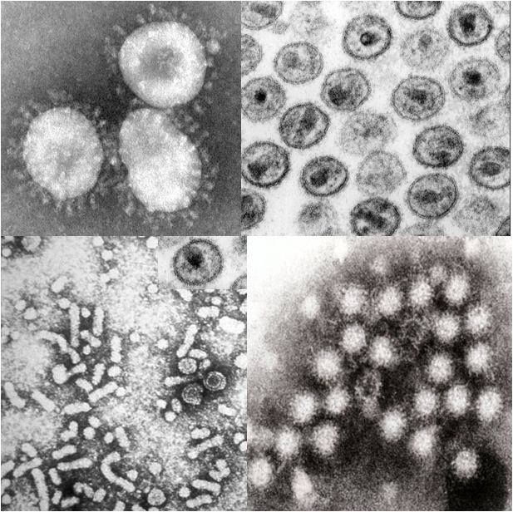
Version 18, May2023, Q-pulse MAN-Q-037

West of Scotland Specialist Virology Centre User manual, Q-pulse document MAN-Q-037 version 18
Document prepared by Dr Samantha Shepherd and Mrs Pamela Saunders on behalf of the West of Scotland Specialist Virology Clinical Group
Authorised by Professor Rory Gunson, Consultant Clinical Scientist and Virology Clinical Lead/Laboratory director

Pictures on the front: coronavirus (https://en.wikipedia.org/wiki/Coronavirus#/media/File:Coronaviruses_004_lores.jpg), HIV (https://emedicine.medscape.com/article/211316-overview), norovirus (https://www.norovirus.com/wp-content/uploads/2014/06/norovirus-e1403938112285.jpg) and HBV (https://upload.wikimedia.org/wikipedia/commons/1/12/Hepatitis-B_virions.jpg)

Table of contents

Content | Page
West of Scotland Specialist Virology Centre introduction | 4
Laboratory location | 5
Laboratory delivery details | 6
Working hours | 7
Contact details | 7
Urgent and on-call requests | 7
Staff contacts – main laboratory staff | 8
Staff contacts – senior clinical team | 9
Request forms and specimen criteria | 10
How to transport specimens to the laboratory | 11
Specimen containers accepted at WoSSVC | 13
Symptoms and specimens used for diagnosis | 16
Investigations available at WoSSVC and turnaround times | 22
User access to results | 29
Requesting additional tests | 29
Retention of specimens | 30
Deviating specimens | 30
Laboratory policy on protection of personal information | 31
Complaints Procedure | 31
User Feedback | 31
Quality assurance and variability | 32
Point of Care testing (POCT) | 33
Kits supplied by the laboratory | 33
Referral to reference laboratories | 34

West of Scotland Specialist Virology Centre
The West of Scotland Specialist Virology Centre (WoSSVC) forms part of the acute division service within NHS Greater Glasgow and Clyde (NHS GGC).
The WoSSVC provides virology services (diagnostic, clinical, educational) for the whole of the Greater Glasgow region. We are also a referral laboratory for the west of Scotland and for regions out with the west of Scotland. We also site a number of national services such as the Blood Borne Virus Specialist Testing Services, Viral Genotyping (including COVID-19, Influenza, RSV and Hepatitis A virus), Avian Influenza testing, Middle Eastern Respiratory Syndrome (MERS) testing and the National Respiratory Surveillance testing.
The West of Scotland Specialist Virology Centre is a UKAS medical laboratory. No. 9319.
We have extensive experience in the diagnosis of viral pathogens using a range of commercial and in-house serological and molecular based assays. We have a high throughput serological laboratory offering tests on both blood-borne viruses (BBV) and non-BBV pathogens. We also provide BBV testing of dried blood spots for community addiction teams, prison service and pharmacies. We are one of only two laboratories in Scotland to offer HIV avidity testing. We also offer serological diagnosis on syphilis. We offer molecular testing for a wide range of viral and non viral pathogens. Thesecan be performed on various sample types including, but not limited to, respiratory specimens, blood, stool and CSF. We provide sexual health screening for Chlamydia trachomatis, Neisseria gonorrhoea and Mycoplasma genitalium (inc. M. genitalium resistance). The laboratory also runs the TB quantiferon assay and Helicobacter pylori antibody test.
National laboratory responsibilities:
- Viral genotyping service
  - Influenza
  - SARS-CoV-2 (COVID-19)
  - Hepatitis A
- Specialist Blood Borne Virus testing service for the West and North of Scotland
  - HIV resistance testing and subtyping
  - CCR5 tropsim testing
  - HIV avidity
  - HCV genotyping and resistance testing
  - HDV quantitative real-time PCR
- Avian Influenza and Middle East Respiratory Syndrome (MERS) coronavirus national testing centre for Scotland (except Lothian, Borders and Fife)
  - 24/7 testing service available
Laboratory Location

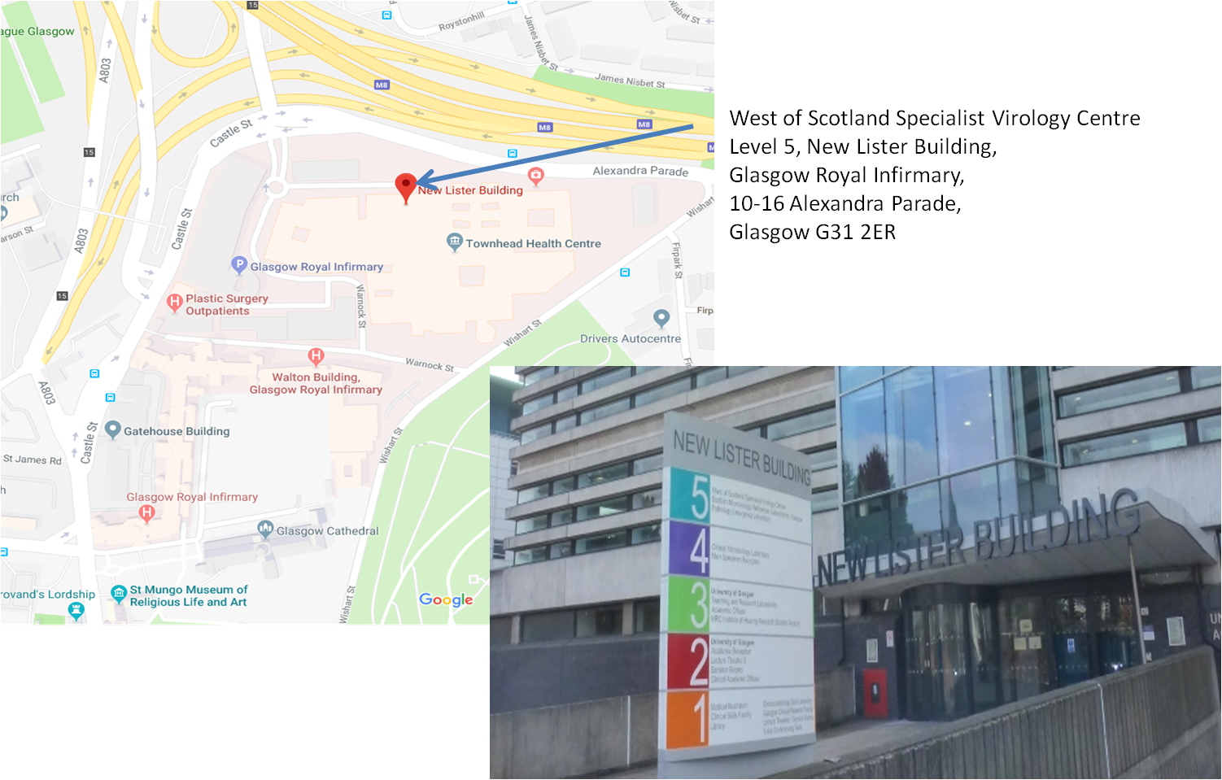
The West of Scotland Specialist Virology Centre is located on Level 5 of the New Lister Building which is located on Alexandra Parade and forms part of the Glasgow Royal Infirmary complex. We share the 5th floor with the Scottish Microbiology Reference Laboratory.

Laboratory delivery details
Main Reception (Level 4) Virology Reception (level 5)
(Deliveries – non-specimens) (Specimen delivery)
New Lister Building New Lister Building
Glasgow Royal Infirmary Glasgow Royal Infirmary
10-16 Alexandra Parade 10-16 Alexandra Parade
Glasgow G31 2ER Glasgow G31 2ER

Dx Address: West of Scotland Specialist Virology Centre
Dx Number: DX 6491304 Glasgow 94G

Glasgow Royal Infirmary POD system: number 605

Urgent samples out-of hours address
Urgent samples should be highlighted to the laboratory via the generic email address: west.ssvc2@nhs.scot. Deliver the urgent specimen to the black box marked “microbiology and virology urgent samples drop box” which can be found in the door way of the:
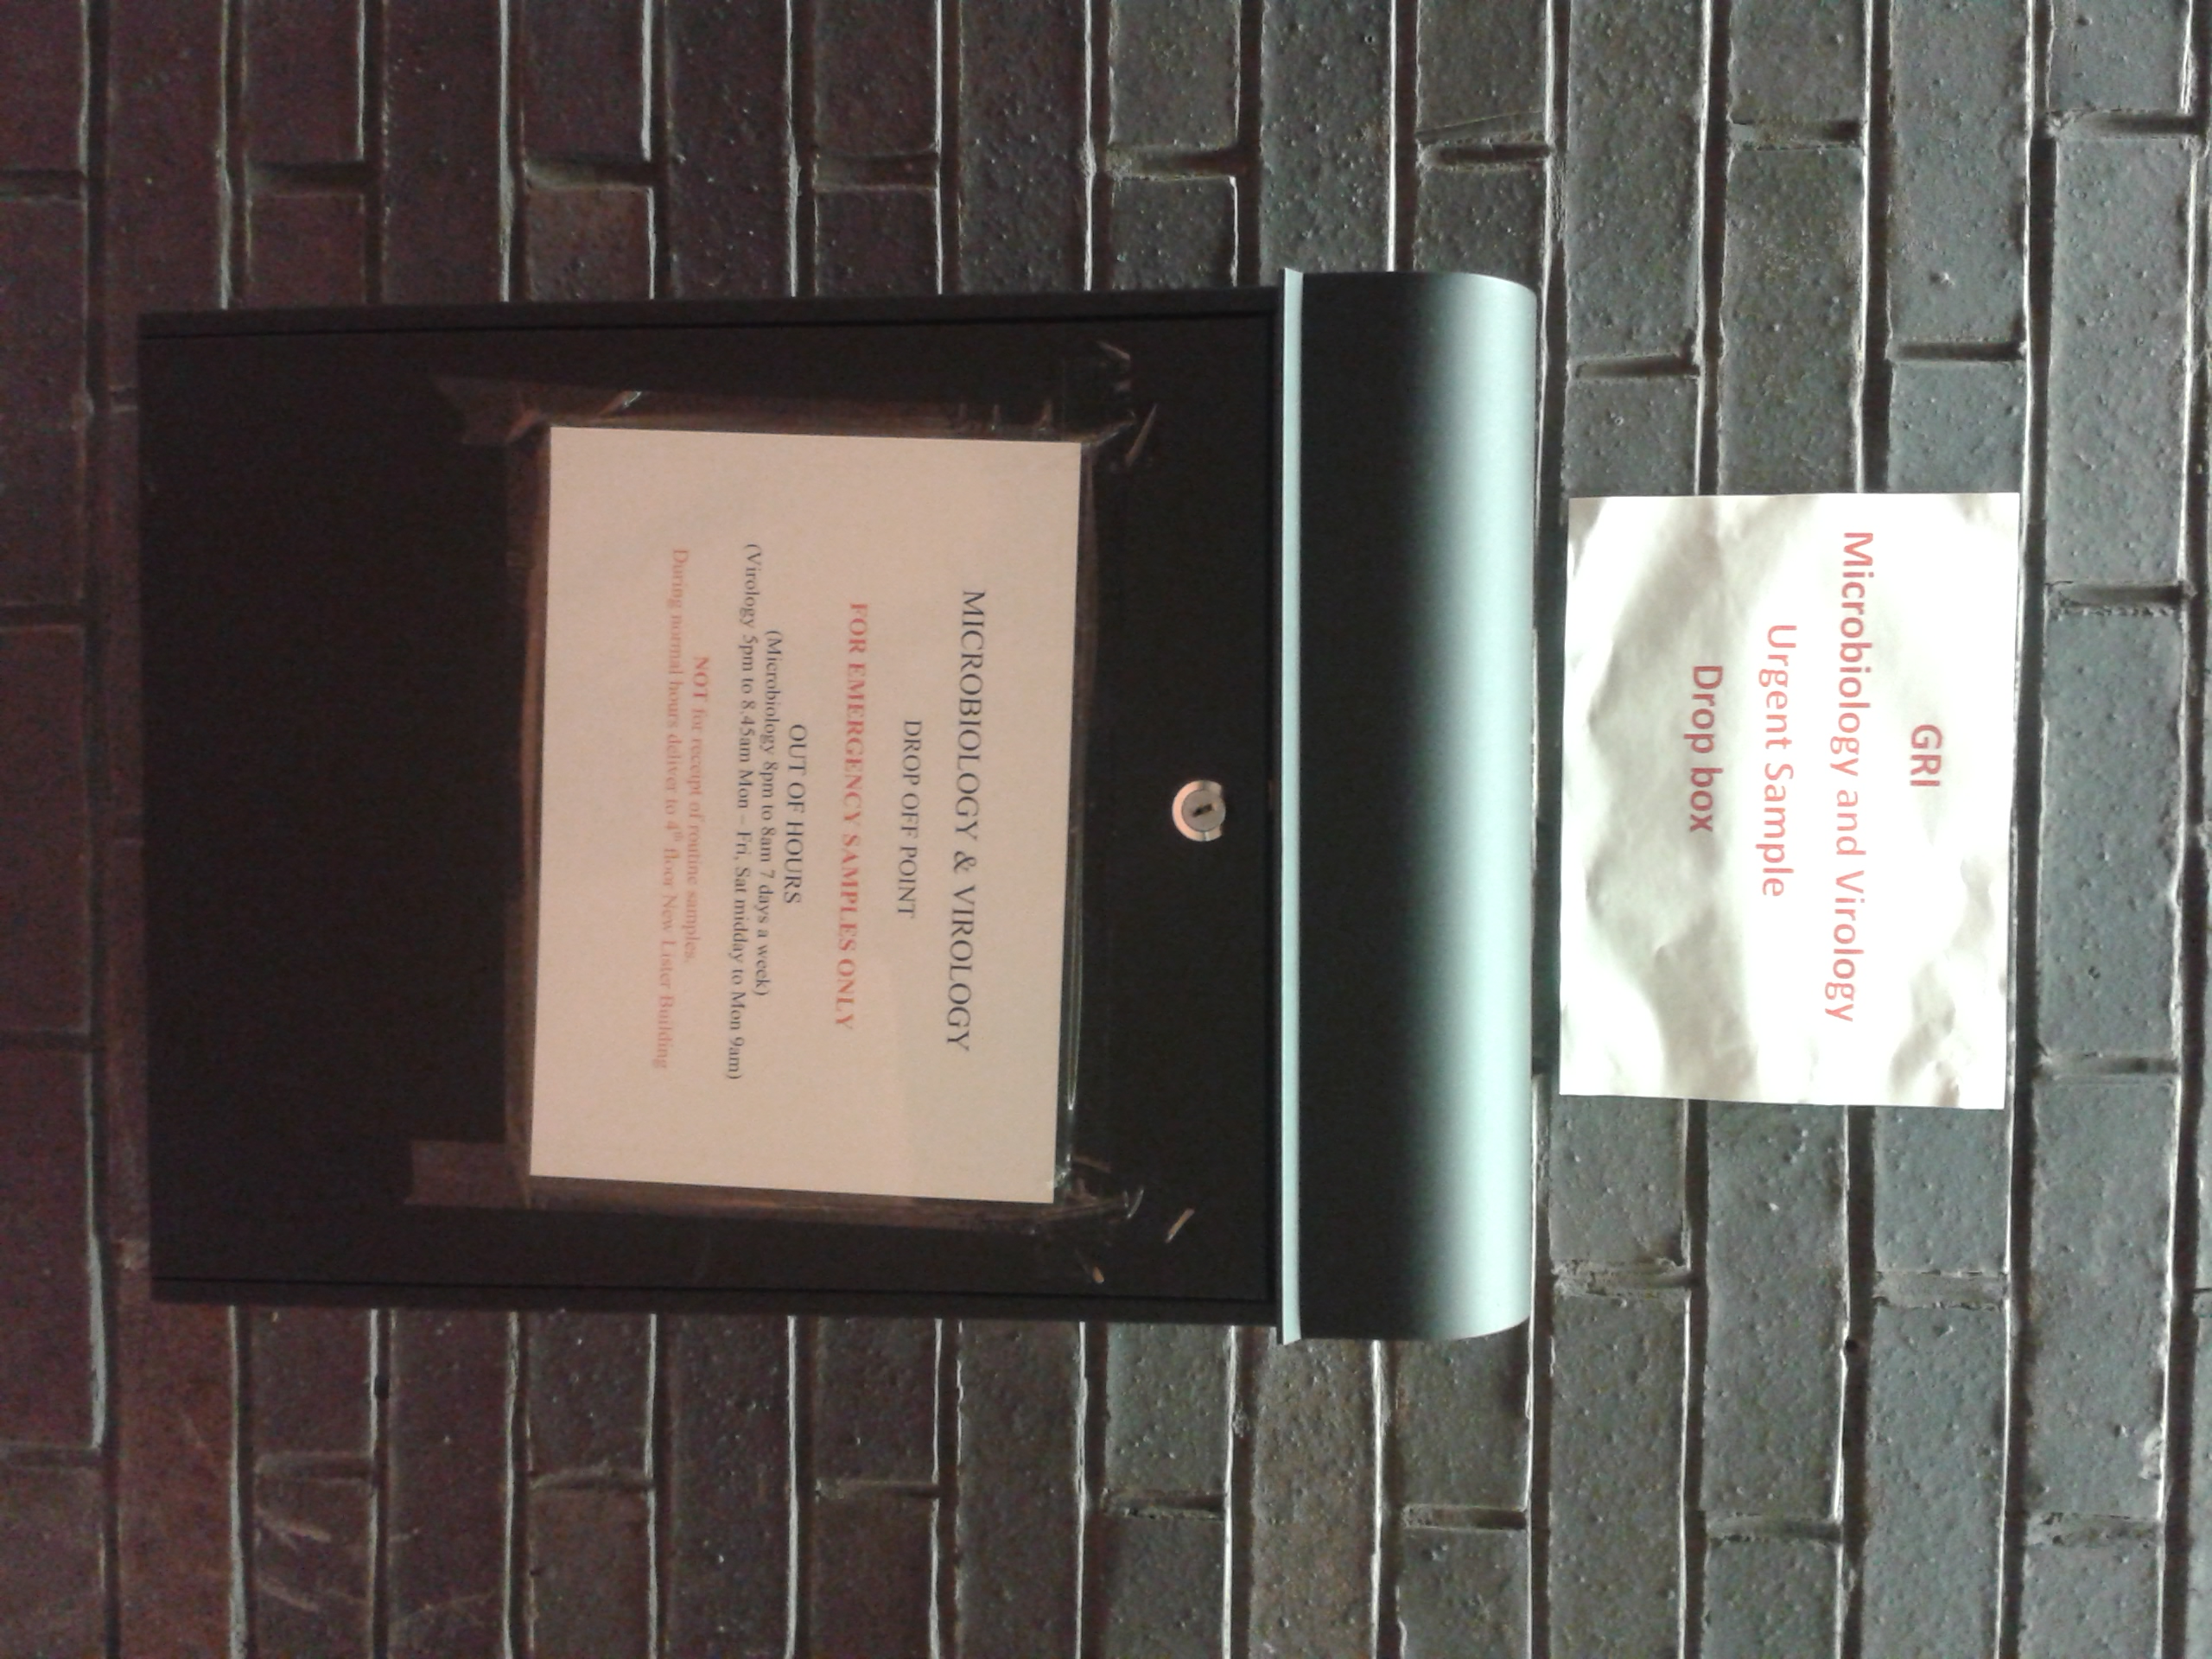
Princess Royal Maternity (Emergency Entrance & drop-off)
Glasgow Royal Infirmary
Wishart Street
Glasgow G31 2HT
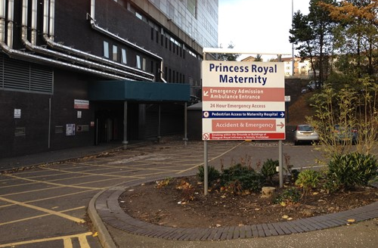

Working hours
Monday to Friday (and public holidays): 08:45 – 17:00
Saturday/Sunday: 08:45 – 14:00
The laboratory offers an on-call service outwith working hours (see contact details below).
Contact details
Working hours
General enquiries: 0141 201 8722 (internal 38722)
Results and report reprints: email west.ssvc2@nhs.scot
Clinical advice and urgent testing: email west.ssvc2@nhs.scot during opening times or phone 0141 242 9656 (internal 29656). Please note during busy times it is easier to email and a member of the clinical team will respond.
To add on tests please email west.ssvc2@nhs.scot with clinical details and tests required. The email is monitored during laboratory opening hours (we aim to reply to your email within 1 hour, however, at busy times this may not be possible)
Results are available on clinical portal, SCI Store, TrakCare and GPICE for GGC patients if a patient’s CHI has been provided on the request form.

Urgent and on-call requests
The laboratory runs a Consultant lead on-call service for clinical advice. A limited range of laboratory tests are also available on call (e.g. antenatal late booker, MERS-CoV, avain influenza) contact GRI switchboard (0141 211 4000) and ask to speak to the on-call virologist. Organ donor screening can be arranged directly with the duty Biomedical Scientist via the GRI switchboard (0141 211 4000).
Staff contacts – key laboratory staff

Mr John Mallon MSc John.Mallon@ggc.scot.nhs.uk
Head of Technical Services
(Microbiology, Virology & SMiRL)

Mrs Pamela Saunders BSc, MSc Pamela.Saunders@ggc.scot.nhs.uk
Laboratory Manager (Virology & SMiRL) Telephone: 0141 242 9647

Dr Scott Nicholson PgCert MSc PhD FIBMS Scott.Nicholson@ggc.scot.nhs.uk
Virology Operational Manager Telephone: 0141 242 9645

Ms Ann Hawthorn BSc, PGdip, MSc Ann.Hawthorn@ggc.scot.nhs.uk
Operations Manager (Covid Testing Hub) Telephone: 0141 242 9646

Ms Louise Sincalir BSc, MSc Pamela.Saunders@ggc.scot.nhs.uk
Compliance Manager

Ms Sally Taylor BSc, MSc Sally.Taylor@ggc.scot.nhs.uk
Quality/Training/Point of Care testing Manager Telephone: 0141 242 9646

Staff contacts – senior clinical staff

Professor Rory Gunson BSc, MSc, PhD, FRCPath
Consultant Clinical Scientist email: Rory.Gunson@ggc.scot.nhs.uk
Clinical Lead Telephone: 0141 242 9659
Laboratory director
Head of Molecular Development and Specialist Typing

Dr Celia Jackson MBChB, MRCP, FRCPath
Consultant Infectious Diseases email: Celia.Jackson@ggc.scot.nhs.uk
& Virology Telephone: 0141 242 9644

Dr Samantha Shepherd BSc (Hon), MSc, PhD, FRCPath
Consultant Clinical Scientist email: Samantha.Shepherd@ggc.scot.nhs.uk
Telephone: 0141 242 9643

Request forms and specimen criteria
Please note NHSGGC request forms are now produced by TrakCare, please refer to the website for further information on how to fill out TrakCare requests: http://www.nhsggc.org.uk/virology
The following request forms are available from the website (http://www.nhsggc.org.uk/virology):
- Manual WoSSVC generic request form
- Manual WoSSVC SARS-CoV-2 PCR request form
- WoSSVC Dried blood spot request form
- Hepatitis B DNA testing for healthcare workers (HCW) involved in exposure prone procedures (EPP)
- HIV genotypic resistance request form
- HCV resistance request form
- CCR5 tropism request form
Specimen essential Information:
- Full name or unqiue coded identifier
- Date of birth and or CHI (Community Health Index) number
Request form essential information:
- Full name or unique coded identifier
- Date of birth or CHI (Community Health Index) number
- Test required
- Specimen type and site where appropriate and relevant clinical information
- Date of collection
- Hazard group, if known or suspected to contain Hazard Group 3 pathogens
- Contact information of requester (vital for urgent requests)
Please note: If a CHI number is provided the results will appear on Clinical Portal/Sci store, Track and GPICE. This negates the need for posting results or users having to email for the result.
Laboratory statement to users:
The laboratory aims to test all specimens within designated turn-around-times. In order for this to occur and the correct investigations to be chosen, we ask that all users fill out the required information clearly on the request forms and that the correct patient identifiers are present on both the specimen and the request form. We ask that specimens are packaged ppropriately and are correctly sealed to prevent leakage in transit. For urgent testing please contact the laboratory in advance to arrange when a result can be available.
How to transport samples to the laboratory

NHSGGC GP collection service, interlab vans and couriers all deliver to the laboratory from: Queen Elizabeth University Hospital, Gartnavel General Hospital, Royal Alexandra Hospital, Inverclyde Royal Hospital, Sandyford Initiative, Monklands Hospital, Wishaw General Hospital, Hairmyres, Crosshouse and Dumfries & Galloway Royal Infirmary.

Specimens also arrive at the laboratory via Royal Mail post or DX collection (DX number 6491304, DX exchange Glasgow 94G).

Glasgow Royal Infirmary wards can send specimens via the POD system, number 0605.

Specimens taken out with working hours of the laboratory should be kept in the fridge at 4ºC and sent to the laboratory on the following day.

Delivery address for the laboratory can be found on page 5-6 of this manual.

All specimens should be packaged according to national and international regulations. Specimens are classified as Category A or Category B according to the micro-organisms they contain (or be reasonably expected to contain).

How to transport samples to the laboratory

Please refer to:
NHSGGC Transport and disposal of specimen containers and specimens policy: http://www.staffnet.ggc.scot.nhs.uk/Acute/Diagnostics/All%20Laboratory%20Medicine/Mortuary%20Services/SGPathology/Documents/Trans%20of%20Specimen%20Policy%20Oct%2016%20final.pdf
Transport of specimens guideline: http://www.nhsggc.org.uk/media/236255/guidance-transport-of-specimens.pdf
WHO guidance on regulations for the transport of infectious substances 2019-2020: https://apps.who.int/iris/bitstream/handle/10665/325884/WHO-WHE-CPI-2019.20-eng.pdf
Instructions for DX packaging should be followed, refer to www.thedx.co.uk
Urgent sending of Middle East Respiratory Syndrome (MERs) coronavirus (CoV) or avian influenza specimens: Please contact the clinical team (0141 242 9656) before sending the samples. Urgent out of hours Mers-CoV or avian influenza testing please contact the switchboard (0141 211 4000) and ask to speak to the on-call virologist before sending any samples. There are UN3373 boxes marked specifically for MERS-CoV in various locations around NHSGGC which can fit in the laboratory out-of-hours urgent testing box. Further information can be found at: http://www.nhsggc.org.uk/your-health/infection-prevention-and-control/mers-cov-information-hub/

Specimen containers accepted at WoSSVC
Swabs (for Chlamydia trachomatis/Neisseria gonorrheae/Mycoplasma genitalium testing please see page 15)
Swabs should be used in conjunction with Molecular Sample Solution (MSS), which is available from the laboratory (see page 31). After the swab is taken it should be emersed in the liquid, swirled and expressed on the side of the vial and discarded. The cap should be replaced tightly prior to being sent to the laboratory. Ensure the swab is NOT left in the sample container or the sample will NOT be tested. We prefer flocked swabs, if these are not available other swab types can be used, if unsure please contact the laboratory. Do not send swabs in charcoal.

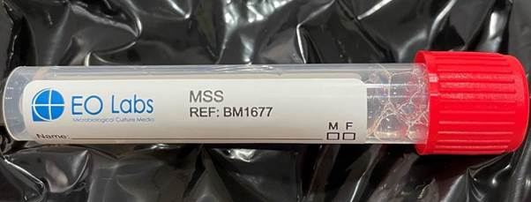

These swabs can be used in the following areas: throat, nasal, eye, vesicle, ulcer, mouth and rectal.

White top universal (sterile) containers (for Chlamydia trachomatis/Neisseria gonorrhoeae/Mycoplasma genitalium testing please see page 15)
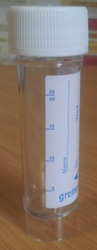
Universal containers can be used for CSF, urine, gargles, sputum, bronchoalveolar lavage (BAL), aqueous humor, corneal scrapings, amniotic fluid, vomit, biopsy and post mortem tissue. Do NOT add MSS to these samples.
Do NOT send Boric acid containers with urine samples; these will be discarded by the laboratory.
Stool specimens can be sent in a white top universal; alternatively we accept stool sample pot containers (see below).
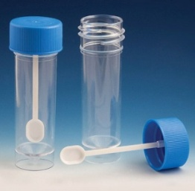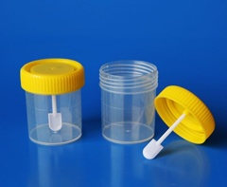

Specimen containers accepted at WoSSVC
Endotracheal secretions
Please ensure that the tubing has been removed from the specimen collection device and the lid has been firmly capped and fitted to prevent leakage. If the tubing is left in, the specimen will leak and the laboratory will discard the specimen.
Nasopharyngeal aspirates
Collect and send in the trap, secure to prevent leakage

Blood samples
Most assays in our laboratory (both serological and molecular) use EDTA blood.
Please send a single 9ml EDTA blood tube (5ml if paediatric or difficult to bleed, please note that this may be insufficient if confirmatory testing is required on the specimen). 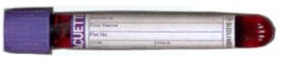
Clotted blood can also be sent to the laboratory as an alternative, if EDTA blood tubes are not available. Viral load cannot be quantified on clotted blood. Clotted blood is also required by some reference laboratories when a specimen needs to be sent away.

Dried blood spot
The DBS sample is an alternative method of screening for HIV, HCV and HBV. Please ensure that all five spots on the card are fully saturated up to the dotted lines both on the front and back of the card. Insufficient saturated sample will result in the card being discarded.

Specimen containers accepted at WoSSVC
Abbott multi-collect specimen collection kit for Chlamydia trachomatis/Neisseria gonorrheae/Mycoplasma genitalium PCR ONLY (Please DO NOT use for other clinical scenarios)
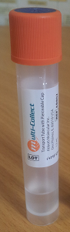
Please make sure the swab remains within the container (only specimen sent to WoSSVC where this should happen)*.
Please follow the manufacturer’s instructions provided with the kit, this is a commercial assay and therefore all manufacturers’ guidelines on the appropriate way to take these samples should be followed.

Female: Vaginal swab (self-collected or clinician-collected)
Rectal swab*
Pharyngeal swab*
DO NOT SEND URINE for WOMEN

Male: Urine – MUST BE SENT IN THE ABBOTT COLLECTION TUBE
Urethral swab*
Rectal swab*
Pharyngeal swab*
*The swabs should be removed from the Abbott multi-collection tube. Do not send dry swabs or samples in amies, charcoal or MSS for Abbott testing.

QuantiFERON-TB Gold Plus Tubes:
The following tubes should be used:
1. QuantiFERON Nil Tubes (gray cap with white ring)
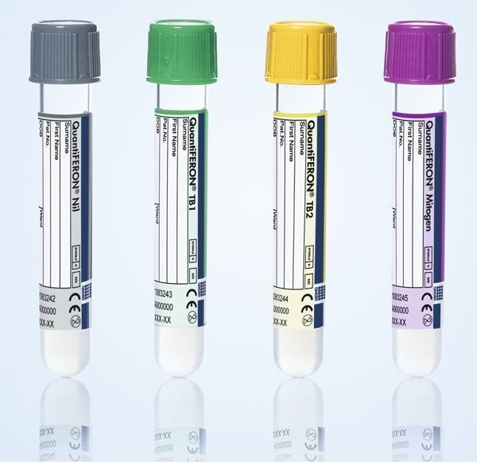
2. QuantiFERON TB1 Tubes (green cap with white ring)
3. QuantiFERON TB2 Tubes (yellow cap with white ring)
4. QuantiFERON Mitogen Tubes (purple cap with white ring)
Each patient MUST have one of each tube type with the correct volume of blood present in each tube
TB Quantiferon Gold Plus tubes are ordered from the user’s local Microbiology department.
Immediately after filling the tubes, invert them ten times just firmly enough to ensure that the entire inner surface of the tube is coated with blood, to dissolve antigens on tube walls. Once filled the blood tubes are required to reach the laboratory within 16 hrs post collection. If samples arrive after 16 hours from collection the samples will be discarded. Samples may arrive at the laboratory Monday to Friday up to 5pm.

 |  | Symptoms and specimen used for diagnosis | Specimens for testing  Please see pages 22 – 28 for the full range of tests available at WoSSVC and turn-around times
System involved/  clinical group | Clinical features | Common pathogens | Mouth swab / buccal swab | Throat swab | Throat/nose swab | NPA | Sputum | ETA |  | BAL | CSF | Eye (swab), aqueous humor, corneal scrapings | DBS | EDTA | Clotted blood | Stool | Urine | Skin / vesicle swab | Biopsy
Respiratory | URTI/LRTI  (Adults & outpatient paediatrics) | Influenza (A&B), RSV, SARS-CoV-2 |  | Any respiratory specimen  (SAR-CoV-2 screening send combined throat and nose swab )
 | URTI/LRTI  (Patients in ICU, critical care, immunocompromised or in-patient paediatrics) | Influenza (A&B), adenovirus, RSV, parainfluenza 1-4, coronavirus, rhinovirus/enterovirus, human metapneumovirus, Mycoplasma pneumoniae, SARS-CoV-2  Pneumocystis/Aspergillus will be tested on LRT samples if requested or if evidence of immunocompromised.  Babies < 8 weeks test for Chlamydia trachomatis if clinically requested. |  | Any respiratory specimen  (one is enough)
 | Travel related LRTI | Middle East Respiratory Syndrome (MERS-CoV) | A throat swab, lower respiratory tract specimen and a clotted blood are required for this investigation. Testing must be arranged with the laboratory. DO NOT send any specimens before contacting the laboratory.
 |  | Avian influenza | A throat swab and/or a lower respiratory sample (if possible) are required for this investigation. DO NOT send any specimens before contacting the laboratory.
 | Immunocompromised*  (automatically receive a full extended respiratory screen see above) | Pneumocystis jirovecii / cytomegalovirus (CMV) |  |  |  |  | ✓ | ✓ |  | ✓
 |  | Aspergillus species and Aspergillus fumigatus |  |  |  |  |  |  |  | ✓ |  |  |  | ✓
 | Whooping cough | Bordetella pertussis |  | Any respiratory specimen  (one is enough)
 | Parotitis/Mumps | Mumps virus | ✓
* Please clearly state immunocompromised on the patient request form when requesting Pneumocystis jirovecii or Aspergillus testing. If these tests are required on patients who are not immunocompromised please contact the laboratory to arrange testing or clearly request on the form. Please note that these tests are only validated for LRT samples. Aspergillus testing can be carried out on blood in immunocompromised patients such as HSCT. The results should be interpreted alongside other tests such as Galactomannan Ag testing and Beta Glucan.

Specimens for testing
Please see pages 22 – 28 for the full range of tests available at WoSSVC and turn-around times
System involved / clinical group | Clinical features | Common pathogens | Mouth swab / buccal swab | Throat swab | Throat/nose swab | NPA | Sputum | ETA | BAL | CSF | Eye swab, aqueous humor, corneal scrapings | DBS | EDTA | Clotted blood | Stool | Urine | Skin / vesicle swab | Biopsy
GI tract | Gastroenteritis | Norovirus |  |  |  |  |  |  |  |  |  |  |  |  | ✓  (also vomit)
 |  | Adenovirus, sapovirus, astrovirus, rotavirus  (children <10 years, immunosuppressed & outbreaks only) |  |  |  |  |  |  |  |  |  |  |  |  | ✓
 | Hepatitis | Hepatitis A (HAV), Hepatitis E (HEV) |  |  |  |  |  |  |  |  |  |  | ✓ |  | (✓)  Available on request
 |  | Hepatitis B (HBV), Hepatitis C (HCV), Hepatitis D (HDV) |  |  |  |  |  |  |  |  |  | ✓  (not HDV) | ✓
 | Gastric ulcer | Helicobacter pylori |  |  |  |  |  |  |  |  |  |  | ✓ | ✓
 | Crohn’s  (Pre-biologic screening) | Epstein barr virus (EBV), cytomegalovirus (CMV) |  |  |  |  |  |  |  |  |  |  | ✓
 | Crohn’s  (active colitis) | Epstein barr virus (EBV), cytomegalovirus (CMV) |  |  |  |  |  |  |  |  |  |  | ✓ |  |  |  |  | ✓

Specimens for testing
Please see pages 22 – 28 for the full range of tests available at WoSSVC and turn-around times
System involved/ clinical group | Clinical features | Common pathogens | Mouth swab / buccal swab | Throat swab | Throat/nose swab | NPA | Sputum | ETA | BAL | CSF | Eye (swab), aqueous humor, corneal scrapings | DBS | EDTA | Clotted blood | Stool | Urine | Vesicle swab | Biopsy
Nervous system | Aseptic meningitis, encephalitis | HSV1, HSV2, VZV, Enterovirus/Parechovirus |  | (✓)  Enterovirus  Parechovirus  only |  |  |  |  |  | ✓ |  |  |  |  | (✓)  Enterovirus  Parechovirus  only
 | Immunocompromised aseptic meningitis/encephalitis | HSV1, HSV2, VZV, Enterovirus/Parechovirus  HHV6, CMV, EBV, JCPyV (JC virus) |  | (✓)  Enterovirus  Parechovirus  only |  |  |  |  |  | ✓ |  |  |  |  | (✓)  Enterovirus  Parechovirus  only
 | Progressive multifocal leukoencephalopathy (PML) | JCPyV (JC virus) |  |  |  |  |  |  |  | ✓
 | Ring enhancing regions | Toxoplasma gondii |  |  |  |  |  |  |  | ✓ |  |  | ✓
 | Guillian Barre Syndrome (GBS) | CMV, EBV, enterovirus |  |  |  |  |  |  |  | ✓
 | Transverse myelitis | HSV1, HSV2, VZV, CMV, EBV, enterovirus, mycoplasma |  | (✓)  Enterovirus  Mycoplasma |  |  |  |  |  | ✓
 | MS, demyelination, parethesia and/or peripheral neuropathy | HSV1, HSV2, VZV, enterovirus |  | (✓)  Enterovirus  only |  |  |  |  |  | ✓
 | Febrile Convulsions | HSV1, HSV2, VZV,  HHV6/HHV7  Enterovirus, influenza, lower respiratory tract infection |  | Any respiratory specimen  (one is enough) |  |  |  |  |  | ✓

Specimens for testing
Please see pages 22 – 28 for the full range of tests available at WoSSVC and turn-around times
System involved/ clinical group | Clinical features | Common pathogens | Mouth swab / buccal swab | Throat swab | Throat/nose swab | NPA | Sputum | ETA | BAL | CSF | Eye (swab), aqueous humor, corneal scrapings | DBS | EDTA |  | Clotted blood |  | Stool |  |  | Urine |  | Vesicle swab | Biopsy
Sexually transmitted diseases/ GUM clinic | Vaginal discharge, pain on urination, lower abdominal pain, urethritis, fever | Chlamydia trachomatis  Neisseria gonorrheae ,  Mycoplasma genetalium | Specimens should be collected in Abbott multi-collect specimen collection kit devices  (refer to page 15 of the user manual)
 | Vesicles/ulcers | Syphilis |  |  |  |  |  |  |  |  |  |  |  | ✓ |  |  |  |  |  |  | ✓
 |  | HSV1 and HSV2 |  |  |  |  |  |  |  |  |  |  |  |  |  |  |  |  |  |  | ✓
 | Blood borne virus infection | HIV-1, HIV-2, HBV, HCV, HTLV-1/HTLV-2 |  |  |  |  |  |  |  |  |  | ✓  (not HTLV) |  | ✓
Ophthalmic | Conjunctivitis, keratitis, uveitis, ARN, PORN | Adenovirus, HSV, VZV, Chlamydia trachomatis |  |  |  |  |  |  |  |  | ✓
Transplant | Pre-transplant Donor/Recipient screen (exact tests depend on transplant) | HIV-1/HIV-2, HBV, HCV, HTLV-1/HTLV-2, HEV, CMV, EBV, VZV, HSV, Syphilis, Toxoplasma gondii |  |  |  |  |  |  |  |  |  |  |  | ✓
 | Post-transplant surveillance and diagnosis | CMV, EBV, adenovirus, HBV, HEV, HSV, VZV |  |  |  |  |  |  |  |  |  |  |  | ✓
 | Haemorrhagic cystitis | BKPyV (BK virus), JCPyV (JC virus) |  |  |  |  |  |  |  |  |  |  |  | ✓ |  |  |  |  | ✓

Specimens for testing
Please see pages 22 – 28 for the full range of tests available at WoSSVC and turn-around times

System involved/  clinical group | Clinical features | Common pathogens | Mouth swab / buccal swab | Throat swab |  | Throat/nose swab |  | NPA |  | Sputum | ETA | BAL | CSF | Eye (swab), aqueous humor, corneal scrapings | DBS | EDTA | Clotted blood | Stool | Urine | Skin/ Vesicle swab | Biopsy
Haematological | Thrombocytopenia | CMV, EBV, B19 |  |  |  |  |  |  |  |  |  |  |  |  |  | ✓
 | Atypical lymphocytes | EBV, CMV , HIV |  |  |  |  |  |  |  |  |  |  |  |  |  | ✓
 | Henoch-Schonleinpurpura | Mycoplasma pneumoniae |  | Any respiratory specimen  (one is enough)
 | Persistent anaemia | CMV, EBV, B19, HIV |  |  |  |  |  |  |  |  |  |  |  |  |  | ✓
Skin and mucosa | Maculopapular / erythematous | B19, CMV, EBV |  |  |  |  |  |  |  |  |  |  |  |  |  | ✓
 |  | Enterovirus, HHV6, HHV7, measles, rubella | ✓ | ✓
 | Vesicular | HSV1, HSV2, VZV, Enterovirus |  |  |  |  |  |  |  |  |  |  |  |  |  |  |  |  |  | ✓
 | Erythema mutliforme/Steven Johnson syndrome | HSV, CMV, EBV |  |  |  |  |  |  |  |  |  |  |  |  |  | ✓ |  |  |  | ✓
 |  | Mycoplasma pneumoniae |  | Any respiratory specimen  (one is enough)
 | Mouth ulcers | HSV, enterovirus |  |  |  |  |  |  |  |  |  |  |  |  |  |  |  |  |  | ✓
Systemic | Fulminant hepatitis | HBV , HAV, HEV |  |  |  |  |  |  |  |  |  |  |  |  |  | ✓
 | Lymphadenopathy | EBV, CMV, Toxoplasma gondii, HIV-1, HIV-2 |  |  |  |  |  |  |  |  |  |  |  |  |  | ✓

Specimens for testing
Please see pages 22 – 28 for the full range of tests available at WoSSVC and turn-around times

System involved/  clinical group |  | Clinical features | Common pathogens | Mouth swab / buccal swab | Throat swab | Throat / nose swab | NPA | Sputum | ETA | BAL | CSF | Eye (swab), aqueous humor, corneal scrapings | DBS | EDTA | Clotted blood | Stool | Urine | Skin/ Vesicle swab | Biopsy
Pregnancy |  | Antenatal screen | HIV-1, HIV-2, HBV, syphilis |  |  |  |  |  |  |  |  |  |  | ✓
 |  | Fetal abnormalities on scan, intrauterine death | CMV, B19, Toxoplasma gondii, VZV, rubella (rare)  Please note that a historical sample may also be required. |  |  |  |  |  |  |  |  |  |  | ✓
 |  | Maternal rash | B19, measles, rubella, (rare), Enterovirus, HSV1, HSV2, VZV |  | ✓ |  |  |  |  |  |  |  |  | ✓ |  |  |  | ✓
 |  | Maternal exposure to rash | VZV, B19, measles, rubella (rare) |  |  |  |  |  |  |  |  |  |  | ✓
Neonatal |  | Congenital CMV  (samples from babies >21 days may be postnatally acquired CMV) | CMV |  | ✓ |  |  |  |  |  |  |  |  |  |  |  | ✓
 |  | Neonatal HSV infection  (Discuss with the laboratory prior to sending specimens) | HSV |  | ✓ |  |  |  |  |  | ✓ | ✓ |  | ✓ |  |  |  | ✓  (rectal & skin swab)
 |  | Maternal HIV | HIV-1, HIV-2 |  |  |  |  |  |  |  |  |  |  | ✓
 |  | Septic baby | Enterovirus, parechovirus, HSV |  | ✓ |  |  |  |  |  | ✓ | ✓ |  | ✓ |  |  |  | ✓
 |  | Conjugated bilirubinemia | CMV, HSV, Toxoplasma gondii, syphilis, Enterovirus (rare), rubella (rare) |  | ✓ |  |  |  |  |  |  |  |  | ✓ |  |  | ✓

Investigations at WoSSVC and turnaround times
Recent/current infections can use both serology and/or molecular techniques, depending on the pathogen. Past exposure/immunity requires serology testing only.
Please see “specimen containers accepted at WoSSVC” on pages 13-15 for specimen types accepted at WoSSVC.
Amount of specimen required will depend on the number of investigations requested for that specimen.
In general the following rules apply:
Specimen | Amount
Clotted blood | 6ml
CSF | ≥0.2ml
Dried Blood Spot (DBS) | 5 spots fully saturated back and front
EDTA blood | 5ml or 9ml
Plasma aliquot | 0.5 -1 ml (1000μl required for molecular)
Serum aliquot | 0.5 -1 ml (1000μl required for molecular)
Respiratory specimen | 1ml

Turn-around-times are cited below next to each test, please contact the clinical team on 0141 242 9656 (internal 29656) or email west.ssvc2@nhs.scot if urgent testing is required. Turn-around-times cited are based on the number of working days.

Investigations at WoSSVC
Hepatitis Viruses | Test | Specimen type | Turnaround time (days)
Hepatitis A  (HAV) | HAV IgM | EDTA | 1-3
 | HAV IgG | EDTA | 1-3
 | HAV PCR | EDTA  Stool | 3-7
Hepatitis B  (HBV) | HBsAg | EDTA  DBS | 1-3
 | HBsAg neutralisation | EDTA  DBS | 1-4
 | HBsAg quantification | EDTA | 1-3
 | HBcore IgM | EDTA | 1-4
 | HBcore IgG | EDTA  DBS | 1-4
 | Anti-HBs | EDTA | 1-3
 | HBV DNA PCR | EDTA | 3-7
 | HBV resistance testing  (not routine test, available on request) | EDTA | 12
Hepatitis C  (HCV) | Antibody | EDTA  DBS | 1-3  3-7
 | HCV RNA detection/quantification (viral load) | EDTA  DBS | 3-7
 | HCV genotyping | EDTA/clotted blood | 12
 | HCV resistance testing  (not routine test, available on request) | EDTA/clotted blood | 12
Hepatitis D (HDV) | RNA detection/quantification | EDTA | 12
Hepatitis E (HEV) | Antibody (IgM / IgG) | EDTA | 5-10
 | HEV qualitative PCR | EDTA  Stool | 3-7
Retroviruses
HIV-1/ HIV-2 | HIV screen (antigen/antibody) | EDTA  DBS | 1-2
 | HIV-1/2 antibody differentiation | EDTA  DBS | 1-2
 | HIV-1 avidity | EDTA | 1 month
 | HIV-1 RNA quantification (viral load) | EDTA | 3-7
 | HIV-1 resistance testing | EDTA/clotted blood | 12
 | HIV-1 subtyping | EDTA/clotted blood | 12
 | CCR5 tropism | EDTA* | 12
HTLV-1/ HTLV-2 | Antibody | EDTA | 1-3

*CCR5 resistance testing varies as per HIV viral load, viral load >1000 copies/ml send at least 5 ml EDTA, viral load <1000 copies/ml send at least 2ml EDTA
Investigations at WoSSVC
Herpesviruses | Test | Specimen | Turnaround time (days)
Cytomegalovirus (CMV) | Antibody IgG | EDTA | 1-4
 | Antibody IgM | EDTA | 1-4
 | IgG Avidity | EDTA | 1-4
 | DNA detection  (quantification available only on EDTA) | Amniotic fluid  BAL  CSF  EDTA  Throat swab  Urine  Biopsy | 1-3
Epstein Barr Virus (EBV) | Antibody IgG (VCA/EBNA) | EDTA | 1-4
 | Antibody IgM | EDTA | 1-4
 | DNA detection (quantification available only on EDTA) | CSF  EDTA  Biopsy | 1-3
Herpes simplex  (HSV1 & HSV2) | Antibody IgG | EDTA | 1-4
 | DNA detection | CSF  EDTA  Eye  Throat swab  Rectal swab  Skin swab  Vesicle swab  Biopsy | 1-3
Varicella Zoster (VZV) | Antibody IgG  (past immunity only) | EDTA  Clotted blood | 1-4
 | DNA detection | CSF  EDTA  Eye  Vesicle swab | 1-3
Human herpes virus 6 (HHV6) | DNA detection | CSF  EDTA  Throat swab | 1-3
Human herpes virus 7 (HHV7) | DNA detection | CSF  EDTA  Throat swab | 1-3

Investigations at WoSSVC
Respiratory pathogens | Test | Specimen | Turnaround times (days)
Respiratory viruses  (Influenza (A and B), Adenovirus, RSV, parainfleunza 1-4, coronaviruses, rhinovirus/Enterovirus, human metapneumovirus, SARS-CoV-2 | RNA detection  Influenza typing by PCR  Oseltamivir resistance (H1N1 only)  Influenza HA1 and SARS-CoV-2 sequencing (surveillance only, variant of concern may be available when required by PHS) | Any respiratory sample | 1-3
Middle East Respiratory Syndrome coronavirus (MERS-CoV) | RNA detection | Nose/throat swab or NPA in VPSS  AND  Induced sputum or ETS or BAL  AND  Clotted blood | To be agreed with laboratory
Mycoplasma pneumoniae | DNA detection | Any respiratory sample | 1-3
Pneumocystis jirovecii (PCP) | DNA detection | ETS  Sputum  Induced sputum  BAL | 1-3
Bordetella pertussis | DNA detection | Any respiratory sample | 1-3
Aspergillus species and Aspergillus fumigatus | DNA detection | BAL  EDTA blood | 1-3
Cystic fibrosis screen  Pseudomonas aeruginosa  Burkholderia cepacia complex | DNA detection | Isolates only (Only available for NHSGGC microbiology laboratories) | 1-4

Investigations at WoSSVC
Gastroenteritis | Test | Specimen | Turnaround time (days)
Norovirus | RNA detection | Stool  Vomit | 1-3
Rotavirus  Adenovirus  Sapovirus  Astrovirus | RNA detection (multiplex PCR) | Stool | 1-3
Sexually transmitted pathogens
Syphilis | Screen (IgM/IgG combination)  Antibody IgM  RPR  TPPA  Syphilis line immunoassay  DNA detection | EDTA  Vesicle swab | 1-3 screen  2-7 for confirmation testing  1-3
HIV | See retrovirus section
HBV | See hepatitis virus section
HSV | See herpes virus section
Chlamydia trachomatis | Abbott multi-collect specimen collection kit for DNA detection | Vaginal swab  Rectal swab  Pharyngeal swab  Urine (men only) |  | 7
 | DNA detection | Eye swab in VPSS |  | 1-3
Neisseria gonorrheae | Abbott multi-collect specimen collection kit for DNA detection | Vaginal swab  Rectal swab  Pharyngeal swab  Urine (men only) |  | 7
 | DNA detection | Eye swab in VPSS |  | 1-3
Mycoplasma genitalium | Abbott mulit-collect specimen collection kit for DNA detection  Mycoplasma genitalium resistance testing | Vaginal swab  Rectal swab  Pharyngeal swab  Urine |  | 7

Other pathogens | Test | Specimen | Turnaround time (days)
Enterovirus | RNA detection  (NO serology available) | CSF  EDTA  Stool  Throat swab  Vesicle swab | 1-3 for CSF  1-7all other samples
Parechovirus | RNA detection  (NO serology available) | CSF  EDTA  Stool  Throat swab  Vesicle swab | 1-3 for CSF  1-7 all other samples
JC Polyomavirus (JCPyV) | DNA detection  Antibodies | CSF  Blood/CSF | 1-3  Please send directly to reference laboratory
BK Polyomavirus (BKPyV) | DNA detection | Urine  EDTA | 1-3
Adenovirus | DNA detection  (NO serology available)  Quantitation (viral load) available on EDTA (transplant ONLY) | Any respiratory sample  EDTA  Eye  Urine  Stool | 1-3
Measles | RNA detection | Mouth swab  Throat swab | 1-3
 | Past immunity IgG antibody | EDTA | 1-3
Mumps | RNA detection | Buccal swab  Mouth swab  Throat swab | 1-3
 | Past immunity IgG antibody | EDTA | 1-3
Rubella | RNA detection | Throat swab | 1-3
 | Past immunity IgG antibody (available in limited scenarios contact the laboratory) | EDTA | 1-4
Parvovirus B19 | Antibody IgG | EDTA | 1-7
 | Antibody IgM | EDTA | 1-7
 | DNA detection | Throat swab  Amniotic fluid  EDTA | 3
Toxoplasma | Antibody IgG | EDTA | 1-3

Other pathogens | Test | Specimen | Turnaround time (days)
Helicobacter Pylori | Antibody IgG | Clotted blood  EDTA | 5
Mycobacterium tuberculosis | QuantiFERON-TB Gold Plus | Quantiferon Nil  Quantiferon TB1  Quantiferon TB2  Quantiferon Mitogen | 5
User access to results

If a patient CHI is available, an electronic copy of the report will be found on Clinical Portal, SCI store and Track Care for all NHSGGC patients. This is the fastest way for results to be reviewed.
Urgent results are communicated to the user in the manner agreed when the user emailed/called to arrange urgent testing – phone call, email or Clinical Portal/SCI Store. Please note, urgent SARS-CoV-2 PCR results are released onto Clinical Portal/SCI store/Track
All HIV new diagnosis and acute hepatitis B are phoned to the requesting physician or emailed to the sending laboratory. In NHSGGC these results are also phoned to public health (HBV) and emailed to the Sandyford clinical (HIV and HBV).
Health Protection Scotland (HPS) receive laboratory reports via ECOSS
Results can be emailed to users and laboratories on request using a secure NHS account.
Non-electronic reports are printed out and sent via the Royal Mail in envelopes marked confidential.
Users can email (west.ssvc2@nhs.scot) / call the laboratory 0141 201 8722 (internal 38722) to ask for results or to discuss the interpretation of results. A member of the clinical team will be available to respond during laboratory opening times. For urgent clinical advice outwith these times please contact the on call virology consultant via switchboard (0141 211 4000).

Requesting additional tests
To request additional tests, email west.ssvc2@nhs.scot with clinical details and investigations required. Please supply name and contact telephone/page number in case the clinical team need to discuss the request.
For urgent requests including varicella (chickenpox/shingles) and parvovirus B19 (“slapped cheek”) contacts in pregnancy email west.ssvc2@nhs.scot or telephone 0141 201 8722. Please supply the laboratory with the gestational age at time of contact, nature of exposure and date of contact and your contact telephone number.

Retention of specimens
Routine specimens (excluding respiratory) are stored at -80ºC for six months and then discarded. All positive respiratory samples are stored for 2 years and all negative respiratory samples are discarded after 7 days (please note: negative samples tested at the west regional HUB will be discarded after 48 hours).
Specimens sent to the laboratory with no clinical information will be stored for six months.
Antenatal booking blood samples – stored for 2 years
Needlestick injury stored blood – stored for 2 years
If Chlamydia trachomatis/Neisseria gonorrhoea/Mycoplasma genitalium specimens are rejected, the specimen is only stable for 14 days post collection, so testing will only be considered for processing if within this 2 week time period.

Deviating specimens
The laboratory must ensure the results of all examinations carried out on samples are valid. To do this we must be critical of the samples we receive with all samples assessed on receipt to ensure the integrity of the sample is maintained allowing confidence that the result produced is accurate. Samples which do not fit with the laboratory’s criteria are deemed ‘deviating’. Deviating samples can include samples which are sent in the incorrect container, lack identifying data, have been sent with the incorrect additive, lack date and time of sampling, exceeded their maximum holding time, grossly haemolysed or leaking. If a sample is deviating, the validity of the results is in doubt. These samples will not be tested by the laboratory.
In certain cases, if the deviating sample is hard or impossible to repeat, it may be tested at the discretion of the clinical team. These samples include: CSF, biopsy material, post-mortem samples, theatre samples or swabs, placenta or placenta swabs and BAL.
Refer to page 10 for request forms and specimen criteria and pages 13-15 on specimen containers accepted at virology

Laboratory policy on protection of personal information
The West of Scotland Specialist Virology Centre is part of NHSGGC. The laboratory complies with NHS Scotland information security policy when handling and processing personal data.
For full details refer to the NHS GG&C Data Protection link below.
http://www.staffnet.ggc.scot.nhs.uk/Corporate%20Services/eHealth/InfoGovIndex/Pages/DataProtection.aspx

Complaint Procedure
All positive and negative feedback is stored within the laboratory quality management system.

Any complaints regarding the service of the Laboratory should be communicated directly to any member of the Laboratory Management Team. All complaints will be recorded formally within the QPulse electronic system upon where a full investigation will be carried out. All complaints will receive a response from management.
NHS GG&C Complaints procedure can be access directly from staff net or from the link below.
http://www.staffnet.ggc.scot.nhs.uk/Corporate%20Services/Complaints/Pages/NHSComplaints.aspx

User Feedback
Users are encouraged to give feedback to the department. This can be done by contacting the laboratory by telephoning using the stated contacts listed in this manual or by email.
A user survey is also available on the laboratory web page (https://www.nhsggc.org.uk/about-us/professional-support-sites/laboratory-medicine/laboratory-disciplines/microbiology-and-virology/west-of-scotland-specialist-virology-centre/wossvc-user-feedback/).

Quality assurance and variability
The West of Scotland Specialist Virology Centre is a UKAS medical laboratory. No. 9319. The full scope of accredited tests offered is available on the UKAS website http://www.ukas.com. Any tests reported by the laboratory which are NOT on this scope are clearly identified as such on the report. The laboratory has a quality management system in place to direct and control the laboratory with regard to quality.
The laboratory participates in external quality assurance schemes:
- Quality Control for Molecular Diagnostics (QCMD)
- UK National External Quality Assessment Scheme (NEQAS)
- LabScala
- PHE HIV-1 genotypic resistance EQA scheme
- DBS EQA (informal EQA arranged among DBS laboratories)
There are various factors which can influence testing within the laboratory leading to the factors which can result in random errors. Uncertainty of measurement provides quantitative estimates of the level of confidence that a laboratory has in its analytical precision of test results and therefore represents the expected variability in a laboratory result if the test is repeated a second time. Negative/positive controls are run with all molecular tests and the majority of molecular tests have an internal control.
To ensure the highest quality of testing please ensure:
- Whole blood arrives in the laboratory within 3 days of being taken
- The blood specimens are NOT haemolysed or hyperlipaemic
- DBS should arrive in the laboratory within 14 days of being taken
- Heparinised specimens should not be sent for molecular testing
- The specimens are not leaking
- Appropriate specimen is taken for the appropriate test

Point of Care testing (POCT)
West of Scotland Specialist Virology Centre co-ordinates a point of care testing for Influenza A/B, RSV, and COVID-19 using the following analysers

COBAS® Liat® PCR system, provided by Roche Diagnostics. This analyser utilises NPS to provide ward staff with influenza, RSV and COVID-19 results for patients within 20mins. This analyser can be found in several locations across Greater Glasgow and Clyde. Precise locations of these point of care analysers can be found on the West of Scotland website.

Cepheid's GeneXpert® System, is provided by Cepheid. This analyser utilises NPS to provide ward staff with influenza, RSV and COVID-19 results for patients within 50 mins. There are three analysers located within the Emergency Department at Glasgow Royal Infirmary

LumiraDX which is provided by Lumira. This analyser provides ward staff with COVID-19 results for patients within 12 mins. This analyser can be found in several locations across Greater Glasgow and Clyde.

Any queries regarding POCT please email ggc.virologypoct@ggc.scot.nhs.uk

Kits supplied by virology

DBS kits are available from the WoSSVC by emailing west.ssvc2@nhs.scot. When requesting the order make sure to include the name and address of where the kits are to be sent and the number of kits required. Please indicate if Freepost labels are required.

Molecular Sample solution (MSS) requests are available by email west.ssvc2@nhs.scot.
The GRI PPE hub is next to the ambulance bay on Wishart Street. (hub tel 29873). We supply the hub with MSS and swabs for covid testing which they then supply to the rest of the hospital.

Abbott multi-collect specimen collection kit for Chlamydia trachomatis/Neisseria gonorrhoea/Mycoplasma genitalium NAAT testing, email west.ssvc2@nhs.scot

Referral to reference laboratories
Users may request investigations which are not in the repertoire of WoSSVC and these will be sent to appropriate reference laboratory. Alternatively, WoSSVC may send samples to reference laboratories for confirmation of results.
Reference Laboratory | Testing
PHE Virus Reference Department (VRD), Colindale  https://www.gov.uk/government/collections/virus-reference-department-vrd | Main tests sent from WoSSVC are:  HSV resistance testing  Intrathecal antibody testing (HSV, VZV, JC, measles)  Confirmation of avian influenza (H5, H7 & H9)  HHV8 PCR  ORF and Molluscum contagiosum.  Please refer to VRD website for VRD manual and appropriate forms to fill out and samples to send. Please ensure that the VRD form as well as a TrackCare or manual WoSSVC form are both filled out, send the specimens and both forms to WoSSVC.
Diagnostic Virology Barts Health NHS Trust  https://www.bartshealth.nhs.uk/pathology | HIV-2 RNA viral load (EDTA blood).
Regional Antimicrobial Laboratory, Bristol  https://www.nbt.nhs.uk/severn-pathology/pathology-services/antimicrobial-reference-laboratory | Therapeutic drug monitoring:  Aciclovir  Ganciclovir
Animal and Plant Health Agency (APHA)  https://www.gov.uk/government/organisations/animal-and-plant-health-agency | Rabies antibody titres (clotted blood).
Rare Imported Pathogens Laboratory (RIPL), Porton Down  https://www.gov.uk/government/collections/rare-and-imported-pathogens-laboratory-ripl | RIPL offer a wide range of tests on imported fevers, including haemorrhagic fever, arboviruses and bacterial infections including anthrax, riskettsiae, leptospirosis and Q-fever.  Routine tests are run in regional and symptomatic panels. For the most up-to-date list of pathogens tested for please see the website.  Please refer to RIPL website for RIPL manual and appropriate forms to fill out. Please ensure that the RIPL form as well as a TrackCare or manual WoSSVC form are both filled out, send the specimens and both forms to WoSSVC.

Reference Laboratory | Testing
Manchester Medical Microbiology Partnership (MMMP), Clinical Sciences Centre, Manchester Royal Infirmary  https://mft.nhs.uk/the-trust/other-departments/laboratory-medicine/manchester-medical-microbiology-partnership/ | HSV 1 & 2 type specific antibody.
Scottish National Blood Transfusion, Heriot Watt University | HTLV 1/2 confirmation.
PHE West Midlands, Birmingham  https://www.gov.uk/guidance/the-midlands-public-health-laboratory-services | HIV-2 resistance testing.  CMV resistance testing.
Cambridge Clinical Laboratories  https://www.camclinlabs.co.uk/virology | HIV therapeutic drug monitoring.
The National Creutzfeldt-Jakob & Surveillance Unit  https://www.cjd.ed.ac.uk/ | Contact the Surveillance unit to organise sending samples directly to them for testing
SBSTIRL Microbiology Department, Edinburgh Royal Infirmary  https://edinburghlabmed.co.uk/Specialities/reflab/sbstirl/Pages/default | Lymphogranuloma venereum (LGV) testing
Scottish Human Papillomavirus Reference Laboratory (SHPVRL), Edinburgh Royal Infirmary  http://www.edinburghlabmed.co.uk/Specialities/reflab/hpv/Pages/default.aspx | Please refer to the SHPVRL website for contact information and appropriate request forms.
Scottish National Viral Haemorrhagic Fever Test Service, Royal Infirmary Edinburgh  https://edinburghlabmed.co.uk/ | Please contact RIE directly regarding urgent testing: Ebola, Lassa fever, Marburg, Crimean-Congo haemorrhagic fever virus.
Scottish Toxoplasma Reference Laboratory, Microbiology Department, Raigmore Hospital, Inverness  https://www.nhshighland.scot.nhs.uk/Services/Pages/STRL.aspx | Toxoplasma for identitication of current and chronic infection, ocular infection and congenital infection.

