Management Guidance

Waiting Time Initiative Payments for Medical Staff

Management Guidance

Waiting Time Initiative Work
Payments for Medical Staff

It is recognised that from time to time Medical Staff may be asked if they wish to volunteer to work additional sessions, not previously identified within their job plan, to assist with addressing waiting times for patients. In order to ensure consistency of practice, the following arrangements have been developed and agreed in line with the National Terms and Conditions of Service for the Consultant Grade Staff, Specialist Doctor (2022) & Specialty Doctor (2022) .

1. Basic Principles

  - In accordance with Consultant Grade Terms & Conditions (para 4.5), Specialist Doctor (Schedule 10 para 25) and Specialty Doctor (Schedule 10 para 22) in circumstances where, as a result of published national or local waiting times targets, the employer requires increased ad hoc activity not previously identified within the job plan the employer and consultant/SAS may agree additional work for this purpose. Such work will be voluntary.

1.2 A doctor employed by NHS Greater Glasgow & Clyde will not be asked to undertake waiting times work for NHS Greater Glasgow & Clyde during a period of annual leave or on a designated TOIL day.

1.3 Doctors not directly employed by NHS Greater Glasgow & Clyde, i.e., honorary contract holders, which include academics or visiting consultants/SAS employed by other Health Boards, can support waiting time work and receive the appropriate Waiting Times Initiative (WTI) rate for this work via their employer (cross-charge to NHS Greater Glasgow & Clyde) or through the NHS Greater Glasgow & Clyde Staff Bank.

1.4 The core working week for the purpose of this protocol will be defined as 8.00am to 5.00pm Monday – Friday. WTI sessions to be delivered outwith core hours regardless of the consultant/SAS job plan (e.g. part time or finishing earlier than 5 p.m.)

1.5 There will be no reimbursement of travel expenses or travel time for the member of staff attending their normal place of work to carry out the WTI session.

2. Consultant and SAS Medical Staff

The following must be in place before WTI payments will be offered:

2.1 A regular commitment is where the work that requires to be undertaken will last for more than three months in duration. This would be by agreement with the General Manager/Clinical Director and would be included in any future Job Plan review.

2.2 Where a regular commitment to waiting times activity is anticipated, Job Planning discussions should take place with the consultant/SAS staff who have the capacity to either increase their overall PAs or take on EPAs as agreed, to meet the expected need. It should be noted that staff are under no obligation to accept the increase and that any additional PAs undertaken will be in line with 1.1 above.

2.3 If there are specific pressures on service, discussions should take place about substituting additional theatre time within the consultant core working week for other direct clinical care activities they would normally undertake as part of their job plan i.e. outpatient clinics, ward rounds etc. and these would then be cancelled. This would be discussed as part of the departments team service planning and then via individual job plan reviews. In these circumstances, as the work is being carried out as part of agreed scheduled commitments, the work is no longer ad hoc and therefore will not attract WTI payments.

2.4 It may also be possible in exceptional circumstances and following discussions with the Chief of Medicine and Director, to consider moving SPA sessions during the core working week to allow a further clinical session to be undertaken. In these circumstances, as the additional session is being carried out during the core working week, the work will not attract WTI payments.

3. Associate Specialist (2008), Pre-2008 Associate Specialists and Specialty Doctors (2008)

3.1 There are no specific payments for WTI work for these grades of staff identified within the Terms and Conditions of Service, nor is there any requirement or obligation on SAS staff to participate in such work. However, it is recognised that a Specialty Doctor (2008) or Associate Specialist (2008) undertaking ad hoc work required to meeting local or national waiting time targets, is likely to be doing this work out with the core defined at 1.4 above. In these instances the doctor will be remunerated at time and one third based on their own hourly rate for any work undertaken out-with the core working hours identified above. However, if the work is undertaken during the core working hours, as identified above, then the doctor will be paid at their own plain time normal hourly rate for all time worked.

4. Training Grade Doctors (Doctors in Training) and Clinical Fellows

4.1 Additional training grade doctors who volunteer to support WTI work should be secured via the NHS Greater Glasgow & Clyde Staff Bank. The rates that will be paid in these circumstances will be in line with the nationally agreed terms and conditions of service.

Band | Working Arrangement
LA | Outside Monday to Friday 9am to 5pm for shift working patterns
LB | Outside Monday to Friday 9am to 5pm for on-call working patterns
LC | Monday to Friday 9am to 5pm for all working patterns.

5. Waiting Time Initiative Sessions

5.1 WTI sessions must be agreed in advance with service. Thereafter, the process for managing, approval and payment of WTI sessions is through the MicroStrategy Waiting List Initiative App (see screenshot below). All WTI sessions will require to be authorised in advance by the Chief Operating Office and reported to the relevant Deputy Medical Director and the Deputy Director of HR and OD. Requests should be submitted no later than 3 weeks before the WTI session where possible.

WTI activity must be delivered on the dates and times requested on the WLI App under the specified consultant name on Trak/OPERA and should not take place on a generic list. This will be subject to regular audit.

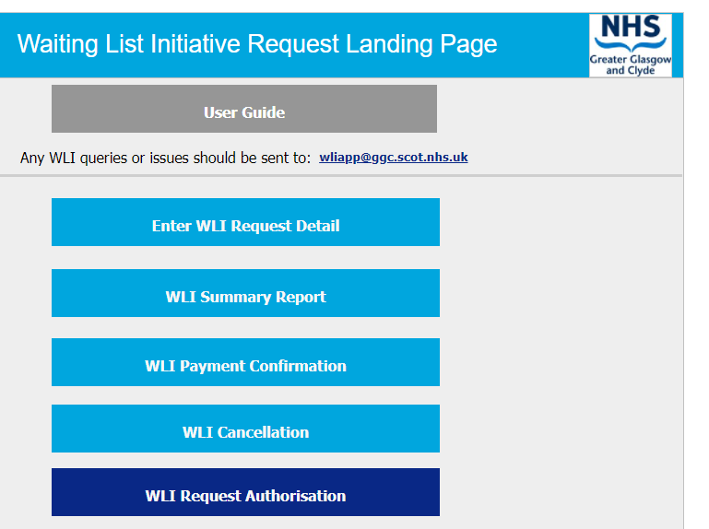

5.2 For Consultant Grades, payment will be made in accordance with Consultant Grade Terms & Conditions (par 4.5) ‘Such work will be paid at three times the hourly rate appropriate to point 20 of the seniority scale, or alternatively and by agreement with the employer:

- Paid at twice the hourly rate appropriate to point 20 of the seniority scale and equivalent time off in lieu; or
- Paid at hourly rate appropriate to point 20 of the seniority scale and twice the equivalent time off in lieu

5.3 For Specialist Grades and Specialty Doctor Grades (2022) payment will be made in accordance with the respective Terms & Conditions (Schedule 10) ‘Such work will be paid at twice the hourly rate appropriate to the top of the Specialist Grade/Specialty Doctor (2022) payscale.

5.4 It is anticipated through close working between the Consultant/SAS and those scheduling the theatre lists that additional sessions will be full days. A full day list would therefore start with pre-operative assessment and be scheduled to run for 8 hours or until the last patient is out of recovery. It is recognised however, that on occasion the session may overrun in which case the session should be rounded up to the nearest 30 minutes.

5.5 However, there may be instances where a list is not scheduled to last a full day and this is known in advance, and therefore in these instances payment will be based on the actual hours worked rounded up to the nearest half hour.

5.6 It is also recognised however, that on occasions where a full theatre list is planned, something may happen on the day which was not predicted and as a result the theatre will under run. On these occasions if there is no opportunity to supplement the theatre list with additional patients, the Consultant/SAS will be paid for the hours originally committed to undertake

5.7 Session/theatre capacity to be maximised with up to a maximum of 30 minutes admin time allocated to each 4 hour outpatient clinic session.

5.8 In the case of an evening session, WTI work will be scheduled to start after 5.00pm.

6. Payment Authorisation

6.1 Any claim for a WTI payment (previously authorised by the Chief Operating Officer, paragraph 5.1) should be progressed through the WLI app. General Managers must confirm the consultant name, GMC number, session date and time and verification of activity delivered before the session details are passed to Finance for payment.

6.2 Payment will always be in arrears and normally be paid within 2 months of the work undertaken provided that optimal timelines have been adhered to.

7. Review & Audit

7.1 These arrangements will be reviewed as required and will be subject to audit.

