**Topic F**

**Influences on Smoking**

**Media and Peer Pressure**

|  |
| --- |
| **F: Influences on Smoking - Lesson One** |
| **Objectives:** To develop an awareness of the changing image of tobacco. |
| **Activities:**   * Divide class into cooperative learning groups. Each group will look at one of the sections on the [Stanford University tobacco library website](http://lane.stanford.edu/tobacco/index.html):   Groups discuss and record how smoking is portrayed in the images (select as appropriate). Use the Recording Sheet to record their views.   * Groups then share their findings. * Groups then watch the NHS advertisements ‘Blue Stix’ and ‘Stinx’ & ‘Butts’ (available to stream from YouTube - see resources below). Groups discuss their views of the adverts. Use the Recording Sheet to record their views. * Groups then share their findings. * Whole class plenary session on how the image of tobacco has changed over the years. Why is this? |
| **Time: One hour** |
| **Resources:**  Stanford University Tobacco Library:  <http://tobacco.stanford.edu/tobacco_main/main.php>  Recording Sheet (see next page)  NHS Health Scotland adverts on youtube:  Blue Stix [www.youtube.com/watch?v=6tQsXJEza6A](http://www.youtube.com/watch?v=6tQsXJEza6A)  Stinx [www.youtube.com/watch?v=DcJy5m36n4o](http://www.youtube.com/watch?v=DcJy5m36n4o) |
| **Reference Materials:**  [The History of Tobacco Advertising](http://www.doctorfox.co.uk/news/the-history-of-cigarette-advertising-in-the-uk/) (Doctor Fox)  [This is the end of Tobacco Advertising](https://scienceblog.cancerresearchuk.org/2017/05/19/this-is-the-end-of-tobacco-advertising/) (Cancer Research 2019)  [Key Dates in the History of Anti-Tobacco Campaigning](http://ash.org.uk/information-and-resources/briefings/key-dates-in-the-history-of-anti-tobacco-campaigning/) (ASH, UK)  [Tobacco Control Legislation in Sotland](http://www.ashscotland.org.uk/ash/4263) (Ash Scotland) |
| **Assessment:**  Successful completion of recording sheet  Participation in discussion |
| **Teacher Feedback on Lesson:**  *“The children loved the Stinx advert and followed this by making their own adverts.”* |

**F: Influences on Smoking - Lesson One**

**Recording Sheet 1**

**Pupil Names:**

|  |
| --- |
| **Focus material:** |
| **Brief description of focus material:** |
| **How was tobacco or smoking portrayed?** |
| **Would this encourage or discourage someone from smoking? Give a reason for your answer.** |

|  |
| --- |
| **F: Influences on Smoking - Lesson Two** |
| **Objectives:** To increase understanding about the influence of the media, advertising and the law on choices about smoking. |
| **Activities:**   * Discuss with children if they read magazines, go to cinema, watch TV, and go to supermarket with parents or family. * Can they think of any celebrities or actors they have seen smoking on TV or films? Is it necessary to the story-line? (see reference materials at end of lesson) * There have been two significant changes to tobacco control legislation:   + The tobacco display ban (2013) - Legislation banning the display of cigarettes and other tobacco products in small shops in Scotland has come into force.   + Plain Packaging Campaign (2017) – All tobacco must be sold in drab green coloured packs with brand names in small uniform font at the bottom of the pack. Large graphic health warnings must cover 65% of the front packaging and 35% of the back.   Discuss with the learners feel about these initiatives:   * Will they make harder for young people to purchase tobacco? * Do they make smoking more tempting and/or acceptable? * Split children into groups of 3 or 4. Give each group some images of celebrities smoking. Ask group to discuss why celebrities smoke. Allow children time to discuss their ideas/feelings with the rest of class.   **🎜**   * Ask children to produce a poster, rap or song encouraging children to share their views of smoking and wider tobacco issues. |
| **Time: One hour** |
| **Expressive Arts Activity: Produce a poster, rap or song**  **🎜**  Creating a rap or song will need structure but can generate effective results that could even be performed at an assembly.  **Song**: Pick a song that the pupils already know well and ask them to write new lyrics to a verse or the chorus. You may want them to work individually on some lines but together on others. The verses could then be strung together across the whole class.  **Rap:** The whole class creates 2 lines that they will all shout out together at the end of their piece. Next each pupil writes 2 lines that don’t have to rhyme with the final line but can if they are able to. Think of it more as a chant, and have the class clap in time to set a beat. The pupils may even want to use beatbox (create a drum beat with their mouths) in the background.  **Rap Example:** Pupil one: *Once you start smoking. You can’t get enough.*  Pupil two: I *don’t smoke. I’m saving my money.*  Pupil three: *Don’t smoke on the bus. You have to get off.*  All together: *Tobacco smells bad. It makes me cough!* |
| **j0078717Resources:**  Teacher Caution Note: Some of the images on these websites contain sexual imagery. There are also some disturbing photographs of health effects of smoking. Teaching staffshould print theimages prior to the lesson.  Smoking on Movies  Smokefree Movies Database: this database was produced by  The University of California, San Francisco and contains a listing of all  Hollywood movies and whether or not they contain images of smoking:  <https://smokefreemovies.ucsf.edu/>  Smoking on TV  [Google Images search](https://www.google.com/search?rlz=1C1CHBD_en-GBGB837GB837&biw=1600&bih=757&tbm=isch&sa=1&ei=paY1XfHHJpPsxgP47rzgBQ&q=smoking+on+tv+shows&oq=smoking+on+tv&gs_l=img.3.2.0i24l6.5700.6891..9100...0.0..0.53.143.3......0....1..gws-wiz-img.rjC7n71nSBc)  Images / pictures of celebrities smoking from:  [Celebrities who smoke](http://www.ranker.com/list/celebrities-who-smoke/celebrity-lists) (Ranker.com 2018)  [Celebrities who have quit](https://www.ranker.com/list/celebrities-who-quit-smoking/celebrity-lists?ref=collections_btm&l=1685561&collectionId=1586&li_source=LI&li_medium=desktop-bottom-collection) (Ranker.com 2019) |
| **Reference Materials:**  Representation of smoking of TV and movies:  [Netflix vows to go smokefree](https://eu.usatoday.com/story/entertainment/tv/2019/07/02/tobacco-images-rise-tv-targeting-youth-study-says/1613329001/) (USE today, 2019)  [How the Tobacco Industry built its relationship with Hollywood](http://tobaccocontrol.bmj.com/content/11/suppl_1/i81.full)  (Tobacco Control Journal, 2002)  [The smoking ban 10 years on... What’s changed on page and screen?](http://www.theguardian.com/books/2017/jul/07/smoking-ban-movie-cigarettes-legislation-work-public-tobacco) (The Guardian, 2017)  Tobacco and the Law:  [Tobacco Control Legislation in Scotland](https://www.ashscotland.org.uk/ash/4263) (Ash Scotland)  [Tobacco Display Ban](http://www.scotsman.com/news/tobacco-display-banned-in-all-shops-1-3739280) (Scotsman, 2015)  [Plain Packaging Campaign](https://www.ashscotland.org.uk/what-we-do/campaign/policy-reports/plain-packaging-campaign/) (Ash Scotland report 2017)  [E Cigarettes / Vaping Gudie for Schools](http://www.ashscotland.org.uk/media/782891/ecigs-and-vaping-guide-for-schools.pdf) (Ash Scotland, 2019) |
| **Assessment:**  Group discussion  Production of smoking poster and/or rap song |
| **Teacher Feedback on Lesson:**  *“Children enjoyed discussing the media element of this lesson. Enjoyed working together to create a tobacco rap.”*  *“Children knew about celebrities and could spend time discussing who smoked on TV. They enjoyed the activity about celebrities.”* |

|  |
| --- |
| **F: Influences on Smoking: - Lesson Three** |
| **Objectives:** Explore the reasons why people, especially young people choose to smoke. |
| **Activities:**   * Initiate discussion with children on the reasons why people choose to smoke. * Divide class into 6 groups, giving each group a large sheet of paper and pens. * Assign group roles (e.g. time-keeper, resource manager, encourager, noise monitor etc). * Give each group one of the following to consider and make a list of responses to the question (use handouts at end of lesson):   1. Why do young people smoke?  2. Why do older people smoke?  3. What are the effects of smoking (health & environment)?  4. Why do young people choose **not** to smoke?  5. Why do people give up smoking?  6. What are the alternatives to smoking?   * Allow time for discussion and completion of list. Ask each group to report back on their findings.   ***Alternatively*** groups can view each others findings through a “snowball” or “graffiti board” activity.   * Afterward, children to work in pairs and complete ‘I choose to…’ and ‘I choose not to…’ (see sheets at end of lesson). Work in pairs then jigsaw and share findings. |
| **Time: 45 minutes** |
| **Resources:**  Group Role Cards (Topic A)  Paper, pens  Handouts at end of lesson |
| **Assessment:**  Oral discussion  Production of list of reasons in response to question |
| **Teacher Feedback on Lesson:**  *“Children enjoyed working together, discussing questions. Children got to share their thoughts and opinions.”* |

**F**: **Influences on Smoking - Lesson Three**

**Why do young people smoke?**

**F**: **Influences on Smoking - Lesson Three**

**Why do older people smoke?**

MCj02909550000[1]

MCj02909550000[1]

MCj02909550000[1]

MCj02909550000[1]

MCj02909550000[1]

MCj02909550000[1]

**F**: **Influences on Smoking - Lesson Three**

**What are the effects of smoking?**

ENVIRONMENT APPEARANCE

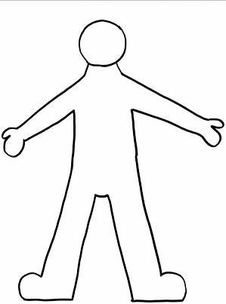



**Health**

**F**: **Influences on Smoking - Lesson Three**

**Why do young people choose not to smoke?**

**F**: **Influences on Smoking - Lesson Three**

**Why do people give up smoking?**

**F**: **Influences on Smoking - Lesson Three**

**What are the alternatives to smoking?**

**F**: **Influences on Smoking - Lesson Three**

**I choose to smoke because……**

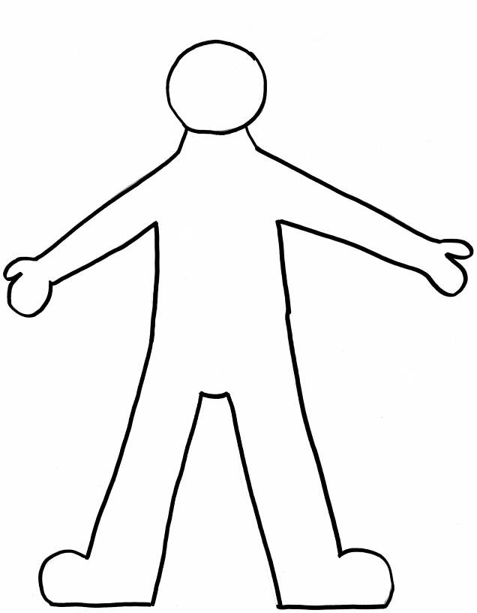

**F**: **Influences on Smoking - Lesson Three**

**I choose not to smoke because……**

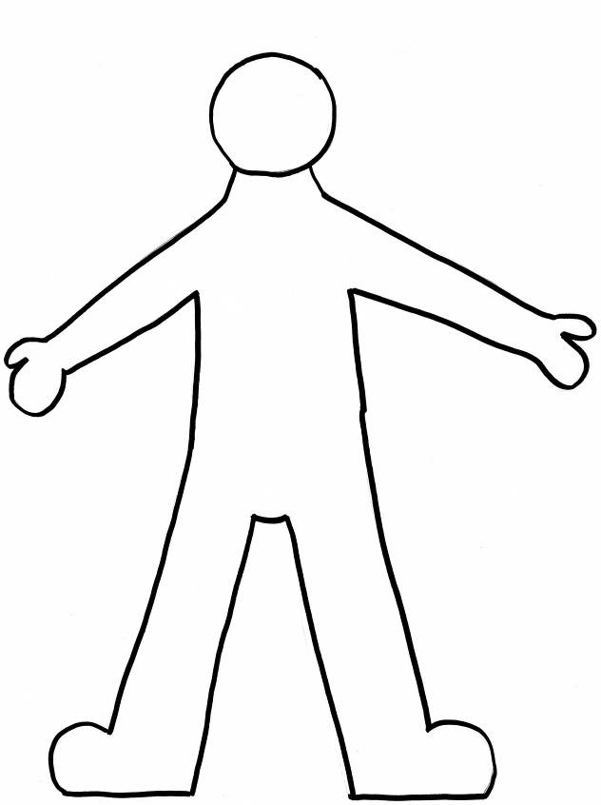

|  |
| --- |
| **F: Influences on Smoking - Lesson Four** |
| **Objectives:** To enable children to explore the emotions encountered when dealing with peer pressure and to develop positive strategies to deal with these. |
| **Activities:**   * Discuss with children what is meant by **assertive** behaviour. Can they give examples of when they have used assertive behaviour? Discuss the influence friends and peers can have on the decisions they make or the way they behave.   **Assertive** - self-assured, positive, confident  **Non-assertive -** not aggressive or self-assured, though not necessarily lacking in confidence  **🗣**   * Split children into groups of 4 and issue groups with one of the Peer Pressure Scenarios (see end of lesson).   Allow children time to discuss and complete the ‘What Happened?’ worksheet using words and pictures. (**See guidance notes below).**   * Discuss with class what strategies would work well and the emotions connected to being assertive. * Allow groups to act out resolutions to scenarios in front of class. |
| **Time: 45 minutes** |
| **Expressive Arts Activity: Guidance Notes**  When acting out scenarios the following ideas will help get the most from the activity:   * Firstly don’t allow any violence or touching in the drama, ensuring that the ‘pressures’ to smoke are entirely psychological.   **🗣**   * Ask the pupils to create a freeze frame/statue/photograph of the scene first. This forces them to think about acting with their bodies as well as where they stand in relation to each other. The power of body language can be discussed. * Next they can devise the whole scene. Limit the scenes to 5 lines in total to help focus the pupils on telling the story. * Once a piece has been performed the audience can suggest alternative choices the main character could have taken. The group could then rehearse a different version of the same scene based upon this new choice (this is basic ‘forum’ theatre). You could try asking the pupils to create a ‘worst case scenario’ and a ‘best case scenario’ for the main character. |

|  |
| --- |
| **F: Influences on Smoking - Lesson Four** |
| **Resources:**    Peer Pressure Scenario Cards (attached)  ‘What happened?’ Worksheet (attached) – one copy per group  Pens, pencils, crayons |
| **Assessment:**  Participation in group discussion  Completion of ‘what happened?’ sheet  Participation in drama activity |
| **Teacher Feedback on Lesson:**  *“We used* [*Comic Life*](http://comiclife.com/) *and the children made a page of themselves acting out scenarios related to tobacco and peer pressure. The children really enjoyed imagining they were in character.”*  *Note: Comic Life is web based tool that can be used to design and produce your own comics. Visit* [*http://comiclife.com/*](http://comiclife.com/) *for more information* |

**F: Influences on Smoking** - **Lesson Four**

**Peer Pressure Scenario Cards**

1) Imagine you are Kai who is 12 years old and has just started secondary school. Kai is hanging around with a new bunch of friends from different primary schools, Omar and David. Omar and David hang around the smokers’ corner in school, and although it smells a bit, Kai wants to stay in this friendship group because Omar and David are really popular. After a few weeks David offers Kai a cigarette. Kai has never tried smoking, hates the smell, and knows it isn’t allowed on school grounds, but he also wants to stay in with the crowd. What will you do as Kai?

2) Rashda is 11 years old and is about to start secondary school. Rashda moves house over the summer to a new area and quickly makes friends with Jayde, who lives across the road. Jayde goes to youth club every Tuesday night and asks Rashda to come too. After a few weeks Rashda has become good friends with Jayde and her friends who are all 14 and 15. Jayde offers you a cigarette and tells you that she smokes when she goes to youth club to make her look more adult and fit in with her older friends. She also thinks it keeps her weight down, and she wants to stay thin. You are Rashda - what do you do?

3) Mai and Eva are both 14 years old and are best friends. Mai has been smoking since she was in Primary 7. She used to get her cigarettes from her big brother Jack, but now that she is a bit older and gets more money from their parents, Jack tells her to buy her own. Mai is nervous about trying to buy cigarettes in the shop as she knows the law says you have to be 18 to buy them. But, she has also heard that the shopkeeper is relaxed about it and is already selling cigarettes to people her age. You are Eva and you are with Mai outside the shop – what can you do?

4) Aleksander and Dean are both 13 years old and go to the local secondary school. Imagine you are Scott and you are 10 years old. Scott sees Aleksander and Dean at the gates to the primary school when school’s coming out and wonders what they are up to. As he passes them, Aleksander and Dean offer Scott a single cigarette for 50p. Nathan hasn’t ever tried smoking, and knows his granddad is quite ill as he smoked for more than 40 years, but at the same time he feels a bit threatened by Aleksander and Dean who are blocking his way and starting to make fun of him for being a ‘baby’. You are Scott, what do you do?

|  |  |  |
| --- | --- | --- |
| What happened? | What happened next? | Feelings |
|  |  |  |

**F: Influences on Smoking: Lesson Four**

**What Happened?**

**Teacher Feedback Sheet – F: Influences on Smoking**

**School/Class:**

**Teacher:**

|  |  |  |
| --- | --- | --- |
| **Lesson** | **Feedback from Pupils** | **Recommended Changes** |
| **Lesson 1**  **Influences on Smoking** |  |  |
| **Lesson 2**  **Influences on Smoking** |  |  |
| **Lesson 3**  **Influences on Smoking** |  |  |
| **Lesson 4**  **Influences on Smoking** |  |  |

**Return Via:**

[**Quityourway.smokefreeschools@ggc.scot.nhs.uk**](mailto:Quityourway.smokefreeschools@ggc.scot.nhs.uk)

**Post: Quit Your Way Smokefree Schools, West House, Gartnavel Royal Hospital, Glasgow, G12 0XH**