



Director of Estates and Facilities
Candidate Information Pack

Ref No: 240206
Closing Date: 8th March 2026








Contents

Message from our Chief Executive 2
Advertisement 3
Job Description 5
Person Specification 10
NHSGGC Values 13
NHS Scotland Leadership Success Profile 14
Terms and Conditions 15
Recruitment Process 17
About NHS Greater Glasgow and Clyde 18
Useful publications 23
Executive Structure 24
Organisational Structure 25



Message from our Chief Executive

Dear Candidate,
Thank you for your interest in the position of Director of Estates and Facilities within NHS Greater Glasgow and Clyde. I am excited to share this unique opportunity with you, and hope this role captures your enthusiasm to lead within one of the most innovative and dynamic healthcare organisations in Scotland.
As Scotland’s largest health board, NHS Greater Glasgow and Clyde manages an annual revenue budget of £4.65 billion, with an annual capital spend in excess of £70 million. This represents nearly a quarter of Scotland’s overall health expenditure. Our services encompass integrated acute hospital care, primary care, community services, and mental health support, ensuring we address the diverse and complex healthcare needs of our communities across the Greater Glasgow and Clyde area.
The next phase of our journey is ambitious and filled with exciting opportunities. Despite the recent challenges presented by the global pandemic, our teams have demonstrated resilience, creativity, and determination. We are proud of the remarkable work everyone has contributed, including the innovative redesign and rapid response of services to meet the evolving demands of healthcare delivery.
This position offers you the chance to join an organisation that is driving positive change. You will have the opportunity to work alongside a talented and committed team of clinical and non-clinical professionals dedicated to delivering exceptional care. We are looking for candidates who bring a strong blend of leadership, experience, and innovation, and who are passionate about shaping the future of healthcare in our region.
As a Director within NHS Greater Glasgow and Clyde, you will play a key role in our exciting change programme, ‘Transforming Together,’ and in shaping services to meet the needs of the diverse communities we serve. Most importantly, we are looking for someone who can offer a fresh, forward-thinking, and collaborative approach to ensure continued progress in the delivery of high-quality, patient-centred care.
We hope you find this career opportunity inspiring and look forward to receiving your application.
If you have a disability or long-term health condition, we are committed to providing reasonable adjustments throughout the recruitment process and in employment.
For further information or support, please contact Heather Silvester at Heather.Silvester@nhs.scot.
Thank you once again for considering this exciting opportunity. I look forward to receiving your application.
Professor Jann Gardner, Chief Executive
NHS Greater Glasgow and Clyde – Feb 2026

Advertisement

Salary: Executive and Senior Manager Grade F £111,501 - £147,614 per annum (pro rata for part time)

Tenure: Permanent

Hours: 37.5 hours per week

Location: JB Russell House

NHS Greater Glasgow and Clyde (NHSGGC) is seeking an exceptional, values-driven leader to join our Corporate Management Team as Director of Estates and Facilities.
This executive role offers a rare opportunity to shape the environments, infrastructure and support services that enable safe, high-quality, person-centred care for a population of 1.3 million people across Scotland’s largest NHS Board.
Reporting directly to the Chief Executive, the Director of Estates and Facilities will provide strategic leadership across a highly complex and diverse portfolio, encompassing, property and asset management, sustainability and energy strategy, fire and security, logistics, decontamination, waste, catering and wider facilities services. With responsibility for over 4,900 staff and an annual revenue budget of approximately £350m, the post holder will ensure services are safe, resilient, and financially sustainable and aligned to NHSGGC’s long-term clinical and organisational priorities.
As a senior system leader, you will play a critical role in shaping Board-level decision-making and influencing regional and national strategy. Working in close partnership with clinical leaders, Health and Social Care Partnerships, Executive and Non-Executive Directors, trade union colleagues and external partners, you will lead transformation that improves patient experience, supports staff wellbeing and delivers best value across the public sector.
You will bring significant senior leadership experience within the NHS or a similarly complex organisation, with a proven track record of leading multidisciplinary services, and managing substantial budgets. You will be commercially astute, politically aware and confident operating at Board level able to balance competing priorities while keeping patients, staff and communities at the heart of decision-making.
Above all, we are seeking a leader who lives NHS values, leads with compassion and integrity, and is committed to reducing inequality, promoting sustainability and supporting Scotland’s public health ambitions.
This is a unique opportunity to make a lasting impact shaping the physical and operational foundations of healthcare delivery today, while building resilient, future ready services for generations to come.

For more information about the key result areas for the role please refer to the Job Description and Person Specification contained in the Candidate Information Pack for the post

We look forward to receiving your application. If you want to find out more about this role before applying, for a confidential discussion please contact:

Jann Gardner, Chief Executive, NHS Greater Glasgow and Clyde Telephone 0141 201 4642 or email at jann.gardner@nhs.scot or Tom Steele, Director of Estates and Facilities on Telephone 0141 211 0270 or email Tom.Steele3@nhs.scot

Closing Date: Sunday 8th March 2026 at 23:59

NHS Greater Glasgow and Clyde encourages applications from all sections of the community. We promote a culture of inclusion across the organisation and are proud of the diverse workforce we have. Applications are welcome from UK, EEA and non-EEA candidates.

Job Description

Job Details
Job Title: Director of Estates and Facilities

Directorate : Estates and Facilities

Accountable to: Chief Executive

Location: Board Headquarters, JB Russell House, Glasgow

Band: Executive and Senior Managers Grade F
£111,501 - £147,614per annum (pro rata for part time)

Job Purpose
As a member of the Corporate Management Team (CMT) and reporting directly to the Chief Executive, the Director of Estates and Facilities plays a key role in the strategic and operational direction of NHS Greater Glasgow and Clyde, with the purpose of delivering high quality, patient focused care within the resources available.

The post holder leads on the overall estates and facilities management strategy, policy and project delivery, aligned to the corporate objectives of NHS Greater Glasgow and Clyde. He/she will also ensure that all estates and facilities services are provided in a robust, reliable manner and perform to established quality and safety standards. The post holder will provide a high standard of leadership and guidance to the Directorate management team in delivery of its strategic and operational activities which incorporate :

- Strategic disposals/acquisitions of land and other assets
- Asset Management
- Sustainability Strategy
- Strategic and operational direction in relation to Fire and Security arrangements of all premises
- Energy Strategy
- Support Services (Inc. Catering, domestic, portering, transport, laundry and grounds/gardens)
- Waste management
- Estates and property maintenance management
- Supplies logistics
- TSSU/Decontamination and regional CSSD
- Health & safety in the built environment, including being the NHS Greater Glasgow and Clyde Ligature Reduction Lead.

Job Purpose contd../
- Operational management of leases/rents and other income generation projects
- Planning and delivery of revenue funded significant projects within the Health and Social Care community
- Delivery of contracts where the NHS Board is the supplier of Facilities Management services to external organisations.

The Director will work closely with key decision makers in clinical and non-clinical services to identify, recommend, develop, implement, and support cost-effective facilities services for all aspects of the organisation.

This is an Executive post, which interfaces at Board level across the organisation and beyond in the influencing and development of regional and national strategy. This includes ensuring NHS Greater Glasgow and Clyde is represented on national groups, and plays an important role in the emerging regional work.

The Directorate currently employs c4,900 wte staff and has an annual revenue budget of approximately £350m

Dimensions
NHS Greater Glasgow and Clyde: Total Population: 1.3 million
Total Budget: £4.65bn
Total Staff (headcount): 42,000
Annual capital spend: £70m
- A full range of Acute, Community, Mental Health and Corporate Services are provided to a population of 1.3 million covering 6 local authority areas, i.e. Inverclyde, Renfrewshire, East Renfrewshire, the City of Glasgow, East Dunbartonshire and West Dunbartonshire.
- NHS Greater Glasgow and Clyde has areas of great social need, deprivation and an increasingly diverse population.
- NHS Greater Glasgow and Clyde and its partners have seen improvements in these areas but there is still much work to be done to improve and develop existing services and to provide high quality facilities.

Key Result Areas
- As a Senior Manager of the Board, contribute to Board Strategy and Policy which supports
the clinical service delivery
- Work with senior colleagues, to compile and implement the NHS
Board’s transformational plan, Transforming Together.
- Lead and promote service redesign, innovation and organisational development both within the Directorate and across traditional boundaries to improve services to patients, and make best use of resources
- Work with other key stakeholders to deliver the national and regional priorities
- Ensure proper and effective maintenance of the Board’s assets, including the development and maintenance of an accurate Asset management database to support key strategic decisions

Key Result Areas contd../
- Manage delegated capital investment programmes, energy plans and strategic site developments
- Identify key capital projects and work with the Director Strategic Infrastructure Planning and Delivery, Chief Operating Officer within the Acute Division, the Chief Officers for the Integrated Joint Boards and the Corporate Directors, along with the clinical planning teams, to take responsibility for the planning and implementation of capital projects
- Develop appropriate business cases to support the capital investment projects in accordance with Scottish Government processes and procedures (SCIM)
- Ensure efficient project management arrangements are in place for the timely delivery of the delegated capital projects.
- Ensure arrangements are in place to monitor and review all support services, taking corrective action as necessary, to deliver high quality support services to meet user requirements
- Manage services across the NHS Greater Glasgow and Clyde geographic catchment (i.e. laundry, decontamination services, waste management etc.) to ensure best value is being achieved
- Provide Facilities Management contractual services to third parties
- Ensure the implementation of Staff Governance Frameworks within the Directorate, systems and processes to ensure a system of corporate accountability exists for the fair and effective management of staff
- Lead, manage and develop all staff within the Directorate, promoting excellent functional relationships within and out with the Directorate, ensuring staff are able to contribute effectively to the achievement of the NHS Board’s objectives
- Ensure partnership working is embedded across the Directorate, promoting a culture of partnership working at all levels to involve staff, patients and external partners in the decision making process
- Ensure compliance with all relevant infrastructure regulations, including fire prevention
- Develop and implement the Directorate’s Operational Plan, ensuring appropriate targets are set for individual service areas in line with NHS Board and Divisional objectives, and that progress is monitored and corrective action taken as required
- Working with the Medical and Nurse Director, lead the clinical governance agenda within the Directorate to ensure highest possible quality of patient care is achieved including issues such as Hospital Acquired Infection and compliance with standards and guidelines
- Manage the Risk Management process within the Directorate, in particular to identify risks and develop strategies to address these issues
- Develop business continuity and disaster recovery plans for the Directorate and other stakeholders
- Manage the Directorate budget in line with Standing Financial Instructions and the Financial Improvement Plan, ensuring appropriate controls are in place to achieve good financial management and the best use of resources to maximise patient care
- Develop income generating business opportunities
- Oversee and deliver the scoping, tendering and awarding of all major contracts, ensuring best value and compliance with all relevant legislation and guidance

Assignment and Review of Work
The post holder is directly accountable to the Chief Executive. The post holder will work under broad direction within the parameters of Scottish Government priorities and policies for health and social care. The post holder will contribute actively and directly to the development of corporate policies and priorities of NHS Greater Glasgow and Clyde, which in turn provide the framework, within which the individual works.

The post holder is expected to work with a high degree of autonomy and professional scope on a day to day basis will be substantial.

Review of performance is undertaken through the agreement of performance objectives and individual performance appraisal by the Chief Executive. Formal appraisal is annual but informal reviews will take place between the post holder and the Chief Executive.

Communications and Working Relationships
The post holder will have an extensive network of communication and working relationships and will communicate regularly with a wide range of individuals, clinical and non-clinical, internal and external to NHS Greater Glasgow and Clyde.
These will include:
Internal –
- NHS Board Members
- Chief Executive
- Executive and Corporate Directors
- Chief Officers and Chief Finance Officers
- Senior clinical and non-clinical Staff
- Sector/Service Management Teams
- Trade Union/Partnership representatives
- Corporate Services teams
- Internal Audit

External –
- Scottish Government colleagues/other NHS Boards
- NSS Procurement Directorate/External suppliers
- NHS Assure, Health Protection Scotland
- Central Legal Office
- Elected members - locally and nationally
- The Health and Safety Executive
- Local Authorities
- Third Sector and Charitable Organisations
- National Representatives of Trade Unions/Professional Organisations
- Universities and Further Education Colleges
- External Auditors and Inspectorates
- Press/Media
- Hub West Scotland/Scottish Futures Trust
- PFI Organisations
- Other professional organisations as required

Communications and Working Relationships contd../
The post holder will be required to prepare Management Team and Board Committee papers and formally present papers to a variety of committees and groups. The post holder will also act as the Chair on a number of key internal committees and will also be expected to represent the Board on external groups and committees.

The post holder will work in partnership with commercial partners and suppliers and develop relationships with consultancy and construction industry to influence how these companies can align their business in support of health initiatives and of particular focus in regards the development of the health care facilities.

Most Challenging Parts of the Job
This is a strategic role, focused on continuous development and improvement, with the aim of implementing significant, innovative and transformational change within NHS Greater Glasgow and Clyde, while managing and prioritising large, critical and complex support services over a large number of locations.

The post holder is also required to ensure the best use of resources to achieve service improvement and delivery within the set financial parameters. They will also be required to deliver cost releasing efficiency savings to ensure a balanced budget.

Working against a background of multiple competing demands and priorities, the post holder will require to identify appropriate solutions, both at a strategic and operational level to manage a large portfolio of services, based on optimal solutions for patients.

Person Specification

Post: Director of Estates and Facilites
Criteria | Essential | Desirable
Education , Training and Qualifications | - Educated to degree level or equivalent.  - Evidence of continuing , relevant professional and personal development  - Post graduate /Masters or equivalent management qualification  - An appropriate professional qualification/chartered status
Experience | - Significant general management experience in a senior leadership role within the NHS or similar complex organisation  - Significant experience of managing and leading multidisciplinary teams including a technical workforce  - Proven track record of achievement in managing significant service change and operational management in a large complex organization with experience of leading large scale change projects.  - Experience of working on large capital projects.  - Proven track record of senior level leadership across a large and complex portfolio of Hard and Soft Facilities Management Services including property, teams, services and budgets  - Thorough experience demonstrate a high level of strategic planning and organisational skills, including risk assessment, forward planning and forecasting  - Significant ability to function at NHS Board/Corporate level and taking responsibility for strategic decision making  - Experience of implementing operational efficiency programmes relevant to the professional discipline of the role  - Experience of leading and implementing operational efficiency programmes  - Substantial experience of working in partnership with trade unions/professional organisations  - High level of technical expertise in water systems and ventilation | - Experience of progressing discussions and/or leading shared service projects.  - Programme and Project Management experience delivering complex and large building/construction projects  - Significant commercial business acumen  - Proven track record of preparing and presenting full business cases  - Significant experience of working with a broad range of internal and external stakeholders
Criteria | Essential | Desirable
Skills, Competency and Disposition | - Strong persuasive, influencing and interpersonal skills and ability to put across complex technical issues to both clinical and non-clinical colleagues across all staffing grades  - Ability to operate at Board level and externally to provide clear advice in respect of relevant issues  - Well-developed political awareness, in influencing, negotiating and conflict resolution skills  - Comfortable communicating on complex subjects and ideas to diverse professional and public audiences  - Can evidence ability to develop a culture that encourages initiative, individual and team responsibility and open communication  - Able to make sense of conflicting priorities and reach effective and timely solutions  - Ability to interpret and shape complex issues and awareness of current developments in PPFM solutions for large and operationally complex organizations  - Highly developed analytical and reporting skills  - Strong decision-making skills with the ability to make decisions and recommendations based on the analysis of options  - Capacity to work effectively and efficiently under pressure to meet deadlines and organisational priorities  - Able to demonstrate the ability and resilience to operate effectively in a challenging environment  - Highly developed leadership skills, including leading large and diverse teams across multiple sites | - Understanding of the future of NHS/Public sector services as it relates to best practice in facilities and estates management  - Experience of procurement processes for services and goods  - Experience of developing stakeholder engagement strategies in relation to NHS/Public Sector Capital Development Projects  - An understanding of Equality and Diversity principles as they apply to NHS organisations  - Proven experience of leading a large and complex procurement function

NHSGGC Values

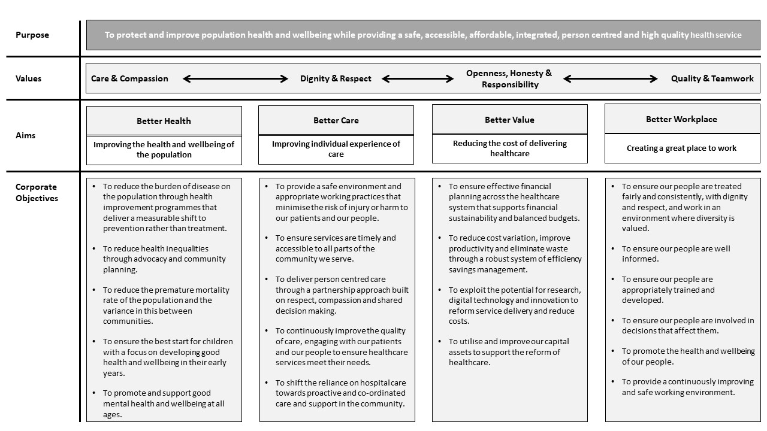

NHS Scotland Leadership Success Profile

The NHS Scotland Leadership Success Profile consists of nine behaviours in which candidates will be assessed against during the recruitment and selection process.

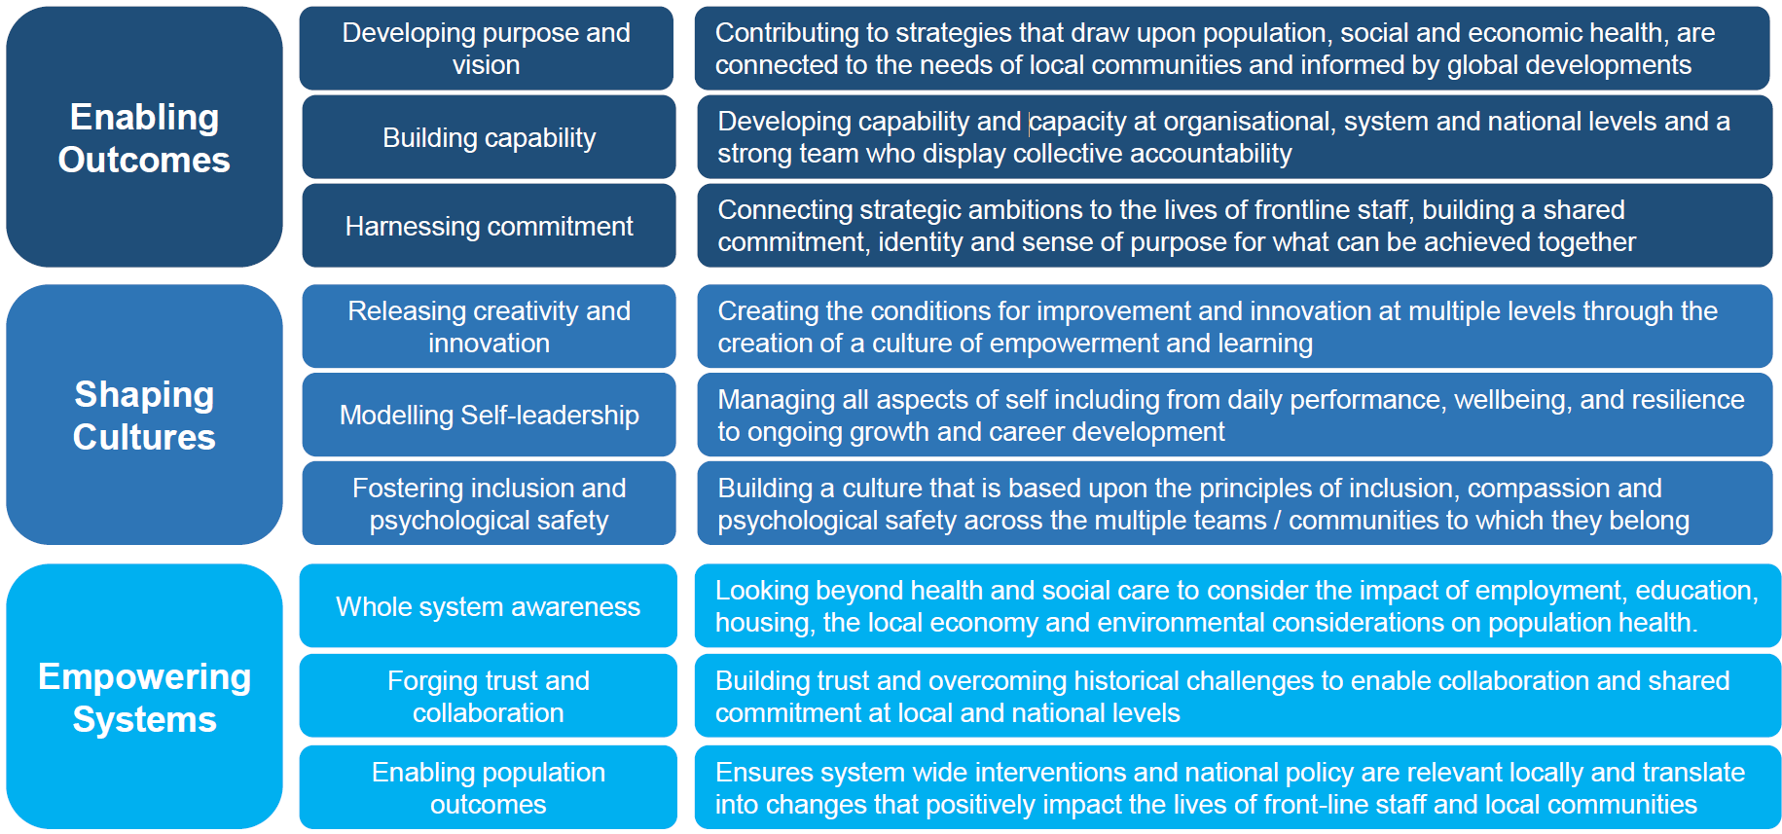

Terms and Conditions

Executive Pay and Terms and Conditions of service are under the direction of the Cabinet Secretary for Health and Social Care.

Salary
The grade and salary range for this post is £111,501 - £147,614 per annum (pro-rata if applicable) Senior Managers | MSG

Placing on the range will be determined by a range of factors, taking into account current salary. The starting salary will be part of the formal offer of appointment. Progression through the pay range is on the basis of an annual assessment of performance in a year beginning 01 April and ending 31 March. A pay uplift determined by performance rating is applied in line with national circulars.

The post holder is expected to participate in the Board’s Executive on-call rota.

Contract tenure
Permanent

Hours of work
Full time: 37.5 hours per week.

The number and pattern of hours will reflect the demands of the post. There is no contractual right to additional pay or time off in lieu for additional hours. This will not affect individual rights under the Working Time Regulations.

Annual Leave
The annual leave entitlement is:

- 27 days upon commencement
- 29 days after 5 years’ service
- 33 days after 10 years’ service.

8 additional Public Holidays are allocated in addition for all Board employees.

Location
The base for this post will be Board Headquarters, J.B. Russell House, Gartnavel Royal Hospital, 1055 Great Western Road, Glasgow, G12 0XH.

The post will require you to travel throughout the Board’s area, and both within and out with Scotland, when necessary. Home to work expenses will be met by the post holder; however, all other travel expenses incurred as a result of your employment will be reimbursed by the Board.

Superannuation Scheme
New entrants to NHSGGC who are aged sixteen but under seventy-five will be enrolled automatically into membership of the NHS Scotland Pension Scheme
(managed by the Scottish Public Pensions Agency). Arrangements can be made to ‘opt out’ of the scheme.

Removal expenses
Assistance with removal and associated expenses may be given and would be discussed and agreed prior to appointment.

Performance Appraisal and Personal Development
The annual performance cycle is from 01 April to 31 March. Performance is assessed against a performance plan, which contains individual service objectives relating to the Board’s corporate objectives and individual behavioural objectives based on the NHS Scotland Leadership Success Profile. The performance plan is agreed with the NHSGGC Chief Executive.

Performance against the plan is assessed by the NHSGGC Chief Executive and performance is rated on a five-point rating scale.

Other Terms and Conditions of Service
Terms and Conditions of Service which are not set down in the arrangements for Executive and Senior Managers Pay are those contained within the NHS Scotland Agenda for Change Terms and Conditions Handbook, and the Board’s Human Resources Policies.

Recruitment Process

The recruitment process for this role will involve a range of selection activities allowing you to demonstrate your knowledge, skills and talent to various panel members.

The timescale for this recruitment process will be short in order to maximise the handover period between the incoming and outgoing Directors of Finance. The table below summarises the dates when the selection activities will be facilitated to enable candidates to plan their diaries accordingly. Any changes to these dates will be communicated with candidates at the earliest opportunity.

Face-to-face assessment exercises will be conducted in Glasgow, UK.

Recruitment Stage | Date
Advert Opens | 20 February 2026
Advert Closes | 8 March 2026
Shortlisting | Week Commencing 16th March 2026
Psychometric Testing | Week Commencing 16th March 2026
Stakeholder Panel | Week Commencing 23rd March 2026
Final Panel Interview | Week Commencing 6th April 2026

About NHS Greater Glasgow and Clyde
Greater Glasgow Health Board (“the Board”) was established on 1 April 1974, under the National Health Service (Scotland) Act 1972, with responsibility for providing health care services for the residents of Greater Glasgow. On 1 April 2006 the area covered by the Board was enlarged to include the Clyde area of the former Argyll and Clyde Health Board. NHSGGC serves a population of approximately 1.3m. The Board also provides a wide range of regional West of Scotland Services and National services. The image below shows the geographical area covered by the Board.
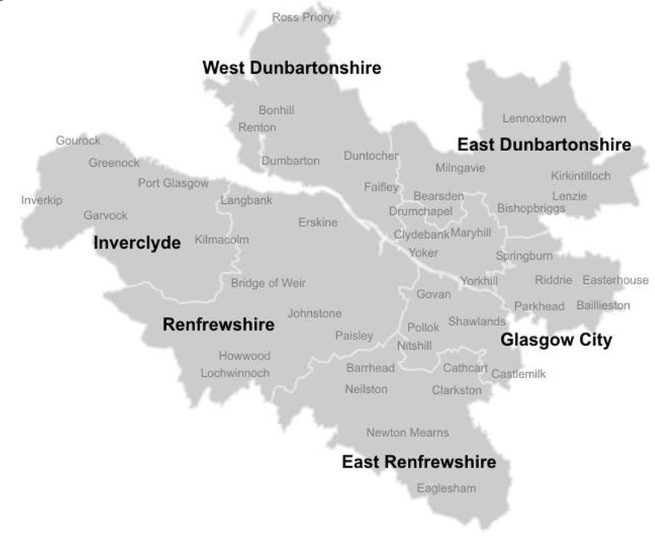
NHSGGC has a statutory duty to plan, commission, and deliver, healthcare for the residents of the local authority areas of Glasgow City, Inverclyde, Renfrewshire, East Dunbartonshire, East Renfrewshire and West Dunbartonshire. In delivering this NHSGGC works with the Scottish Government, our 6 Integrated Joint Board (IJB) partners, community planning partnerships, other NHS bodies, and other organisations in the public sector such as local authorities, the police, and the fire and rescue service. This partnership approach supports the implementation and delivery of the strategies and plans of NHSGGC, our 6 IJB partners, and the Scottish Government.

Our six IJB partners are:
- Glasgow City Health and Social Care Partnership
- Inverclyde Health and Social Care Partnership
- Renfrewshire Health and Social Care Partnership
- East Dunbartonshire Health and Social Care Partnership
- East Renfrewshire Health and Social Care Partnership
- West Dunbartonshire Health and Social Care Partnership

The overall purpose of the Board is to protect and improve population health and wellbeing whilst providing safe, accessible, affordable, integrated, person centred and high quality health services. To realise the overall purpose, the Board has developed a suite of values (based on those of NHS Scotland), aims and corporate objectives described as the Corporate Statements. In addition, Annual Operating Priorities are created in line with the Corporate Objectives and the Annual Delivery Plan which is submitted to the Scottish Government.

NHSGGC works to the 4 NHS Scotland key values:
- Care and compassion
- Dignity and respect
- Openness, honesty and responsibility
- Quality and teamwork

With these values at the forefront, the Board aims to improve health and individual care, whilst also reducing the cost of delivering healthcare. It is important that in doing so, the Board also creates a great place to work for all staff.

The Board has 4 corporate aims which each align to a set of corporate objectives:
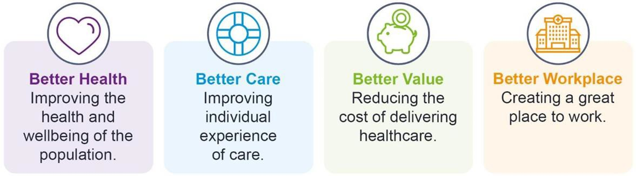

Each of these corporate aims is underpinned by the following corporate objectives:

Better Health
- To reduce the burden of disease on the population through health improvement programmes that deliver a measurable shift to prevention rather than treatment.
- To reduce health inequalities through advocacy and community planning.
- To reduce the premature mortality rate of the population and the variance in this between communities.
- To ensure the best start for children with a focus on developing good health and wellbeing in their early years.
- To promote and support good mental health and wellbeing at all ages.
Better Care
- To provide a safe environment and appropriate working practices that minimise the risk of injury or harm to our patients and our people.
- To ensure services are timely and accessible to all parts of the community we serve.
- To deliver person centred care through a partnership approach built on respect, compassion and shared decision making.
- To continuously improve the quality of care, engaging with our patients and our people to ensure healthcare services meet their needs.
- To shift the reliance on hospital care towards proactive and co-ordinated care and support in the community.

Better Value
- To ensure effective financial planning across the healthcare system that supports financial sustainability and balanced budgets.
- To reduce cost variation, improve productivity and eliminate waste through a robust system of efficiency savings management.
- To exploit the potential for research, digital technology and innovation to reform service delivery and reduce costs.
- To utilise and improve our capital assets to support the reform of healthcare.

Better Workplace
- To ensure our people are treated fairly and consistently, with dignity and respect, and work in an environment where diversity is valued.
- To ensure our people are well informed.
- To ensure our people are appropriately trained and developed.
- To ensure our people are involved in decisions that affect them.
- To promote the health and wellbeing of our people.
- To provide a continuously improving and safe working environment.

The Board provides services through approximately 6,000 beds across:
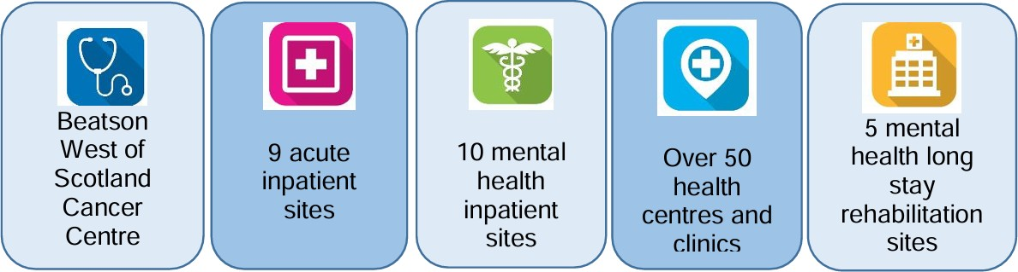

The Board monitors its performance against a range of quality and performance measures and submits performance information to the Scottish Government and other bodies throughout the year. You can find up-to-date information on health matters via the Public Health Scotland website.

There are 6 teaching hospital sites with additional teaching and research facilities for Medical, Nursing and Allied Health Professionals across Acute Services, which have responsibility for ensuring effective partnerships with 4 universities and local colleges who play a vital role in the education and training of all our health care professionals:

- University of Glasgow
- Glasgow Caledonian University
- University of Strathclyde
- The University of the West of Scotland

In addition we are supported by our Board wide Corporate Service’s directorates including Public Health, Estates and Facilities, eHealth, as well as corporate teams in Finance, Planning and Human Resources and Organisational Development and other specialist services.

We are committed to delivering high quality, innovative health and social care that is person-centred. Our ambition is to be a quality-driven organisation that cares about people - patients, their relatives and carers and our staff - and is focused on achieving a healthier life for all.

When you work with NHSGGC, you will have access to an attractive benefits package with training and support to expand your skills and progress your career. For roles which demand it, we also offer pay enhancements on top of your basic salary for out-of-hours, shift and overtime working.

We also offer comprehensive maternity, paternity and adoption leave schemes with benefits in excess of the statutory schemes.

We recognise that many employees have caring responsibilities outside of work and that from time to time, emergency leave may be required.

We offer a number of schemes to help staff combine work and home life. Colleagues within NHSGGC are currently taking advantage of a large range of flexible working opportunities, including part-time working, job sharing, compressed hours, unpaid employment breaks and flexible working.

Visit the NHSGGC Staff Benefits website for more information on what is on offer, including:

- Annual leave  - Continuing professional development opportunities  - Flexible working  - High street discounts  - Personal qualifications  - Staff bursary scheme  - Travel to work assistance  - NHS Credit Union | - Gym membership  - Pensions  - Cycle to Work scheme  - Library network  - Staff flu vaccination programme  - Employee assistance  - Volunteering  - Career Ambassador


Useful publications

The following publications and websites will provide an overview of the current priorities, strategies and Board members.

NHSGGC Board
Meet the Board - NHSGGC
NHSGGC - NHSGGC Board Meeting Agendas, Papers & Minutes

NHSGGC Strategies
Workforce Strategy 2025-2030 - NHSGGCStakeholder Communications and Engagement Strategy 2024-2027 - NHSGGC NHS Greater Glasgow and Clyde Quality Strategy 2024_29 - NHSGGC
Public Health Strategy 2018-2028 - NHSGGC Digital Health & Care Strategy - Digital On Demand 2023-2028 - NHSGGC
A Fairer NHS Greater Glasgow and Clyde 2020-2024 - NHSGGC
Transforming Together - NHSGGC

NHSGGC Finance
Annual reports and reviews - NHSGGC

About Greater Glasgow and Clyde
Living and working in Greater Glasgow and Clyde

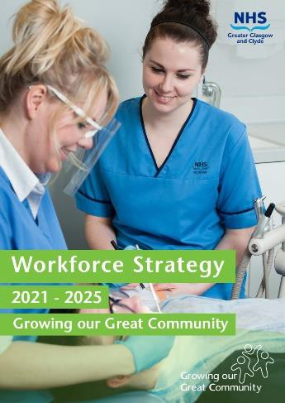
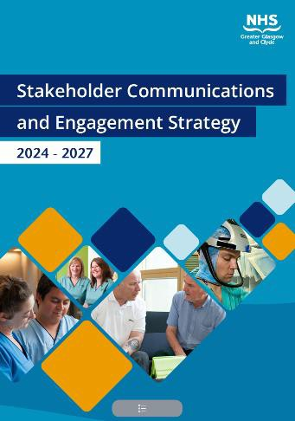


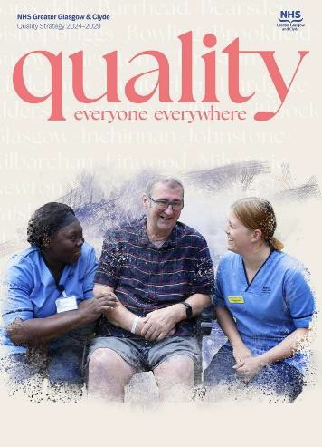


Executive Structure

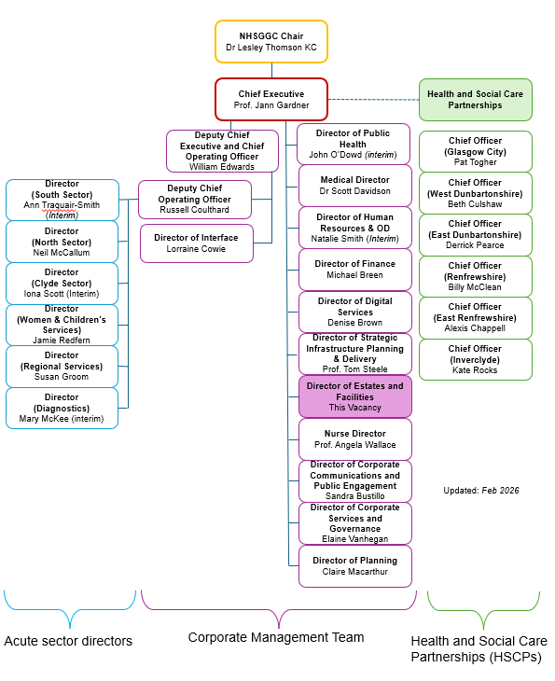

Organisational Structure

Organisational Structure

