Winter 2022 Booster Vaccinator Guidance (V1.0) 05.09.22

Practitioners should always make sure they refer to the Green Book Chapter Greenbook chapter 14a - COVID-19 (publishing.service.gov.uk) and other authoritative sources, ensuring the most up to date version is referred to.

This guidance tool is for winter booster/flu information only. Please refer to GBC /PGD’s for those commencing a primary course or first booster dose.

Group | Between Primary Doses | From Final Primary Doses to First Booster | From Last Spring Booster to Winter 2022 Vaccine* | Time to wait between COVID-19 Infection and COVID-19 Vaccine
5 to 15 with no additional risk factors | 12 weeks | N/A | N/A | 12 weeks
16 to 17 with no additional risk factors | 12 weeks | 12 weeks | N/A | 12 weeks
Over 18 or  Under 18 with additional risk factors* | 8 weeks | 12 weeks | 12 weeks | 4 weeks

*Clinically at risk, immunosuppressed, severely immunosuppressed, or a close household contact (5+) of someone who is clinically at risk. The main exception to the eight week lower interval would be those about to commence immunosuppressive treatment. In these individuals, the minimal intervals outlined in the green book may be followed to enable the vaccine to be given whilst their immune system is better able to respond.

NOTE: Citizens requiring a separate COVID-19 or flu appointment can re-book via the online portal or helpline 72 hours following initial appointment. Children under 18 years old cannot book via the online portal and will be required to call phoneline (www.nhsinform.scot/wintervaccines / 0800 030 8013)

 | Primary COVID-19 Doses
 | 1st | 2nd | 3rd | Winter 22/23  COVID-19 |  | Flu | Appointing Method | COVID-19 Booster Vaccine | Flu Vaccine
Residents and staff in care homes and housebound | ✓ | ✓ | ✗ | ✓ |  | ✓ | Residents through care home  Staff can receive at work or book online via portal / helpline | 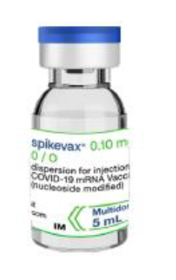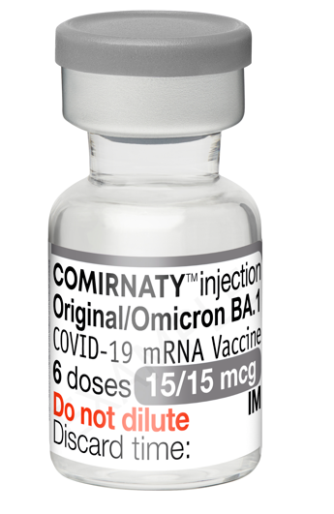 | <65s >65s  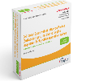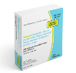
Frontline HSC Workers | ✓ | ✓ | ✗ | ✓  Frontline only |  | ✓  Frontline SCW &  All NHS | Book online via portal / helpline/ local arrangements |  | <65s >65s
65+ universal population | ✓ | ✓ | ✗ | ✓ |  | ✓ | Scheduled appointment  Can reschedule via online portal / helpline
16 – 64 at risk | ✓ | ✓ | ✓  IS/SIS only | ✓ |  | ✓ | Scheduled appointment  Can reschedule via online portal / helpline  Flu: 16+ still at school will receive in school setting | 16 & 17 yrs 18+  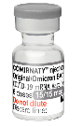
Pregnant women | ✓ | ✓ | ✗ | ✓ |  | ✓ | Maternity setting or online via portal / helpline/ local arrangements | 16 & 17 yrs 18+
Carers / unpaid carers &  household contacts of immunosuppressed | ✓ | ✓ | ✗ | ✓ |  | ✓ | Scheduled appt for registered carers**  Carers prompted within invite letter to book online via portal / phoneline for all others | 16 & 17 yrs 18+ | <65s >65s
At risk 5-15s (including household contacts and IS) | ✓ | ✓ | ✓  IS/SIS only | ✓ |  | ✓ | COVID-19: Scheduled appointment  Can reschedule via helpline  Flu: Will receive at school | 5-11 yrs 12-15 yrs  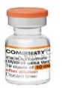 | See below – given at school
50–64 year-olds (no additional risk factors) | ✓ | ✓ | ✗ | ✓ |  | ✓ | Prompt letter to book online via portal / helpline
Teachers and support staff | ✓ | ✓ | ✗ | ✗ |  | ✓ | Can receive in school setting or book online via portal / helpline | N/A
Prison population and staff | ✓ | ✓ | ✗ | ✗ |  | ✓ | In prison setting, or staff can book online via portal / helpline  NOTE: Prisoners are eligible for covid-19 vaccine if they meet the general criteria by age or at risk | N/A | <65s >65s
School age pupils (primary and secondary) | ✓ | ✓ | ✗ | ✗ |  | ✓ | Will receive at school – letter home with child | N/A
Children 2-5 (not at school) | ✗ | ✗ | ✗ | ✗ |  | ✓ | SIRS letter - Preschool clinic | N/A
At risk children 6 months to 2 years | ✗ | ✗ | ✗ | ✗ |  | ✓ | SIRS letter - Preschool clinic | N/A | 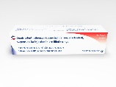

Please Note:

- Pfizer-BioNTech vaccine (Comirnaty®) original* may be used if 12 to 18 year olds present prior to Pfizer-BioNTech vaccine (Comirnaty® Original/Omicron BA.1) bivalent being available at clinics
- Those in Orkney and Shetland should follow local arrangements and will not be asked to use the booking portal
- Where age criteria applies, individuals must be the age specified by 31 March 2023. Exception being for 2-5 year old flu where children must be aged 2 by 1 Sept 2022

** If registered as a carer with GP then this data has been extracted and a scheduled appointment will be sent. All other carers remail eligible however should book via portal

Vaccine Reference Guide

 | A full 0.5ml dose of the bivalent (25/25 micrograms) of the bivalent Moderna COVID-19 vaccine (Spikevax® bivalent original/Omicron)
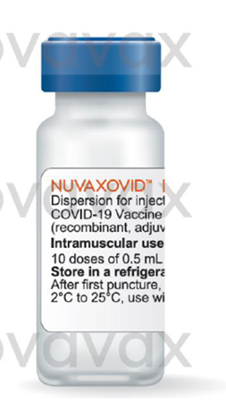
  Nuvaxovid One dose (0.5 mL) (COVID-19 Vaccine recombinant, adjuvanted) dispersion for injection
  (Novavax COVID-19 vaccine may used for primary vaccination of adults over 18 years, including to complete a course or as a booster, although the latter is currently off-label. This is for exceptional use only).
 | A full 0.3ml booster dose of bivalent (15/15 micrograms) Pfizer-BioNTech vaccine (Comirnaty® Original/Omicron BA.1) (Currently expected to be in use from 19.09.22)
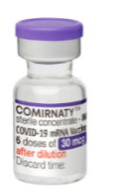 | *A full 0.3ml dose (30 micrograms) of adult/adolescent Pfizer-BioNTech vaccine (Comirnaty®)
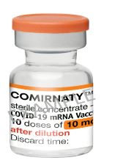 | A full 0.2ml dose (10 micrograms) of paediatric Pfizer-BioNTech vaccine (Comirnaty®10)  Currently off-label as a booster.
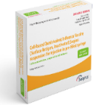 | Cell-based Quadrivalent Influenza Vaccine (Seqirus)
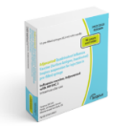 | Adjuvanted Quadrivalent Influenza Vaccine (Seqirus)
 | Fluenz Tetra Nasal Spray Suspension, influenza vaccine (live attenuated)
 | Quadrivalent Influenza Vaccine (standard egg – grown quadrivalent influenza vaccine). Split virion inactivated.

