Pride Badge Pledge Form

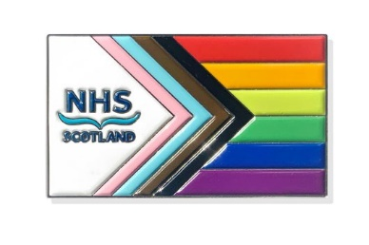
New Pride Badge

Please do not complete this form on behalf of other people.

This form must be completed by the person requesting the NHSScotland Pride Badge so that they fully understand what it means.

Name:

Work e-mail:

I confirm that:

I understand wearing a badge gives a positive message of inclusion and means I have a responsibility to be someone who is a friendly ear to the LGBT+ and minority ethnic communities.

I have read the information on this page and explored the supporting NHSScotland Pride Badge toolkit.

I understand that I can use the toolkit to help signpost people to relevant organisations if they need more specific support that I cannot offer.

By wearing this badge you are demonstrating your support for the LGBT+ and minority ethnic communities.

You pledge to be a listening, friendly, and responsive ear to people in need, signposting them to organisations and local contacts who can provide more specific assistance.

Sometimes, you may need to call out hate speech, report incidents of discrimination or acts of verbal or physical abuse against patients, people who use our services, and staff (including contractor staff).

Finally, you are agreeing to wear your badge with pride as an ally to progress.

If you agree with the above please tick the box:

continued over...

Additional Information:
NESD1499 | Produced for Scottish Government by NES Design Service

Finally, if you are happy for colleagues to contact you in 6-12 months’ time and gather feedback on your experience as a badge wearer, please tick the following box:

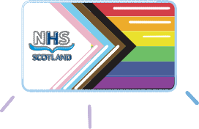
*Disclaimer: This information will not be shared with any external organisations. It is only to be used to count how many staff have agreed to wear the badge and gather insights from the wearers. It will not be used for any other purposes.

