Information for patients receiving a

PET/CT Scan

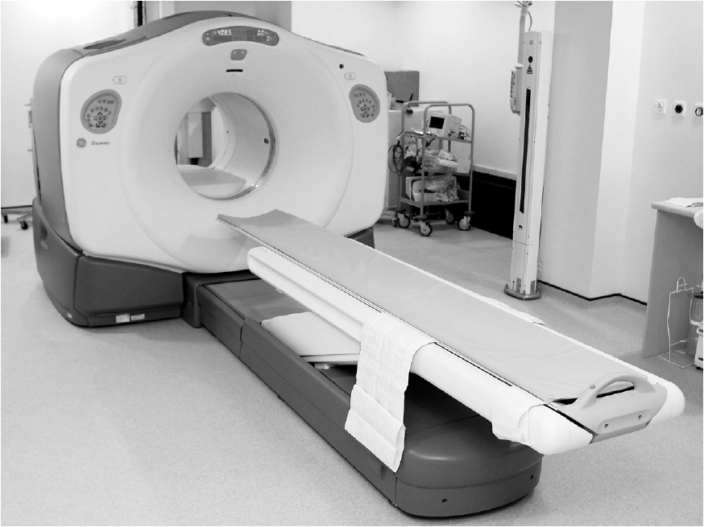

West of Scotland PET Centre

Tom Wheldon Building

Gartnavel General Hospital

1053 Great Western Road

Glasgow, G12 0YN

Telephone: **0141 301 7800**

About your appointment

Your PET/CT scan will be at the **West of Scotland PET Centre, Tom Wheldon Building, Gartnavel General Hospital.**

* You need to confirm that you will attend your appointment by telephoning us on:

**0141 301 7800** (Monday – Friday, 8:30am – 5:00pm)

If you use the voicemail service, please leave your **full name and contact telephone number** so we can call you back. We will ask you a few questions prior to your scan.

If you cannot make this appointment please telephone us as soon as possible. This will allow us to give your appointment to another patient.

It is important that you allow plenty of time to arrive promptly at the PET Centre for your appointment. If you have any questions about your scan please phone us.

**Help with specific needs** 

If you need help with any of the following please telephone the department:

* Sight, hearing or require an interpreter.
* Mobility, specialised equipment or any other need.

Your wellbeing

You are having a PET/CT scan so that your doctor can either make a diagnosis or monitor the progress of your treatment.

PET/CT scans involve the use of radiation. We make sure when you have your scan that the benefits outweigh the low risk involved with the radiation itself.

What is PET/CT scanning?

PET stands for Positron Emission Tomography. It is a scanning method where a radioactive tracer (generally a form of slightly radioactive sugar) is injected into a vein in your arm. It produces images to show how your body is working.

A CT (Computed Tomography) scan uses X-rays to produce a 3D picture of inside your body.

By combining these two techniques in one scan, we can provide important information to help your doctor plan your treatment.

How long will the scan take?

It depends on the type of scan, but you should expect to be in the department for 2-3 hours.

Preparation

**Do not have anything to eat for 6 hours before your scan (unless you have diabetes, see below).** However, you should drink as much plain water as you can during this time. Do not drink flavoured, sweetened or fizzy water, tea or coffee, as this can affect your scan result.

You should continue to take your regular medication during this time.

Please avoid chewing gum or doing any strenuous exercise **for 24 hours before your scan** as this can affect your scan result.

Patients with diabetes

If you have diabetes, it is really important you let us know as soon as possible before your appointment. You can contact us on the number on the front of this leaflet.

It is important that your blood sugar is in the correct range when you have your scan. We will therefore give you specific advice about when to eat and when to take any medication. We may suggest changing your appointment time to fit in with your meal and medication times.

Pregnancy and breastfeeding

It is important to avoid using radioactive tracers with patients who are or may be pregnant. Therefore please contact us if you are either pregnant, breastfeeding or you think you could be pregnant.

As our tests use radiation, we do not routinely carry out scans on patients that are pregnant. We will therefore ask all patients aged 12-55 years and registered as female at birth about their pregnancy status.

If we are unable to confirm pregnancy status (e.g. you have irregular periods or your period is late), we may ask you to take a pregnancy test. We may also have to reschedule your appointment until pregnancy status can be confirmed. These steps are to ensure the safety of the unborn foetus.

What should I wear?

We suggest that you wear something loose, comfortable and warm. Where possible, avoid wearing metal items such as watches, jewellery and clothes with metal fastenings. We may give you a hospital gown to wear whilst in the department. If you need assistance getting changed, please bring a relative or friend to help you.

Can I bring someone with me?

If you wish, a relative or friend may accompany you and wait in the waiting room. However space is very limited so it will be helpful if only one person accompanies you.

As the PET Centre operates with radioactive materials, **please do not bring children or anyone who may be pregnant.**

What will happen to me when I arrive?

* We will explain the whole procedure to you.
* Your blood sugar level will be tested. If your sugar level is too high or too low, it may not be possible to do the scan as it can affect the quality.
* You will receive an injection of a small quantity of radioactive material similar to sugar.
* After the injection, we will ask you to relax quietly for 30-90 minutes before your scan.
* We will then take you to the scanning room.
* We will ask you to lie flat and remain still on the scanning couch whilst we perform the scan.
* The scanner collects images for approximately 30 minutes.
* You breathe normally throughout the scan, so there are no instructions to follow.

**When will my results be available?**

The report will be sent to the doctor that referred you. If results are needed urgently, your doctor can telephone us. If you have a further appointment with your doctor please let us know the date when you come for your scan.

**Use of your images**

We may use images or details from your test for research, teaching or presentation purposes. This can help to improve our service. You will not be able to be identified from this information. Please let us know if you do not wish your data used in this way.

Are there any side-effects from the scan?

The scan involves some X-ray exposure and the use of a small amount of radioactive tracer. This will only remain in your body for a few hours. This small amount of radiation will not cause you any side effects.

We recommend that you drink more than usual, about 1 to 2 pints of water, over the rest of the day to help wash the tracer out of your body.

Because of the radioactive injection, we ask you to minimise close contact with other members of the public (particularly children, babies or pregnant people) for about 8 hours after you leave. This means not having a child sitting next to you or on your knee during this period.

If you are planning to travel home on public transport and your journey time is more than 2 hours, please let us know this before your injection.

Carers and comforters

If a friend or relative cares for you during this procedure or when you go home, they will receive a small amount of radiation from you. It is therefore important that your carer is not pregnant or breastfeeding.

Please show this leaflet to any carer so that they understand this before you come for your PET/CT scan.

**If you live in a care or nursing home**

Please show this leaflet to the care or nursing home staff. They should read the following section:

**Care or nursing home staff**

As your resident is coming for a nuclear medicine test there are some responsibilities for the care or nursing home staff.

At their appointment your resident will receive a small amount of radiation to perform their test. We will issue instructions when the patient attends. These instructions are specific to the test they are having. They explain the additional precautions to be taken and the duration of these (usually a few days). All staff nursing or caring for a patient should be aware of, and follow, these instructions when caring for them at this time. If you need more information please telephone the department.

Putting it in perspective

We are all exposed to natural background radiation every day of our lives. This comes from our environment, the air we breathe, the food we eat and even from outer space (cosmic rays).

By having a PET/CT scan you will receive a small amount of radiation in addition to the natural background radiation you already receive.

The amount of radiation you will receive is small. It is equivalent to what you might be exposed to naturally over 3-7 years, depending on the type of PET/CT scan you are having.

The risks from radiation are lower for older people and higher for children. The amount of radiation used is carefully monitored for all patients, and is reduced for young children.

**If you would like more information about the radiation you will receive for your PET/CT scan** **please ask a member of staff.**

**Comments and suggestions**

Feedback from patients and carers helps us to improve our service. We welcome comments and suggestions about any aspect of your attendance at the hospital.

Please speak with a member of staff or you can use our online feedback system: [www.nhsggc.org.uk/get-in-touch-get-involved/patient-feedback](http://www.nhsggc.org.uk/get-in-touch-get-involved/patient-feedback)

**Complaints**

If you wish to complain about any aspect of your care when attending our department, please speak with a senior member of staff in the first instance. You can also contact the Complaints Office on: 0141 201 4500 or complaints@ggc.scot.nhs.uk

For more information about the West of Scotland PET Centre you can visit our webpage on:

<https://www.nhsggc.scot/hospitals-services/services-a-to-z/nuclear-medicine/information-for-patients/nuclear-medicine-at-gartnavel-general-hospital/pet/>