How to find your employee’s FFP3 Face Fit Test record on eESS
- Log in to eESS
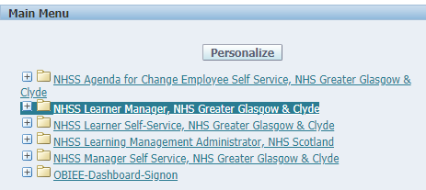
- Click on the ‘+’ beside ‘NHSS Learner Manager, NHS Greater Glasgow & Clyde’

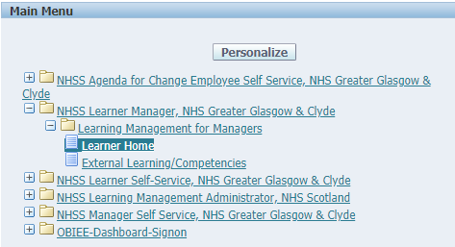
- Click on ‘Learner Home’

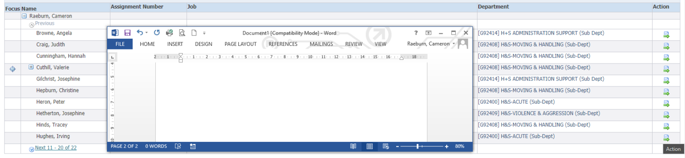
- This will produce a list of your direct reports. Click on the Action symbol beside the employee you are looking at

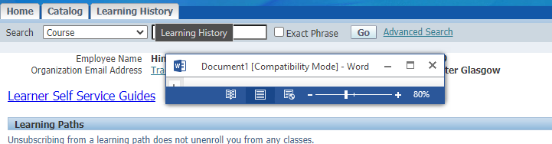
- Click on the ‘Learner History’ tab

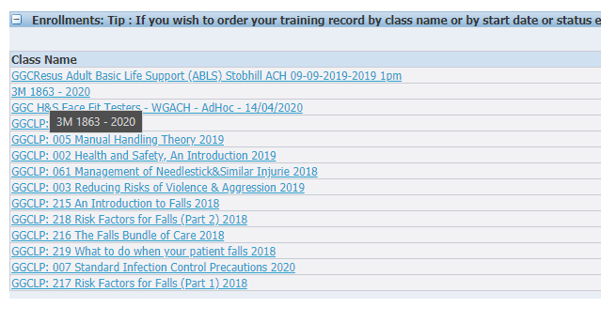
- If the employee has a fit test to an FFP3 mask you will see the mask make, model, year of test. In the example provided the fit test was a pass, where the fit test was a fail it would have read ‘3M 1863 – 2020, FAIL’

