NHSGGC Long COVID Service

Personal care aids
The following list of small aids can support you when completing personal care tasks. These items can be purchased from many online websites such as, Amazon, Argos, Ebay, Mobility Smart, NRS Health care or at stores such as Able World in Paisley. If you need more information, you can complete a self-assessment by accessing the Ask SARA website on equipu.livingmadeeasy.org.uk
Equipu - AskSARA

Local Providers where these may be purchased:
Mobility solutions (Mobility Solutions - Powerchairs, Wheelchairs & Mobility Scooters)
Care co (Wheelchairs | Manual Self-Propel, Transit & Travel Wheelchair ♿)
Ableworld (Paisley - Ableworld Mobility & Stairlifts Paisley)
Local contacts -
Glasgow contact Contact Health and Social Care - Glasgow City Council
Inverclyde (Inverclyde Centre for Independent Living - Inverclyde Council)

Dressing stick | Button and zip aid | Sock aid
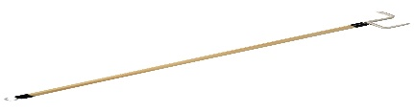 | 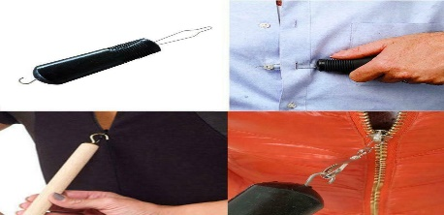 | 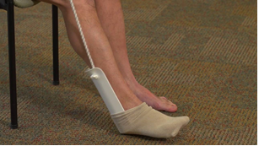
Long handled shoes horn | Helping hand | Long handled sponge
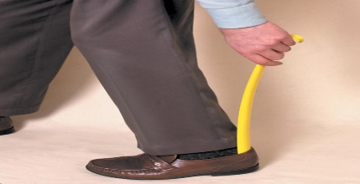 | 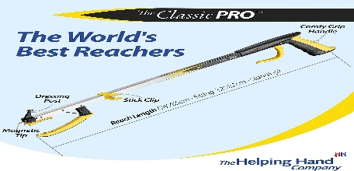 | 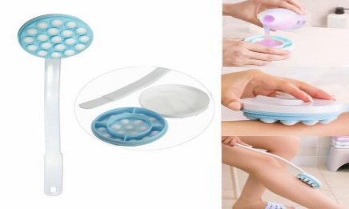
Long handled brush | Bottom wiper | Cream applicator
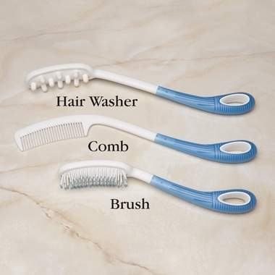 | 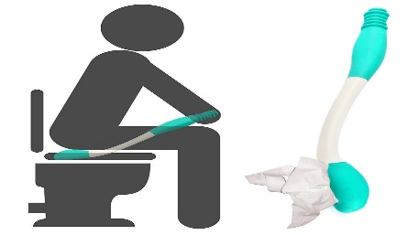 | 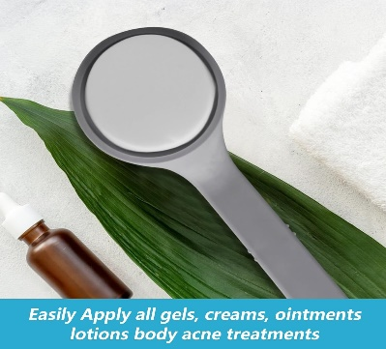
Male urinal
