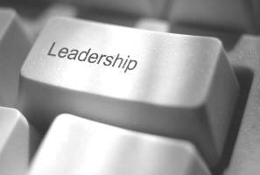
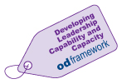
90 Minute Leadership
OD recognise the challenges our leaders have in managing time constraints and setting aside
time for development activities. Short, intensive development sessions can be a useful way of
learning. Rather than spending a full day covering a relatively wide range of topics, our
“90 Minute” leadership sessions will focus on specific topics, concentrating on key issues
rather than the broader picture.
The next session is:
“Having Impact and Influence”

We’ve all been in situations where your team is de-energised and we seem to have little impact on those around us.

Drawing on 50 years of leading organisations and helping leaders become more effective and fulfilled, Laurence will help you understand how you affect those around you. Being energised at work – getting your mind in gear, Building your presence – Helping others catch your positive emotion, Influencing without authority – Guiding people to your way of thinking. We will look at practical tools to improve our impact and to energise both our team and ourselves. How to protect yourself from the negative impact of others and how to be the best version of you more of the time, will also be explored.

Sp Speaker: Date: Time:
L Laurence J Clarke, Taylor Clarke Tuesday 26th May 2026 08.30am – 10.00am

Register for the session –

https://link.webropol.com/ep/onlineleadershiphavingimpactnadinfluencemay2026

