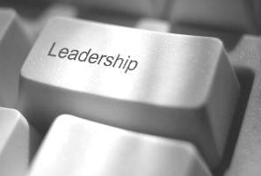
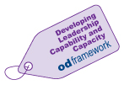
90 Minute Leadership
OD recognise the challenges our leaders have in managing time constraints and setting aside
time for development activities. Short, intensive development sessions can be a useful way of
learning. Rather than spending a full day covering a relatively wide range of topics, our
“90 Minute” leadership sessions will focus on specific topics, concentrating on key issues
rather than the broader picture.
The next session is:
ALL LEADERS
Who will benefit from attending this session?
“Civility Saves Lives - “Making Life Work Better”

Building on the Civility Saves Lives campaign, Michael Murray will take a light-hearted look at some of the issues we all experience at work – incivility and its impacts, the effect of poor behaviour on stress and performance and how we manage when things don’t go to plan – equally importantly, what can we do to make the working environment better. Effective low cost or free suggestions.

Life can become quite industrial and routine at times, and often we forget to look after ourselves or to do what we enjoy – simple changes to improve life. Home and work are inextricably linked and we need both to be as good as they can be as most of us need to be here!

Speaker: Date:
Dr Michael Murray Wednesday 25th February 2026
Consultant Neuroanaesthetist,
and CSL Clinical Lead Time:
08:30am - 10.00am

Register for the session – https://link.webropol.com/ep/onlineleadershipfebruary2026cslmakinglifeworkbetter

