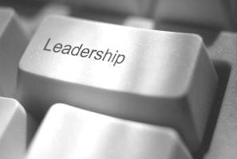
Online Leadership
OD recognise the challenges our leaders have in managing time constraints and setting aside time for
development activities. Short, intensive development sessions can be a useful way of learning. Rather than
spending a full day covering a relatively wide range of topics, our Online Leadership sessions will focus on
specific topics, concentrating on key issues rather than the broader picture. The next session is:

Who will benefit from attending: this session?
Everyone who wants to explore their inner leader, looking at how both body and mind can impact how you feel, speak and show up as a leader within the NHS

“Fierce Compassionate Leadership”

Enhance your leadership skills with RAIN, an easy-to-remember tool for practising mindfulness and compassion and overcoming complex challenges at work and in life.
- Introducing the “RAIN” process: Recognize → Allow →Investigate →Nurture;
- Time to practice “RAIN” together as a group;
- Live coaching opportunity to demonstrate using “RAIN” as a tool in challenging time.

Moon Li is a Certified Mental Fitness Coach and an ICF Impact Award winning coach who believes in self-awareness and connection. She brings her passion for cultivating courage, clarity and confidence into leadership for individuals and teams.

Speaker: Date: Time:
Moon Li, Wednesday 26th August 2026 08.30-10.00am
Kapow Coaching

Register for the session OR 

