NHS Greater Glasgow and Clyde

Real Time Staffing and Risk Escalation

Standard Operating Procedure

|  |  |
| --- | --- |
| **Approved by** | HCSSA Transition Oversight Board |
| **Date Approved** | 19 August 2025 |
| **Version** | V.1.5 |
| **Review date** | 6 Months from date of approval |
| **Author** | Lynn Marotta, Lead Nurse |

1. Purpose 2

2. Scope 3

3. Background 3

4. Education / Training 4

4.1. Essential Learning 4

4.2. Local Learning 4

5. Definitions / Roles and Responsibilities 4

5.1. All staff named in the Act 5

5.2. Patients, families and Carers 5

5.3. Who is the Lead Professional 5

5.4. Who can provide appropriate clinical advice 6

5.5. Who is a “more senior decision-maker” 6

5.6. What are Severe and Recurrent Risks 7

5.7. Datix 7

6. Real Time Staffing Process 7

6.1. Real Time Staffing Assessment 7

6.2. Risk Mitigation 8

6.3. Disagreements 8

7. Staffing Incidents 9

8. Local Records 10

8.1. SSTS 10

9. Staffing Discussion/Huddle/Staffing Meetings 11

9.1. Pre Team discussion/huddle/staffing Meeting 11

9.2. Discussion/Huddle/Staffing Meeting 11

10. Severe and Recurrent Risk 13

10.1. Step 1 Identify 13

10.2. Step 2 Define 13

10.3 Step 3 Risk Assessment 14

11. Useful Checklist 15

12. Appendices 15

Appendix 1: Professions within Scope 15

Appendix 2 Frequently Asked Questions 16

Appendix 3 Flow Diagram – Health Care Improvement Scotland 18

Appendix 4 Assessment 19

Appendix 5 National RAGG Classification 21

Appendix 6 Mitigations 22

Appendix 7 Checklist 23

Useful Resources 25

# **Purpose**

This Standard Operating Procedure (SOP) supports NHSGGC to fulfill the duties of the Health and Care (Staffing) (Scotland) Act 2019 (HCSSA), enacted in April 2024. The main duties this SOP relates to are:

* 12IC: Duty to have real-time staffing assessment in place
* 12ID: Duty to have risk escalation process in place
* 12IE: Duty to have arrangements to address severe and recurrent risks
* 12IF: Duty to Seek Clinical Advice on Staffing

These duties are required to be in place and maintained to ensure appropriate staffing for:

* The health, wellbeing and safety of people in our services
* The provision of safe and high-quality health care
* In so far as it affects either of those matters, the wellbeing of staff

NHSGGC must demonstrate that these processes:

* Are embedded in practice
* Inform staffing discussions
* Inform staffing decisions
* Support the short and long-term provision of appropriate staffing

How these duties have been carried out must be reported on a quarterly basis, by senior and corporate management teams to the NHS Greater Glasgow and Clyde (NHSGGC) board and be included in an annual report to Scottish Ministers under section 12IM Reporting on Staffing.

# **Scope**

The duties contained in this SOP apply to all named professions covered in the Act. A comprehensive list can be found here: [Roles in scope of the Act - Health and Care (Staffing) (Scotland) Act 2019: overview - gov.scot (www.gov.scot).](https://www.gov.scot/publications/health-and-care-staffing-scotland-act-2019-overview/pages/roles-in-scope-of-the-act/#healthcarestaff) This list is a living document which can incorporate new professions/roles over time as appropriate. A high-level list is provided in **Appendix 1**.

This SOP is designed to be used by clinical leaders and management teams.

# **Background**

This SOP supports NHSGGC to have robust arrangements in place to ensure appropriate staffing and high-quality care in the daily running of services. This requires real-time assessment through identification, escalation and mitigation of risks caused by staffing concerns which are below that required to provide safe, effective person-centered care.

Risk is an inevitable part of all healthcare services but must be mitigated as far as possible to enable safe and high-quality services.

Real Time Staffing (RTS) processes should also provide a consistent means of recording the escalations and mitigations of any staffing risk.

The NHSGGC Health and Care Staffing team completed multi professional testing of the noted duties in the Act, with the outcomes presented in an SBAR, supporting processes, policies and reports added to an evidence bank and required actions for improvement displayed in a driver diagram. This led to an RTS and Risk Escalation Short Life Working Group (SLWG) which explored various RTS options. The preferred option of the SLWG is a system named SafeCare. This will take time to approve, plan and implement therefore this SOP will describe what to do in the interim period.

Testing found that most teams have an RTS process, so management teams must review and update their local SOPs to align with this overarching SOP.

# **Education / Training**

## **4.1. Essential Learning**

These modules must be completed as once only (or if significantly updated).

**Roles in Scope of the Act:** [Learning resources : Informed level | Turas | Learn (nhs.scot)](https://learn.nes.nhs.scot/62182)

**Leadership roles**: [Learning resources : Skilled level | Turas | Learn (nhs.scot)](https://learn.nes.nhs.scot/64721)

## **4.2. Local Learning**

Management teams are responsible for ensuring local teams receive education on local RTS and Risk Escalation processes.

# **Definitions / Roles and Responsibilities**

## **5.1. All staff named in the Act**

**All staff** named in the Act are responsible for escalating staffing concerns to a Lead Professional (LP) in real time, at the earliest opportunity and follow locally agreed processes.

**Management teams require to include this in their SOPs.**

## **5.2. Patients, families and Carers**

A patient, family or carer can also raise a voiced concern to an LP.

**Management teams require to include this in their SOPs.**

## **5.3. Who is the Lead Professional**

Duties 12IC and 12ID require people with LP responsibility (clinical or non-clinical) to have specific responsibilities for the mitigation and escalation of staffing risks identified by members of staff or patient/family/carers. An LP is someone with a leadership role in a particular setting in relation to staffing.

Who LPs are dependent on the local context in which the service is operating and on professional and clinical governance structures. LPs should be of sufficient seniority. Different sections of the Act describe different types of leadership relevant to the duties in the legislation:

* 12IC duty to have RTS in place and 12ID duty to have risk escalation process in place – “individual with lead professional responsibility (whether clinical or non-clinical)”;
* 12IH duty to ensure adequate time given to clinical leaders – “individual with lead clinical professional responsibility for a team of staff”. This individual must be a clinician
* 12IF duty to seek clinical advice on staffing and section 12IJ duty to follow the common staffing method “individual with lead clinical professional responsibility for the particular type of health care”. This individual must also be a clinician.

The term clinician is used in its most general sense and covers all professionally regulated colleagues including those without a patient-facing role. There may be times when these leaders may be the same individual; however, this is not always the case.

**Appendix 2 provides examples of who an LP may be in practice and how they can be identified. Management teams must define who the LPs are within their services/SOPs. An LP must be available and identifiable on each shift including out of hours, for example, the person in charge.**

## **5.4. Who can provide appropriate clinical advice**

LPs involved in staffing risk mitigations, and more senior decision-makers reaching a decision on risk, must “seek and have regard to appropriate clinical advice”. This is required when the LP or more senior decision-maker:

* is not a clinician
* is assessing risk, or making a decision, in relation to a clinical workforce for which they are not professionally responsible

**and/or**

* is making a decision in a specialty/setting in which they are not an expert and/or do not normally work.

Clinical advice is appropriate when it is relevant to the identified risk and is provided by a person with clinical expertise in the relevant clinical area and responsibility for the clinical workforce engaged in the risk. Clinical advice may need to be obtained from more than one person. The LP/more senior decision-maker must consider this advice and, when it conflicts, should use their professional judgement to decide to mitigate, escalate or accept the risk(s). For escalated risks, the person providing clinical advice may record disagreement with the decision and request a review from any decision-maker up to but not including members of the NHSGGC board.

**Management Teams must include appropriate clinical advice processes within local SOPS/flow diagrams to ensure clarity regarding roles and responsibilities.**

## **5.5. Who is a “more senior decision-maker”**

A more senior decision-maker is someone who receives risk escalations from an LP. Senior decision-makers can keep escalating risks to more senior decision-makers up to the level of the NHSGGC board. Who is a more senior decision-maker is dependent on the local context of a service and on the professional and clinical governance structures in place. A senior decision maker must have sufficient seniority and an agreed understanding within the organisation, supported by NHSGGCs arrangements, of their authority to act to mitigate identified risk(s).

LPs and senior decision makers require to assess how far through the professional or management structure to escalate a risk, at each step, depending on the severity and/or repeated nature of the identified risk and, at times (e.g. out of hours), the availability of staff.

**Examples of who this may be in practice are given in Appendix 2. Management teams must define who the LPs are within their services/SOPs.**

## **5.6. What are Severe and Recurrent Risks**

Severe and recurrent risks are not defined within the Act; the definitions found within section 9.2 have been adopted by NHSGGC.

A risk is an uncertain event which can have an impact on an organisation’s ability to achieve its objectives. To prevent the risk from occurring controls and mitigation actions are required to manage the risks. Some examples of staffing risks can be found in **Appendix 2**.

An incident is any event or circumstance that led to unintended or unexpected harm, loss or damage. A near miss is as a result of chance or intervention; the outcome could have led to harm but on this occasion it did not. Some examples of staffing incidents can be found in **Appendix 2**.

# **5.7. Datix**

Datix is the NHSGGC System used to record incidents and risks. Incidents and risks are recorded within two separate modules located within Datix. For this SOP, any incident that has occurred should be reported in the Incident Module within Datix. Risks should be managed within the Risk Module. [GGC-Datix - Home (sharepoint.com)](https://scottish.sharepoint.com/sites/GGC-Datix)

**Management teams must include the use of the Datix Incident module and reporting process within their SOPs.**

# **Real Time Staffing Process**

This SOP must not replace Sector/Health and Social Care Partnerships (HSCPs) SOPs and should complement and provide guidance and consistency. All Sectors/HSCPs must review their SOPs to ensure they align with this SOP and the Act. If areas do not have SOPs in place they must be developed.

**Appendix 3** provides a Risk Escalation flow diagram to support the development of Sector/HSCP flow diagrams.

**Staffing concerns and voiced care concerns can be raised at any point during a working period therefore escalation SOPS/flow diagrams must** **include in and out of hours process.**

## **6.1. Real Time Staffing Assessment**

Management teams are required to consider within their SOPs what factors in **Appendix 4** are appropriate for their areas of practice when assessing actual and potential staffing concerns.

Actual staffing concerns are immediate on the day, Example provided in **Appendix 2.**

Potential staffing concerns are the future shift, issues identified within the week, month or longer term. Example provided in **Appendix 2,**

These factors support the consideration of thresholds for risks being identified as severe or recurrent. Where the LP/senior decision maker is not a clinician and/or where decisions are being made in relation to a workforce that the LP/ senior decision-maker is not professionally responsible, they must seek and have regard to clinical advice from an appropriate person.

**To support the assessment of RTS management, teams require to use the national RAGG classification in their SOPs. Appendix 5.**

## **6.2. Risk Mitigation**

**Appendix 6** sets out what management teams are required to consider as appropriate for their areas of practice when mitigating risk.

Where the LP/senior decision maker is not a clinician and/or where decisions are being made in relation to a workforce that the LP/senior decision-maker is not professionally responsible, they must seek and have regard to clinical advice from an appropriate person.

**LPs/senior decision makers must notify the individual who originally escalated the staffing concern of any decisions, reasons and any required actions. LPs must have consideration for mitigations that may affect the wellbeing of staff and must follow NHSGGCs** [Health and Wellbeing - NHSGGC](https://www.nhsggc.scot/staff-recruitment/hrconnect/policies-and-staff-governance/polices/health-and-wellbeing/) **guidance. This must be included in local SOPs/flow diagrams.**

## **6.3. Disagreements**

Disagreements relate to any staff involved in relation to the RTS assessment or risk escalation in:

* Identifying a risk
* Attempting to mitigate a risk
* Giving clinical advice in relation to mitigation of risk
* Reporting a risk (including onward reporting)
* Giving clinical advice on a risk

Management teams must have arrangements in place for staff to be notified of every decision made and the reasons for it. Where staff disagree with a decision, they may record it and may choose to request a review of the decision. An exclusion from this is where the final decision has been made by the members of the NHSGGC board: these decisions may not be reviewed at the request of individual staff.

**Management teams should set out how staff can record disagreements and formally request a review within their SOPs.** It is also good practice to review the numbers and reasons for formal disagreements as part of governance arrangements.

# **Staffing Incidents**

**Reporting of staffing incidents within the Datix Incident Module (or other Incident Management Systems in place) is intended as a retrospective recording tool and does not replace local escalation, mitigation, or recording processes.**

When reporting a staffing incident, the Incident Management and Reporting Policy should be followed. The assessment and escalation for staffing incidents must be conducted by the Lead Professional, although any individual employee may submit a Datix Incident.

Staffing incidents include:

* Staff wellbeing (e.g., missed breaks)
* Business Continuity
* Holding RAGG Status Risk – Unable to Mitigate
* High Risk to appropriate staffing in future
* Voiced Care Concern
* Disagreements

Generally, these concerns are identified after reviewing census data, participating in site safety ‘Huddle’ meetings to assess RAGG status, and using Professional Judgement with related actions. They pertain to situations where staffing concerns cannot be mitigated, and the risk has been accepted through the appropriate escalation route.

For patient-related staffing incidents, the CHI number should be included. If not specifically related to a patient, do not enter a CHI number.

Individuals who provided clinical advice to decision-makers can be listed in the “Investigators” field if they have an NHS Scotland email account and will receive updates accordingly. The original reporter may opt-in to receive feedback once a resolution is achieved.

Disagreements arising during assessment or escalation, such as differences in professional judgement regarding staffing adequacy, mitigation actions, or risk status, may also be documented as part of the incident report. Documenting these disagreements supports transparency, facilitates resolution, and enhances understanding of staffing dynamics.

In the future, following NHSGGC’s full transition to the SafeCare system, formal recording of Clinical Advice and Disagreements will be incorporated within SafeCare. At that point, the continued use of Datix for these purposes will be reviewed to ensure consistent and efficient reporting processes.

Datix incident reports should be created as soon as reasonably practical.

If staffing is a contributory factor in other clinical incidents, this must be included in the incident description. The reviewer may then use the contributory factors field to formally record this information.

# **Local Records**

Management teams and local areas are also required to hold local records.  
This SOP is not prescriptive regarding how this is captured; **Appendix 2 provides examples** (General Data Protection Regulations must be followed). The minimum Items that must be recorded are:

* National RAGG Status (before and after)
* Escalations
* Mitigations (Clinical advice provided)
* Staff notification
* Disagreements

**8.1. SSTS**

If SSTS is used by your profession, the borrow function must be used when staff are redeployed to allow reporting. [SSTS Interactive Rostering](https://scottish.sharepoint.com/sites/GGC-SSTS/Shared%20Documents/Forms/AllItems.aspx?id=%2Fsites%2FGGC%2DSSTS%2FShared%20Documents%2FSSTS%20Interactive%20Rostering%20NEW%20Manual%20V1%203%20Update%20060719%2Epdf&parent=%2Fsites%2FGGC%2DSSTS%2FShared%20Documents)

**Reporting**

Click on the borrow icon  to create a borrow within SSTS.

You can then run a SSTS BOXI report to identify the borrow ins and the borrow outs.

In SSTS BOXI Manager folder -SCN/Midwife Folder – General.

Report name

1t – Borrowed In hours – by date range select location length of shift

**or**

1v – Borrowed out hours – by date range select location length of shift

To apply for a Boxi account please see: [GGC-Scottish Standard Time System (SSTS) - Home (sharepoint.com)](https://scottish.sharepoint.com/sites/GGC-SSTS)

# **Staffing Discussion/Huddle/Staffing Meetings**

The frequency of discussions/huddle/staffing meetings must be determined locally within SOPs; however, must be held as a minimum at least once per day.

## **9.1. Pre Team discussion/huddle/staffing Meeting**

It is recommended that LPs within their own teams have a pre-staffing discussion/huddle/staffing meeting before the wider team discussion/huddle/staffing meetings. At this stage assessment, escalation, mitigations and disagreements can be explored and may be resolved. Issues that can't be mitigated or unresolved disagreements will be fed into the team discussion/huddle/staffing meeting via telephone, email or shared templates. Local team records must be kept.

## **9.2. Discussion/Huddle/Staffing Meeting**

**Responsible>Accountable>Consulted>Informed**

* Meetings can be in person, via Microsoft Teams, telephone, or through email discussion
* Agenda items and attendees will be determined by the area and local context
* This may be a site/HSCP wide discussion/huddle/staffing meeting. A multidisciplinary approach and joint recording are recommended
* The LP is tasked with completing all the elements of this SOP.
* The meeting must be led by senior decision makers alongside LP representatives
* The information from the pre team discussions/huddle/staffing meetings will be explored in terms of mitigations, disagreements and further escalations to more senior decision makers
* LP representatives and senior decision makers must notify teams regarding the outcomes and any required actions

**Considerations:**

* IT/Screens/network
* Compliance reporting (for areas that have not completed their staffing information call and ask to complete)
* Information sharing
* Escalation/mitigation/where do unresolved issues go
* Data assurance
* Discussion/Huddle/meeting periods
* Weekends/public holidays/out of hours
* Staff engagement/notification process
* Record keeping

# **Severe and Recurrent Risk**

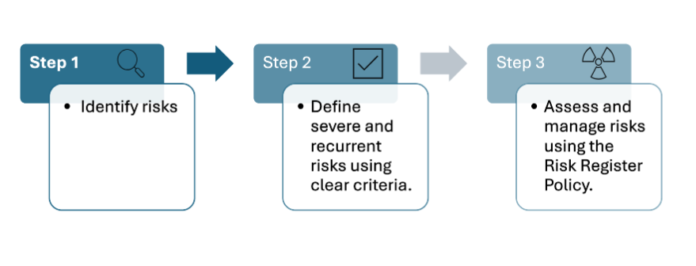

## **10.1. Step 1 Identify**

To identify areas of severe and recurrent risk, NHSGGC Senior Decision makers and Managers within each Directorate / Sector / HSCP shall review monthly:

* Staffing Datix incident reports
* Rosters SSTS or Optima eRoster (where appropriate)
* Locally held records, such as Site Safety ‘Huddle’ meeting templates or SafeCare (if utilised), should be reviewed for staffing-related incidents. This includes:
* Assessment of National RAGG Status (both before and after mitigation)
* Documentation of escalation processes and outcomes
* Recording of mitigations, including any clinical advice provided
* Noting and tracking any disagreements arising during staffing management

## **10.2. Step 2 Define**

Senior Decision makers and Managers within each Directorate / Sector / HSCP are required to identify these risks by applying the agreed definitions outlined below.

**Severe Risk**

Red Flag (holding RAGG-unmitigated staffing concern)

**Recurrent Risk**

* Recurrent risks are captured through the frequency of RAGG status whereby Safe and Appropriate Care is potentially compromised (AMBER/RED) before and after mitigation (Professional Judgement actions)
* The frequency of RED flags (escalation) that identify a reduction in staff or patient experience, increase in concerns raised about service delivery and/or safety (i.e. Voiced Care Concerns, Business Continuity and staff wellbeing red flags)
* The frequency in which mitigations are detrimental to the delivery and quality of service (Professional Judgement Actions – cancelling clinical activity, non-clinical activity, Clinical Lead takes a workload, cancel training)

## **10.3 Step 3 Risk Assessment**

Each Directorate / Sector / HSCP is required to adhere to the [Risk Register Policy and Guidance for Managers](https://scottish.sharepoint.com/sites/GGC-Finance/Shared%20Documents/Forms/AllItems.aspx?id=%2Fsites%2FGGC%2DFinance%2FShared%20Documents%2FRisk%20Register%20Policy%20and%20Guidance%20for%20Managers%20%2D%20ARC%20approved%20Dec%202022%2Epdf&parent=%2Fsites%2FGGC%2DFinance%2FShared%20Documents) to identify, analyse, evaluate, and manage RTS and Escalation risks consistently.

Monthly reviews of severe and recurrent risks require to be conducted to ensure that Risk Scores accurately reflect current level of risk. Responsibilities for preventative actions should be assigned, with corresponding owners and deadlines. These risks are to be discussed at Senior Management Team meetings, with relevant actions identified, recorded, and reported through applicable governance structures and partnership forums.

Severe and recurrent risks are managed within the Datix Risk Module. If HSCPs use an alternative risk register or policy, the [Excel Risk reporting spreadsheet](https://www.nhsggc.scot/downloads/hcssa-rts-risk-escalation-template-with-example-v1-4/), compliant with NHS GGC Risk Scoring, must be completed and submitted with quarterly HCSSA submissions.

The GGC Risk Management process has an escalation process in place for the management of risks, which would result in a risk being removed from the current Risk Register and escalated to a higher management level risk register. However, for Safe Staffing Risk there should be a staffing risk identified, as a minimum, at Directorate / Sector / HSCP level. These risks should be used to record the level of Safe Staffing Risk within each area, along with details of all controls currently in place and additional actions required. The current score for the risks should reflect the current risk score based upon the number of defined severe and recurrent risks that have occurred over the previous month. This enables a clear risk profile to be created across NHSGGC. To ensure this process is visible, the risks should be managed at Directorate / Sector / HSCP level and not escalated to a higher level (i.e. Acute Divisional). This to ensure that there is visibility across Directorates of the staff risk level and escalation of risks to Divisional would prevent this happening.

Instead of escalation a process has been developed by the Health and Care Staffing Oversight Programme to monitor the level of risk within each Directorate / Sector / HSCP. Severe and Recurrent Staffing Risks across NHSGGC undergo quarterly review by corporate team members. Each Directorate / Sector/ HSCP provides a quarterly report outlining current risk scores, any changes, and planned mitigation actions for both HCSSA quarterly and annual reporting purposes. This enables overall visibility of level of current risk across Directorates / Sectors / HSCPs, and clear identification of the areas of highest risks or where further action is required.

1. **Useful Checklist**

Appendix 7 provides a useful checklist for senior managers to use when reviewing current SOPs, processes.

# **Appendices**

## **Appendix 1: Professions within Scope**

**This list is not exhaustive**

* Allied Health Professions (AHP) (All HCPC registrants, all bands, working in all areas)
* Anaesthetics
* Dental
* Health Care scientists
* Assistant practitioners, associate practitioners, healthcare support workers, maternity care assistants and medical laboratory assistants
* Medical
* Nursing and Midwifery
* Operating Department Practitioner
* Optometry
* Pharmacy
* Public Health roles (not covered elsewhere in the list)
* Psychology
* Registered Chaplains

## **Appendix 2 Frequently Asked Questions**

**Question. 1**

Which Staff groups are Lead Professionals?

**Answer.**

This list is not exhaustive:

* Senior charge nurse or team leader of a nursing team
* Charge nurse
* Nurse in charge
* Consultant in charge of a medical team or delegated individual in charge for the day
* AHP team leader or delegated deputy
* Operational / general manager of a team or service
* Team leader of a multi-disciplinary team

**Question 2.**

How can Lead Professionals be identified?

**Answer.**

Some examples of this are:

* Person in charge badge
* Wearing the appropriate uniform
* Identified on Safety Brief
* Identified on Roster
* Communicated as the responsible LP to the team

**Question 3.**

Which staff groups are more senior decision makers?

**Answer.**

This list is not exhaustive

* Lead nurse
* Associate chief nurse/ Professional nurse lead/chief nurse
* Chief midwife or director of midwifery
* Deputy nurse director/executive nurse director
* Clinical director
* Associate chief AHP/Professional AHP lead/chief AHP/AHP director
* Service manager or a general manager in either a hospital or community setting
* Chief operating officer of a hospital or community team

**Question 4.**

What is an example of an actual staffing assessment concern?

**Answer.**

E.g.

An immediate skill mix issue.

**Question 5.**

What is an example of a potential staffing assessment concern?

**Answer.**

E.g.

The following shift is short a member of staff.

**Question 6**.

What is an example of a staffing Risk?

**Answer.**

E.g.

Working in a service area with less than minimum staffing numbers as per local agreements, that without mitigation/action could have resulted in an incident occurring.

**Question 7**.

What is an example of a staffing incident?

**Answer.**

E.g.

For example, a clinical area may be designated as RED RAGG due to higher-than-normal acuity, necessitating additional staff with specific skills to manage the situation. Despite appropriate escalation, the issue has not been fully mitigated, and thus, the area remains in a RED RAGG holding status.

**Question 8.**

What can I use for local record keeping?

**Answer.**

This list is not exhaustive

* Locally held Safety Briefs
* Excel huddle/staff meeting templates
* Word
* Email

## **Appendix 3 Flow Diagram – Health Care Improvement Scotland**

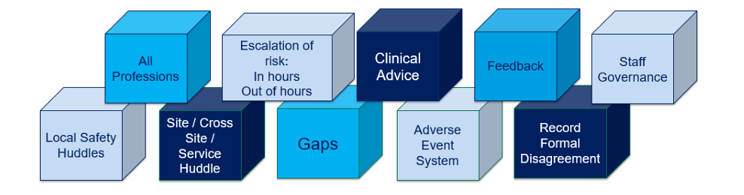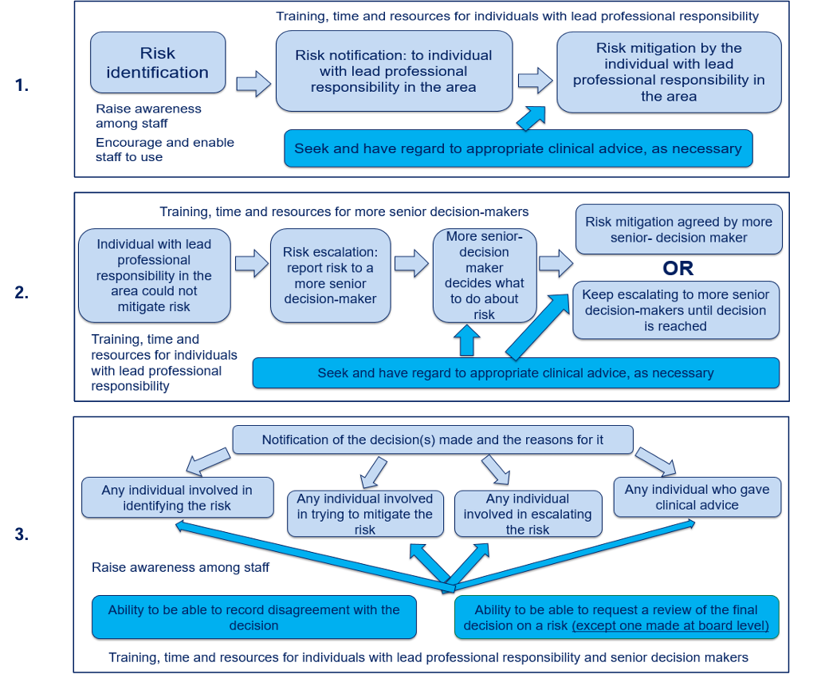

**HIS HSP Diagram**

## **Appendix 4 Assessment**

When assessing actual or potential staffing concerns, the NHSGGC should take account of, but not limit their consideration to, the following factors:

**Workforce:**

* Staffing numbers assessment
* Identify and plan for known roster gaps
* Assessment of skills and experience of staff on duty including capacity and capability of staff to undertake role e.g. restricted duties, mental and physical wellbeing of staff
* Consider appropriate roster management
* Consider the impact of supplementary staffing
* Location of staff on duty e.g. in community geographical spread of visit
* Consider appropriate use of on-call staff in the workplace
* Consider impact of staffing deficits across the MDT e.g. AHP or medical support available in a ward, or support available for clinicians to perform clinical interventions or procedures
* Consider staff regulatory requirements
* Ability to fulfil time to lead requirements (linked to the time to lead SOP).

**Workload and Capacity**

* The number, dependency, acuity and complexity of patient/service users who require care
* Staff workload across sectors, where services are delivered across acute and primary care services e.g. maternity services, or the impact on community nursing or AHP workload to support earlier discharge from hospital
* Any specific clinical issues which increase staffing requirements, including, but not limited to, infection, pandemic, specialist clinical interventions, high level of child protection cases, winter pressures, enhanced observation requirements for service users, number of patients with cognitive impairment, high levels of discharge from acute to primary care settings, high levels of palliative care patients/service users in the community
* Escorting or transfer requirements
* Cross cover arrangements for other clinical areas and sites
* Unplanned staff leave or absence impact
* Supplementary staffing
* The location and spread of the service user group in the community and the impact of this on staff travel time
* Skills deficits

**Environmental concerns**

* Infection control restrictions
* Consider the impact of any equipment / systems failures / availability
* The physical environment e.g. single rooms / temporary wards etc.
* Workplace disruption e.g. planned building works or emergency repairs
* Travel disruption e.g. weather, roadworks
* Consider staff caring responsibilities e.g. impact of school or day centre closures or reduced social care due to adverse weather etc.

**Nationally agreed staffing considerations**

* Business continuity
* High Risk to appropriate staffing in the future
* Missed care or service delivery
* Skill mix
* Staff wellbeing
* Voiced Care concern

## **Appendix 5 National RAGG Classification**

|  |  |
| --- | --- |
| **Red** | Safe and appropriate staffing is compromised. Potential of missed care and /or high risk to service delivery. Cannot assist with shortages and action required. |
| **Amber** | Potential for safe and appropriate staffing to be compromised. Potential of missed care and /or moderate risk to service delivery |
| **Grey** | Safe and appropriate staffing. Are working within recommended parameters and do not need any additional staffing hours. Potential to be able to assist with shortages. |
| **Green** | Safe and appropriate staffing. There are excess staffing hours and the potential to assist with shortages. |

## **Appendix 6 Mitigations**

When mitigating actual or potential risks arising, NHSGGC could consider, but not limit their consideration to, the following factors:

**Immediate (on the day)** including out of hours and weekends:

* Requirement for staff redeployment between clinical areas, considering the need to ensure redeployed staff have the appropriate skills and knowledge in the area they are being moved to
* The use of supplementary bank staffing
* The use of agency staffing
* Any need for reduction in clinical activity (elective activity/planned community visits)
* Any need to transfer clinical activity (emergency admission divert/divert activity to different teams in the community or different acute sites)
* The prioritisation of clinical workload (e.g. prioritising admission avoidance/ supported discharge/palliative care and child protection activity)
* The acceptance of all or part of the risk(s)
* Time to lead suspended to provide support to clinical workload
* Overtime/excess hours
* Training suspended to provide support to clinical workload
* Nonclinical activity suspended to provide support to clinical workload

**Short term** (approximate timescale of 1 week):

* Any known short-term absence beyond immediate
* Any known increased patient/service user dependency
* The need to redeploy staff with appropriate skills and knowledge for a period where risk is known to be sustained for a few days
* Any environmental factors identified during the assessment are thought to be short-term e.g. bad weather or equipment/system failures that can be corrected quickly.

**Medium term** (approximate timescale of 1 month)

* Any medium-term absence
* The need to redeploy staff to meet skills mix deficit
* Any environmental factors
* Roster management to ensure most appropriate rostering in place in a timely manner

**Long term** (more than 1 month):

* Any long-term absence e.g. maternity leave/long term sickness/absence
* The need for a review of staffing establishment to ensure planned staffing is appropriate in the long-term following the section 12IJ duty to follow the common staffing method for those areas where it applies
* The need to plan for long-term solutions to trends in risks identified
* Review service delivery models or patient pathways to reduce risk, e.g. virtual consultation
* Roster management to ensure most appropriate rostering in place in a timely manner

## **Appendix 7 Checklist**

|  |  |  |  |
| --- | --- | --- | --- |
| **No** | **Requirement** | **Yes/No** | **If no what actions are required?** |
| 1. | Are education and training in place at informed level for all roles in the Act? |  |  |
| 2. | Are education and training in place at skilled level for leadership roles? |  |  |
| 3. | Are local education and training in place? |  |  |
| 4. | Is Datix incident reporting process within your SOP? |  |  |
| 5. | Are staffing concerns and voiced care concerns escalation processes in your SOP for in and out of hours? |  |  |
| 6. | Are Staff Wellbeing considerations included in your SOP? |  |  |
| 7. | Are LPs and senior decision makers clearly defined and identifiable in your SOP? |  |  |
| 8. | Are appropriate clinical advice processes included within your local SOP to ensure clarity regarding roles and responsibilities? |  |  |
| 9. | Does your SOP include LPs/senior decision makers notification to the individual who originally escalated the staffing concern? |  |  |
| 10. | Are the factors for assessing actual and potential staffing concerns in your SOP? |  |  |
| 11. | Are the appropriate mitigations included within the SOP? |  |  |
| 12. | Does your SOP set out how staff can record disagreements and formally request a review? |  |  |
| 13. | Are local records held and include the minimum requirements? |  |  |
| 14. | Are LPs recording redeployment (borrowing) on SSTS? |  |  |
| 15. | Are pre team discussion/huddle/staffing meetings in place and recorded? |  |  |
| 16. | Are team discussion/huddle/staffing meetings in place and recorded? |  |  |
| 17. | Are you using Datix reports, SSTS reports and local records to systematically identify, analyse, evaluate and manage RTS severe and recurrent risks consistently and at an appropriate level? |  |  |

# **Useful Resources**

[GGC-Datix - Home (sharepoint.com)](https://scottish.sharepoint.com/sites/GGC-Datix)

[GGC-Scottish Standard Time System (SSTS) - Home (sharepoint.com)](https://scottish.sharepoint.com/sites/GGC-SSTS)

[Healthcare Staffing Programme – Healthcare Improvement Scotland](https://www.healthcareimprovementscotland.scot/improving-care/healthcare-staffing-programme/)

[Health and Care Staffing in Scotland | Turas | Learn (nhs.scot)](https://learn.nes.nhs.scot/61827)

[Health and Care (Staffing) (Scotland) Act 2019: statutory guidance - gov.scot (www.gov.scot)](https://www.gov.scot/publications/health-care-staffing-scotland-act-2019-statutory-guidance/)

[Risk Management - Corporate](https://scottish.sharepoint.com/sites/GGC-Finance/SitePages/Risk-Management.aspx)

[Quick Guides relating to the Act | Turas | Learn (nhs.scot)](https://learn.nes.nhs.scot/74342)

<https://www.nhsggc.scot/downloads/hcssa-rts-risk-escalation-template-with-example-v1-4/>