

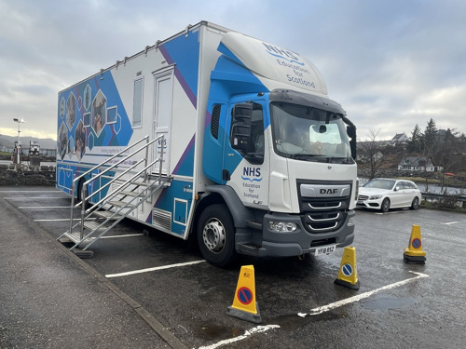

Mobile Skills Unit (MSU)
Participant Handbook

Dates: Monday 19th October – Friday 23rd October 2026
Venues:
- Eastwood Health and Care Centre Glasgow, (G76 7HN) (19th and 20th October )
- Clydebank Health and Care Centre, (G81 1BS) (22nd and 23rd October)

Contents

Welcome | 3
MSU Summary Itinerary | 4
Clinical Sessions | 5
Locations | 11
Useful Resources | 14

Welcome

Dear Participant, thank you for your interest in the MSU. We are looking forward to welcoming you to a session. This handbook is intended to give you an idea of what to expect and how to get the most from your session.
We have worked in partnership with colleagues from Holy Rosary, Golfhill, and Campsie View care homes to bring clinical skills opportunities to care home teams across the Greater Glasgow and Clyde area.
Following consultation with care home staff, we have designed a programme to reflect the most requested clinical skills
- Male catheterisation (Refresher) (RNs only)
- Syringe Pumps (RNs Only)
- A to E Assessment
- Wound care for RNs and Senior Carers

The Mobile Skills Unit (MSU) was developed to support the delivery of clinical skills training and education to all healthcare practitioners, the emergency services and members of the public across Scotland.
The MSU provides a safe learning environment, part-task trainers and state of the art simulation equipment (including SimMan 3G Plus) which allow a broad range of clinical skills education to be delivered.
If you would like to learn more about the Mobile Skills Unit, please see the following link About | Clinical Skills Managed Educational Network

Sometimes it can get a little chilly on the MSU, so please ensure you dress warmly or bring layers!

Please don’t hesitate to contact the Care Home Collaborative if you have any queries about any of the information in this handbook.

Email: ggc.chccontact@nhs.scot Telephone: 0141 427 8254

MSU Summary Itinerary

Monday 19th October
09:00 - 12:30 | CSCI (Syringe Pumps)  RN only (10)
13:15 - 16:15 | Male Catheterisation (8)  RN only
Tuesday 20th October
09:00 - 12:30 | A-E assessment) (8)  RN only
13:15 - 16:15 | Wound Care (10)
Thursday 22nd October
09:00 - 12:30 | A-E assessment) (8)  RN only
13:15 - 16:15 | Male Catheterisation Refresher (8)  RN only
Friday 23rd October
09:00 - 12:30 | Wound Care (10)
13:15 - 16:15 | CSCI (Syringe Pumps)  RN only (10)

Clinical Sessions

A to E assessment
This session focuses on supporting the identification and escalation of a deteriorating resident. Assisting care home staff to undertake assessment and corresponding actions while waiting for help.

This session will include the use of established care home scenarios and simulation using SimMan 3G Plus. The session time is approx. 3 hours.

Audience: This session is suitable for Registered Nurses, with training in basic life support (BLS). This session will not include the teaching of physical observations.

Suggested reading: Adult basic life support Guidelines | Resuscitation Council UK

Learning outcomes:
- Use of deterioration tools
- The importance of knowing the person you care for
- Familiarising you with A to E assessment
- Undertaking timely escalation​
- Confidently using structured communication tools​

Male Urinary Catheterisation Refresher

This session provides an opportunity for registered nurses to refresh their skills on male catheterisation, preparing to undertake the practice supervisor/ assessor role. This session will consider legal concerns, the anatomy and physiology of the urinary system, and the theory of the procedure. Participants will have the opportunity for simulation and to practice their technique. This session will last approximately 3 hours.

Suggested pre-reading: CSMEN national urinary catheterisation learning programme. Access Turas modules here
Audience: This session is suitable for experienced nurses seeking to refresh their catheterisation skills, and prepare to undertake the practice supervisor role for other RNs.

Learning outcomes
- Understand the anatomy and physiology of the male urinary system
- Demonstrate the ability to undertake male catheterisation using an Aseptic Non Touch Technique (ANTT®)
- Explain the infection risks and appropriate preventative measures
- Identify appropriate PPE and equipment for undertaking urinary catheterisation
- Identify potential complications and discuss appropriate actions to prevent or treat these complications
- Describe the procedure for reporting incidents and accidents involving self, resident and others
- Describe the correct documentation for male catheterisation
- Consider the role requirements of a practice supervisor

CSCI (Syringe Pumps)

This interactive session is designed to enhance participants' knowledge and confidence in the safe set-up, operation and ongoing management of the BD BodyGuard T syringe pump. The BD BodyGuard T is the preferred Continuous Subcutaneous Infusion (CSCI) pump used across health and social care services within NHSGGC.

Participants will explore the principles of CSCI pump therapy, indications for its use, and practical aspects of pump management. The session includes hands-on learning opportunities to support safe practice and build confidence in using the device in the care home setting.

Please note that this training forms part of a board-wide quality improvement project aimed at developing a sustainable approach to syringe pump education and development for care home nurses. Your care home may already have a trained facilitator who has delivered this session. If this is the case, please only register if you have not previously attended the training in your care home or would benefit from additional support or refresher education.

This session will be approximately 3 hours long.

Audience: This session is suitable for Registered Nurses working within care homes across the NHSGGC area.

Learning Outcomes
By the end of the session, participants will be able to:
- Explain the rationale for using a Continuous Subcutaneous Infusion (CSCI) syringe pump.
- Describe the advantages and limitations of CSCI therapy.
- Understand the principles and operation of the BD BodyGuard T syringe pump.
- Demonstrate safe and correct set-up of a BD BodyGuard T syringe pump.
- Recognise and respond appropriately to common alarm conditions and hazard warnings.
- Apply basic troubleshooting techniques to support safe pump management.
- Understand local processes for incident reporting and escalation of concerns relating to syringe pump use.

Wound Assessment, Packing and Swabbing: Principles and Practice
This practical and interactive session provides nurses and senior carers (with an already existing competency) with the essential knowledge and skills required for effective wound assessment, wound packing, and wound swabbing. Participants will learn how to assess different types of wounds using recognised frameworks, identify signs of infection, and select appropriate management strategies. The session includes a focus on accurate wound swabbing techniques, as well as hands-on training in wound packing for cavity wounds. Through demonstration and discussion, participants will gain confidence in delivering evidence-based wound care and documenting their findings in line with clinical guidelines

Audience: This program is suitable for RNs and Senior Carers with an existing training and competency in wound care. You should have the support of your care home manager.

Learning outcomes:

- Describe the principles of wound assessment, including identification of wound types.
- Identify signs of wound infection and when to escalate care or seek specialist input.
- Demonstrate correct technique in assessing a wound and performing wound swabbing for microbiological testing.
- Apply appropriate wound packing techniques based on wound type, depth, and clinical indication.
- Document wound findings and interventions accurately in line with local protocols.

Locations

Eastwood Health and Care Centre

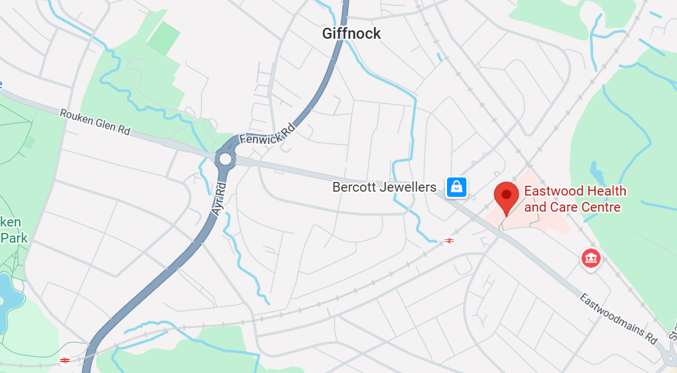

Eastwood Health and Care Centre Glasgow, (G76 7HN)

Car parking
- Car parking is available on site

Using public transport
- Click here

Facilities and refreshments
- Toilets are available within the health centre, participants will be directed from community reception
- Tea and coffee will be available on the MSU
- There is a café on site

Clydebank Health and Care Centre
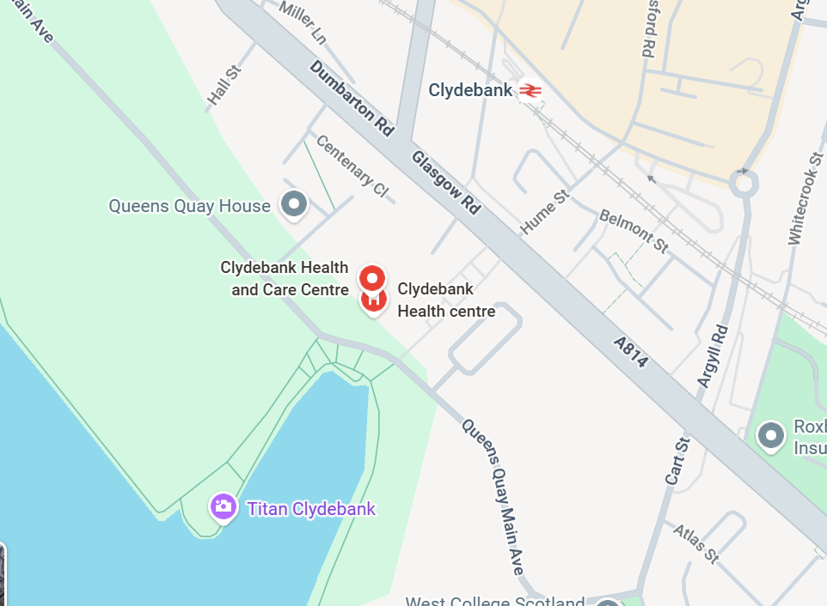

Clydebank Health and Care Centre, (G81 1BS) (26th – 27th March)

Car parking
- Car parking is available on site

Using public transport
- Click here

Facilities and refreshments
- Toilets are available within the health centre, participants will be directed from community reception
- Tea and coffee will be available on the MSU
- If attending for the full day, participants are encouraged to bring lunch

Useful Resources
- Care Home Collaborative Website
- Clinical Skills Management Educational Network (2024) Homepage. Available at: Clinical Skills Managed Educational Network (scot.nhs.uk)
- National Education for Scotland (NES) (2022) Excellence in Care. Available at: Leading Excellence in Care Education and Development Framework | Turas | Learn (nhs.scot)
- National Education for Scotland (NES) (2022) Simulation based education scenarios - decision making. Available at: Developing and maintaining clinical skills in the practice setting
- National Education for Scotland (NES) (2022) Simulation based education toolkit. Available at: Simulation based education toolkit | Turas | Learn (nhs.scot)

