

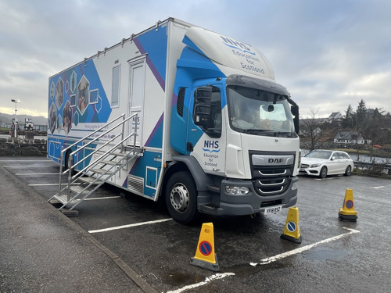

Mobile Skills Unit (MSU)
Participant Handbook

Dates: Monday 20th October – Friday 24th October 2025
Venues:
- LSOP Holy Rosary, Greenock, (PA16 8DP) (20th and 21th October 2025)
- Golfhill Care Home, Glasgow, (G31 2HG) (22nd and 23rd October 2025)
- Campsie View Care Home, Kirkintilloch, (G66 1QY) (24th October 2025)

Contents

Welcome | 3
MSU Summary Itinerary | 4
Clinical Sessions | 6
Additional Sessions | 9
Locations | 11
Useful Resources | 14

Welcome

Dear Participant, thank you for your interest in the MSU. We are looking forward to welcoming you to a session. This handbook is intended to give you an idea of what to expect and how to get the most from your session.
We have worked in partnership with colleagues from Holy Rosary, Golfhill, and Campsie View care homes to bring clinical skills opportunities to care home teams across the Greater Glasgow and Clyde area.
Following consultation with care home staff, we have designed a programme to reflect the most requested clinical skills
- Male catheterisation (Refresher)
- Venepuncture
- A to E Assessment
- Wound care for RNs and Senior Carers

Additionally we are providing the following sessions
- Strength and balance taster session
- Palliative care for carers/ Last Breath
- Wellbeing for staff
- Delirium
- Pressure ulcer prevention and airflow mattress

The Mobile Skills Unit (MSU) was developed to support the delivery of clinical skills training and education to all healthcare practitioners, the emergency services and members of the public across Scotland.
The MSU provides a safe learning environment, part-task trainers and state of the art simulation equipment (including SimMan 3G Plus) which allow a broad range of clinical skills education to be delivered.
If you would like to learn more about the Mobile Skills Unit, please see the following link About | Clinical Skills Managed Educational Network

Sometimes it can get a little chilly on the MSU, so please ensure you dress warmly or bring layers!

Please don’t hesitate to contact the Care Home Collaborative if you have any queries about any of the information in this handbook.

Email: ggc.chccontact@nhs.scot Telephone: 0141 427 8254

MSU Summary Itinerary
Time | Session
Monday 20th October
09:15 – 10:45  11:00 – 12:30 | Venepuncture (7)  (RN and seniors)
13:15 - 16:15 | Male Catheterisation Refresher (7)  (RN only)
Additional sessions | Hall
09:30 - 10:45  11:00 – 12:15 | Delirium (20)
13:00-16:00 | Palliative care for carers (40)
Tuesday 21th October
09:00 :- 12:30 | A-E assessment (8)  (RN only)
13:15 - 16:15 | Wound Assessment/ Packing and Swabbing (8)  (RN and seniors)
Additional session | Hall
09:30 – 10:30  11:00 – 12:00 | Strength and Balance Taster (20)
Wednesday 22nd October
09:00 - 12:30 | A-E assessment (8)  (RN only)
13:15-14:45  15:00-16:30 | Venepuncture (7)  (RN and seniors)
Additional Sessions | Café
09:15 – 12:30 | PUP and  Airflow mattress for carers  (Carers)  (20)
Thursday 23rd October
09:15 - 12:30 | Wound Assessment/ Packing and Swabbing (8)  (RN and seniors)
13:15 - 16:15 | Male catheterisation Refresher (7)  (RN only)
Additional sessions | Café
09:15 - 10:45  11:00 - 12:15 | Delirium (20)
13:30 – 14:30  15:00 – 16:00 | Strength and Balance Taster (20)
Friday 24th October
09:15- 16:15 | CSCI (Syringe Pump) (Closed session)
Additional sessions | Training Room
10:30 - 12:00 | Venepuncture (6)  (RN and seniors)
13:15 - 16:15 | Male Catheterisation Refresher (6)  (RN only)

Clinical Sessions

Venepuncture Competency Programme
This program has been developed to give care home nurses and seniors the opportunity to develop their knowledge, skills and practice in venepuncture. The session time is approx. 1.5 hours.

Numbers for this session are very limited to allow time for practice, therefore participants are required to complete pre-reading prior to registering for the practical session. Please note that spaces are allocated on a first come basis.

The competency programme has 3 components:
- Online workbook and assessment
- Attendance at a practical workshop for the simulation of venepuncture technique
- A period of supervised practice within your care home (usually 2 months) and the completion of the competency booklet

Audience: This program is suitable for RNs and seniors. You should have the support of your care home manager and a practice supervisor/ assessor within your team.

Learning outcomes:
- Describe how to prepare a resident for venepuncture
- Demonstrate the ability to undertake venepuncture competently using an aseptic or non-touch technique
- Explain the infection risks and appropriate preventative measures
- Identify appropriate equipment and PPE for undertaking venepuncture
- Identify potential complications and discuss appropriate actions to prevent or treat these
- Demonstrate the accurate completion of records appropriate to venepuncture

A to E assessment
This session focuses on supporting the identification and escalation of a deteriorating resident. Assisting care home staff to undertake assessment and corresponding actions while waiting for help.

This session will include the use of established care home scenarios and simulation using SimMan 3G Plus. The session time is approx. 3 hours.

Audience: This session is suitable for Registered Nurses, with training in basic life support (BLS). This session will not include the teaching of physical observations.

Suggested reading: Adult basic life support Guidelines | Resuscitation Council UK

Learning outcomes:
- Use of deterioration tools
- The importance of knowing the person you care for
- Familiarising you with A to E assessment
- Undertaking timely escalation​
- Confidently using structured communication tools​

Male Urinary Catheterisation Refresher

This session provides an opportunity for registered nurses to refresh their skills on male catheterisation, preparing to undertake the practice supervisor/ assessor role. This session will consider legal concerns, the anatomy and physiology of the urinary system, and the theory of the procedure. Participants will have the opportunity for simulation and to practice their technique. This session will last approximately 3 hours.

Suggested pre-reading: CSMEN national urinary catheterisation learning programme. Access Turas modules here
Audience: This session is suitable for experienced nurses seeking to refresh their catheterisation skills, and prepare to undertake the practice supervisor role for other RNs.

Learning outcomes
- Understand the anatomy and physiology of the male urinary system
- Demonstrate the ability to undertake male catheterisation using an Aseptic Non Touch Technique (ANTT®)
- Explain the infection risks and appropriate preventative measures
- Identify appropriate PPE and equipment for undertaking urinary catheterisation
- Identify potential complications and discuss appropriate actions to prevent or treat these complications
- Describe the procedure for reporting incidents and accidents involving self, resident and others
- Describe the correct documentation for male catheterisation
- Consider the role requirements of a practice supervisor

Wound Assessment, Packing and Swabbing: Principles and Practice
This practical and interactive session provides nurses and senior carers (with an already existing competency) with the essential knowledge and skills required for effective wound assessment, wound packing, and wound swabbing. Participants will learn how to assess different types of wounds using recognised frameworks, identify signs of infection, and select appropriate management strategies. The session includes a focus on accurate wound swabbing techniques, as well as hands-on training in wound packing for cavity wounds. Through demonstration and discussion, participants will gain confidence in delivering evidence-based wound care and documenting their findings in line with clinical guidelines

Audience: This program is suitable for RNs and Senior Carers with an existing training and competency in wound care. You should have the support of your care home manager.

Learning outcomes:

- Describe the principles of wound assessment, including identification of wound types.
- Identify signs of wound infection and when to escalate care or seek specialist input.
- Demonstrate correct technique in assessing a wound and performing wound swabbing for microbiological testing.
- Apply appropriate wound packing techniques based on wound type, depth, and clinical indication.
- Document wound findings and interventions accurately in line with local protocols.

Additional Sessions

Delirium
This session will explore the recognition, causes, and management of delirium, with a focus on supporting care home residents and improving outcomes through timely intervention. This session take approximately 1.5 hours

Audience: This session is suitable for all care home staff who would like to find out more about how to reduce the risk of your residents developing delirium.

Learning outcomes:
- Build on existing knowledge of delirium
- Identify the causes of delirium
- Understand the different types of delirium
- Consider your role, and how you can reduce delirium risks for residents
- Describe what actions you will take forward if delirium is suspected
- Understand the difference between dementia and delirium

Palliative Care for Carers
This half-day session is designed to give an introduction to palliative care. Increasing participants understanding of what palliative care is and your role in it. This session last approximately 2.5 hours

Audience: This session is has been designed for entry level care staff, but is suitable for all member of the wider care home team, such as housekeepers, admin and maintenance staff. It is worth noting that the content may be particularly emotive for some
Learning Objectives:
- Recognising your role and responsibilities as part of a team in palliative and end of life care.
- Know how you can assist in delivering person centred palliative care.
- Recognise the importance of reflection and self-care.

Pressure Ulcer Prevention and Airflow Mattress Awareness
Pressure ulcer prevention: This session equips you with the knowledge and skills to identify risks early, apply preventive measures, and reduce harm. Improving resident safety, enhancing the quality of care you provide and, and helping you to meet legal and professional standards.
Airflow Mattress Awareness: Supports your understanding of how to use and maintain airflow mattresses effectively to help prevent pressure ulcers. You’ll learn more about correct resident positioning, promoting comfort and safety, and reducing the risks of equipment misuse or failure.
This session will last approximately 3 hours
Audience: This session is suitable for all care staff who would like to find out more about how to reduce the risk of your residents developing pressure ulcers.

Strength and Balance Taster Session
This interactive taster session will explore the importance of physical activity for care home residents, with a particular focus on strength and balance. It will cover why staying active matters, the evidence around strength and balance training, what the programme involves, data and feedback so far.
This session take approximately 1 hours

Audience: This session is suitable for all care home staff who would like to find out more about how to get involved in developing strength and balance within their home.

Locations
LSOP Holy Rosary Care Home

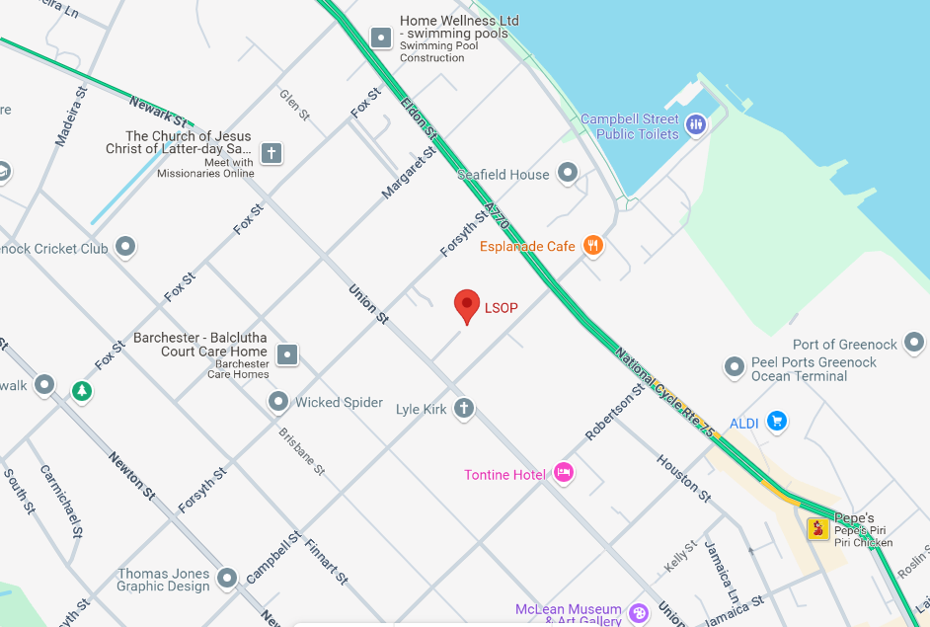

LSOP Holy Rosary, Greenock, (PA16 8DP) (20th and 21th October 2025)

Car parking
- Car parking is available on site/ on road

Train
- Greenock West Station- 10-12 minute walk at a steady pace

Buses
- McGill’s Clyde Flyer – Routes 901 or 906 (run every 15 minutes)
  - Departure from Buchanan Bus Station and arrives at West Stewart Street, Greenock (central bus stop) (70 minutes) and 2 min walk to Holy Rosary

Facilities and refreshments
- Toilets will be available in the Home. Participants will be directed from Reception
- Tea and coffee will be available on the MSU
- If attending for a full day, participants are encouraged to bring lunch

Golfhill Care Home
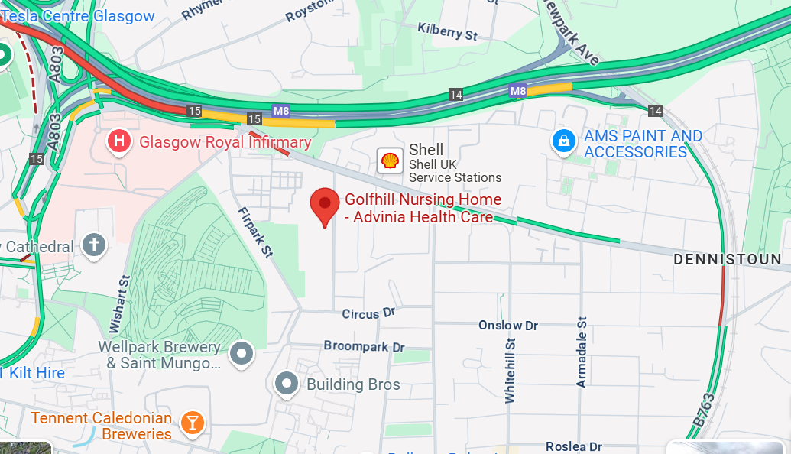

Golfhill Care Home, Glasgow, (G31 2HG) (22nd and 23rd October 2025)

Car parking
- Car parking is available on site/ on road

Train
- Alexander Parade which is a 10 minute walk
- Duke Street station is a 10 minute walk (although this is uphill).

Buses

Local bus services which are within walking distance are the 60, 38, 38a,38b from the city centre.

Facilities and refreshments
- Toilets will be available in Dennistoun Unit
- Tea and coffee will be available on the MSU and in Dennistoun Unit
- If attending for the full day, participants are encouraged to bring lunch

Campsie View Care Home
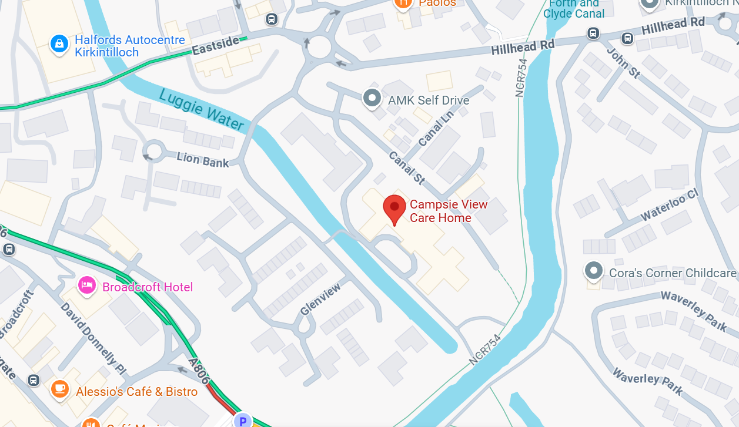

Campsie View Care Home, Kirkintilloch, (G66 1QY) (24th October 2025)

Car parking
- Car parking is available on road

Train
- Lenzie – would take 30 minutes to walk or less than 8 minutes by taxi
- Lenzie Taxis located outside the train station number 0141 775 0100

Buses
- X87 and 89 from Buchanan Bus Station to Ledgate, 4 min walk
- X85 from Buchanan Bus Station to Alexander Street 6 min walk

Facilities and refreshments
- Toilets will be available in Wallace unit.
- Tea and coffee will be available on the MSU
- If attending for the full day, participants are encouraged to bring lunch

Useful Resources
- Care Home Collaborative Website
- Clinical Skills Management Educational Network (2024) Homepage. Available at: Clinical Skills Managed Educational Network (scot.nhs.uk)
- National Education for Scotland (NES) (2022) Excellence in Care. Available at: Leading Excellence in Care Education and Development Framework | Turas | Learn (nhs.scot)
- National Education for Scotland (NES) (2022) Simulation based education scenarios - decision making. Available at: Developing and maintaining clinical skills in the practice setting
- National Education for Scotland (NES) (2022) Simulation based education toolkit. Available at: Simulation based education toolkit | Turas | Learn (nhs.scot)

