Generic Load Moving and Handling Risk Assessment Form
Site / Hospital |  | All maternity units within NHSGGC |  |  |  |  |  |  |  | Reference No. |  |  |  |  |  | MU003
Department |  |  |  |  |  |  |  |  |  | Date of Assessment |  |  |  |  |  | 21/07/2011
Assessor |  | Cameron Raeburn, MHSL |  |  |  |  | Local Manager |  |  |  |  | Senior Charge Midwives
Operation / Activity Being Assessed
Assisting post natal mothers with breastfeeding
Manual Handling Risks Associated With The Activity
List hazards associated with lifting, lowering, pushing, pulling, twisting, carrying and working in an awkward posture. The risks involved may include issues relating to; the Task – carrying long distances, stooping twisting etc or involving equipment – is it maintained, in good working order etc; the Individual – previous / current health problems, pregnancy etc; the Load – heavy, unstable, sharp, hot etc; the Environment – space, flooring, lighting etc; Other Factors including
Assisting a woman with breastfeeding her baby requires the Healthcare Worker (HCW) to visualise the baby’s mouth and the woman’s nipple. Depending on the positioning of both and the surrounding environment this can induce top heavy rotated postures. This activity usually occurs for 5 to 10 minute periods for up to an hour at a time. Depending on the number of women who are breastfeeding that a HCW is looking after, this can account for fifty percent of a HCW’s shift.

Musculoskeletal risks associated with this occur from having to maintain a static posture in top heavy and / or rotated position for extended periods of time. There is a high degree of concentration required; however, the force exerted is negligible. It should be noted that HCW’s with less experience are likely to hold these postures for longer.

A number of common breastfeeding positions can occur, these are identified below in order of highest risk, identified by Rapid Entire Body Assessment (REBA):

1. 2.
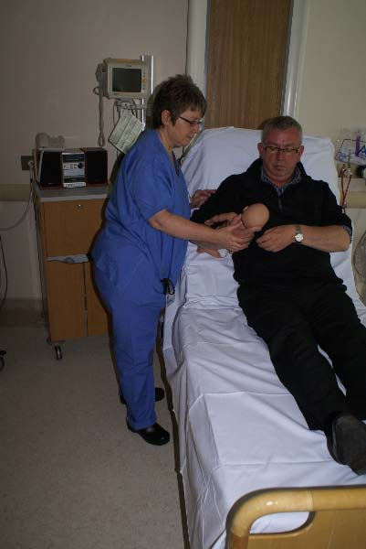
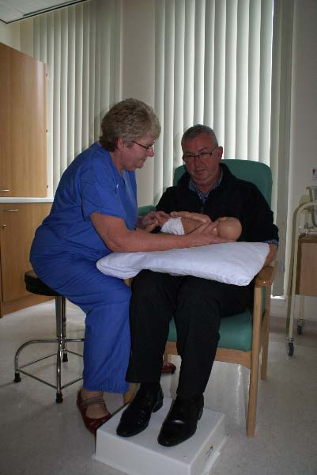
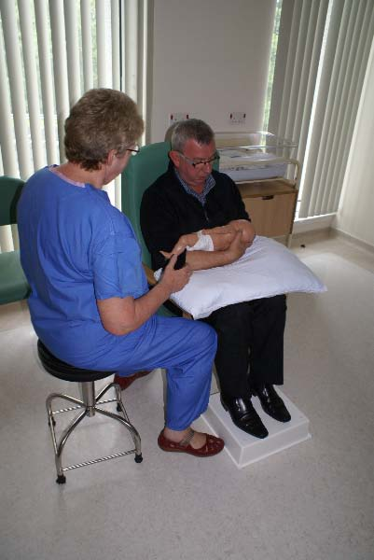
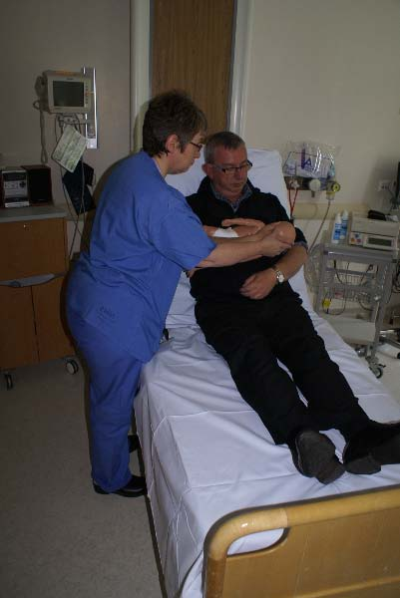
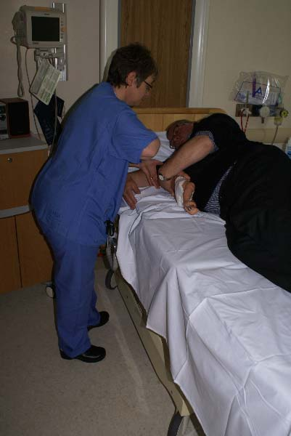
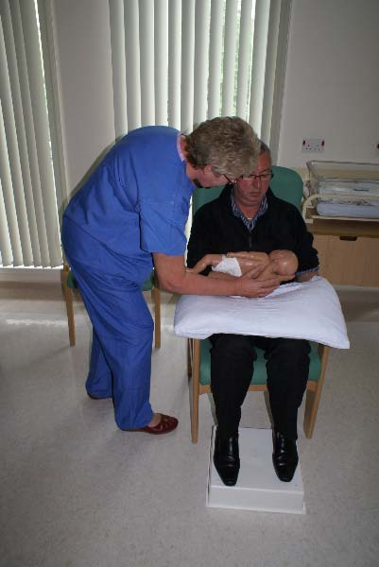
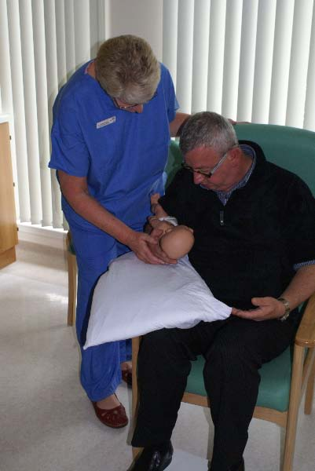
- Woman on chair, baby under arm
- The HCW stands, adopting a highly flexed, rotated posture
- REBA score = 8 / Risk level = High

- Woman on chair, baby across chest.
- The HCW stands, adopting a highly flexed, rotated posture
- REBA score = 8 / Risk level = High
- Woman on side on bed
- The HCW stands, adopting a flexed, rotated posture
- REBA score = 6 / Risk level = Medium
- Woman semi-reclining on bed, baby across chest
- The HCW stands, adopting a flexed posture to reach across
- REBA score = 5 / Risk level = Medium

- Woman on chair, baby across chest
- The HCW sits, adopting a flexed to reach across
- REBA score = 5 / Risk level = Medium
- Woman semi-reclining on bed, baby under arm
- The HCW stands, adopting a slightly flexed posture
- REBA score = 3 / Risk level = Low
- Woman on chair, baby across chest or under arm
- The HCW sits offering no physical assistance
- REBA score = 1 / Risk level = Negligible

3. 4.

5. 6.

7.

Current Control Measures
Only mention those control measure currently in place and not what you intend to put in place. In addition to noting the current control measures, you should identify any problems associated with the measure e.g. a task previously assessed and communicated to staff as requiring 2 people that is still often done by one person
Within some maternity units, current control measures may include:
- When assisting a mother on a bed, adjust bed to appropriate height to reduce stooped postures
- When assisting a mother on a chair, position the HCW’s chair as close to the mother as possible to reduce stooped postures
- HCW’s are advised to support breastfeeding in a hands off way where possible
- Take frequent breaks and stretch to reduce tension

Further Control measures Required
There are a number of breastfeeding positions that require to be taught and supported, these are, under arm and across chest in whilst sitting on a chair and a bed; and whilst side lying on a bed. Each position needs to be taught / supported to encourage rotation of feeding positions and to give breastfeeding the best opportunity for success. Musculoskeletal risks to staff associated with breastfeeding are recognised, and as such, HCW’s must be encouraged and supported in making choices to reduce risks to their own their own health and safety.

All HCW’s to be made aware of risk assessment for breastfeeding and potential effects on own postures and musculoskeletal health. The following are examples of good practices that will reduce risks whilst minimally affecting the client, the following control measures are presented in a control hierarchy, that is, the most significant control measure is presented first;

- High risk activities (Risk 1 & 2) must not be undertaken. The HCW must explore alternatives to standing including kneeling and sitting on an appropriate chair. If kneeling on the floor padding for the knees should be used. Kneeling with one knee on the bed should also be explored.
- Teaching / support sessions should be ‘hands off’ as far as is possible
- Prior to beginning a teaching / support session the HCW should ensure the mother and baby are positioned to allow best access for the HCW, this may include moving the chair to gain side access or asking the mother to move closer to the side of the bed.
- At the earliest opportunity post teaching / support session, HCW are strongly encouraged to take the time to stretch and move appropriately to relieve tension.
Action – SCM to monitor

Risk Level | LOW |  |  |  | MEDIUM |  |  |  | HIGH |  |  |  |  | Very High
Date |  |  | 1/8/11 |  |  | 12/09/12
Signature |  |  | C Raeburn |  |  | C Raeburn
Proposed review date

