**Arjo slings with grey clips**

**Background**

Following information from Arjo, all Arjo slings with grey clips, as per the picture below, should be replaced as they are now significantly beyond their specified life expectancy. That is, the life expectancy of this particular sling design is 2 years from date of manufacture and manufacturing stopped in 2005.

***This does not affect any other slings including Arjo slings with black clips***. Most slings are manufactured without a life expectancy as this can vary significantly depending on a variety of factors including frequency of use; frequency and type of laundering and drying processes; and exposure to light.

**Action required**

1. Remove all Arjo slings with grey clips. Cut the clips off of the sling at the webbing and dispose of through the clinical waste stream. Details for ordering replacement patient specific slings are available [here](https://www.nhsggc.scot/staff-recruitment/hrconnect/safety-health-and-wellbeing/moving-and-handling/).

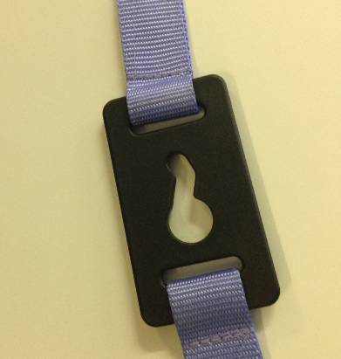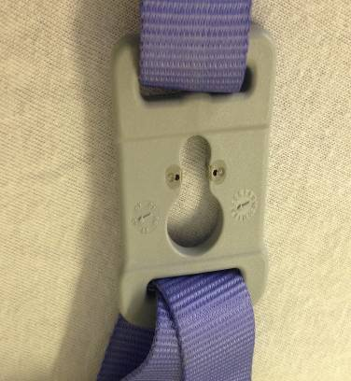

1. Remind all staff who use hoists that all slings should be routinely checked prior to use. Checks should include the fabric, seams and suspension straps. Checks should be made for tears or cuts; frayed edging or stitching; damaged clips; and, washed out or overly worn fabric which could indicated the slings is not safe to use. User guides for hoists and slings are available [here](https://www.nhsggc.scot/staff-recruitment/hrconnect/safety-health-and-wellbeing/moving-and-handling/).