When all other options have been considered, the person should be assisted to the floor using the guidance below:
1a) The Falling person - when already in physical contact
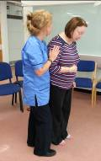
- Do not try to hold the person up / prevent them from falling

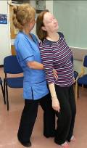

- Move behind the person, sliding your hold round to the persons’ trunk with your hands / forearms pointing down towards the persons’ hips.

NB Avoid taking hold under the persons’ auxilla

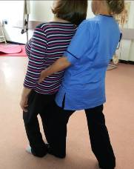

- Take a step back to improve your balance, keeping your forward leg / thigh in contact with the person.

- Guide the person backwards on to you, allowing them to slide down your trunk and forward leg. Step further back if necessary to allow them to reach the floor.

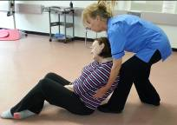
- Guide them completely to the floor and rest them on their side if possible or however is comfortable.

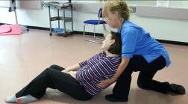
- If able to do so, staff can open kneel during the decent to reduce over bending of their own back.

1b) The falling person – when you are not in physical contact
- If the person is falling away from you onto furniture, for example, an over bed table, you should concentrate on moving the obstacles out of the falling path if possible – do not try to catch the person .
- If the person is falling into traffic, you should try to redirect the fall.

1c) The falling person – on the stairs
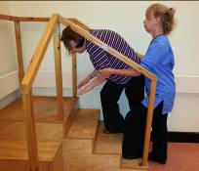
- If falling up the stairs, staff should try to redirect the fall towards the higher steps.
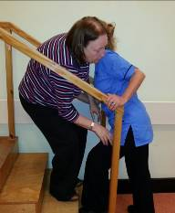

  - If falling down the stairs, staff should be at an angle to the front of the person. Staff may be able to push the person back, using their own bodyweight, onto the higher step

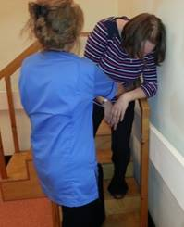

  - Staff may be able to push the person towards the banister or wall and allow them to slide down to sit on the steps.

2) Coming across a fallen person
Check airway, breathing and circulation, if ok, check for injuries including bruising, signs of fracture, pain and / or altered behaviour. Staff may want to call for a medical opinion prior to moving the person.
Check environment for obvious causes of fall. If nothing is found, seek medical advice / assistance.
If person is ‘well’ after the fall, follow the Recovering a patient from the floor guidance.

