Within this guidance document you will find advice on how to reposition a patient in bed using sliding sheets. This guidance provides one way to undertake this activity, other methods are available. For further assistance contact the Moving and Handling Team.

Preparation
- In a ward environment there should be a minimum of two staff to carry out this manoeuvre. Risk assessment should be ongoing considering patient height, shape; medical condition; and, working environments, for example, theatres, diagnostic and recovery areas
- An efficient movement pattern should be applied to the best of the individual’s ability throughout. Guidance to support staff regarding this is available on the MH HR Connect pages (Link)
- Throughout the manoeuvre, one person should take the lead, communicating with the patient and other staff, explaining the process and ensuring all understand what is happening
- The bed area should be cleared to allow space for the transfer to happen without obstruction, for example, bed side lockers and chairs
- To prevent potential top heavy / stooped postures, the bed should be raised to an appropriate height to accommodate the shorter operator
- If the patient is lying on an air mattress, ensure the air mattress ‘max inflate’ function is activated
- Two flat sliding sheets should be used. Check sliding sheets are fit for purpose for example; no loose stitching on handles, signs of wear & tear or loss of slippiness
- Prepare two sliding sheets by placing them together, placing both smooth surfaces together leaving handles exposed on outer side

Inserting the sliding sheets under the patient
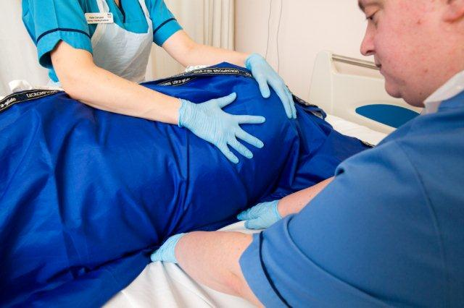
- Facilitate the patient to roll onto their side to insert sliding sheets (for additional guidance click here). The operator on the side the patient has been rolled to, secures the patient on their side. The second operator place’s the sliding sheets on top of the patient’s side (the first operator holds the sliding sheets in place at hips and shoulders), ensuring they come up to the top of the patients head
- The second operator rolls the remaining sliding sheets up to the patient and slides them slightly under the patient’s body. Both operators facilitate the patient to roll/ turn onto their back, so patient is now supine lying on top of the sliding sheets. First operator unrolls and smooth’s out the sliding sheets from underneath the patient
- A third sliding sheet may be required under the patient’s feet / calves to ensure the patient’s entire body is protected
Repositioning the patient with the use of sliding sheets
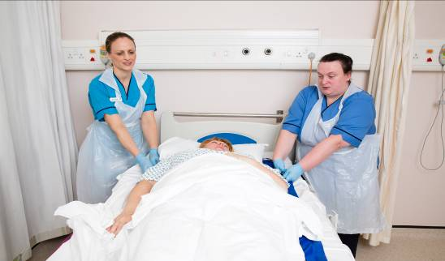
- Both operators should be positioned between the patient’s shoulder and elbow, facing across the bed towards the patients feet
- One operator will lead and take charge of the manoeuvre giving clear concise instructions on when to move and how far to move the patient, for example; moving only a short distance at a time using the commands - relax, head, step
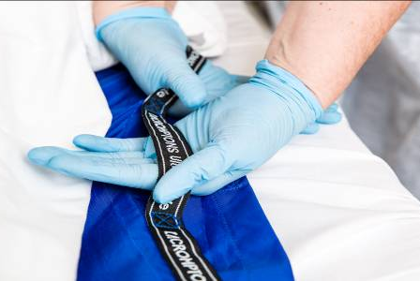
- Efficient movement pattern (link) should be applied, including taking an indirect hold of the handles of the top sliding sheet only; positioning your feet so that your elbows are straightened but relaxed; leading with the head; and then take a small step back with the foot nearest the bed. This step back facilitates a small sliding movement of the patient toward the operator, hence moving patient up the bed
- Ensure the manoeuvre is carried out over a minimum of 2 small moves (30cms or so) dependant on size / girth of patient to reduce effort required to carry out manoeuvre and also to control manoeuvre. Remember the patient should be positioned correctly to allow functions of bed to work fully, this may mean for shorter patients they do not need to be repositioned to the top of the bed
- To assist with the movement up the bed, the knee brake section of the bed can be raised

Removing the sliding sheets
- At the patient’s neck or ankle / knee, one operator folds the corner of the bottom sliding sheet back on itself, passing the bottom sliding sheet under the patient to the other operator, who will slowly slide the sliding sheet from under the patient
- Remove the remaining sliding sheet as above. Should the operator feel resistance around the hips stop removing the sliding sheet. Go to the other end of the patient and repeat the process, removing the sliding sheet in the opposite direction until both sections of the folded sliding sheet are under the hips. Slowly tease the sliding sheet, alternating direction of pulls, until it is removed, being careful to protect the patient’s skin throughout
- If using a third sliding sheet it should be removed by pulling from bottom, protecting patient skin

