Within this guidance document you will find advice on the following activities where a person needs the assistance of one or two people. This guidance provides some of the many options available for each activity; it is not an exclusive list of options. If none of the options are working for you contact the moving and handling department for advice. Clicking on the headings below you will be taken to the guidance for that activity:
- Repositioning in a chair
1a) 1 person assisting to lean forward (1)
1b) 1 person assisting to lean forward (2)
1c) 2 people assisting to lean forwards
1d) 1 person assisting to move back in chair (1)
1e) 1 person assisting to move back in chair (2)
1f) 2 people assisting to move back in chair
1g) Assisting to move forwards in a chair
- Standing up from a chair / bed
2a) 1 person assisting to stand from a chair
2b) 1 person assisting to stand from a bed
2c) 2 people assisting to stand
- Stepping and walking
3a) Minimal assistance
3b) 1 person assisting
3c) 2 people assisting
- Sitting down onto a chair / bed
4a) Minimal assistance
4b) 1 person assisting
4c) 2 people assisting
In each of the above activities you will be undertaking an initial assessment, during which you should consider:
- The depth of assessment. This will depend on your familiarity with the person and the likelihood that the person’s condition may have changed since the last time you saw them.
- That general observation can be part of the assessment e.g. looking for signs of good sitting posture, whether the person is engaging with you during conversation etc.
- The equipment required e.g. walking aid, and seating is appropriate in style and size.
- That in order to stand, the person must have a sufficient degree of strength, balance and the ability to understand and follow instructions and / or prompting. An ‘initial’ assessment (next page) gives an indication of the person’s ability allowing you to make an informed decision as to how many people may be required

Initial Assessment
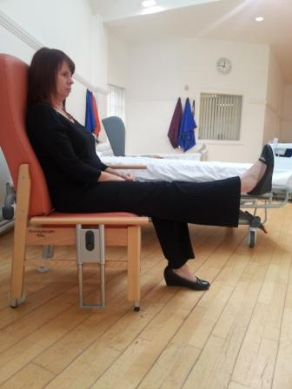

Ask the person to lift their foot off the floor and straighten their knee (one at a time) so that their leg is straight out in front of them. This will inform you of the person’s muscle control and range of movement, for example, someone who is unable to straighten one of their knees is likely to find standing on that leg difficult and/or more tiring and may need more assistance / support I standing.

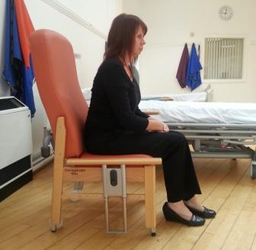

Ask the person to lean forwards in the chair. This will inform you about their sitting balance control and suggest how they may be in standing, for example, someone with less control over their sitting balance is likely to require more assistance / support in standing.

1) Assisting someone to reposition themselves in a chair
General points to consider:
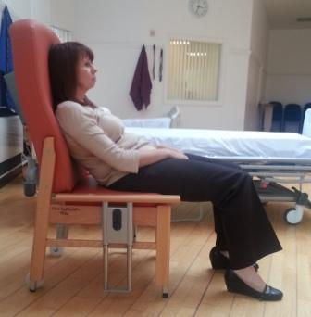
- There should be enough clear space where you are working to ensure that you are able to move efficiently, that is, without twisting or becoming top heavy (stooping)
- Explain the commands to be used, e.g. “when you are ready, sit forwards and I will help you”
- If the person’s bottom has gone beyond the edge of the seat this approach is not suitable and it is likely that you will need to assist the person to the floor in the first instance
- An alternative to manual assistance may be to ask the person to stand and then sit into the back of the chair, or to use a standing aid
(1a) One person assisting someone to lean forward in a chair (possibility 1)
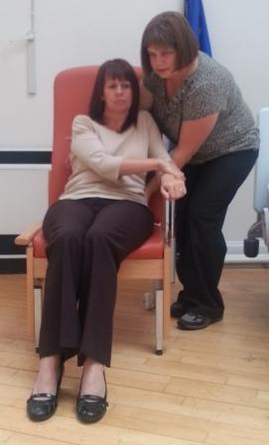
  - On the same side the person is holding onto the arm of the chair, stand slightly behind and to the side of the person, angled slightly towards them. Your feet should be offset with the outside foot having stepped forwards a little
  - Lower your height to allow you to take your hold. Check you are balancing equally through both feet
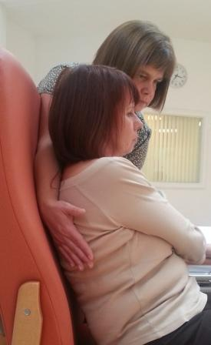

  - Take a short hold low down on the same side of the person’s trunk that you are standing on
  - Take a long hold by going behind the person’s head / neck, with your hand coming to rest on the person’s shoulder blade furthest away from you.
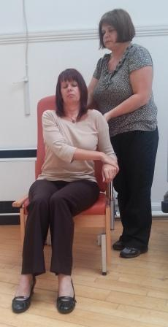
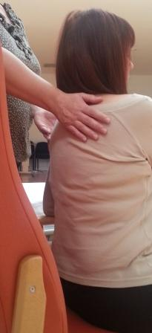

  - When the person starts to sit forward you should lead up with your head and move your feet forward, stepping with the outside foot then the inside foot.
  - As you stand, allow your hands to slide across the person’s back and up their trunk, finishing closer together.
  - Check that you are balanced and not twisted

(1b) One person assisting someone to lean forward in a chair (possibility 2)
This option can be used for to help people where access behind the person’s neck / shoulders is difficult.
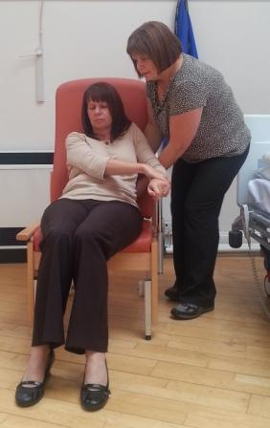
- Ask the person to reach across so that both their hands are holding onto the chair arm on the same side. Ensure their feet are flat on the floor.
- On the same side the person is holding onto the arm of the chair, stand slightly behind and to the side of the person, angled slightly towards them. Your feet should be offset with the outside foot having stepped forwards a little
- Lower your height to allow you to take your hold. Check you are balancing equally through both feet

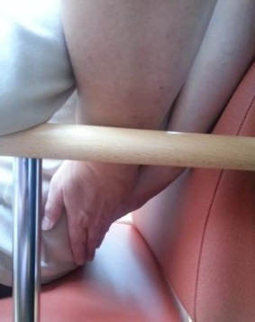
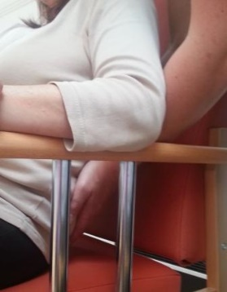
- Take a short hold low down on the same side of the person’s trunk that you are standing on

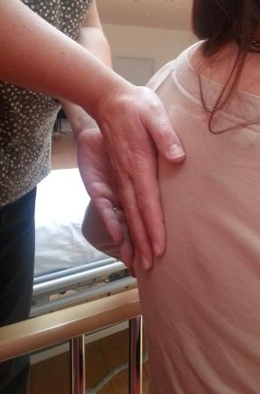
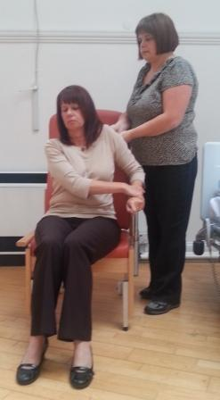
- When the person starts to sit forward you should lead up with your head and move your feet forward, stepping with the outside foot then the inside foot. Allow your hands to slide up the person’s trunk finishing close to their shoulder blade.
- Check that you are balanced and not twisted

(1c) Two people assisting someone to lean forwards in the chair
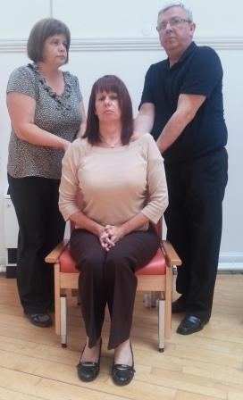
This is the same as that described above in (1b). Two people are likely to be required, for example, when the person requires assistance with balance in sitting

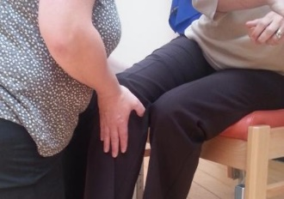
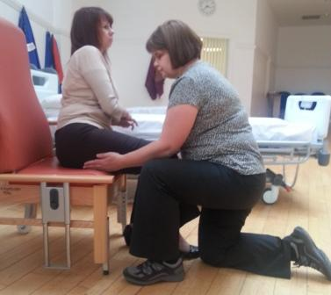
(1d) One person assisting someone to move back in the chair (Possibility 1)
- Kneel on one knee in front of the person with one hand under the person’s thigh and the other on the front of the knee
- Ask the person to lean away from the hip they are going to move

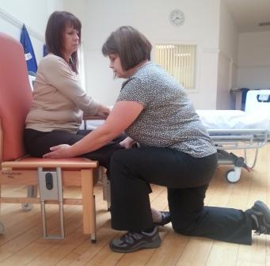
- Ask the person to push up on the arm of the chair, lifting their hip as they do and moving it towards the back of the chair. You can facilitate this as required.
- Repeat this for the other side. This may require a number of movements depending on the person’s size and ability

(1e) One person assisting someone to move back in the chair (Possibility 2)
This can be used if either you cannot kneel on the floor or you cannot apply pressure to the person’s knee.
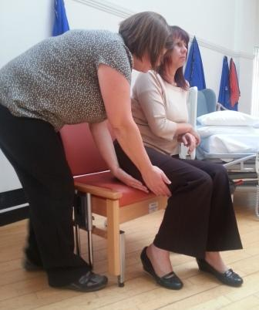
- Stand to the side of the person, angled slightly towards them. Your feet should be offset with the outside foot having stepped forwards a little
- Lower your height to allow you to take your hold. Check you are balancing equally through both feet
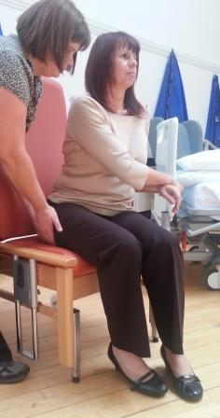
- Ask the person to take a small step backwards with their foot closest to you.

- Place both hands slightly under the person’s thigh
- When the person starts to take the weight off of the hip and move their thigh backwards, allow your hands to slide back along the thigh to facilitate the movement of the thigh back in the chair

(1f) Two people assisting someone to move back in the chair
Two people may be required when the person has difficulties shifting their balance to one side and moving their hip, requiring somebody to assist with balance transfer and another to help move the hip. Moving the person’s hip backwards in the chair can be achieved as previously described (1d & 1e).
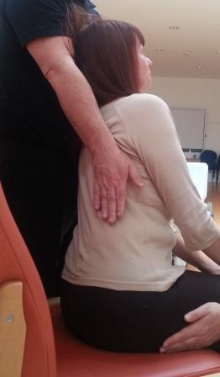
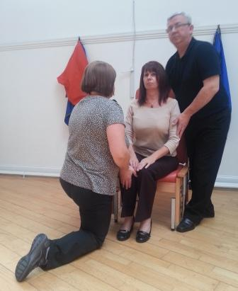
- To assist the person to balance transfer, follow the guidance in 2a. In this case rather than asking the person to stand ask them to come up & over towards you.
- As they start to move, lead up with your head, allowing your long hold to come up, encouraging the person towards you.
- As the person move towards you, the hip can be moved backwards

(1g) Assisting to move someone forwards in a chair
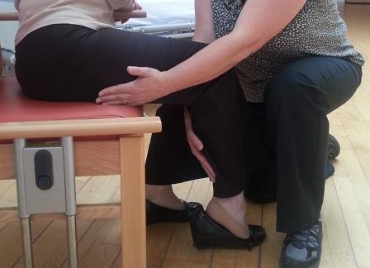
This is similar to assisting the person to move back in the chair. The main difference is the hand positioning to facilitate the movement. Two options are pictured here.

2) Assisting someone to stand up from a chair / bed
(2a) Assisting someone to stand up from a chair
General points to consider:
- There should be enough clear space where you are working to ensure that you are able to move efficiently, that is, without twisting or becoming top heavy (stooping)
- Explain the commands to be used, e.g. “when you are ready, stand up and I will help you”

Working from behind the person
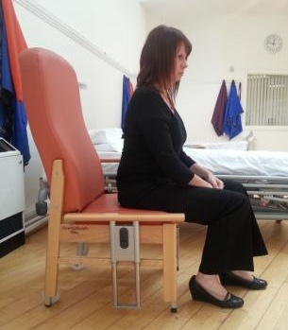
A) The person should be at the front edge of the chair.
Ask the person to place one foot slightly in front of the other

B) Stand slightly behind and to the side of the person, angled slightly towards them. Your feet should be offset with the outside foot having stepped forwards a little

C) Lower your height to allow you to take your hold. Check you are balancing equally through both feet

Working from in front of the person
A) The person should be at the front edge of the chair.
Ask the person to place one foot slightly in front of the other

B) Stand to the front and side of the person, angled slightly towards them. Your feet should be offset with the outside foot having stepped forwards a little

C) Lower your height to allow you to take your hold. Check you are balancing equally through both feet

Working from behind the person (Cont/d)

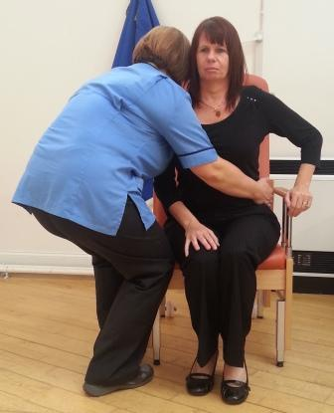
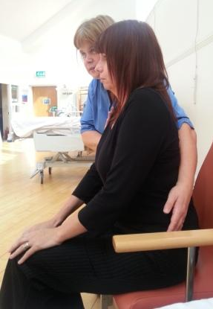
D) Take a long hold by placing your arm nearest the person across the their back towards the opposite hip. Your arm should be in full contact with the person’s back
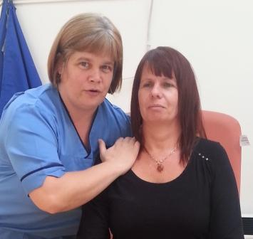
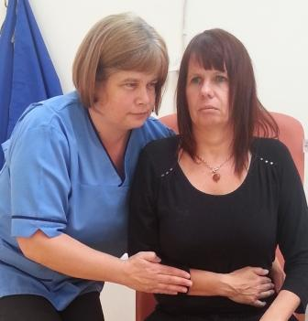
E) Take a short hold. The two most common options are under the collar bone or forearm. The decision of which to use should be based on your own assessment, considering for instance, your height versus the person’s height, any upper limb weakness the person may have and whether or not the person will be using their hands to push up out of the chair.
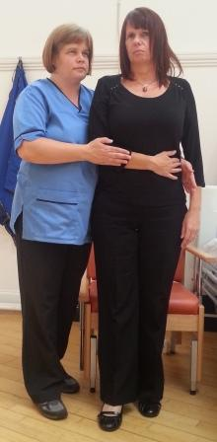
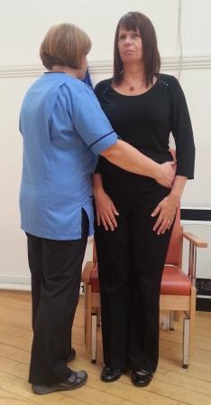
F) When the person starts to stand up you should lead up with your head and move your feet forward, stepping with the outside foot then the inside foot. You should finish close to the person, either beside or slightly behind their hip. Check that you are balanced and not twisted
Working from in front of the person (Cont/d)

D) Take a long hold by placing your arm nearest the person across the front of the person towards the opposite hip. Your arm should be in full contact with the person’s front.

E) Take a short hold. The most common option is under from under the person’s shoulder blade.

F) When the person starts to stand up you should lead up with your head. You should finish close the person. Check that you are balanced and not twisted

(2b) Assisting someone to stand up from a bed / plinth
General points to consider:
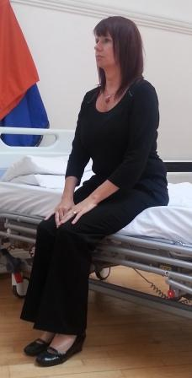
- There should be enough clear space where you are working to ensure that you are able to move efficiently, that is, without twisting or becoming top heavy (stooping)
- Ensure the person’s feet are touching the floor before attempting to stand
- Explain the commands to be used, e.g. “when you are ready, stand up and I will help you”
- It may be appropriate for the bed / plinth to be raised to make the manoeuvre easier

Working from in front of the person
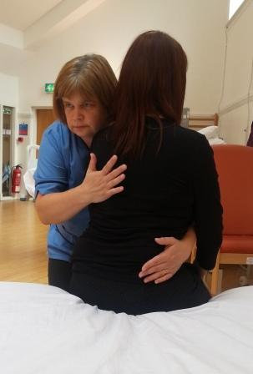
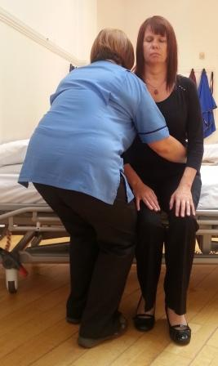
The process of assisting someone to stand from a bed is the same as that for assisting someone to stand from a chair.
However, you will generally approach the person from the front and use a long hold across their front.

Working from behind the person
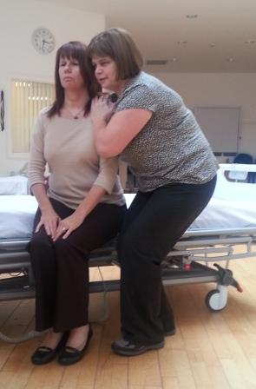
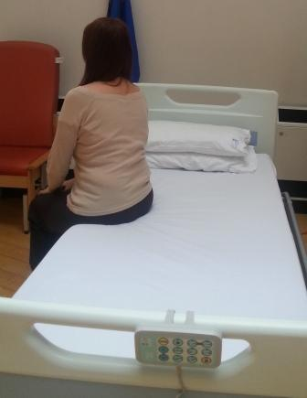
If working from behind the person is the only option, the person can be asked to turn to face the top or bottom of the bed a little.
This will allow you access to one side of the person for a long hold across their back without twisting or compromising your balance.

2c) Working with the assistance of two from a bed or chair
General points to consider:
- Decide prior to the manoeuvre who will be taking the lead
- Generally, the shorter person will take their long hold first with the second person’s arm positioning their arm over the first person’s.
- The short holds can be the same for both or different
i) The assistance of two using a long hold across the person’s back

.

ii) The assistance of two using a long hold across the front of the person
NB This can be useful for reassuring anxious patients who are fearful of falling forwards

iii) The assistance of two using a combination of long holds
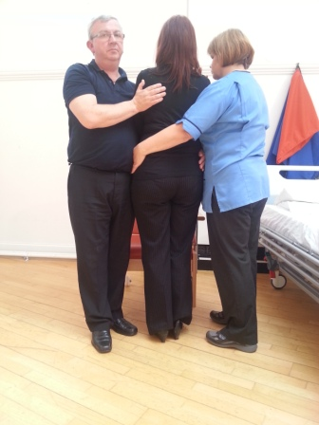
NB This combination can be useful for assisting people in tight spaces

3) Assisting someone to take step and or walk
General points to consider:
- There should be enough clear space where you are working to ensure that you are able to move efficiently, that is, without twisting or becoming top heavy (stooping)
- Explain the commands to be used, e.g. “when you are ready, take a step and I will help you”
- Consider how the person usually walks, for example, with / without a walking aid, the type of walking aid used, short distances with frequent rests
- Consider whether the person’s footwear is appropriate
- Prepare the environment before assisting to mobilise the person, for example, check the floors, move chairs out of the way etc.
- Consider the falls risk of the person and measures you can take to minimise the risks should a fall occur, for example, having someone walking behind the person with a wheelchair
- It may be appropriate to use an alternative piece of equipment, for example a standing aid, transfer device (Rota stand) or transport device (Arjo Stedy).

3a) Walking with minimal assistance

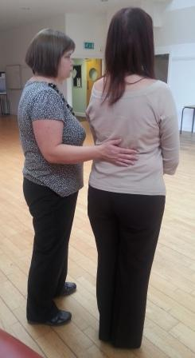
- Stand to the side and slightly behind the person with one hand close to or lightly placed on the person’s lower back
- Provide verbal prompts and / or gentle pressure to direct the person if required
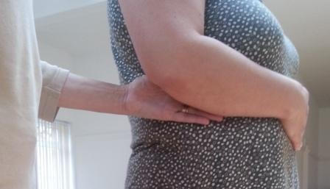
- Generally do not allow the person to hold onto you. Exceptions may be for visually impaired people who require guidance rather than assistance. In this case hold the person’s hand between your elbow and side.

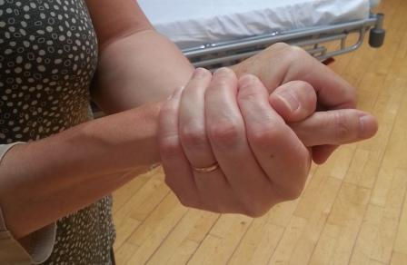
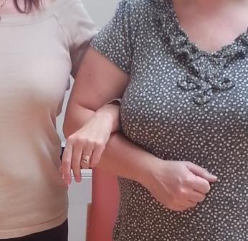
- Holds to avoid include - Thumb to thumb and through arm holds.
Both these holds directly link the person to you and can encourage the person to lean onto you. Additionally these holds can prevent you from helping the person should they begin to feel unwell.

3b) Assistance of 1 to assist someone to step

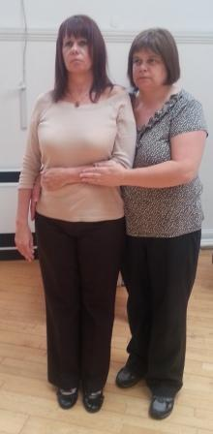
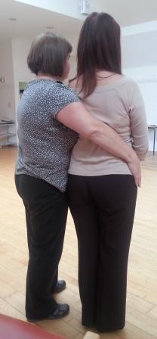
- Stand slightly behind and to the side of the person, angled slightly towards them. Your feet should be offset with the outside foot having stepped forwards a little
- Lower your height to allow you to take your hold. Check you are balancing equally through both feet
- Take a long hold by placing your arm nearest the person across their back towards the opposite hip. Your arm should be in full contact with the person’s back
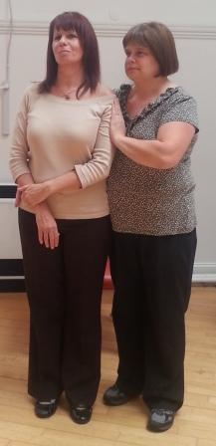
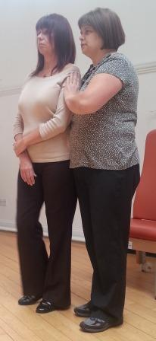
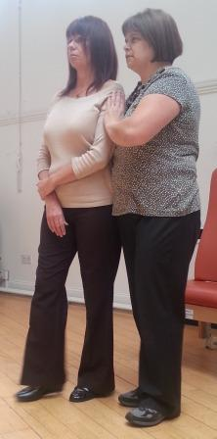
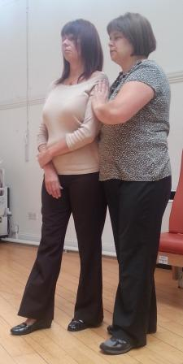
- Take a short hold. The two most common options are on the upper arm or forearm. The decision of which to use should be based on your own assessment, considering for instance, your height versus the person’s height, any upper limb weakness the person may have and whether or not the person will be using a walking aid

- Before being able to take a step, you may need to prompt the person to shift their balance to one side, for example, ‘lean towards me, now step forward’.

3c) Assistance of 2 to assist someone to step
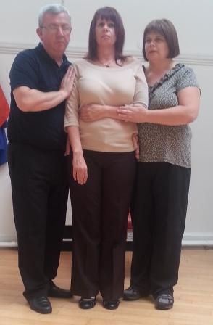
General points to consider:
- Decide prior to the manoeuvre who will be taking the lead
- Generally, the shorter person will take their long hold first with the second person’s arm positioning their arm over the first person’s.
- The short holds can be the same for both or different

4) Assisting someone to sit down onto a chair / bed
General points to consider:
- Consider that the person may not require assistance to sit down even if they needed help to stand up and walk.
- There should be enough clear space where you are working to ensure that you are able to move efficiently, that is, without twisting or becoming top heavy (stooping)
- Explain the commands to be used, e.g. “when you are ready, sit down and I will help you”

4a) Sitting down with minimal assistance
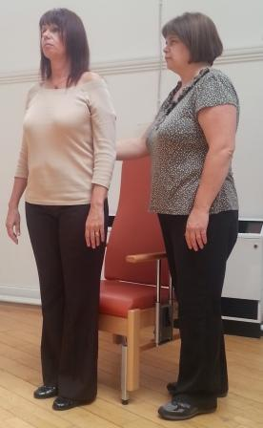
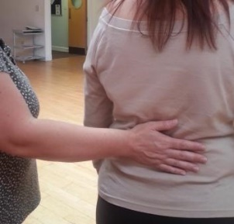
- Stand to the side and slightly behind the person with one hand close to or lightly placed on the person’s lower back
- Ask the patient to feel the chair with the back of their legs and then take a small step forward with one foot
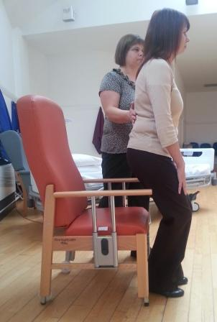
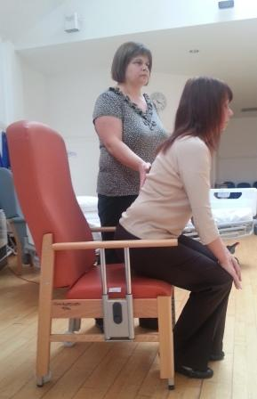
- Provide verbal prompts and / or gentle pressure to direct the person if required
- Consider prompting the person to sit into the back of the chair if they are able or to use the arms of the chair if required
- As the persons sits down you should remain in upright standing

4b) Assisting someone to sit down with 1 person

Working from behind the person

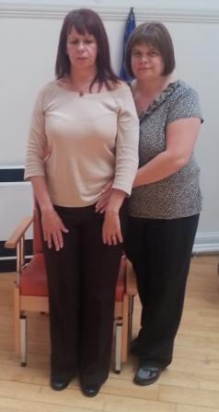
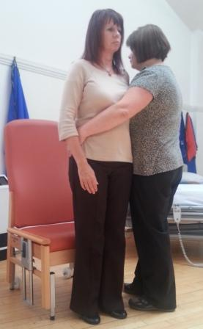
A) Stand to the side and slightly behind the person
B) Take a long hold by placing your arm nearest the person across their back towards the opposite hip. Your arm should be in full contact with the person’s back.

Working from in front of the person
(This approach will is used when there is no access to the side of the person e.g. sitting onto a bed)

A) Stand to the side and slightly in front of the person
B) Take a long hold by placing your arm nearest the person across their front towards the opposite hip. Your arm should be in full contact with the person’s front.

Working from behind the person (cont/d)

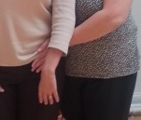
C) Take a short hold on the top of the person’s pelvis. Applying slight pressure here can encouraged the person to bend at the hips

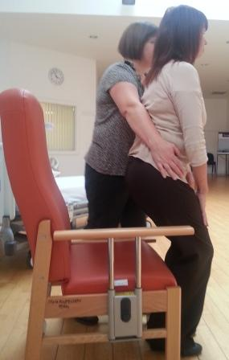
D) When the person starts to sit down, take a step back with your foot closest to the person, closely followed by your other foot.
Use the friction between the person and your arm to control the movement, allowing the person to slide downwards towards the chair
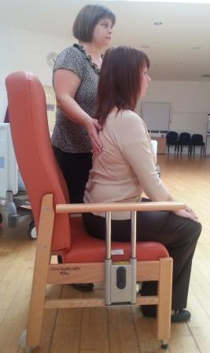
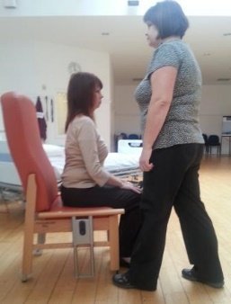

E) You should finish close to upright standing

4c) Assisting someone to sit down with 2 people
General points to consider:
- Decide prior to the manoeuvre who will be taking the lead
- Generally, the shorter person will take their long hold first with the second person’s arm positioning their arm over the first person’s.

Working from behind the person
This is similar as for 1 person assisting
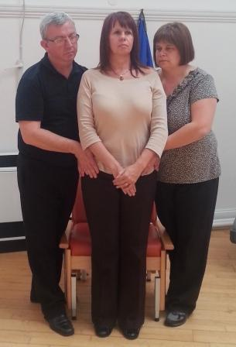
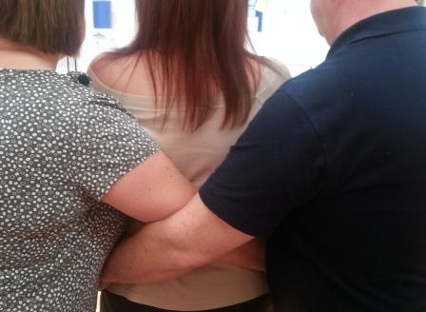
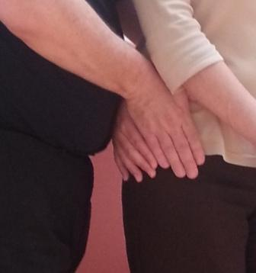

Working from in front of the person (cont/d)

C) Take a short hold on over the person’s shoulder blade. Applying slight pressure here can encouraged the person to bend at the hips
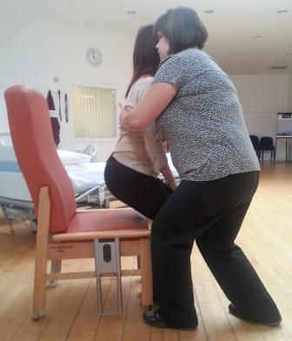
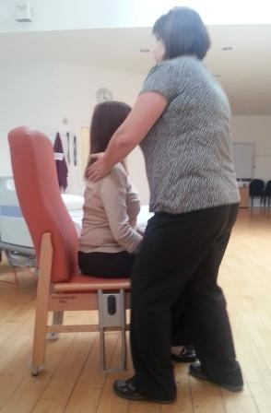

D) When the person starts to sit down, you can chose to step back with your foot closest to the person; or forwards with your foot furthest from the person.
Use the friction between the person and your long and short holds to control the movement, allowing the person to slide downwards towards the chair

E) You should finish close to upright standing

Working from in front of the person

Working from in front of the person
This is similar as for 1 person assisting
