Moving and Handling Midwifery Guidelines
1. Introduction
The aim of this document is to provide midwives with practical advice regarding working postures, whilst maintaining best practice. While research indicates that best practice is to promote alternative positions to the mother during labour, the Royal College of Midwives refers to these types of delivery positions as being significantly hazardous for midwives in terms of exposure to musculoskeletal strain and injury (RCM, 1999). Figures released by the RCM (1999) suggest studies looking at musculoskeletal injury in midwives estimate approximately 6000 midwives suffer from back injury annually, with 300 having to leave the profession.
Hignett (1996) highlighted the main areas of manual handling risk as being
- Position and posture at delivery
- Assisting with breast feeding
- Working environments, especially during home births

2. Specific Issues Relating To Manual Handling
This section will outline some common positions encountered whilst working as a midwife. When improvisations are required, refer to these as examples of good practice. Although posture will vary, try to adhere to the following;
- Make best use of any equipment available
- Change position regularly
- Apply the principles of efficient movement
- Get in close, in balance
- Lower your height and take an indirect hold
- Relax and lead up with your head

2a. Working at Low Levels
Assisting the mother in labour can often require working at low levels. Lowering your height through efficient movement is possible for very short periods. More prolonged activities will require a different method, as prolonged flexion of the back, even in balance, is detrimental to the back. Working at floor level can make movement and adoption of safe postures difficult for both midwife and labouring mother.
Avoid floor level working if:
- There is a history of musculoskeletal injury.
- Pain or discomfort is experienced
- Mother or midwife is unable to get up from the floor independently.
- There is no obvious benefit to the mother/baby

2b. Equipment Options

The pictures below show some of the equipment options that can be used to facilitate low level working.
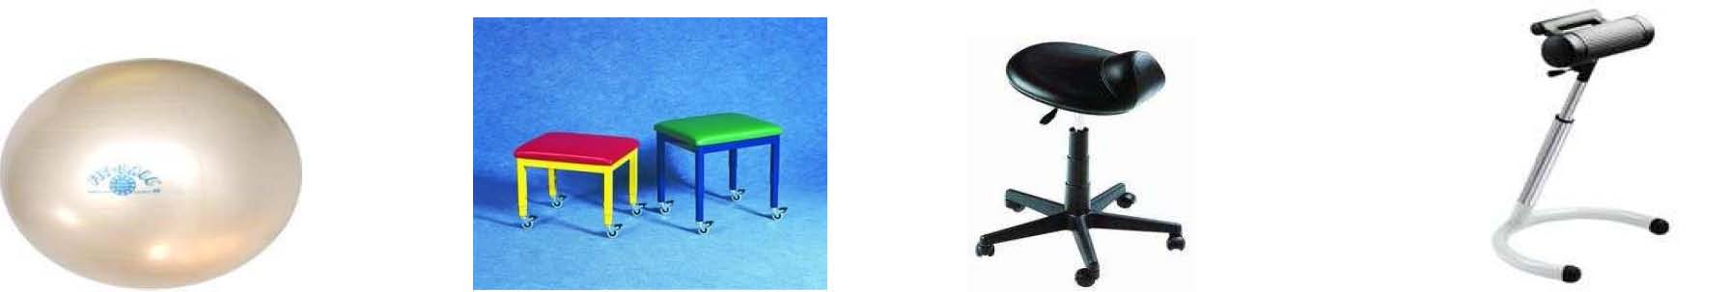

Therapy Ball Therapy Stool Saddle stool Perch stool

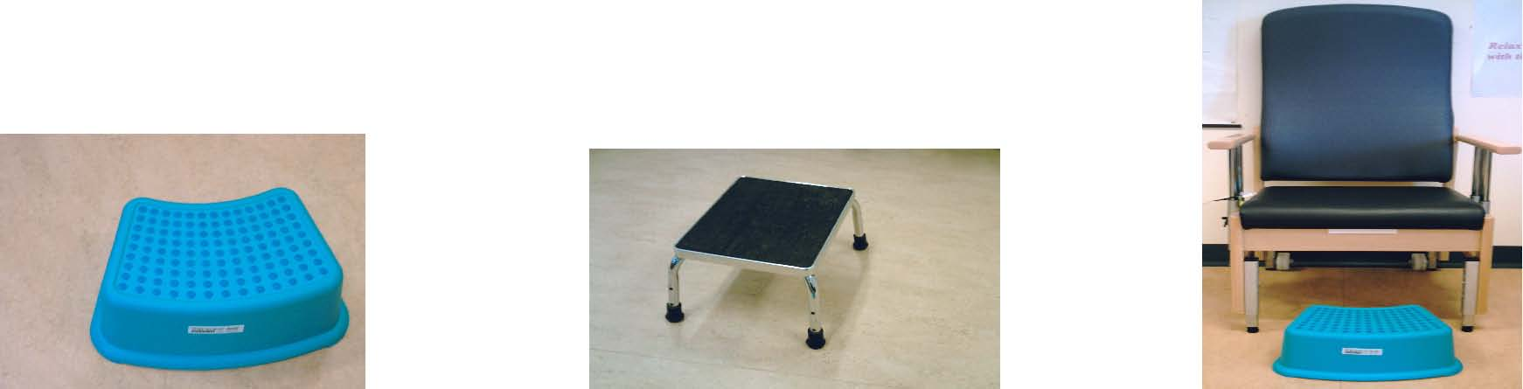
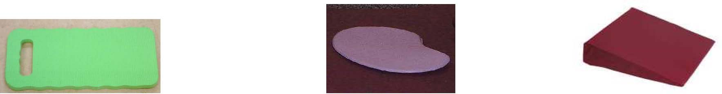
Kneel pad Kneel mat Wedge Cushion

Footstool Couch Step Height-Adjustable Chair

Multimover glidesheet Bed pull

2c. Kneeling

There are a number of kneeling positions that can be used to enable a midwife to work at lower levels with reduced strain. Any one of the kneeling options shown would need regular changes in position, to prevent build up of pressure and strain on joints, ligaments and muscles.

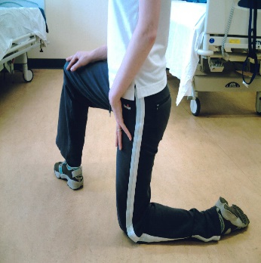
- Open kneeling (half kneeling)

- Spine is maintaining neutral position.
- Body weight is evenly distributed.
- Alternating between left to right knee further reduces loading of the weight bearing knee

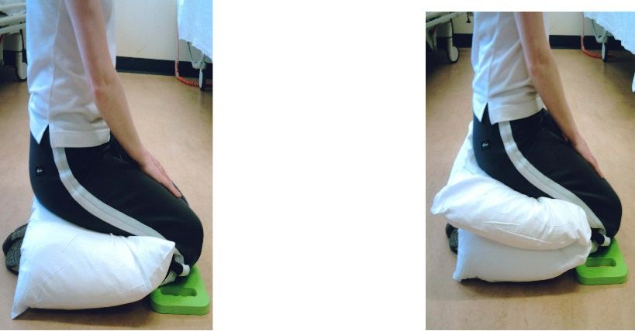
- Low kneeling with 1 pillow and knee pad
- Low kneeling with 2 pillows and kneel pad

- Kneeling with pillow(s)

N.B. Avoid any of these positions if you find them painful.

2d. Hospital births
Beds
- The Huntleigh Birthright delivery bed has a safe working load of 180kgs (28 stones), and the Hillrom Affinity 4 birthing bed has a SWL of 227kg. Certain features of the bed allow the more traditional birthing positions during labour to be adopted.
- The bed is electrically operated and has one available handset, which allows the height and backrest to be adjusted as required.
- The adjustability of the bed can encourage the midwife to adopt a safer working posture. There are a number of accessories including limb, foot and hand supports, which allows the mother to position herself during labour.

Risk Assessment for Hospital Births
Applying the principles of Ergonomics to the working environment can reduce the manual handling issues faced by midwives carrying out their duty of care to mother and baby. It is advised that midwives follow a risk assessment process. The Generic factors to be considered are:

1. Environment Considerations
Space
- Adequate space for mother, the handlers and equipment set-up?
- Has unnecessary equipment and clutter been removed to maximise the space available?

Access
- Are door widths and mechanisms acceptable?
- Is there adequate hoist access?

Flooring
- Are there any uneven floors, slopes or slip hazards?
Ventilation / Temperature Control
- Is the temperature level comfortable, can it be adjusted?
- Can windows be opened or are electric fans available if required?

2. Patient Factors
Mother’s risk level
- Is it her first baby?
- Previous difficult pregnancies?
- Past medical history

Weight
- Is there an accurate weight of the mother?
- If mother is considered very heavy or bariatric please refer to the Bariatric Guidelines and inform the Manual Handling Dept.

Size / Shape
- Consider the mother’s weight distribution, as this will have an impact on handling tasks and equipment selection.
Mobility / Capability
- Is the mother fully mobile?
- What level of handling assistance is required?
- Is there handling equipment available?

3. Equipment
Requirement
- First establish what equipment/furniture is required.
- Establish Safe Working Load of available equipment?
- Are there any concerns regarding the shape and weight distribution of the mother in relation to the equipment selected?

Availability
- Can equipment be borrowed from another department if required?
- Is it necessary to hire/purchase equipment? (Please refer to appendix.)

4. Staffing and Organisational Factors furniture considerations

Staff availability / individual capability
- Based on the risk assessment, are there enough staff members available?
- Consider different times of day e.g. night shift. It may be necessary to request an increase in staffing levels. All staff shortages should be reported and documented.
- Consider individual capabilities/training experience/training of handlers.
- Consider staff availability in other areas if transferring patient for treatment.
- Is it possible to rotate staff and ensure adequate rest breaks?

Preparation
- Consider planned admissions i.e. known due dates. Is there any planning regarding staff and equipment?

2e. Home Births
Risk assessment for home births
Applying ergonomic principles can reduce the manual handling issues faced by midwives carrying out their duty of care to mother and baby. It is advised that midwives follow a thorough home birth risk assessment to identify any specific manual handling issues.
Please refer to the generic factors to be considered in the risk assessment section for the hospital setting.
Additional specific factors to consider:
- External factors, for example, access to home / car parking facilities
- Lone Working Policy
- Is equipment being delivered to the home or transported by the midwife
- Flooring, for example, carpeting / laminate / vinyl
- Suitable home equipment / furniture / pillows, cushions / type of bed etc

Monitoring and assisting mother, for example, adequate planning and instruction regarding birthing positions. Due to the fixed height and position, it is necessary for the midwife and the mother to communicate the importance of appropriate positioning on the bed. It is recommended that the midwife positions herself in front of the mother, in close as possible, therefore avoiding unnecessary twisting and over reaching. Ideally the mother should be positioned at the side or end of the bed to allow the midwife maximum access without compromising her posture. If the midwife is required to work at floor level, it is recommended that equipment is used.

2f. Post delivery care
Hospital Birth - Suturing
- Midwife is positioned directly in front of the mother with no unnecessary bending and twisting of the spine.
- Midwife has the option of standing or sitting (see equipment options).
- Midwife should adopt an offset / mobile base. Regular changes in position whether sitting or standing.

Points to consider - Adequate lighting / unrestricted access / is the position comfortable for midwife and mother?

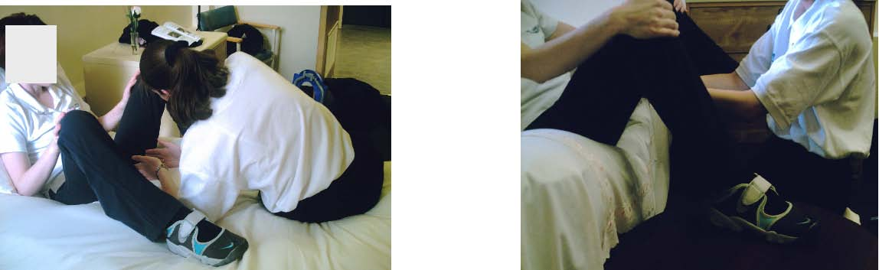
Homebirth – suturing

The picture on the left identifies poor practice, where the midwife is working in a position which causes bending and twisting of the spine. Increased pressure and strain through joints, ligaments and muscles is required to maintain the position.

The picture on the right indicates good practice, with the mother sitting at the edge of bed in a semi-recumbent position, supported behind by pillows/cushions. Legs apart with feet supported on stable furniture. The midwife can be positioned between the mothers legs either kneeling or sitting, using available equipment.

Points to consider - Adequate lighting / unrestricted access / is the position comfortable for midwife and mother?

Bathing baby
Points to consider:
- Fixed height work surface
- Getting in close at angle may require moving the baby closer to the side of the bassinette to reduce overreaching and twisting to gain access.
- If standing ensure handler has an offset and mobile base, consider the use of a perch stool (see equipment section).

NB Filling and emptying the bath can have handling implications. Avoid lifting a bath that is full of water; alternatively decant water using a container.

Bottle Feeding
Points to consider:
- Handler is comfortable and in a supported sitting position.
- Feet supported on footstool.
- Baby is supported by cushions/ pillows

2g. Birthing pools
Attending a water birth can have implications for handling and maintaining safer postures. Please refer to the generic factors to be considered in the risk assessment section for the hospital setting.
Specific factors to consider for the hospital births:
- Has a risk assessment document been completed, establishing suitability of mother for using a birthing pool? What are the potential hazards/risks?
- Repetitive tasks/sustained postures, e.g. access for monitoring baby’s / mother’s vital signs.
- Design of birthing pool – shape, size, depth, access, handrails, steps, etc.
- What is the birthing pool evacuation procedure? Are staff trained and updated regularly.
- Is there a checklist of equipment to be used in an emergency evacuation, including hoists or pool netting? All equipment should be stored in an area for all staff to access.
- Consider the immediate working environment; is the birthing pool design appropriate?  

3. Summary
The information presented here is not exhaustive and should not be utilised in isolation, please refer to relevant risk assessment documentation and moving and handling handouts. This document has highlighted the importance of applying the process of ergonomic risk assessment as well as the adoption of safer working postures. The individuals involved in developing this document, recognise the need to avoid prescriptive handling techniques and that each situation requires an individual assessment and professional judgement.

4. References / Bibliography
HSE (2004). Manual Handling Operations Regulations 1992, Guidance on Regulations, HMSO.
Royal College of Midwives, (1999) Handle with Care, 2nd Ed. A Midwife’s Guide to Preventing Back Injury, RCM, London.
Midwifery Handbook (2007). 2nd Ed, Northumbria Healthcare, NHS Trust
“Backs Matter” (2006), Guidance Notes for Midwives Assisting with Births in the Home Environment, Maidstone and Tunbridge Wells, NHS Trust.
Hignett S (1996), Manual Handling Risks in Midwifery: Identification of Risk Factors, British Journal of Midwifery, Vol 4 No 11, November 1996

