Within this guidance document you will find advice on how to assist or recover a person who is on the floor. This guidance provides some of the many options available for each activity; it is not an exclusive list of options. For further assistance contact the Moving and Handling Team.
Clicking on the headings below will take you to the guidance for that activity:
- Assisting a person to recover from the floor
1a) To sitting on a chair to the side
1b) To standing up
1c) To sitting on a chair behind
- Recovering a person from the floor using a hoist
In each of the above activities you will be undertaking an assessment, during which you should consider:
- The depth of assessment. This will depend on your familiarity with the person and the likelihood that the person’s condition may have changed since the last time you saw them.
- That general observation are part of the assessment e.g. looking for signs of injury as a result of a fall, for example, head injury, hip fracture or spinal injury. If a hip fracture or spinal injury is suspected arrangements must be made to ‘straight lift’ the person from the floor:
- In a main acute hospital setting, the flat lifting kit (Hoverjack & Hovermatt) must be utilised. Currently one Mental Health in patient service (Leverndale Hospital) can also access this equipment on site. In other environments a 2222 call will be required.
- Use the passive hoist as carefully and as safely as possible, keeping the person in as reclined a position as possible and transfer onto their bed.
- If the fall occurs in a confined space, slide the person into a more spacious area, preferably with use of a sliding sheet.
- In order to recover from the floor with minimal assistance, the person must have a sufficient degree of strength, balance and the ability to understand and follow instructions and / or prompting. An ‘initial’ assessment (next page) gives an indication of the person’s ability allowing you to make an informed decision as to whether a hoist should be used, for example:
  - Ask the person to bend up their legs one at a time. This will inform you of the person’s muscle control and range of movement, for example, someone who is unable to bend one of their knees is unlikely to be able to kneel on that leg and therefore will require a hoist.

1) Assisting a person to recover from the floor.
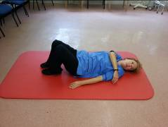
If you find you are having to provide more than minimal assistance, you will probably require a hoist.
- Prepare the area for the task, bring a chair near and ensure privacy for the person.
- Ask the person to bend their knees and cross one arm over their chest.
- Move other arm away from the body (rolling space).
- Ask person to turn head in the direction of the roll.
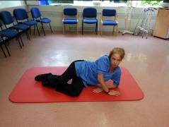
- Ask the person to roll onto their side by letting their knees drop to the side.

- Ask the person to push up on their (free) flat hand and their forearm that is resting on the floor, until they are half sitting.
- Allow person to stay here for a few seconds (assessing dizziness), until ready for next stage.

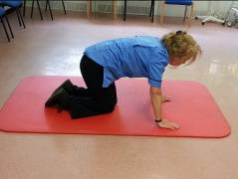
- Ask person to roll round onto all fours. They may need some assistance at this point to bring their hips round.

Option 1a - This is the most common approach when recovering a person after a fall
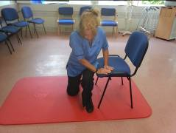
- Bring chair to side of the person
- Ask person to lean the nearest hand onto the chair.
- Ask person to bring nearest leg forward and place the foot flat on the floor.
- With a slight push from the person the bottom can be slid to the side onto the chair.

Option 1B – This is used when teaching the person how to recover themselves
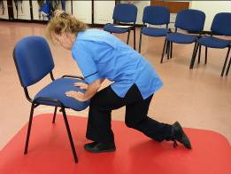
- Bring the chair to the front of the person
- Ask person to lean hands onto the chair.
- Ask person to bring one leg forward and place the foot flat on the floor.
- Ask person to push up with leg and hands until they are standing.

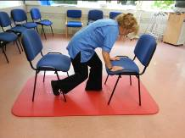
Option 1C – This is used when the person cannot turn round to sit on the chair or stand up fully
- Progress as per Option 2 and as the person brings themselves into crouched standing, position another chair at their bottom so that the person can sit directly down without turning.

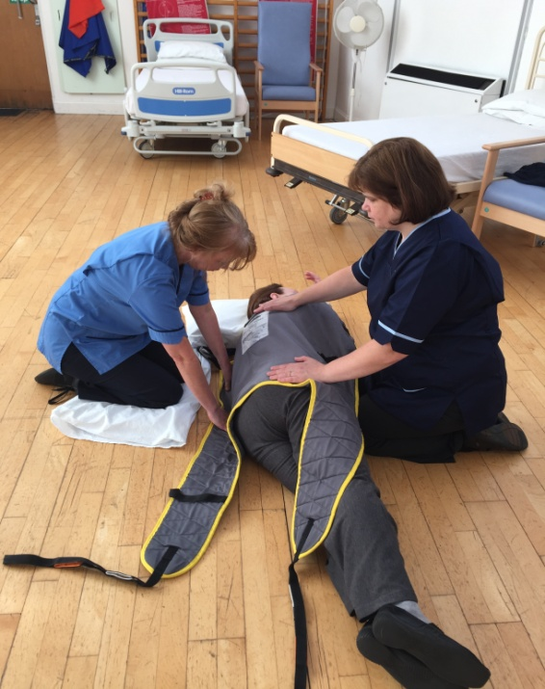
2) Recovering a person from the floor with a hoist (minimum of two staff involved)
- Assist person to bring arm across chest.
- Assist person to bend up their legs
- Ask person to look in the direction of the roll and roll the person towards you on to their side / your knees.
- Fit the sling at one side of the body, easing the bottom edge of the sling under the persons side and roll onto their back.
- Check the sling is fitting correctly (equal material left / right and reaching from tail bone to top of shoulders (or head if sling has head support). If not, you will need to roll the person again to adjust the sling.
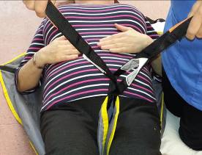
- If using a general purpose sling with leg straps (as in the picture), bring the straps between the persons’ legs (if looped sling, feed one leg strap through the other as in the picture)
- Bring over profiled bed or chair to where the person is being transferred to.
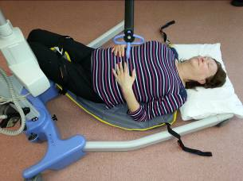

- Bring in the hoist, at an angle to the patient, one hoist leg under the thighs and the other hoist leg along side the head and body of the patient.

- Attach the loops of the sling onto the hoist, the loops chosen will be the ones that can be applied without pulling the patient from the floor.
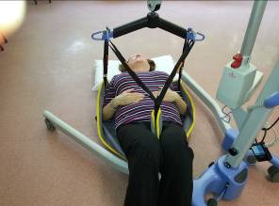
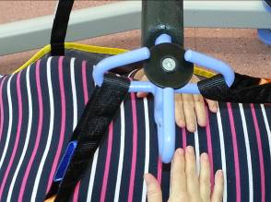

- Raise the patient from the floor, supporting the persons head, if moving onto a bed, place a sliding sheet at the heals to prevent shearing when being lowered into bed.
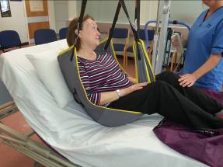
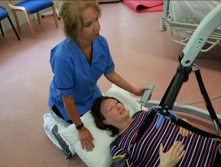

- When lowered into bed or chair, if required, reposition the loops of the sling to raise patient again and adjust lying / seating.

Alternative additional equipment may be available in your area, please apply guidance, local protocols and assessment recommendations to the activity.

