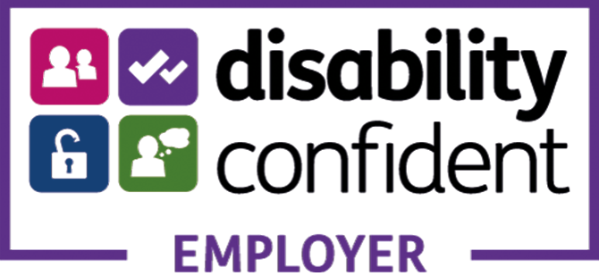

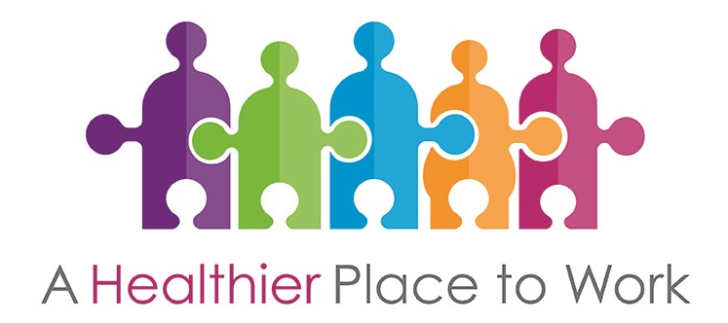

Version | Mental Health and Stress Awareness - Delegate Workbook V9
Last Updated | May 2023
Review Date | May 2024

Introduction
Welcome to the Mental Health and Stress Awareness session for managers.
This booklet includes the course content for all group work at the session.
We’ve also included an action plan template for you to begin planning improvements when you are back in your department.
During the session, we want to you to be involved as much as possible.
All of the team will be happy to answer your questions as fully as we can.
However, we do ask that you respect confidentiality and do not share personal information about employees when discussing examples.
Thank you for coming along today and we hope you enjoy the session.

Defining ‘Mental Health’
Individual/group exercise. Take a few minutes to think about the terms ‘physical health’ and ‘mental health’ and what it means to you.
Use the boxes below to note down words or phrases that come to mind when you think about these terms and write them in the space below. Try to write a definition of the terms too.
Describe/define what we mean by
Mental Health?
Describe/define what we mean by
Physical Health?

There is no right or wrong answer to the question – the important thing for us to remember is that ‘mental health’ can be positive or negative.

When we think about the term physical health and what it means, there is a tendency to use more positive words than those used to describe mental health.

‘Mental health influences how we think and feel about ourselves and others and how we interpret events. It affects our capacity to learn, to communicate and to form, sustain and end relationships. It also influences our ability to cope with change, transition and life events: having a baby, moving house, experiencing bereavement’.

(Friedli) source – Mentally Healthy Workplaces, Healthy Working Lives

There is much debate about terminology in relation to mental health with terms such
as mental illness, mental health problems and mental health conditions being used interchangeably.

Research suggests that mental health consists of two dimensions:

- Mental health problems (mental illness) which includes, for example, depression and anxiety; and,

- Positive mental health (mental wellbeing) which includes, for example, life satisfaction, positive relationships with others and purpose in life.

Mental Health | Mental Health Problems | Mental Wellbeing
It can also be used as an umbrella term to refer to both the concepts of mental health problems and mental wellbeing. | A term that refers to symptoms that meet the criteria for clinical diagnosis of mental health problems.  Examples include depression and anxiety and schizophrenia. | A term that includes life satisfaction and psychological wellbeing.  This covers a range of things such as sense of control, having a purpose in life, a sense of belonging and positive relationships with others.

The extent of mental health problems
- Each year 1 in 4 people experience a mental health problem
- Over half a million people off work as a result of work-related stress, anxiety and depression
- Average of 24 working days lost per case
- Annual cost of £26 billion pa (Sainsbury Centre for Mental Health)
- Public sector most affected (including nursing & midwifery, health and social care)
Source - Health and Safety Executive 2016

Common mental health problems
- While mental health problems are common, most are mild. CMHPs tend to be short-term and are normally successfully treated by a GP.
- Anxiety and depression are the most common mental health problems. Often they are a reaction to a difficult life event, such as bereavement.
Source - HSE website

The Mental Health Continuum
Individual exercise. Our mental health can change, for example due to life events. Take a few moments to reflect on how your own mental health has been affected by different situations and life stages.
Common mental health problems may not always be treated with medication. Talking to friends, family or colleagues, counselling, Cognitive Behaviour Therapy (CBT) and lifestyle changes can all contribute to an improvement in symptoms.
Anxiety and depression can also be triggered by prolonged periods of stress and pressure that can be either related to work, home or it could be a combination of both.
Some mental health problems can be more enduring such as Bi-Polar, personality disorders, schizophrenia and Post Traumatic Stress Disorder (PTSD). Providing a safe and confidential environment for staff to make managers aware of this can make a massive difference to how the employee manages their condition at work. An agreement between employee and manager that behavioural changes are discussed can allow the employee to seek earlier support from their Community Psychiatric Nurse / psychiatrist.

How mental health impacts on the workplace
- Recognising a mental ill health problem early and providing support is good management practice
- Investment in current employees is of more value than recruiting and retraining new staff
- Mental ill health aware managers retain staff and achieve better productivity within the workplace
Source - Scottish Healthy Working Lives

Benefits of supporting mental health
Supporting the mental health of your employees can result in:
- improving the health and wellbeing of staff
- improved attendance
- improved productivity and engagement
- improved teamwork
- lower staff turnover and recruitment costs.

Supporting an employee
Group exercise. What can a manager do to support an employee who has a common mental health problem?
1 | When they call in sick
2 | When they return to work after an absence
3 | When the employee is at work

The Equality Act (2010)

Age, disability, gender reassignment, race, religion or belief, sex, sexual orientation, marriage and civil partnership and pregnancy and maternity are referred to as ‘protected characteristics’.

Disability:

- Aims to remove discrimination on grounds of disability
- Makes such discrimination unlawful
- Applies to all employers regardless of size

Reasonable adjustments

Group discussion. An employee has a mental health issue. What reasonable adjustments could you make?

Stress in the Workplace

This is something we all know is a ‘hot topic’. We hear a lot about stress everyday – at work, at home and in the media.

How would you define ‘stress’? Take a couple of minutes to think about what stress is and write down a definition below.

The HSE defines stress as: “The adverse reaction people have to excessive pressures or other types of demands placed on them”

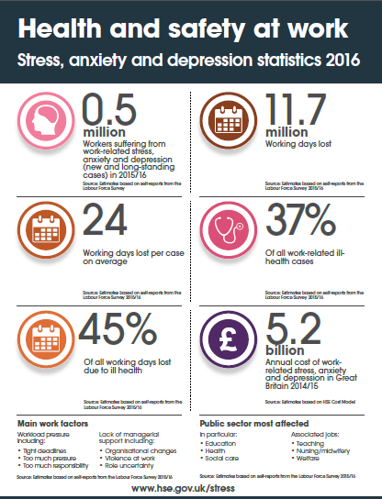

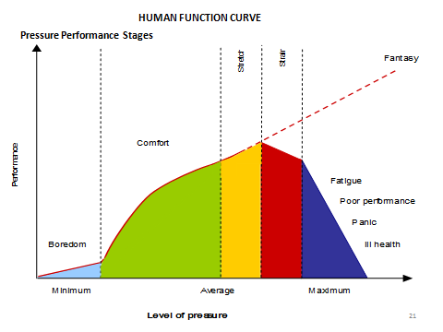
Example:
- One of your team does not have enough work to do and they are bored. (This can also happen when staff find themselves in redeployment or when they do not feel challenged.)

- When provided with work they work well. A little more work is added and they continue to perform well in the stretch phase and can cope with this.

- However, more work is added and a tipping point is reached. This means that they are not completing work and ultimately, the member of staff goes off sick.

- At this stage there is a fantasy where people think they can they are immune and keep going, then all of a sudden they are not coping.

Can you think of times under pressure, what do you do to cope?

This would be different for every person.

Be mindful that what you can handle as an individual may be very different from what members of your team can cope with.

Stress awareness and supporting employees

Group exercise
Consider the situations below and think about your approach to it. Complete the list of questions in the table at the bottom of the page.

Group 1
One of your team is off work with work related stress. Prior to going off work, there had been an incident at work where a complaint was made that they were rude to a patient. This is being investigated.

Group 2
One of your team is off work with personal stress. The employee is caring for their partner who is having treatment for cancer.

Question | Responses
- What are your responsibilities in this situation, in respect of the employee’s health and wellbeing?
- What support could you offer the employee?

- When would you offer support?
- What resources are available to you to help assess the situation?

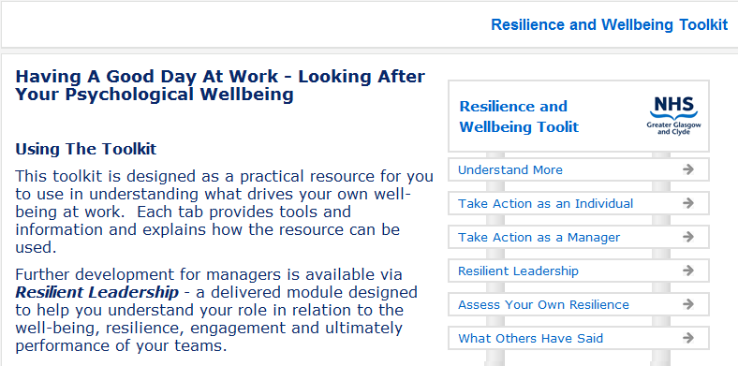

Stress Risk Assessment – Example Summary Report
The HSE Management Standards Analysis Tool allows our organisation to assess our performance in relation to sets of working conditions known to be potential stressors. Our results can be compared with responses from a nationally representative sample of other organisations’ results. The tool assigns colour codes to the seven sets of working conditions, with the colour denoting performance relative to the responses in the national sample. The tool determines the appropriate colour by comparing our responses to ‘benchmarks’ in the national sample as follows:

GREEN | Doing very well - need to maintain performance. Represents those at, above or close to the 80th percentile†
BLUE | Good, but need for improvement. Represents those better than average but not yet at, above or close to the 80th percentile†
AMBER | Clear need for improvement. Represents those likely to be below average but not below the 20th percentile†
RED | Urgent action needed. Represents those below the 20th percentile†

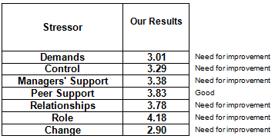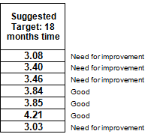

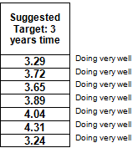

Process for Implementation of Policy on Stress in the Workplace
Stage | Description | Action
Stage 1 | Preparation before you start | Securing management and employee commitment – establish implementation group.  Reviewing the Stress Policy
Stage 2 | Identify the issues | Review existing data  Complete checklist - section 2  Establish Focus Groups  Use Indicator Tool
Stage 3 | Evaluate all the data and consider potential solutions | Develop an action plan
Stage 4 | Ensure Implementation Group regularly reviews implementation of action plan | Implementation Group to review action plan on six-monthly basis.

Action plan

Objective | Actions | By Whom | By When | Possible Issues

