NHSGGC Long COVID Service
Kitchen Aids
The following list of small aids can support you when completing kitchen tasks. These items can be purchased from many online websites such as, Amazon, Argos, Ebay, Mobility Smart, NRS Health care or at stores such as Able World in Paisley. If you need more information, you can complete a self-assessment by accessing the Ask SARA website on equipu.livingmadeeasy.org.uk
Equipu - AskSARA

Local Providers where these may be purchased:
Mobility solutions (Mobility Solutions - Powerchairs, Wheelchairs & Mobility Scooters)
Care co (Wheelchairs | Manual Self-Propel, Transit & Travel Wheelchair ♿)
Ableworld (Paisley - Ableworld Mobility & Stairlifts Paisley)
Local contacts -
Glasgow contact Contact Health and Social Care - Glasgow City Council
Inverclyde (Inverclyde Centre for Independent Living - Inverclyde Council)

Kitchen working station | Spreader board | Adapted utensils | Cooking basket
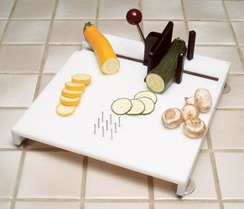 | 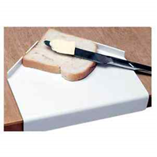 | 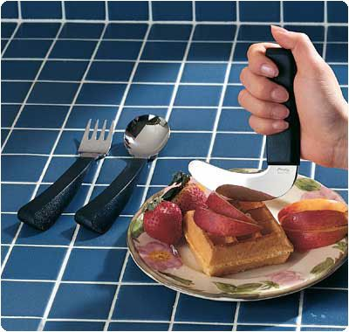 | 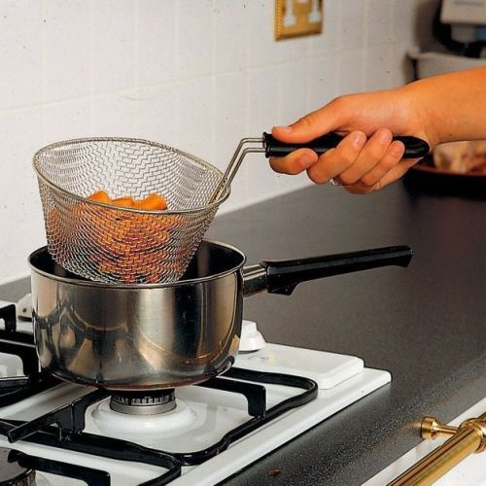
Adapted utensils | Adapted utensils | 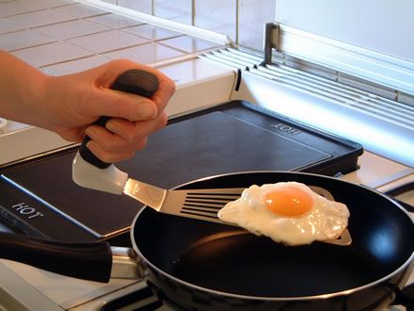  Adapted utensils | Kettle tipper
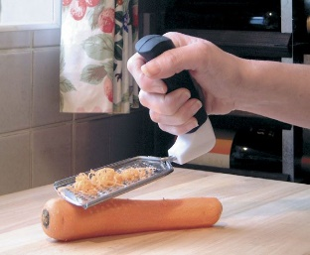
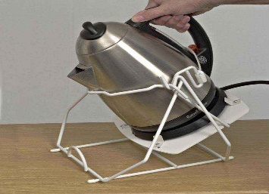

Plate guards | Plate guards | 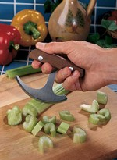  Jar opener | One kettle
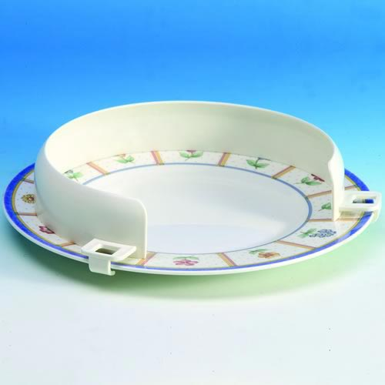 | 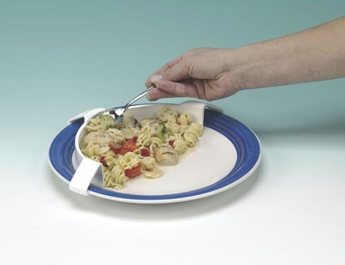 |  | 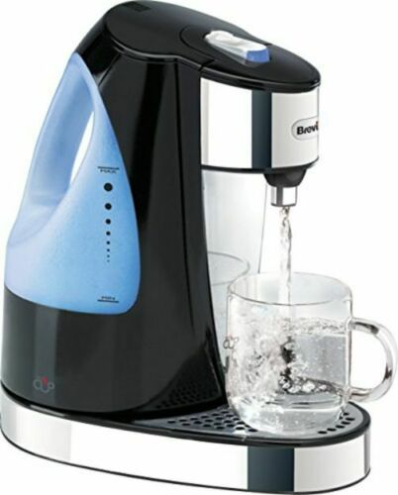
Can Ring puller | .  Spillnot Jar & Bottle Opener | Tap turner | Adapted cutlery
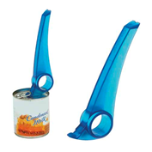 | 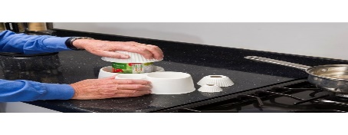 | 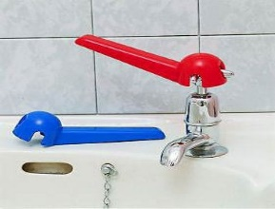 | 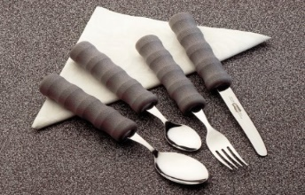
Alternative mugs | Weighted cutlery
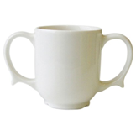 | 