APPENDIX A
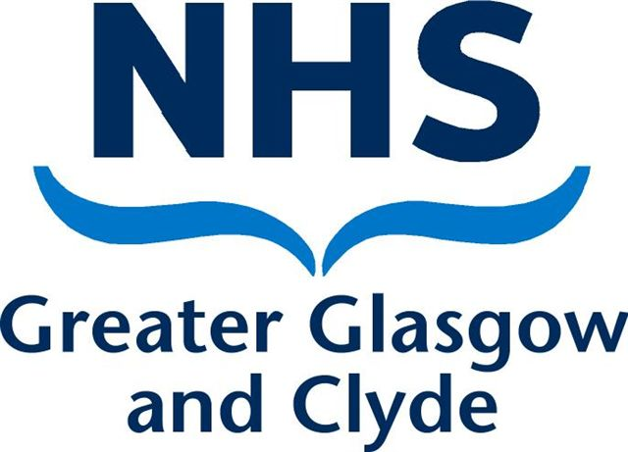NHS GREATER GLASGOW AND CLYDE
APPLICATION FOR INJURY ALLOWANCE
This form should only be completed for an injury or disease occurring on or after 31 March 2013

Please note that injury allowance will not be payable if the accident or illness was wholly or mainly due to, or seriously aggravated by, your own culpable negligence or misconduct.
Please complete Part 1 and forward to your manager who will complete Part 2 and submit to the Human Resources Department for consideration in line with the Board’s agreed process.
PART 1 – TO BE COMPLETED BY THE APPLICANT
SECTION 1 – PERSONAL DETAILS (to be completed in all cases)
Payroll Number |  |  |  |  |  |  |  |  |  |  |  | Group Code |  |  |  |  |  |  |  |  |  |  |  | Pay Point
Surname: |  |  |  |  |  |  |  |  |  |  |  |  |  |  |  |  |  |  | Contact Address:
Forenames (in full):
Title:
Dr |  |  | Mr |  |  |  | Mrs |  |  |  | Miss |  |  |  | Ms |  |  |  | Postcode:
Other title (please specify): |  |  |  |  |  |  |  |  |  |  |  |  |  |  |  |  |  |  | Date of birth (e.g. 18/07/1964):
 |  |  |  |  |  |  |  |  |  |  |  |  |  |  |  |  |  |  |  |  |  |  | / |  |  |  |  |  |  | /
National Insurance number: |  |  |  |  |  |  |  |  |  |  |  |  |  |  |  |  |  |  | Telephone/mobile number:
 |  |  |  |  |  |  |  |  |  |  |  |  |  |  |  |  |  |  | Email address:
Date the injury occurred? (after 31/03/2013) |  |  |  |  |  |  |  |  |  |  |  |  |  |  |  |  |  |  |  |  |  |  | / |  |  |  |  |  |  | /

Current Post: |  | Location:
Job Title/Band |  | Dept / Site:
Post at time of Injury: |  | Location:
Job Title: |  | Dept / Site

SECTION 2 – FURTHER INFORMATION
1. Please give details of all your previous employment showing where you have worked, with dates if possible

2. Please give a description of the incidents(s) leading to your injury or illness and the type of injury or illness suffered (continue on a separate sheet if necessary).

3. Are you receiving or applying for a NHS Superannuation Yes No
Pension due to ill health?

4. Have you applied or are you in receipt of any DWM Yes No
Benefits as a result of your injury?

If the answer is “no” to question 4 but you later claim DWP benefits you must notify NHS Greater Glasgow and Clyde Payroll Department immediately.
Please read and sign the declaration on page 4, enclosing copies of any DWP awarding letters you have received, where possible.
I have included the following documents with my application (please specify below, indicating if you have sent these to us separately). Do not send us originals unless you have to, copies are preferred. Please ensure all documents are marked with your Payroll Number.

SECTION 3 – DAMAGES OR COMPENSATION CLAIMS
SPPA reference – your superannuation number:
(if member of the NHS Superannuation Scheme (Scotland)

Please tick the appropriate box:
- I am currently pursuing a claim for compensation in connection with my work-
related injury/disease. I authorise NHS Greater Glasgow and Clyde to
Approach my legal representative who can be contacted at the address below:

Legal Representative Name: |  | Contact Address:
My Reference Number:

- I am not pursuing a compensation claim at this time. I will notify NHS Greater
Glasgow and Clyde if I decide to pursue such a claim in the future.

I understand that my Injury Allowance can be affected by an award of compensation and I may be required to repay some or all of any Injury Allowance paid to me. I will notify NHS Greater Glasgow and Clyde if I have received or receive a damages or compensation payment in respect of the same injury.

Signature: Print Name:

Date:

SECTION 4: DECLARATION (please read before signing)
(Without a signed declaration we cannot accept your application)

- I hereby apply for NHS Injury Allowance due to injury/disease which I consider to be wholly or mainly attributable to the duties of my NHS employment in NHS Greater Glasgow and Clyde.

- I understand that certain DWP benefits paid in relation to my injury are taken into account with NHS injury allowance.

- I will notify NHS Greater Glasgow and Clyde if I have claimed or intend to claim any DWP benefits or if my DWP benefits change in amount or cease to be paid.

- I understand responsibility lies with me to keep NHS Greater Glasgow and Clyde informed of any changes in DWP benefits.

- I agree to provide NHS Greater Glasgow and Clyde with copies of any awarding documents for DWP benefits and any subsequent changes to benefit awards.

- I authorise NHS Greater Glasgow and Clyde to obtain medical evidence connected to my Injury Benefit Claim and/or monetary details of my DWP details, and any subsequent changes from the DWP.

- I agree that any medical information required to make a decision on my case, will be obtained by me at my expense from my GP/Consultant, and/or other sources.

- I give consent for NHS Greater Glasgow and Clyde to approach my Occupational Health Department or any other relevant sources for information if required.

- I am willing to undergo a medical examination if asked to do so.

- I understand that any payment of Injury Allowance is subject to tax and national insurance deductions but not pension contribution deductions and that my payments will be processed by NHS Greater Glasgow and Clyde’s Payroll Department.

- I understand that any overpayment on my Injury Allowance will be recovered and must be repaid by me.

- I will notify NHS Greater Glasgow and Clyde Payroll Department if/when I return to any NHS post or if my NHS employment is terminated.

- I declare the details I have given in Part 1 of this form are correct to the best of my knowledge.

Signature
Print Name
Date: |  |  |  | / |  |  | /

PART 2– TO BE COMPLETED BY LINE MANAGER
This form should only be completed for an injury or condition occurring on or after 31 March 2013.
The following question must be considered carefully as the terms of the Injury Allowance Regulations do not apply to cases where the injury or disease was wholly or mainly due to, or seriously aggravated by, the applicant’s own culpable negligence or misconduct.
1. In your opinion is the injury or disease wholly or mainly due to or seriously aggravated by the claimant’s own culpable negligence or misconduct? If the answer is yes, please provide all relevant details. | Yes |  | No

2. In order to avoid delay in processing, the following information should, where possible accompany this application form. Tick the boxes to indicate which papers are being enclosed.
Datix/H&S Incident Report Form
Occupational Health Records
Job Description
Other papers included. Please specify below (for example – witness statements, absence review meeting outcome letters)

- Details of Sick Leave, Paid or Unpaid during the last 5 years of NHS Employment:

Period to which entry relates (if applicant is still absent please state ‘ongoing’) |  |  |  | Reason for Absence (required)
From  (start date) |  | To  (return date or ongoing)
From  (start date) |  | To  (return date or ongoing) |  | Reason for Absence
Pay details – date on half pay and nil pay
Date to Half Pay: |  |  | Date to Nil Pay:

Injury Type (please tick)
Asthma |  | Musculoskeletal - knees
Blood Borne Virus |  | Musculoskeletal – lumbar
Burns, Poisoning, frostbite, hypothermia |  | Musculoskeletal – thoracic
Cancers |  | Musculoskeletal- upper body, arms and hands
Cardiovascular - general |  | Neurological
Infectious diseases – excluding those  transmitted by blood borne virus |  | Skin conditions
Musculoskeletal - head |  | Stress and anxiety/depression
Musculoskeletal – shoulders |  | Stress related Chronic Fatigue Syndrome/ME
Musculoskeletal – back attributable  condition |  | Stress related post traumatic
Musculoskeletal - cervical |  | Other – Please Specify below
Musculoskeletal - generalised
Musculoskeletal – lower body, feet and legs
Musculoskeletal – lower body, hips

- Please sign and date the form and return to Employee Relations Team, WG ACH, Dalnair Street, Glasgow G3 8SJ.
Signature
Print Name
Job Title

Date: |  |  |  | / |  |  | /

