Sign in to EESS using the 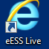 icon on your desktop. Enter your user name and password.
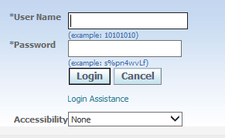
Click on Learner self service or the to expand the selection.
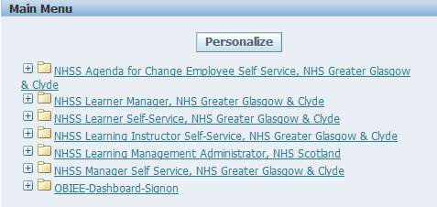
Choose Learner home for training/learning offered within NHSGGC.
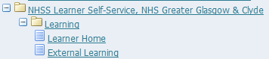
Use the search function to see what is available.
Search by key word or course name.
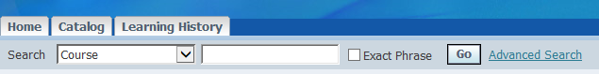
You can also browse and search the learning catalogue by category.
Click on Catalog and then NHS Greater Glasgow and Clyde and then select a category from the list available.
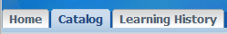
Click on the course title. In this example, we’ll choose the Foundation programme for new managers and supervisors.
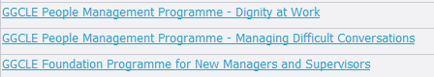

The next page provides information on the learning outcomes and the audience (who is expected to attend this type of training).
Click on the offering name (course name).
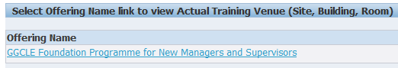
Choose a date from the list available and click on the 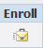 button on the right hand side of the screen.
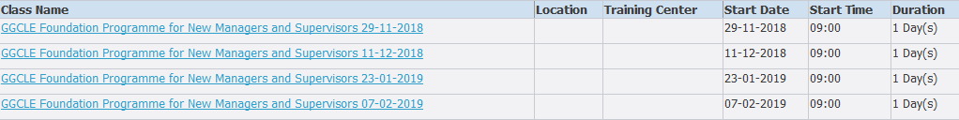
The next screen shows a summary of the course.
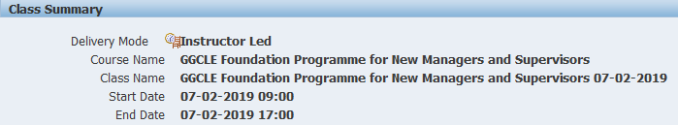
If required, complete the enrolment justification and special instructions. 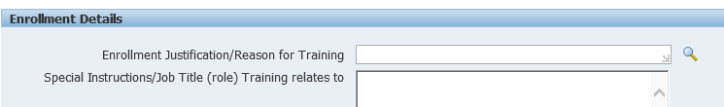
Then click on and on the next page, click on when you have checked the information and want to enrol on the class.

Approval
Your manager will then receive an approval request for completion.
On the home page, details will be available on view Requested Learning tab
