NHSGGC Long COVID Service

Household aids
The following list of small aids can support your activities of daily living. These items can be purchased from many online websites such as, Amazon, Argos, Ebay, Mobility Smart, NRS Health care or at stores such as Able World in Paisley. If you need more information, you can complete a self-assessment by accessing the Ask SARA website on equipu.livingmadeeasy.org.uk
Equipu - AskSARA

Local Providers where these items may be purchased:
Mobility solutions (Mobility Solutions - Powerchairs, Wheelchairs & Mobility Scooters)
Care co (Wheelchairs | Manual Self-Propel, Transit & Travel Wheelchair ♿)
Ableworld (Paisley - Ableworld Mobility & Stairlifts Paisley)

Local contacts -
Glasgow contact Contact Health and Social Care - Glasgow City Council
Inverclyde (Inverclyde Centre for Independent Living - Inverclyde Council)

Key Turner | Car transfer aid | Plug puller
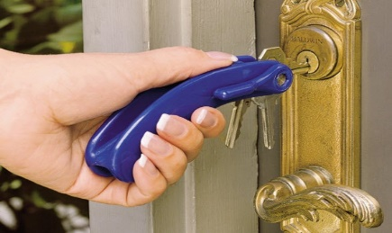 | 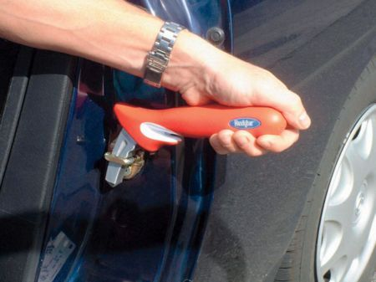
Leg lifter | Easy grip scissors | Pencil grippers
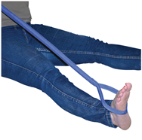 | 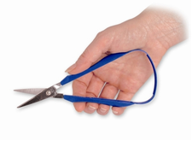 | 