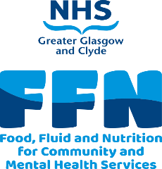
Guidance for using the EMIS Community FFN template.
- To find the template search for Community FFN

- The template has two tabs. MUST and care planning notes (See Below). The MUST tab will be open when you launch the template.

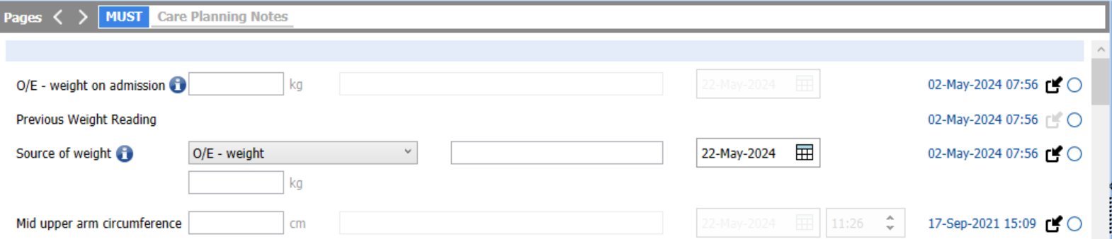

- O/E – weight on admission – This is the weight when a patient is admitted. This can be inserted into the box or pulled across using the circle on the far right and selecting the on-admission weight. Please note that you must change the date to the on-admission date. Hover over information icon for more guidance.

- Select source of weight – O/E if you have an actual weight. This box should be completed every time you screen/rescreen. If you don’t have an actual weight select reported weight (BMI will not be automatically populated if you select reported weight).

- Add the weight (kg) to the box below O/E – weight.

- If you are unable to obtain a weight, you can use the mid upper arm circumference. This will give you a very rough idea of the BMI. Unfortunately, you can’t use this to work out a MUST score, however you can use the subjective questions and clinical judgement to assess risk. Click the link to the alternative measurement chart.
- If you don’t have a height, you can measure the ulna length. This will give you an estimated height that you can use to calculate a BMI. Click the link to the alternative measurement chart.

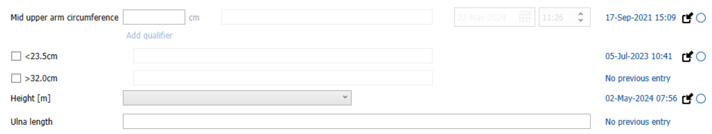

- The BMI will automatically be populated if you selected O/E – weight. If not, populate it manually.
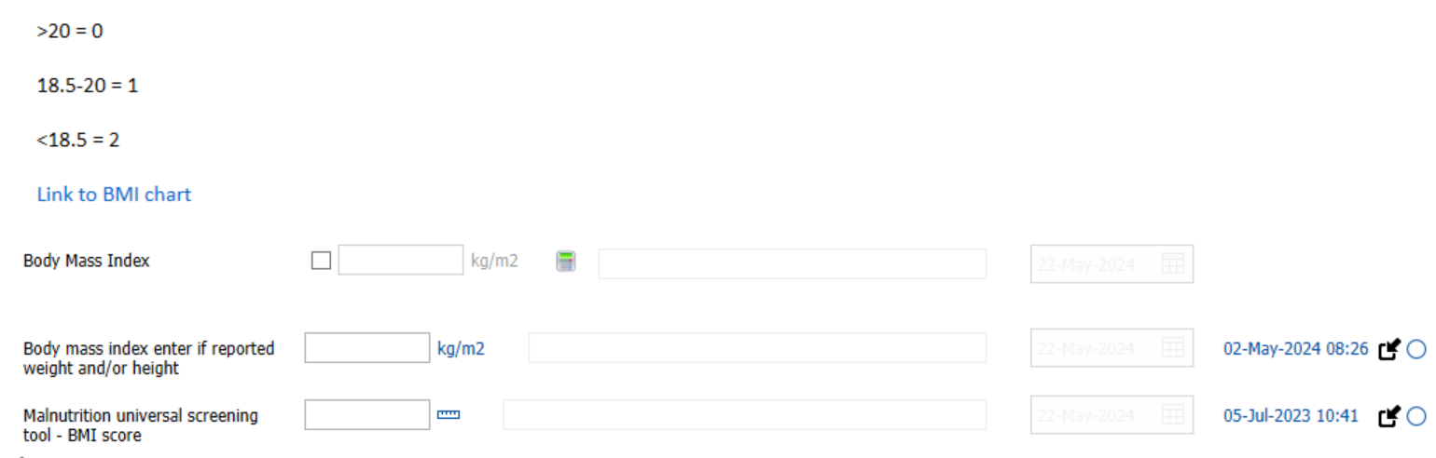
- Insert your BMI score (0-2)

- Use the link to the weight loss chart and calculate your percentage weight loss. Add weight loss score (0-2) to box.

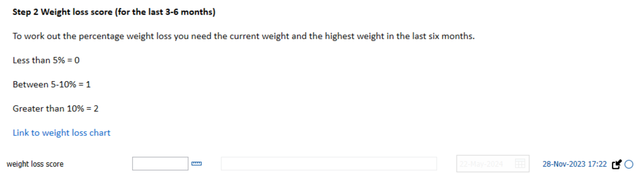

- Answer yes (2) or no (0) to acute disease effect score. Mostly all patients in the community will score a zero here. Add score to box.
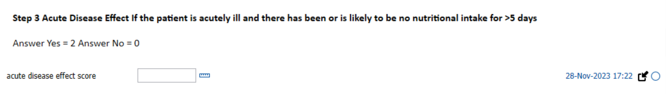
- Add scores from previous section together to find your overall MUST score. Add score to box.
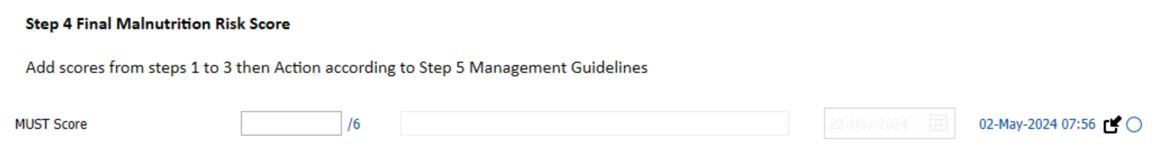
- Now follow the guidelines according to your overall MUST score. Click link to Community MUST Pathway.
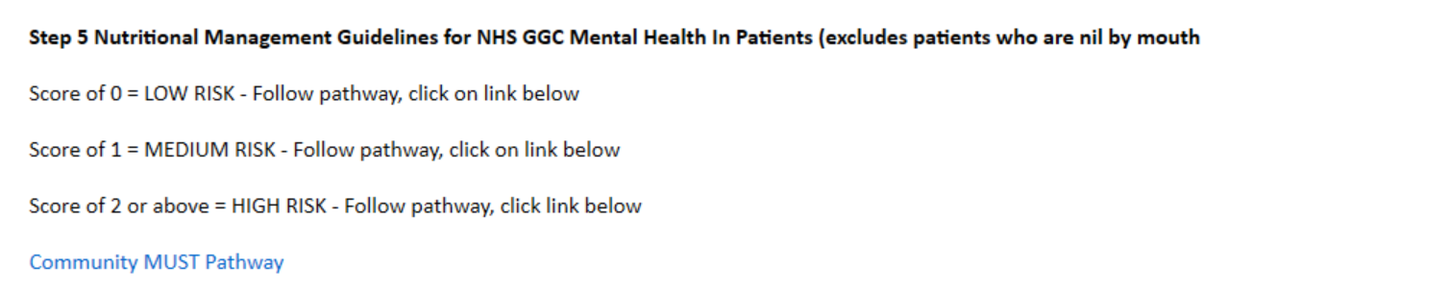
- If your patient scores a 1 or 2 or above give the Eating to Feel Better leaflet and rescreen in one month then follow the instructions on the pathway.

- If your patient scores 0 but has high BMI give the Eat Well Look Good Feel Great Lose Weight booklet or refer onto the weight management services (link in community MUST pathway).

- Remember it is very important to ask the subjective questions to pick up any actual or potential issues. Ask each question and answer yes or no from the drop down.

- Care Planning Notes tab – Homecare provider section has been added for use within OPMHT’s.

