Link to GGC External eHealth Portal - https://nhsscotland.service-now.com/ehealth

Students can register here – Select Register on this page
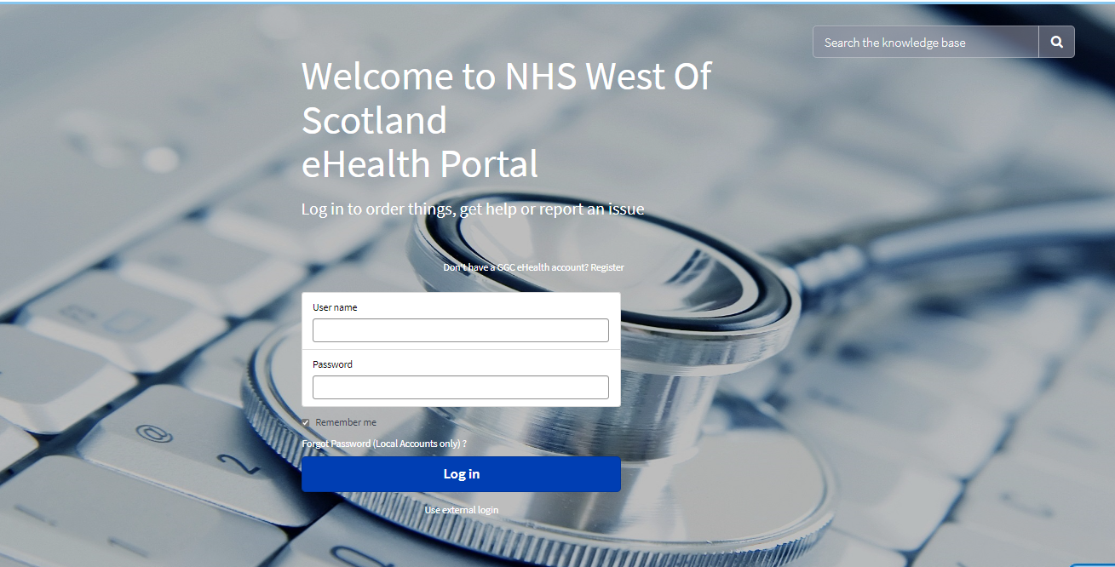

Complete the University Student Self Register details – Select University Student from Type of Service List
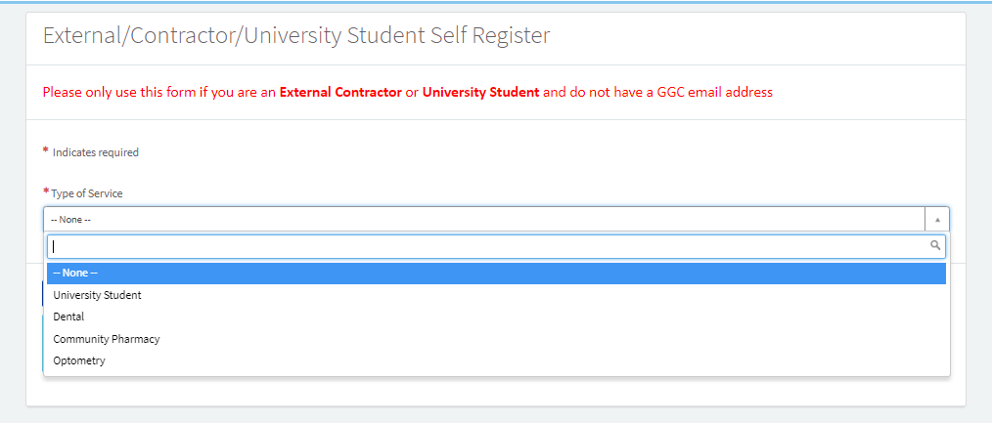

Complete all fields on this form and then select Sign up
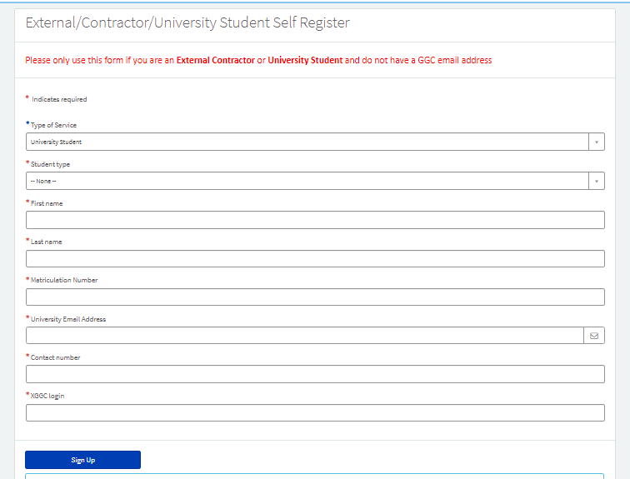

You will receive this prompt after signing up.
Please check your university email address for instructions. This email will have the Subject Heading : Your GGC eHELP Login Details
Your Student eHELP User ID will be your Univesity email address and you will be requested to set a password for your User Account
When ready to raise a support ticket – please enter your Student eHELP User ID into the User Name field and your password
Once you have logged in successfully the page below will be displayed
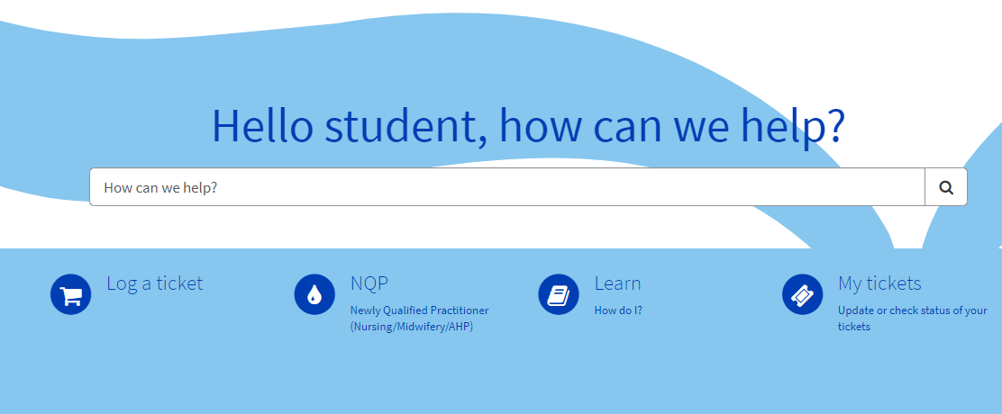

Your default details will be included in any tickets logged, however for each ticket please complete your Location, Exact Location, if you wish to be contacted on your mobile and the nature of the request on any tickets you log.
Log a ticket
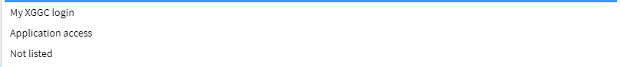

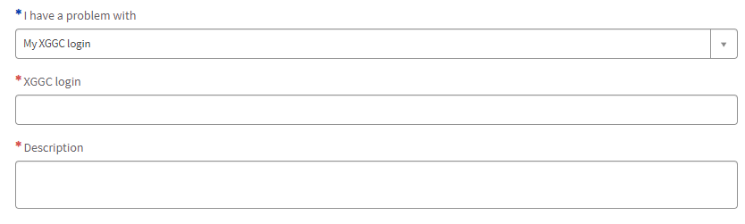

You can select multiple Applications, clicking on Applications line will allow you to select these, you will be prompted to provide you login for each application. Once you have completed all fields please select Submit and your ticket will be logged. You will receive emails with your ticket number and when your request has been actioned.

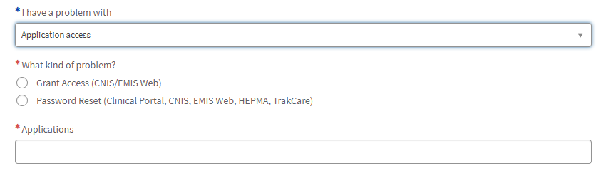
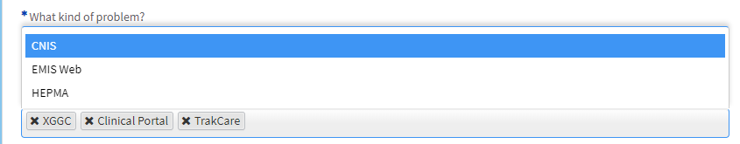

If you are unsure on which option to choose, please select Not listed and provide details, please provide as much information as possible, this will
Assist the Support Teams in resolving your request. Once you have completed all fields please select Submit and your ticket will be logged. You will receive emails with your ticket number and when your request has been actioned.

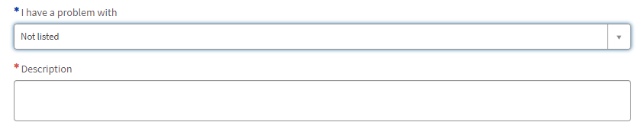

If you are a Newly Qualified Practitioner and require accounts to be updated, please select this option. Please complete all fields, you will be required to provide your Nursing and Midwifery Council Number (NMC number)

Learn is work underway and will soon be populated with useful Student Information – check here periodically to view the progress of this.
My tickets will allow you to view your tickets and the status of these

If you experience any issues in registering or logging tickets, please email itservicedesk.nhss-ggc@atos.net and provide as much information as possible.

