Form number | Form 52.009C | Version | 4.0
Title | Template e-file

Hosted studies e-folder template:
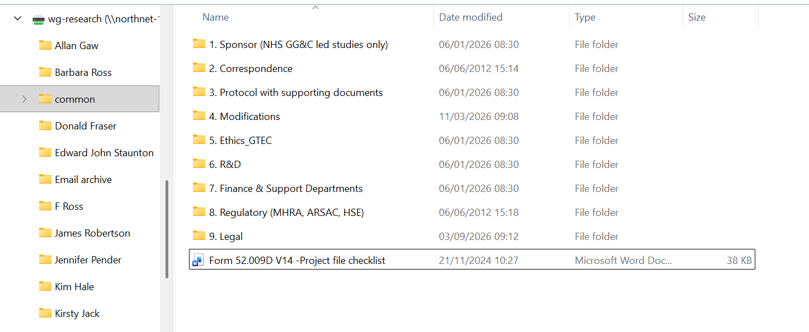

NHSGGC Sponsored Non-CTIMP e-folder template:
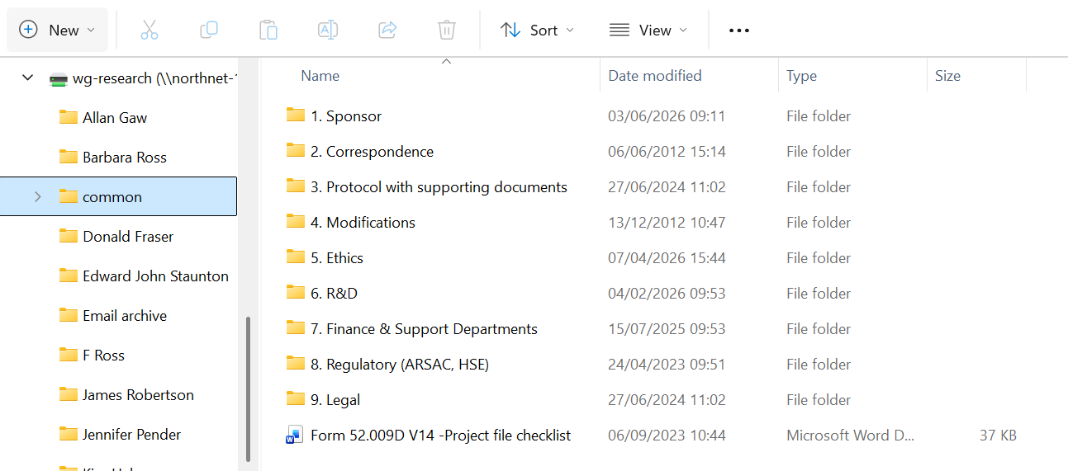

NHSGGC Sponsored CTIMP/CIMD e-folder template:
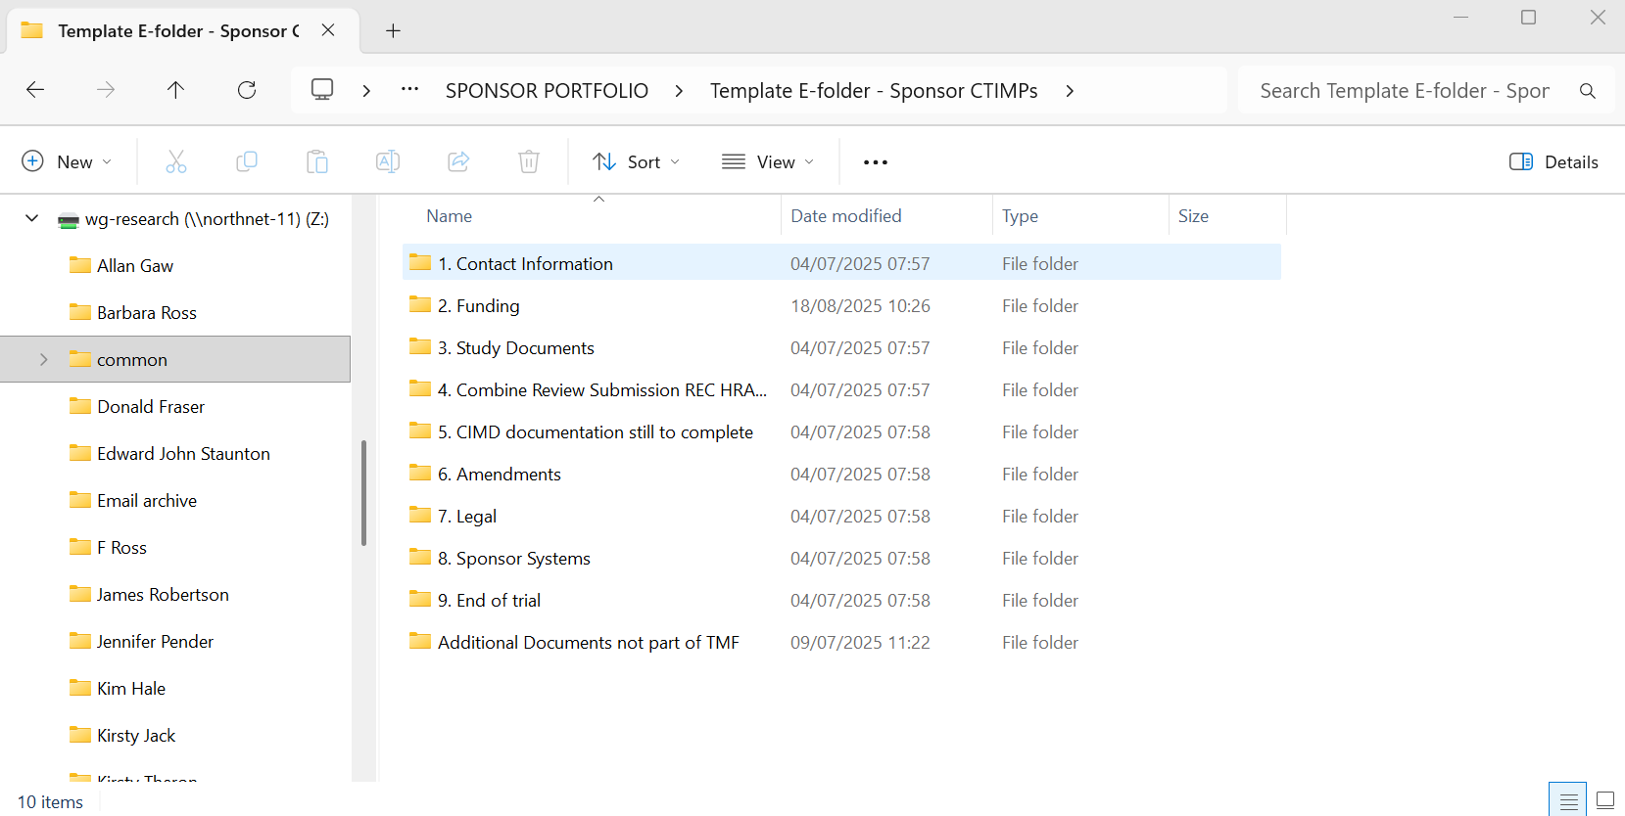

This Form is a controlled document. The current version can be viewed on the R&I website, GCTU website and R&I’s Q-Pulse account.

Any copy reproduced from the website may not, at time of reading, be the current version.

