Form number | Form 52.009C | Version | 3.0
Title | Template e-file

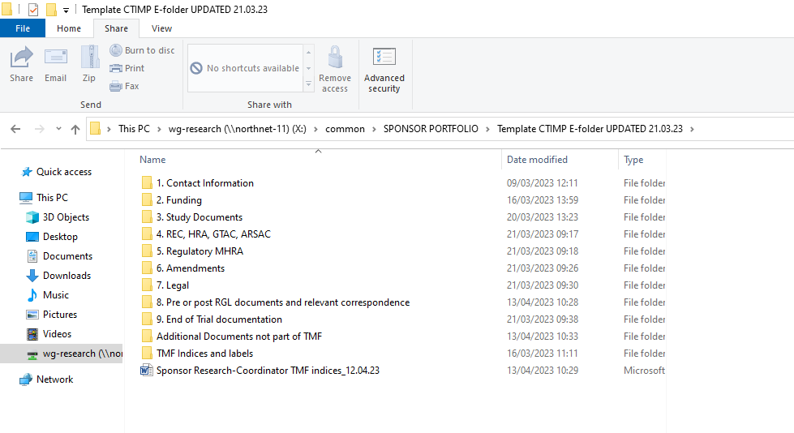

This Form is a controlled document. The current version can be viewed on the GCTU website.
Any copy reproduced from the website may not, at time of reading, be the current version.

