
EPAD Drop in Sessions - Online
From September 2025 all first year student nurses will have the electronic Practice Assessment Document (ePAD)
The Practice Education Team are running drop-in sessions to provide a demonstration of the system and answer any ePAD related queries.
There is no need to book - just come along!
To join an MS teams session click on the link or scan the QR code to join

Date / Time | Link to Join
Friday 6 February 2pm - 3pm | ePAD teams session link
Thursday 12 February 3pm - 4pm | ePAD teams session link
Wednesday 18 February 2pm - 3pm | ePAD teams session link
Tuesday 24 February 3pm - 4pm | ePAD teams session link
Monday 2 March 2pm - 3pm | ePAD teams session link

More information about the ePAD is available on our website here | 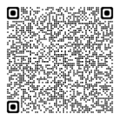 | Scan this QR code to join MS teams session | 