
ePAD Drop-in Sessions - Online
From September 2025 all first-year student nurses will have the electronic Practice Assessment Document (ePAD)
The Practice Education Team are running monthly online drop-in sessions to provide a demonstration of the system and answer any ePAD related queries that you have.
There is no need to book - just come along!
To join an MS teams session click on the link or scan the QR code to join
Date / Time | Link to Join
Wednesday 12th August 2pm - 3pm | ePAD teams session link
Thursday 17th September 3pm - 4pm | ePAD teams session link
Tuesday 12th October 2pm – 3pm | ePAD teams session link

More information about the ePAD is available on our website here | 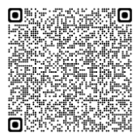 | Scan this QR code to join MS teams session | 