
EPAD Drop-in Sessions - Online
From September 2025 all first year student nurses will have the electronic Practice Assessment Document (ePAD)
The Practice Education Team are running online drop-in sessions to provide a demonstration of the system and answer any ePAD related queries that you have.
There is no need to book - just come along!
To join an MS teams session click on the link or scan the QR code to join
Date / Time | Link to Join
Wednesday 18th March 2pm - 3pm | ePAD teams session link
Thursday 26th March 3pm - 4pm | ePAD teams session link
Monday 30th March 2pm - 3pm | ePAD teams session link
Tuesday 7th April 3pm - 4pm | ePAD teams session link
Friday 17th April 2pm - 3pm | ePAD teams session link
Tuesday 21st April 3pm - 4pm | ePAD teams session link
Thursday 30th April 2pm - 3pm | ePAD teams session link

More information about the ePAD is available on our website here | 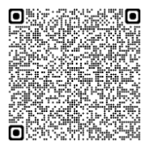 | Scan this QR code to join MS teams session | 