eESS Quick-Start Guide - Employees

This guide has been designed to give you a quick-start to using the system as an employee, and details what you should do when you logon to eESS for the first time.

To Avoid Waiting in Call or E-Mail Queues

Please use this Guide in the first instance to try and troubleshoot any logon or user issues.

We anticipate an extremely high level of calls and e-mails post Go Live on the 23rd and would welcome your support in troubleshooting any logon issues as per the guidance below.

Accessing eESS

To access eESS, click here.

Alternatively, access eESS via your ‘favourites’ menu on your Internet Explorer toolbar (just as you would access SSTS). Select favourites -> GGC Shortcuts -> Admin -> eESS

By 23rd November 2018, you will have received an e-mail with your Username and Password.
(Note - this is a temporary password and you will be required to change this when you first log-on)
There is also an option for login assistance on the logon page.

Troubleshooting

I haven’t received my user ID and Password | If you have not received this, please contact the eESS Support Team at eESS@ggc.scot.nhs.uk.  Your details will be resent to you so please ensure you have sufficient space in your mailbox to receive new emails. Please keep these details safe for future use.
Where can I find eESS on my computer? | The link to the eESS site is found within Favourites on your Internet Explorer toolbar (just as you would access SSTS). Select Favourites -> GGC Shortcuts -> Admin -> eESS
I have forgotten my user ID or password | Passwords on eESS are reset via a link sent by email. Click on the log-in assistance button on the log-in page and follow the instructions given. You can also have an email reminder of your user ID sent to you by following the link on the log-in page.
I can’t connect to the eESS site | First of all, check that you have a valid internet connection by ensuring you can access another external website successfully.  If this works, you should contact the eESS Support Team at eESS@ggc.scot.nhs.uk. to report the issue

First Thing to Check

Check and Update Your Personal Details and Equality Information. To do this:

- 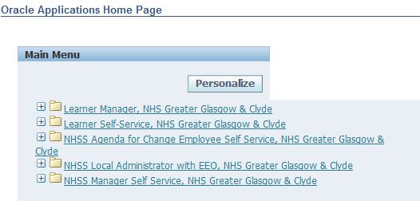Navigate to NHSS *Employee* Self Service | - Click Personal Information
- Scroll to Basic Details. Current details will show. Click Update.  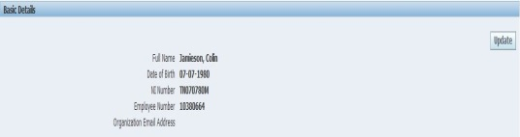 | - Choose whether to correct information or enter new information. Click next.  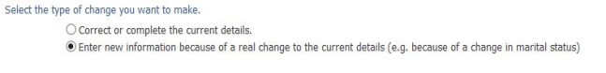
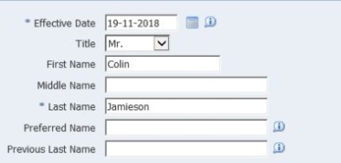  - Amend Effective Date if entering new information  Scroll down and update equalities data. | - Enter new details in blank field or overwrite information if already populated, click Next
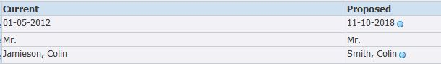  - Review the changes, indicated by the blue dots | - Click Submit

ADD/ UPDATE YOUR PHONE NUMBER
1. Follow Steps 1-2 as ‘Update your Personal Details’ | - Scroll to Phone Numbers, current details will show. Click Add/Update
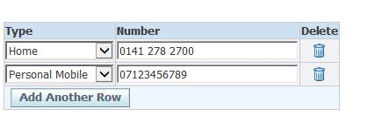  - Overwrite number if record is to change / add a new row for a new number. NB – eESS will only accept one type of each number, e.g. one personal mobile number. | - Click Next.  - Follow steps 7-8 as per ‘Update your Personal Details’

ADD YOUR EMERGENCY CONTACTS / NEXT OF KIN DETAILS
- Follow Steps 1-2 as ‘Update your Personal Details’ | 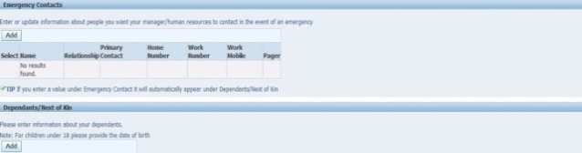  - Scroll to Emergency Contact/Next of Kin, current details will show. Click Add/Update. If you enter a value under Emergency Contact it will automatically appear under Dependants/Next of Kin
- Correct address if record is to change / enter a new address if you have moved. | - Click Next.  - Follow steps 7-8 as per ‘Update your Personal Details’

ADD/ UPDATE YOUR HOME ADDRESS
- Follow Steps 1-2 as ‘Update your Personal Details’ | - Scroll to Home Address, current details will show. Click Add/Update  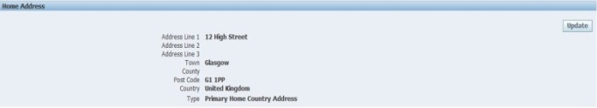
- Correct address if record is to change / enter a new address if you have moved. eESS will only accept 1 type of each address, e.g. 1 primary home address. | - Click Next.  - Follow steps 7-8 as per ‘Update your Personal Details’

ADD NON NHS EMPLOYMENT
- Navigate to Employee self service | 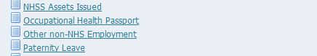  - Click Other Non NHS Employment
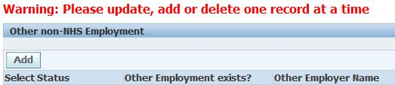  - Click Add | - Complete, Click Apply, then Next  - Follow steps 7-8 as per ‘Update your Personal Details’

Training and Support
We would encourage staff to read the step-by-step user guides and/or view the short e-learning videos on how to make changes on eESS. These are available at https://www.eess.nhs.scot/.

Thank you for taking the time to read and use this Guide. We hope it has helped you get started on eESS and fix any logon queries.

