Display Screen Equipment (DSE) Self-Assessment Form

Adapted from the Health and Safety Executive (HSE) (2021)

Date:
User Guide:
-Answer yes or no to each question
-If answered no please make a comment in the correct box
-Users should fill this form out and forward to their line manager after the assessment
-Any issues highlighted within this assessment should be flagged up by the line manager who should then contact a DSE assessor

User Name
Assessor
Department
Line Manager
Location & Department

DSE Regulations and importance of ergonomics within the work place:

- The DSE checklist can be used to complete a workplace assessment with an electronic device or equipment, this is adapted from the HSE workstation checklist (2013) which was made to comply with the Schedule to the health and Safety DSE regulations 1992 (as amended in 2002).
- This workstation assessment can reduce injury in the work place.
- Following and complying with these regulations ensures healthy working and avoids numerous preventable scenarios such as:
- Musculoskeletal upper limb disorders such as repetitive strain injury (RSI) and postural dysfunction
- Vision Issues associated with the electronic equipment
- Stress as it enhances working conditions for employees and reduces the risk of software and equipment issues, increasing employee morale
- Minimises the risk of hazards such as fires, dangerous equipment and falls and contributes to an adequate safety culture within the workplace
- Reduces employee ill health in turn lowering absences and administration costs through minimising the likelihood of compensation claims

If more information is required on this, please follow these links:

https://www.csp.org.uk/system/files/fit_for_work_leaflet_english.pdf

https://www.unison.org.uk/content/uploads/2013/06/On-line-Catalogue172943.pdf may take out

Resources to read:
Display Screen Equipment (DSE) User guidance NHS GGC
DSE Guidance Documents

Section A: The User, Work Pattern and Training

Work Pattern | Y / N | Guidance | Remedial action/Comments
Approximately how much time does the user spend at the DSE workstation? | Hrs per day | If someone uses the workstation more or less continuously for at least an hour on most days, they are Users.  Those doing shorter spells on the computer (perhaps just half an hour at a time) should be classed as Users if there are several such spells in the day and the use is fairly intensive – requiring speed or high levels of concentration.
Is the work routine of the user organised to provide changes of activity and screen breaks? |  | Recommend 5 to 10 min breaks from the DSE every 50 minutes to help restore energy, keep moving and reduce fatigue.  -Increase movement and encourage stretching, change focus or position every few minutes, examples of stretches: https://www.csp.org.uk/system/files/fit_for_work_leaflet_english.pdf  Ensure that you take regular breaks hourly; short, frequent breaks are more satisfactory than occasional, longer breaks.

Home Environment if Applicable | Y / N | Guidance | Remedial action/Comments
Are you a home worker or work from home for a considerable part of your working week |  | This DSE risk assessment should be used to assess the risk to staff from DSE within the home as well as in the work place.
Please document primary room you expect to carry out home working in |  | Room should be large enough to prevent any trip hazard with adequate light and controlled thermal comfort
Please document what type of surface the DSE will be positioned on when being used? |  | Surface should be a minimum of 1000mm x 600mm.  This may need to be larger dependant on equipment need for task being carried out.
Please document what type of chair you will be using when carry out DSE work? |  | A DSE chair should be used when carry out DSE work and in the home, these should have a 5 star base with castors, the seat back should be adjustable for both height and tilt.  The chair should provide adequate back support and allow the user to get close to the surface used for the DSE.
Are user’s feet flat on the floor, without too much pressure from the seat on the backs of your legs? |  | Your hips should be slightly higher than your knees, with your feet comfortably on the floor.

The User | Y / N | Guidance | Remedial action/Comments
Does the user suffer from any Upper Limb Disorders (ULDs)? |  | Link to an examples of upper limb disorders:  Upper limb disorders - Musculoskeletal disorders – HSE
Are any symptoms or discomfort related to DSE work? |  | The occupational health service provides advice on any of the conditions covered. If yes and is affecting ability to perform work tasks user should be referred to Occupational Health (this should be a management referral).  DSE Health Issue
Has the user any eye sight problems when using the DSE? |  | If yes, user should be encouraged to make an appointment with local opticians using the ‘Letter to Optician form’  Optician GD
Has DSE user undergone an eye test in the last 2 years? |  | Record date of eye test and any relevant information

User Training | Y / N | Guidance | Remedial action/Comments
Has the user received information or guidance on DSE and is the user aware of any risks associated with DSE working? |  | Trained assessor can provide information and guidance on DSE training and education.  Useful links:  GGC DSE guidance
Has the user received training on DSE? |  | Trained assessor can provide training on correct DSE posture and guidance on DSE work. Training is available from Health & Safety Service. There is also an E-Learning module, all staff should be encouraged to access this. | .

Section B: Upper Limb (Key board, Mouse, Document Holder, Display Screen and Software)

Keyboard | Y / N | Guidance | Remedial Action/Comments
Can the user position the keyboard in front of them and is the key board separate from the screen? |  | Keyboard should be positioned so keyboard and screen are in line to prevent unnecessary twisting of upper torso.  If using a laptop then a separate keyboard should be used for prolonged period of work.
Is there ample room to allow user to rest arms and wrist and does the user have a good key board technique? |  | 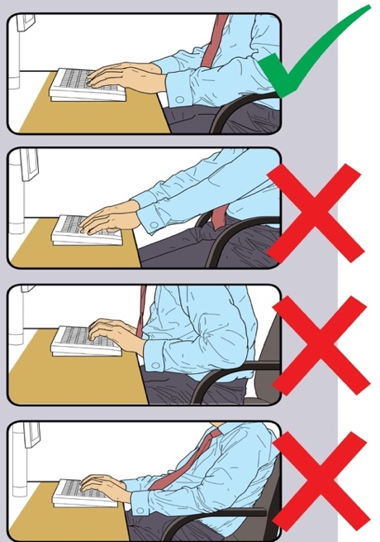  Typing with forearms on the desk reduces tension in the upper back.  A space of at least 100 - 150mm should be available.  The same principle should apply when using a laptop without a separate keyboard
Some keyboards have a built-in tilt which cannot be adjusted, this forces your wrists into a bent-up position which should be avoided. Consider replacement if this is the case
Flat on the worktop is often the best position for the keyboard to avoid bending the wrists.

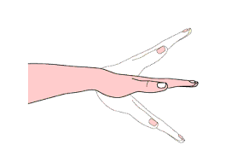
Are the characters on keyboard legible and is the keyboard kept clean? |  | 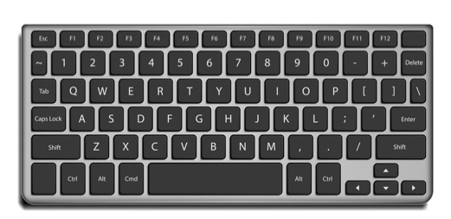  Keyboard should be kept clean and characters legible, replacement keyboard if characters are not legible or not working properly

Mouse | Y / N | Guidance | Remedial Action/Comments
Is the forearm supported? |  | The mouse should be positioned as close as possible to the keyboard.  Do not leave your hand on the mouse when it is not being used.  Your arm should be relaxed when using the mouse with too much over reaching avoiding flexed positions of the wrist, when finished- take hands off the mouse.  A separate mouse should be used when using laptops for prolonged periods of time  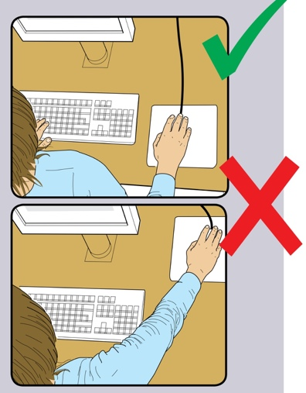
Does the mouse work at a reasonable speed for the user and does the mouse have adjustable settings? |  | Check the user guidance on your mouse and computer for this.
Is the mouse close to the work area and at keyboard height and are they both in the “easy reach zone”? |  | 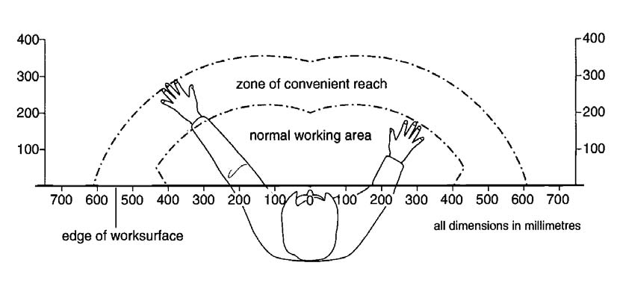

Document Holder | Y / N | Guidance | Remedial Action/Comments on
If you copy from an external paper source, do you have a document holder? |  | If you frequently copy from a paper source, you should have a document holder to reduce the risk of Upper Limb Disorders from inappropriate neck position when reading documents.  A document holder should support all source documents adequately,
If you do use a document holder, is it positioned next to the screen? |  | The document holder should be positioned as close to the screen as possible to reduce the need to turn/twist when referring to text on/off the screen

Display Screen and Software | Y / N | Guidance | Remedial Action/Comments
Is the screen separate from the keyboard? |  | If laptop is used a, separate mouse, keyboard and laptop riser or a docking station should be used  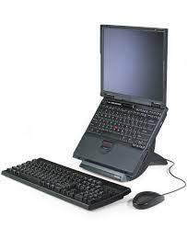  Laptop Guidance
Are the characters readable? |  | If software allows alter, if not contact supervisor or IT department
Is the screen image free of flicker and movement? |  | Inform supervisor or contact IT department
Is screen brightness and contrast adjustable by the user? |  | Most flat screen displays have this capability Inform supervisor or contact IT department.  Set contrast & brightness to personnel preference.
Does the screen swivel and tilt? |  | Consideration to replace if screen does not have this capability  Especially important if tasks include transcribing from tele calls  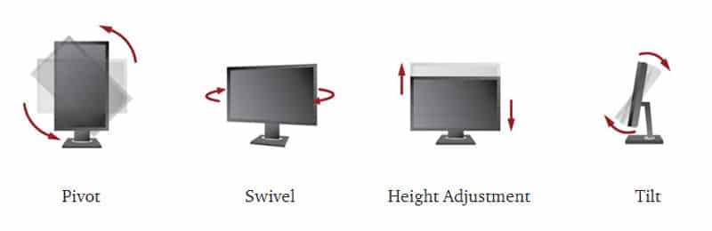  If no height adjustment capabilities a screen riser can be used
Is the top of the screen level with user’s eyes |  | The neck should be straight. A slightly downward gaze is most comfortable for the eyes.  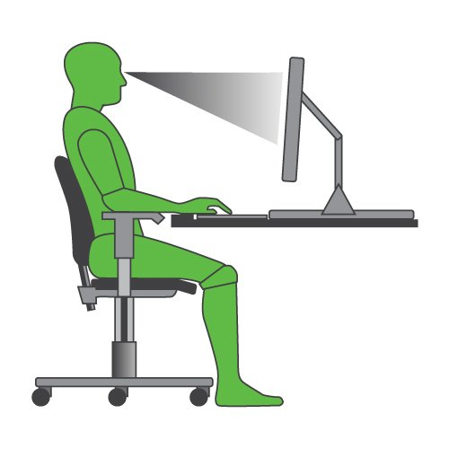
Is the screen at a comfortable viewing distance, and is the screen an adequate distance away from users’ eyes? |  | Generally, an arm length is suitable but can vary from user to user.
Is the screen free from reflection and glare? |  | 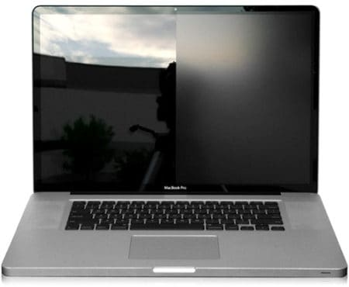  Turn off the screen, if you can see reflective glare on the screen as shown above (right side of picture) you need to reposition the screen to eliminate the reflective glare.  This can be from natural light or artificial light sources

Section C: Chair
Chair | Y / N | Guidance | Remedial Action/Comments
Can the user adopt a comfortable position in the chair and is the right chair being used? |  | 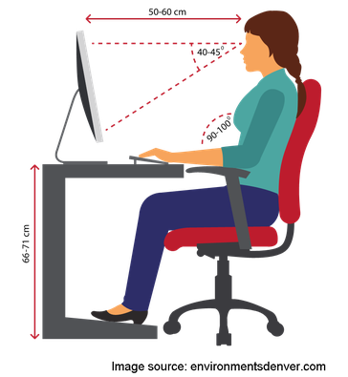  To set up the workstation the user should start from having the correct arm positon and everything should be positioned from there
Does your chair have a 5-star base with castors? |  | If not, it should be replaced.  Your chair should have wheels for ease of movement. There are different castors designed for carpeted and linoleum surfaces
Does the chair allow enough leg room |  | The knee space under the desk should be 508 to 660 mm high, no less than 508 to 610mm wide, and 600mm deep.
Is the seat back adjustable for tilt? |  | The back of the chair should be reclined at a 100- to 110-degree angle
Is the seat adjustable in height and if so is the chair at the right height? |  | Seat height should adjust preferably between 380 mm and 540 mm to suit most individuals.  Height should be adjusted so feet are on floor, with a 90-degree bend in the knee, knees must also be aligned with hips
Does the chair provide adequate lower back support? |  | Consideration should be given to purchase a chair with lumbar support, or a separate lumber support should be purchased.  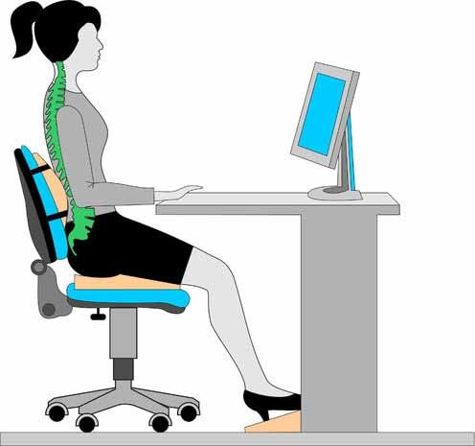
Does the chair allow the user to get close to the desk? |  | A chair with no armrest or half arm rest should be considered to allow user to position themselves close to desk, armrests should preferably be short and height adjustable so that they just support the elbows.

Section D: Work Station & Environment

Workstation | Y / N | Guidance | Remedial Action/Comments
Are user’s feet flat on the floor, without too much pressure from the seat on the backs of your legs? |  | Your hips should be slightly higher than your knees, with your feet comfortably on the floor.  A footrest may be required if you are unable to rest your feet comfortably
Is a footrest available if required? |  | A footrest is required if the feet cannot comfortably be placed on the floor after positioning the arms and shoulder correctly, or if there is pressure under the thighs close to the knees. Choose large footrests, preferably adjustable in height and tilt to suit users.
Is the work desk or surface sufficiently large enough? |  | Make sure the surface area is adequate for the task and the equipment and it is not less than 0.96 square meters
Is there sufficient legroom for your legs when sitting at your workstation? |  | Work surface should be at 600mm deep (minimum) and 720mm high (plus or minus 15mm) and 30 mm thick. Items should not be stored underneath the desk. Most stacked workstations with shelving at leg level are not recommended
Is everything at “easy reach” distance on the desk and is the desk free of clutter? |  | 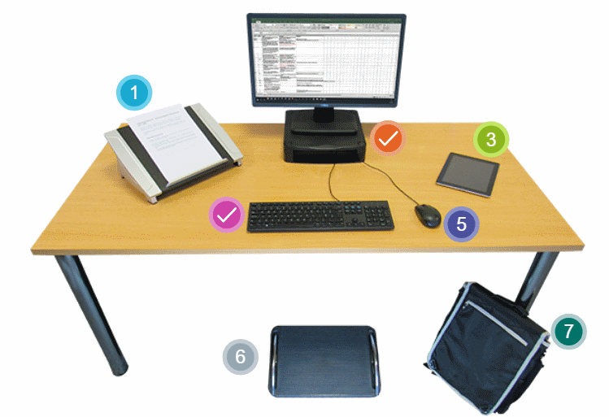  Make sure items are positioned well with minimal equipment on the table  Avoid awkward reaches, twisting to use the phone etc.  Can you create more space by moving printers & reference materials etc. elsewhere?

Environment | Y / N | Guidance | Remedial Action/Comments
Has each worker 11m³ working area not including furniture? |  | Calculate work area by height x width x depth (take ceiling as 3m max) and divide by number of occupants.  This does not include furniture so this should be taken into account when calculating number of person in a room.
Are noise levels from associated equipment and work area low enough to avoid distraction? |  | Normal office noises such as people typing and answering the telephone cannot be avoided.  Try moving sources of noise, e.g. printers, away from your workstation/area.  Consider networking printer/ fax and photocopiers to reduce amount of equipment in office
Are temperature levels generally comfortable? |  | Minimum temperature requirement 16º C. Comfortable sedentary work is generally around 20ºC to 22ºC. Please see Workplace Health, Safety and Welfare Policy for further guidance
Is humidity level comfortable most of the time? |  | Use the Occupational Hygienist referral form to request assistance to measure humidity.
Is working area free from hazards? |  | Electric equipment must have been tested within  For example: too much furniture, trailing cables, manual handling, falling objects from shelves, boxes on floor and electric shock.  Cabling should be fixed to desks  Ensure cabling is not near any heat sources
Is the room brightness at a comfortable level and is there window covers? |  | Recommended light levels in offices/room is 300 – 500 lumens.

We have discussed this assessment, understand the process and support the recommendations.
DSE User Signature |  | Date
Assessor Signature |  | Date
Manager Signature |  | Date

Action Plan
Remedial Action | Assigned To | Date Completed

