

Director of People and Culture
Candidate Information Pack

Ref No: 243754
Closing Date: 5th July 2026




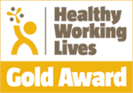



Contents

Message from our Chief Executive 3
Advertisement 5
Job Description 8
Organisational Position 11
Person Specification 15
Wider Organisational Position 17
NHSGGC Values 18
NHS Scotland Leadership Success Profile 19
Terms and Conditions 20
Recruitment Process 22
About NHS Greater Glasgow and Clyde 23
Useful Publications 28



Message from our Chief Executive

Dear Candidate,

Thank you for your interest for the position of Director of People and Culture within NHS Greater Glasgow and Clyde. I am excited to share this unique opportunity with you, and hope this role captures your enthusiasm to lead within one of the most innovative and dynamic healthcare organisations in Scotland.
As Scotland’s largest health board, NHS Greater Glasgow and Clyde manages an annual revenue budget of £4.65 billion, with an annual capital spend in excess of £70 million. This represents nearly a quarter of Scotland’s overall health expenditure. Our services encompass integrated acute hospital care, primary care, community services, and mental health support, ensuring we address the diverse and complex healthcare needs of our communities across the Greater Glasgow and Clyde area.
The next phase of our journey is ambitious and filled with exciting opportunities. Despite the recent challenges presented by the global pandemic, our teams have demonstrated resilience, creativity, and determination. We are proud of the remarkable work everyone has contributed, including the innovative redesign and rapid response of services to meet the evolving demands of healthcare delivery.
This position offers you the chance to join an organisation that is driving positive change. You will have the opportunity to work alongside a talented and committed team of clinical and non-clinical professionals dedicated to delivering exceptional care. We are looking for candidates who bring a strong blend of leadership, experience, and innovation, and who are passionate about shaping the future of healthcare in our region.
As the Director of People and Culture for NHS Greater Glasgow and Clyde, you will play a key role in our exciting change programme, ‘Transforming Together,’ and in shaping services to meet the needs of the diverse communities we serve. Most importantly, we are looking for someone who can offer a fresh, forward-thinking, and collaborative approach to ensure continued progress in the delivery of high-quality, patient-centred care, both within NHS Greater Glasgow & Clyde and across Scotland.
We hope you find this career opportunity inspiring and look forward to receiving your application.
If you have a disability or long-term health condition, we are committed to providing reasonable adjustments throughout the recruitment process and in employment.

For a confidential conversation about this role please contact Will McAlpine, Robin Staveley or Emily Smith of GatenbySanderson via will.mcalpine@gatenbysanderson.com

Thank you once again for considering this exciting opportunity. I look forward to receiving your application.

Professor Jann Gardner, Chief Executive
NHS Greater Glasgow and Clyde – June 2026

Advertisement

Post Title: Director of People and Culture - NHS Greater Glasgow and Clyde

Salary: Grade G (£130,912 - £173,906) per annum (pro-rata for part time)
Location: JB Russell House

Employment type: Permanent

Hours Per Week: 37.5

Lead with Purpose. Shape Culture. Make a Difference. If you are motivated by purpose, driven to improve, and ready to lead meaningful change, we would love to hear from you.
Help us build a workplace where people feel proud to work because great care starts with great culture.
As Scotland’s largest health board, we serve 1.3 million people and employ over 42,000 colleagues. Every role matters, but how people feel at work matters just as much. We know that when our staff feel valued, supported and included, the care we provide improves.
We are now looking for an exceptional Director of People and Culture to help us take the next step, strengthening our culture, improving everyday experience, and making NHSGGC a place where people genuinely want to work and stay.
Why this role matters
This is more than a traditional HR leadership role.
It’s about leading real, visible change, creating a workplace where our values are lived, where people feel heard, and where we build an environment that attracts, develops and retains great people in a highly competitive market.
You will join the Executive Team at a time of opportunity: to sharpen our employee value proposition, modernise our approach to workforce and culture, and ensure every colleague feels they belong and can thrive.
Working at Scale: Subnational West Leadership
This role also offers a unique opportunity to lead beyond organisational boundaries and shape workforce strategy at a system level across Scotland West, as part of Subnational Planning and Delivery arrangements.
In addition to your responsibilities within NHS Greater Glasgow and Clyde, it is expected that you will also undertake the role of Lead Director of People and Culture for Subnational West, providing senior professional leadership across seven NHS Boards, serving a population of over 3 million people and a workforce of more than 100,000 colleagues.
Operating within a complex and evolving national reform agenda, you will work in close partnership with Chief Executives, Executive colleagues, the Scottish Government, and trade union and professional organisations to shape shared workforce strategies, lead system-wide working, influence national workforce policy, support sustainable services, and foster collective leadership across organisational boundaries.
This aspect of the role requires a leader who can navigate complexity, build consensus, lead collaboration, and deliver change without direct line management, working across organisational, geographical and professional boundaries to achieve meaningful system-wide impact.
What you’ll do
As a key member of the Corporate Management Team, you will shape culture, improve staff experience, lead transformation, champion inclusion, support and challenge leaders, and influence at regional and national level.
You will lead a large, skilled People and Culture Directorate, ensuring services from workforce planning and recruitment to organisational development, wellbeing and employee relations are modern, responsive and make a real difference.

What we’re looking for
We are looking for an authentic, visible, and values driven leader with Board level experience, a strong track record of delivering change, and the ability to turn strategy into action. You will demonstrate credibility, compassion, collaboration, and a commitment to improving staff experience and tackling inequality.
What we offer
A unique opportunity to influence change at scale, shape employee experience, and play a key role in a values-led Executive Team.
About NHS Greater Glasgow and Clyde
NHS Greater Glasgow and Clyde is one of the largest healthcare organisations in the UK, providing services across 35 hospitals and more than 50 health centres and clinics, including 10 major acute hospitals.
Find out more
For further details on the key responsibilities and requirements of the role, please refer to the Job Description and Person Specification within this Candidate Information Pack.
If you would like an informal, confidential conversation before applying, you are very welcome to get in touch with Will McAlpine, Robin Staveley or Emily Smith of GatenbySanderson via will.mcalpine@gatenbysanderson.com
Conversations with CEO Professor Jann Gardner will also be possible through the recruitment process, via GatenbySanderson.
Equality and Inclusion
NHS Greater Glasgow and Clyde encourages applications from all sections of the community. We promote a culture of inclusion across the organisation and are proud of the diverse workforce we have. Applications are welcome from UK, EEA and non-EEA candidates.
If you have a disability or long-term health condition, we are committed to providing reasonable adjustments throughout the recruitment process and in employment.
For recruitment support or adjustments, please contact: Heather.Silvester@nhs.scot

Job Description

Job Title: Director of People and Culture

Health Board: NHS Greater Glasgow & Clyde

Responsible to: Chief Executive

Location: Glasgow

Last Update: April 2025

Job Purpose

The Director of People and Culture is responsible for providing professional HR advice to the Board and leadership of the people and associated functions to continue the Board’s journey of a Better Workplace.
As the Executive Lead for culture development the post holder will play a key role in developing an organisational culture that values staff and our community. This will include overseeing the measurement and improvement of employee experience. The post holder will facilitate empowering behaviours to embed a positive organisational culture which:
- demonstrates a clear commitment to the organisation’s values
- is open, fair and compassionate
- promotes equality, diversity and inclusion
- empowers positive behaviours and attitudes
- is attractive to work in
- fosters innovation and supports development of individuals
- is motivating and promotes sustained high performance and engagement
- is people centred.

As a member of the Corporate Management Team shape, implement the strategic direction, governance, and performance management of the organisation, contributing to the collective development and delivery of the Board’s Annual Delivery Plan and Strategic plans.
Fully contribute to and participate in the corporate management and governance of NHS Greater Glasgow and Clyde and to contribute to the overall strategic objectives, direction, and performance of NHS Greater Glasgow and Clyde.
To deliver ambitious, high performing, high quality innovative health and social care that is person centred. Our ambition to be a quality driven organisation that is focused on supporting our population to live healthier lives.
The post fully contributes to the delivery of our Corporate Objectives:
Better Health – Improve health & wellbeing and address inequalities. Establish evidence informed outcomes and objectives that improve the health and wellbeing of our population, address health inequalities and reduce the environmental impact of climate change on population health.
Better Care – Transforming to improve our services. Redesigning and transforming across the whole system to improve access, outcomes, patient experience and to deliver resilient and sustainable health care.
Better Value – Deliver value & sustainability. Provide effective planning that supports financial sustainability, balances budgets, provides value and ensures effective use of resources.
Better Workplace – Improve staff experience & wellbeing. Create a workplace that promotes health and wellbeing, implementing programmes that impact positively on the lives of our workforce, reflect the value we place on them, enhance engagement, and build resilience.
The Director of People and Culture has a strategic leadership role for improving and enhancing workforce development, staff experience and culture development to support and enable transformational change, and to provide high level professional expertise in the Staff Governance Standard. The post holder is responsible for the setting, oversight and delivery of our People and Culture elements of the Annual Delivery Plan, Medium Term Plan, and Workforce Plan.
Influence and shape national and regional workforce strategy, policy, and practice, ensuring implementation of such strategies within NHS Greater Glasgow and Clyde.

Dimension

NHS Greater Glasgow and Clyde (NHSGGC):
Total population: 1.3 million
Total budget: £4.65 billion
Total staff: 42,000

People and Culture Directorate:
People and Culture budget: £21.5m
People and Culture staff: 300 WTE

As the largest Health Board in Scotland, and one of the largest in the UK, NHSGGC serves a population of 1.3 million with around 620,000 people living within the City of Glasgow and the remainder across towns and communities in Renfrewshire, East Renfrewshire, Inverclyde, West Dunbartonshire and East Dunbartonshire.

The Health Board also provides regional services for the 2.2 million people in the West of Scotland, in addition to 42 national services on behalf of 5.5 million people.

It is responsible for acute district, regional and national services and delivers services in 35 hospitals and more than 50 health centres and clinics, including 10 acute hospitals.

The Health Board has a responsibility for ensuring effective partnerships with a number of local universities and higher education facilities. It plays a vital role in the education and training of doctors, nurses and other health professionals, working closely with local universities and colleges.

NHSGGC works in close partnership with six health and social care partnerships (City of Glasgow; East Dunbartonshire; West Dunbartonshire, East Renfrewshire; Renfrewshire and Inverclyde) and also provides addiction, learning disabilities and mental health services.

NHSGGC has six teaching hospital sites with additional teaching and research facilities for medical, nursing and allied health professionals across Acute Services. The Health Board has a responsibility for ensuring effective partnerships with a number of local universities and higher education facilities.

Organisational Position

Role of Department

The Directorate leads strategic workforce change across NHSGGC and provides a range of expert and transactional people and culture associated services to deliver the national Staff Governance Standard including:
- Online and telephone HR advisory services
- Employee relations advice and case management
- Medical Staffing, including being the Lead Employer for the West of Scotland
- Recruitment
- Workforce planning and development
- HR systems and management information
- Board Staff Banks, including Regional provision
- Board Interpreting Services
- Employee training and education (non clinical)
- Health and Safety
- Occupational Health
- Organisational, leadership and team development
- Employee Experience and engagement.

The Directorate is responsible for developing people and culture associated strategies, policy, practice and delivery of services which support corporate objectives, improve staff experience, comply with employment frameworks and legislation, and support organisational culture development and the embedding of organisational values.

Key Results Area

The post holder is required to operate within a NHSGGC, West of Scotland Region and subnational context.
- As professional lead for the People and Culture function within NHSGGC ensure People and Culture services are effectively developed and organised so that they fully support the strategic aims of the board and the planning, implementation and performance management of health services provided by NHSGGC to enable delivery of NHSGGC’s vision for high quality, modern integrated services the GGC Way Forward – Transforming Together.
- Lead the delivery of values-based approaches to HR practice, leadership development and specific workforce programmes, such as measuring and improving employee experience to support the development of our organisational culture.
- Lead the workforce approach to Equality, Diversity and Inclusion, delivering the Anti Racism Plan and jointly be the Board’s Armed Forces Champion.
- Provide strong leadership in the West of Scotland region, collaborating with HR Board colleagues in the region to co-develop workforce strategies which promote and enable sustainable health and social care services across the region, and which support the delivery of regional transformation plans and the national workforce agenda.
- Lead the development of innovative workforce planning and development strategies, maintaining succession planning and talent management frameworks which enhance organisational capability and support delivery of safe and effective patient care locally and regionally.
- Promote a culture of partnership working with trade union partners and other staff organisations to ensure effective processes are established for communication, consultation, negotiation and staff involvement, including staff participation in the development of strategies, policies and procedures affecting the workforce.
- Develop, implement and deliver the Workforce Strategy in collaboration with the Area Partnership Forum, ensuring modern human resources policies are in place to support high quality service delivery.
- Coach and advise senior leaders on strategic HR matters and support them to manage risk and impact: oversee complex ER issues to minimise organisational risk and manage reputation.
- Lead the development of interventions and HR practice informed by staff experience, other business and workforce metrics and provide assurance to the Staff Governance Committee, the People Committee, the Remuneration Committee and others on performance and impact.
- Lead the development and delivery of the Safety, Health and Wellbeing Culture Framework, building a mature and resilient safety culture. Overseeing the delivery of Occupational Health and Health and Safety services to enhance our compliance and safe systems, to protect our colleagues and patients, to reduce harm and to enhance the quality of our services.
- Lead the delivery of the Staff Governance Standard by motivating the staff of the Directorate to support the Board in improving performance around iMatter and wellbeing to create an organisational culture where staff feel valued, supported and involved in decision making.
- Demonstrate and exemplify positive behaviours and attitudes, acting as a role model to others and nurture a culture in keeping with the NHS Greater Glasgow and Clyde values.

Assignment and Review of Work

The post reports directly to the Chief Executive of NHS Greater Glasgow and Clyde and is responsible for providing high level management and co-ordination at corporate and strategic levels. The post holder is accountable for leading and driving progress in identified areas of responsibility and within the parameters of established national, regional, and local priorities and for managing the ongoing re-prioritisation of work.

Review of performance is undertaken through the agreement of performance objectives and individual performance appraisal by the Chief Executive, reviewed by the Chair. Formal appraisal is undertaken on an annual cycle. Whilst the Scottish Government sets the general strategic direction and key targets and performance indicators for NHS Scotland, there is also a unique agenda in NHSGGC which requires innovative leadership, clear strategies, plans, objectives, and robust decision making, particularly in the context of a growing and ageing population and the impact this has on local clinical, financial and workforce planning

Communication and Working Relationships

The post holder will communicate with a wide range of senior and non-clinical staff in NHS Greater Glasgow and Clyde; the wider NHS in Scotland and beyond; and with senior officials of external organisations.

Excellent communication skills are required in order to persuade others and negotiate the implementation of change. Strong presentational skills are required as is the ability to express views convincingly and coherently using a variety of media.

Excluding the post holder’s immediate line manager and his/her team within NHSGGC, the following are key working relationships:
- Members of NHSGGC Board and in particular the members of the Remuneration, People and Staff Governance Committees to ensure the provision of information and support to enable them to effectively fulfill their roles as Non-Executive Board Members and Committee Chairs.
- Members of the CMT; senior managers; senior clinical staff and senior staff side representatives within NHSGGC to ensure the development of Corporate and Service Strategies.
- Representatives of Local Government, voluntary and independent sector agencies, and private sector organisations e.g. in discussions to agree human resources and workforce development strategy for joint provision.
- Further and Higher Education Institutes and NHS Education Scotland education and training delivery
- Executive Directors of neighbouring NHS systems to ensure NHSGGC integration in relevant initiatives.
- Representatives of the Scottish Government Health Department to discuss national workforce strategy, to participate in national working groups and represent the voice of employers.
- MPs/MSPs/Public pressure groups/patient representatives and others on issues and concerns relating to the workforce within NHSGGC.
- Members of the media to respond to media enquiries regarding matters within NHSGGC relating to the postholder's sphere of responsibility.
- National, regional, and local representatives of staff side organisations and Partnership Fora.

Most Challenging Part of Job

Responsible for ensuring the development, prioritisation and implementation of contemporary and innovative HR strategies that make a perceptible and significant improvement to the delivery of health and care services in NHSGGC in the context of a rapidly changing and resource constrained environment.

Maintaining good relationships with a wide range of internal and external stakeholders, finding person-centred solutions to challenging issues and doing so in a calm, kind, positive, professional and compassionate way.

Person Specification

Qualifications and Training

- Educated to degree level with a relevant postgraduate or equivalent experience/qualification.
- Chartered Member, Chartered Institute of Personnel and Development.
- Evidence of continuous professional and personal development.

Leadership

- Significant and demonstrable professional HR leadership experience at a senior strategic decision-making level in an organisation with substantial budget and workforce numbers.
- Experience at Board level as a Director of HR/People and Culture.
- Evidence-based track record of leading and delivering transformational change in a large complex healthcare system or similar, at Board level.
- An inclusive and inspirational leader with integrity at their core, able to create a clear sense of purpose and be inclusive of other stakeholders.
- Ability to communicate an inspiring vision and to empower staff.
- Demonstrable leadership experience of creating, inspiring and driving cultural change and service improvement.
- Demonstrable evidence of deploying a compassionate and collective approach.

Policy, Strategy, Performance

- Experience of influencing policy at a regional and national level.
- The ability to create and drive a sustainable organisational vision and strategy, putting service users at the centre.
- Understanding and experience of working within a political and national policy context and the ability to manage delivery, governance, and assurance in that context.
- Experience of working effectively with Government officials, Board members and frontline staff, with an ability to operationalise strategy for staff, patients, and other stakeholders.
- Evidence of improving organisational performance through implementing a systematic approach to the delivery and transformation based on collaboration and co-production with key partners

Building Culture

- Ability to lead the development of change management and leadership capacity, designing innovative models of support in management and leadership development that improve staff experience through active listening and responding to feedback.
- Demonstrates ethics, values, behaviours and personal qualities consistent with the vision, culture, and values of NHS Scotland.
- Evidence of leading and inspiring system change and integrated working across organisations in an inclusive way where organisational values were integral to delivery and service improvement.
- Ability to challenge existing systems, practices and processes to ensure and facilitate continuous improvement.

Wider Organisational Position

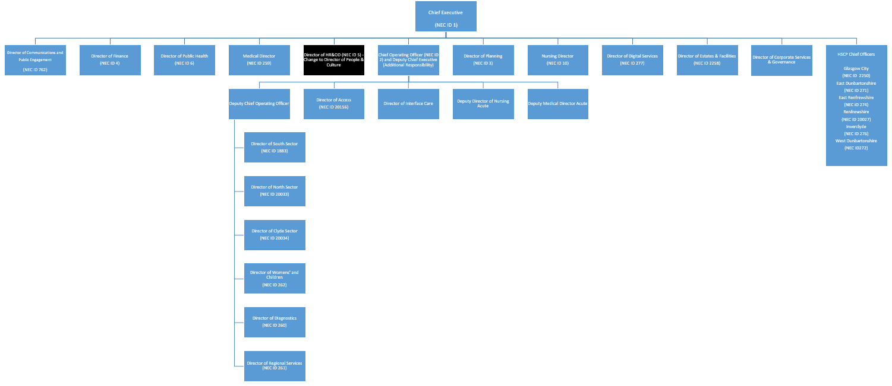

NHSGGC Values
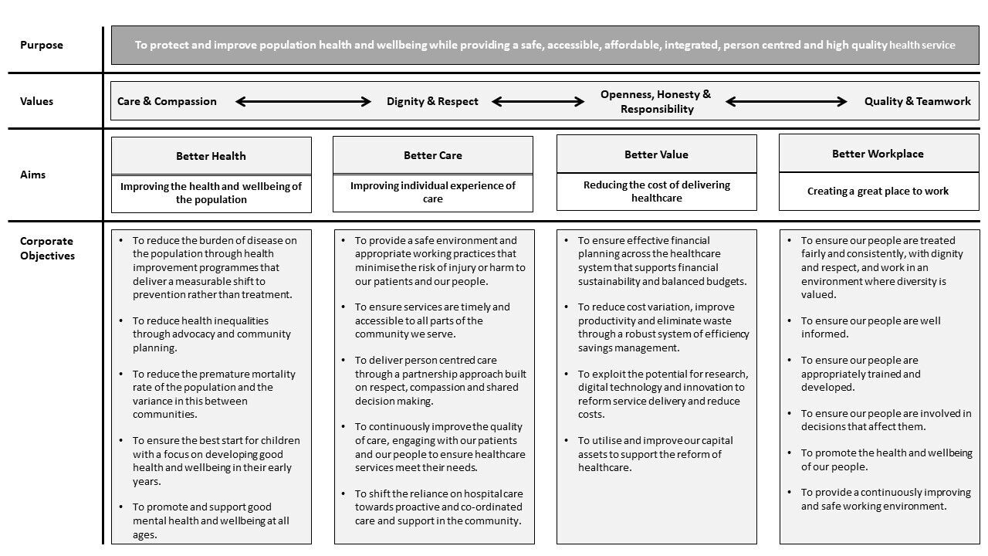

NHS Scotland Leadership Success Profile

The NHS Scotland Leadership Success Profile consists of nine behaviours in which candidates will be assessed against during the recruitment and selection process.

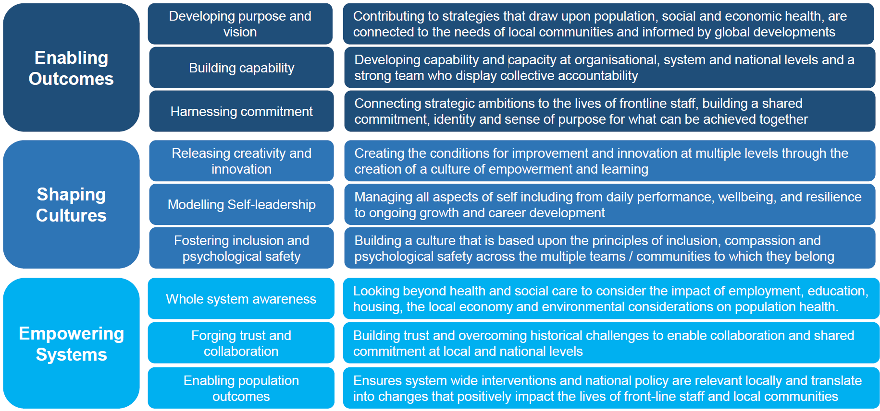

Terms and Conditions

Executive Pay and Terms and Conditions of service are under the direction of the Cabinet Secretary for Health and Social Care.

Salary
The grade and salary range for this post is Grade G £130,912 - £173,906 per annum (pro-rata if applicable) Senior Managers | MSG

Please note grade and salary are indicative only and are subject to NEC job evaluation.
Placement on the range will be determined by a range of factors, taking into account current salary. The starting salary will be part of the formal offer of appointment. Progression through the pay range is on the basis of an annual assessment of performance in a year beginning 01 April and ending 31 March. A pay uplift determined by performance rating is applied in line with national circulars.

The post holder is expected to participate in the Board’s Executive on-call rota.

Contract tenure
Permanent

Hours of work
Full time: 37.5 hours per week.

The number and pattern of hours will reflect the demands of the post. There is no contractual right to additional pay or time off in lieu for additional hours. This will not affect individual rights under the Working Time Regulations.

Annual Leave
The annual leave entitlement is:

- 27 days upon commencement
- 29 days after 5 years’ service
- 33 days after 10 years’ service.

8 additional Public Holidays are allocated in addition for all Board employees.

Location
The base for this post will be Board Headquarters, J.B. Russell House, Gartnavel Royal Hospital, 1055 Great Western Road, Glasgow, G12 0XH.

The post will require you to travel throughout the Board’s area, and both within and out with Scotland, when necessary. Home to work expenses will be met by the post holder; however, all other travel expenses incurred as a result of your employment will be reimbursed by the Board.

Superannuation Scheme
New entrants to NHSGGC will be enrolled automatically into membership of the NHS Scotland Pension Scheme (managed by the Scottish Public Pensions Agency) or arrangements can be made to ‘opt out’ of the scheme.

Relocation expenses
Assistance with removal and associated expenses may be given and would be discussed and agreed prior to appointment.

Performance Appraisal and Personal Development
The annual performance cycle is from 01 April to 31 March. Performance is assessed against a performance plan, which contains individual service objectives relating to the Board’s corporate objectives and individual behavioural objectives based on the NHS Scotland Leadership Success Profile. The performance plan is agreed with the NHSGGC Chief Executive.

Performance against the plan is assessed by the NHSGGC Chief Executive and performance is rated on a five-point rating scale.

Other Terms and Conditions of Service
Terms and Conditions of Service which are not set down in the arrangements for Executive and Senior Managers Pay are those contained within the NHS Scotland Agenda for Change Terms and Conditions Handbook, and the Board’s Policies | NHS Scotland

Recruitment Process

The recruitment process for this role will involve a range of selection activities allowing you to demonstrate your knowledge, skills and talent to various panel members.

The table below summarises the dates when the selection activities will be facilitated to enable candidates to plan their diaries accordingly. Any changes to these dates will be communicated with candidates at the earliest opportunity.

Face-to-face assessment exercises will be conducted in Glasgow, UK.

Recruitment Stage | Date
Advert Opens | 8 June 2026
Advert Closes | 5 July 2026
Shortlisting | week commencing 6 July 2026
Psychometric Testing | week commencing 13 July 2026
Stakeholder Event | week commencing 20 July 2026
Final Panel Interview | week commencing 3 August 2026

About NHS Greater Glasgow and Clyde
Greater Glasgow Health Board (“the Board”) was established on 1 April 1974, under the National Health Service (Scotland) Act 1972, with responsibility for providing health care services for the residents of Greater Glasgow. On 1 April 2006 the area covered by the Board was enlarged to include the Clyde area of the former Argyll and Clyde Health Board. NHSGGC serves a population of approximately 1.3m. The Board also provides a wide range of regional West of Scotland Services and National services. The image below shows the geographical area covered by the Board.
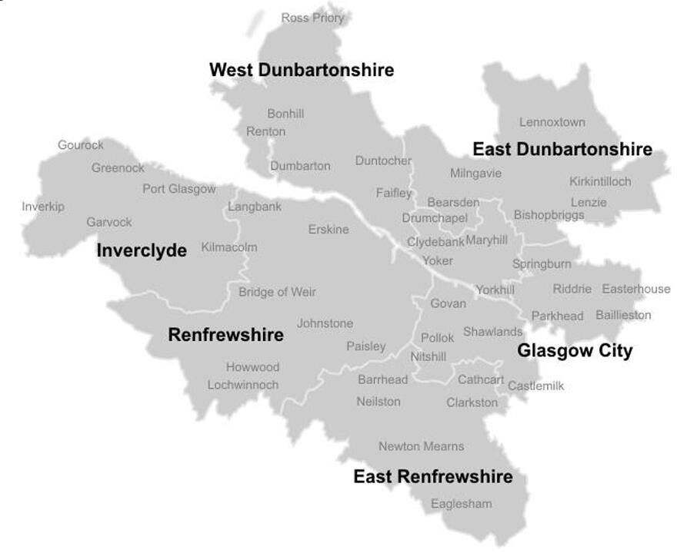
NHSGGC has a statutory duty to plan, commission, and deliver, healthcare for the residents of the local authority areas of Glasgow City, Inverclyde, Renfrewshire, East Dunbartonshire, East Renfrewshire and West Dunbartonshire. In delivering this NHSGGC works with the Scottish Government, our 6 Integrated Joint Board (IJB) partners, community planning partnerships, other NHS bodies, and other organisations in the public sector such as local authorities, the police, and the fire and rescue service. This partnership approach supports the implementation and delivery of the strategies and plans of NHSGGC, our 6 IJB partners, and the Scottish Government.

Our six IJB partners are:
- Glasgow City Health and Social Care Partnership
- Inverclyde Health and Social Care Partnership
- Renfrewshire Health and Social Care Partnership
- East Dunbartonshire Health and Social Care Partnership
- East Renfrewshire Health and Social Care Partnership
- West Dunbartonshire Health and Social Care Partnership

The overall purpose of the Board is to protect and improve population health and wellbeing whilst providing safe, accessible, affordable, integrated, person centred and high quality health services. To realise the overall purpose, the Board has developed a suite of values (based on those of NHS Scotland), aims and corporate objectives described as the Corporate Statements. In addition, Annual Operating Priorities are created in line with the Corporate Objectives and the Annual Delivery Plan which is submitted to the Scottish Government.

NHSGGC works to the 4 NHS Scotland key values:

- Care and compassion
- Dignity and respect
- Openness, honesty and responsibility
- Quality and teamwork

With these values at the forefront, the Board aims to improve health and individual care, whilst also reducing the cost of delivering healthcare. It is important that in doing so, the Board also creates a great place to work for all staff.

The Board has 4 corporate aims which each align to a set of corporate objectives:
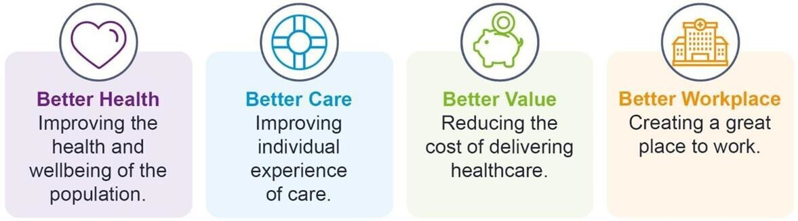

Each of these corporate aims is underpinned by the following corporate objectives:

Better Health
- To reduce the burden of disease on the population through health improvement programmes that deliver a measurable shift to prevention rather than treatment.
- To reduce health inequalities through advocacy and community planning.
- To reduce the premature mortality rate of the population and the variance in this between communities.
- To ensure the best start for children with a focus on developing good health and wellbeing in their early years.
- To promote and support good mental health and wellbeing at all ages.

Better Care
- To provide a safe environment and appropriate working practices that minimise the risk of injury or harm to our patients and our people.
- To ensure services are timely and accessible to all parts of the community we serve.
- To deliver person centred care through a partnership approach built on respect, compassion and shared decision making.
- To continuously improve the quality of care, engaging with our patients and our people to ensure healthcare services meet their needs.
- To shift the reliance on hospital care towards proactive and co-ordinated care and support in the community.

Better Value
- To ensure effective financial planning across the healthcare system that supports financial sustainability and balanced budgets.
- To reduce cost variation, improve productivity and eliminate waste through a robust system of efficiency savings management.
- To exploit the potential for research, digital technology and innovation to reform service delivery and reduce costs.
- To utilise and improve our capital assets to support the reform of healthcare.

Better Workplace
- To ensure our people are treated fairly and consistently, with dignity and respect, and work in an environment where diversity is valued.
- To ensure our people are well informed.
- To ensure our people are appropriately trained and developed.
- To ensure our people are involved in decisions that affect them.
- To promote the health and wellbeing of our people.
- To provide a continuously improving and safe working environment.

The Board provides services through approximately 6,000 beds across:
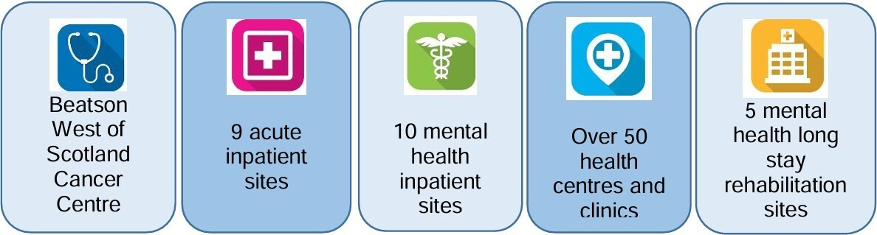

The Board monitors its performance against a range of quality and performance measures and submits performance information to the Scottish Government and other bodies throughout the year. You can find up-to-date information on health matters via the Public Health Scotland website.

There are 6 teaching hospital sites with additional teaching and research facilities for Medical, Nursing and Allied Health Professionals across Acute Services, which have responsibility for ensuring effective partnerships with 4 universities and local colleges who play a vital role in the education and training of all our health care professionals:

- University of Glasgow
- Glasgow Caledonian University
- University of Strathclyde
- The University of the West of Scotland

In addition we are supported by our Board wide Corporate Service’s directorates including Public Health, Estates and Facilities, eHealth, as well as corporate teams in Finance, Planning and Human Resources and Organisational Development and other specialist services.

We are committed to delivering high quality, innovative health and social care that is person-centred. Our ambition is to be a quality-driven organisation that cares about people - patients, their relatives and carers and our staff - and is focused on achieving a healthier life for all.

When you work with NHSGGC, you will have access to an attractive benefits package with training and support to expand your skills and progress your career. For roles which demand it, we also offer pay enhancements on top of your basic salary for out-of-hours, shift and overtime working.

We also offer comprehensive maternity, paternity and adoption leave schemes with benefits in excess of the statutory schemes.

We recognise that many employees have caring responsibilities outside of work and that from time to time, emergency leave may be required.

We offer a number of schemes to help staff combine work and home life. Colleagues within NHSGGC are currently taking advantage of a large range of flexible working opportunities, including part-time working, job sharing, compressed hours, unpaid employment breaks and flexible working.

Visit the NHSGGC Staff Benefits website for more information on what is on offer, including:

- Annual leave  - Continuing professional development opportunities  - Flexible working  - High street discounts  - Personal qualifications  - Staff bursary scheme  - Travel to work assistance  - NHS Credit Union | - Gym membership  - Pensions  - Cycle to Work scheme  - Library network  - Staff flu vaccination programme  - Employee assistance  - Volunteering  - Career Ambassador

Useful Publications

The following publications and websites will provide an overview of the current priorities, strategies and Board members.

NHSGGC Board
Meet the Board
NHSGGC Board Meeting Agendas, Papers & Minutes

NHSGGC Strategies
Workforce Strategy 2025-2030
Quality Strategy 2024-2029
Stakeholder Communications and Engagement Strategy 2024-2027
Public Health Strategy 2018-2028
Digital Health & Care Strategy – Digital on Demand 2023-2028
Equalities Strategy: A Fairer NHSGGC 2020-2024
Transforming Together

NHSGGC Finance
Annual Report and Consolidated Account for year ended 31 March 2025

About Greater Glasgow and Clyde
Living and working in Greater Glasgow and Clyde

