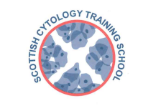

Scottish Cytology Training School

Course Programme 2025

28th January | Update Course
3rd – 5th February | Pre-Exam Course
3rd – 4th March | Training Workshop – The Coombe
26th March | Update Course
13th May | Medic Update Course
28th May | Assessors Course
19th June | Update Course
19th – 21st August | Pre-Exam Course
6th – 10th October | ST1 Introductory Course
11th November | Update Course
4th December | Assessors Course

Additional outreach/workshop days TBA
Topics for Update courses may include:-

- Cytology and Management Pathways
- Categorising Invasive Cancer Reviews
- Borderline and Squamous Metaplasia

No course fee is charged for gynae cytology courses to non-medical staff employees of Scottish NHS Trusts

Non-NHS Scotland laboratories price on application

