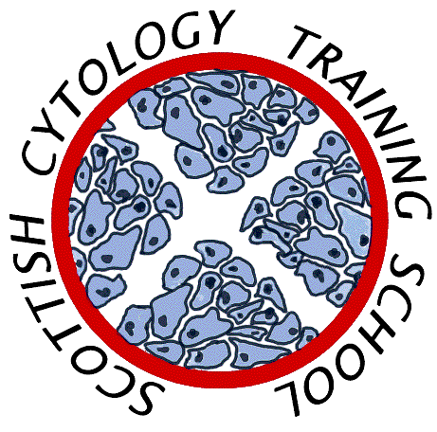

Scottish Cytology Training School

Course Programme 2024

10th January | Training Officer/Assessor Meeting
1st February | Update Course
30th April | Training Officer/Assessor Meeting
14th May | Update Course
28th May | Medic Update Course
19th June | Update Course
19th – 21st August | Pre-exam Course
9th –13th September | Introductory Course Part 2
30th September – 4th October | ST1 Introductory Course
30th October | Training Officer/Assessor Meeting
6th November | Update Course
3rd December | Update Course

Additional outreach/workshop days TBA
Topics for Update courses may include:-

- Cytology and Management Pathways
- Categorising Invasive Cancer Reviews
- Borderline and Squamous Metaplasia

No course fee is charged for gynae cytology courses to non-medical staff employees of Scottish NHS Trusts

Non-NHS Scotland laboratories price on application

