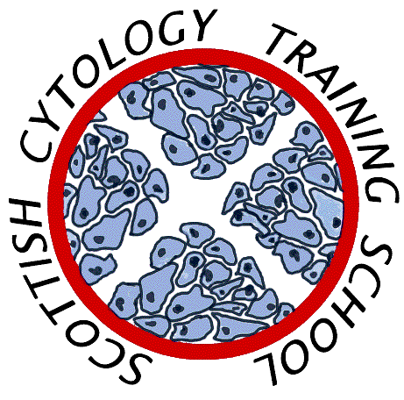

Scottish Cytology Training School

Course Programme 2023

18th January | Update Course
22nd February | Update Course
13th – 24th March | Introductory Course Part 1a
5th April | Medic Update Course
17th – 28th April | Introductory Course Part 1b
16th May | Update Course
24th May | Training Officer/Assessor Course
23rd – 25th August | Pre-exam Course
4th – 8th September | Introductory Course Part 2
2nd – 6th October | ST1 Introductory Course
2nd November | Update Course

Additional outreach/workshop days TBA
Colposcopists and sample taker training by arrangement
Topics for Update courses may include:-

- Cytology in the Primary HPV screening era
- Challenging Cases
- Borderline and Squamous Metaplasia

No course fee is charged for gynae cytology courses to non-medical staff employees of Scottish NHS Trusts

Non-NHS Scotland laboratories price on application

