Health & Safety Management Manual
COSHH Guidance – Hazard Pictograms

The European Regulation on classification, labelling and packaging of substances and mixtures (CLP) has updated hazard pictograms which help us to know that the chemicals we are using might cause harm to people or the environment. The CLP hazard pictograms are very similar to those used in the old labelling system and appear in the shape of a diamond with a distinctive red border and white background. One or more pictograms might appear on the labelling of a single chemical.

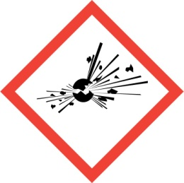  Explosive  (Symbol: exploding bomb) | 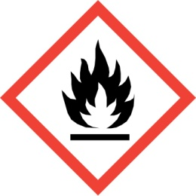  Flammable  (Symbol: flame)
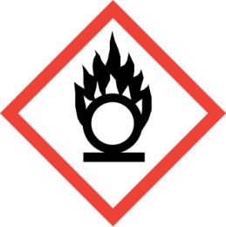  Oxidising  (Symbol: flame over circle) | 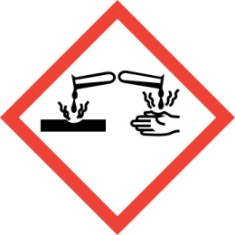  Corrosive  (Symbol: Corrosion)
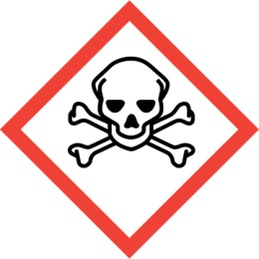  Acute toxicity  (Symbol: Skull and crossbones) | 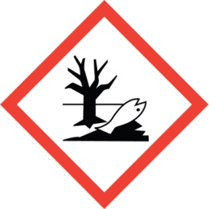  Hazardous to the environment  (Symbol: Dead tree and fish)
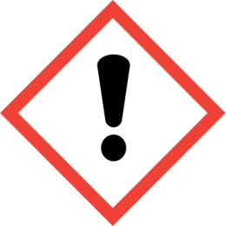  Health hazard/Hazardous to the ozone layer  (Symbol: Exclamation mark) | 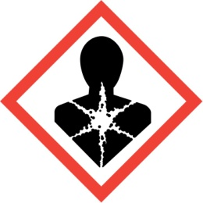  Serious health hazard  (Symbol: health hazard)
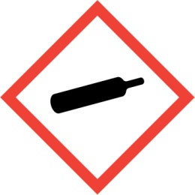
Gas under pressure
(Symbol: Gas cylinder)

