

**Daily update**

**(26 August 2021, 3.25pm)**

Topics in this Core Brief:

* Mental Health Check In – closes Friday 27 August
* Frances McLinden, South Sector Director continues to introduce the Major Trauma Centre and team – today it’s the role of the AHP Rehabilitation Consultant
* September Payroll Cut-Off Date - eESS Downtime
* Guidance on RIDDOR and COVID-19 – update

|  |  |
| --- | --- |
| cid:image003.jpg@01D79A89.7B3AB100 | cid:image005.jpg@01D79A89.7B3AB100 |
| This is your last chance to complete the Mental Health Check In which closes tomorrow (Friday 27 August)!  All staff are being asked to please complete the online questionnaire, even if you filled it in previously and even if you currently feel well. Sometimes people may be experiencing or about to experience mental well-being issues unexpectedly and early intervention may help to resolve any potential or emerging worries or anxieties before they become more difficult to work through.  More information is available on the [Mental Health Check In website](https://www.nhsggc.org.uk/about-us/professional-support-sites/mental-health-check-in/) where you will also find a FAQ page. You can also scan the QR code above, which will take you direct to the online information. | |

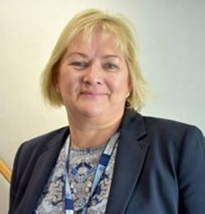**Frances McLinden, South Sector Director introduces the Major Trauma**

**Centre and team**

**New ways of working – AHP Rehabilitation**

Rehabilitation is a key part of the major trauma network and essential to good

trauma care and good recovery.

The aim of the network is not only saving lives but giving life back and following

major trauma, rehabilitation is essential for patients to address the physical and

psychosocial needs that result from their injuries and experiences.   Without such input, patients are unlikely to return to their maximum levels of function, which has significant implications for them, their formal and informal carers and society as a whole.

The ethos of the major trauma ward is one of trauma rehabilitation and we have created a specialist rehabilitation service which will provide rehabilitation support to patients from day one.

One of the new roles we have developed is that of the [AHP Rehabilitation Consultant (see video below)](https://youtu.be/ns-zIy7L5BM) and I would like to introduce you to Karen Scott who has and will continue to support developing the specialist rehabilitation element of the service.

[](https://youtu.be/ns-zIy7L5BM)

**September Payroll Cut-Off Date - eESS Downtime**

A period of downtime for the eESS system has been planned from between 12 noon on Thursday 23 September until Tuesday 28 September. During this time, the payroll interface will be suspended. Managers should please ensure any payroll transactions for staff in September are processed as early as possible ahead of the next Payroll cut-off date at 5pm on Friday 17 September. Your support is greatly appreciated.

**Guidance on RIDDOR and COVID-19 - update**

In line with the organisation’s Incident Management & Recording Policy, NHSGGC is committed to the delivery of effective, safe, and person centred care ensuring there will be no avoidable injury or harm to people or adverse impact on the organisation resulting from the delivery of healthcare or other work related activity.

The policy includes the requirement to report certain serious workplace accidents, occupational diseases and specified dangerous occurrences (near misses) in line with the Reporting of Injuries, Diseases, and Dangerous Occurrences Regulations 2013 (RIDDOR) to the Health and Safety Executive. COVID-19 (Coronavirus) has led to an update from the Health and Safety Executive (HSE) on these regulations.

A guidance document to support Managers has been developed and is available here – [Guidance on RIDDOR and COVID-19](https://www.nhsggc.org.uk/working-with-us/hr-connect/health-safety/policies-guidance-documents-forms/incident-accident-management/covid-riddor-reporting/).

Please contact the Health and Safety department for any further information.

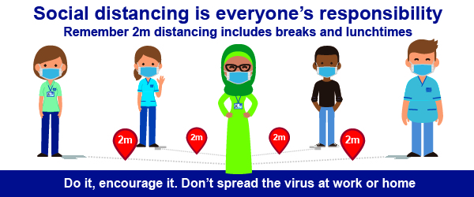

Please keep up-to-date with the latest guidance on our dedicated web pages at: [www.nhsggc.org.uk/covid19](http://www.nhsggc.org.uk/covid19). If you have any questions about the current situation please check the [FAQs](https://www.nhsggc.org.uk/your-health/health-issues/covid-19-coronavirus/for-nhsggc-staff/faqs/) first. If you have any further questions, please email: [staff.covid19@ggc.scot.nhs.uk](mailto:staff.covid19@ggc.scot.nhs.uk)

***Staff are reminded to make sure their [personal contact details are up to date on eESS.](https://www.eess.nhs.scot/ess/)***

;

**It is important to share Core Brief with colleagues who do not have access to a computer.   
A full archive of printable PDFs are available on** [StaffNet](http://nhsggc.us12.list-manage.com/track/click?u=0f385b5aea37eaf0213bd19fb&id=4a0fd596c9&e=5af5e1832c)