Use QR Code or Click date to register.
Tuesday July 8th 230-330 pm | 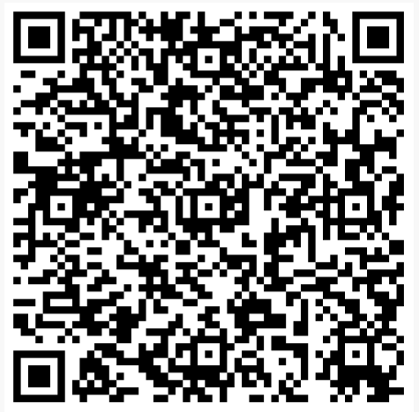 | Tuesday 29th July 230-330pm | 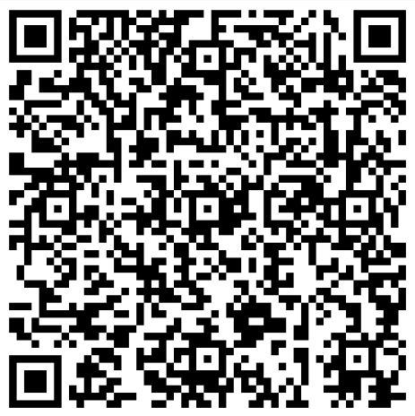 | Thursday 14th August 230-330pm | 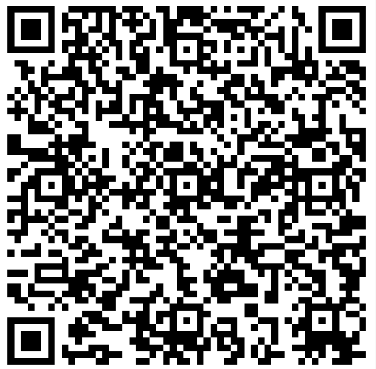
Tuesday 15th July 230-330pm | 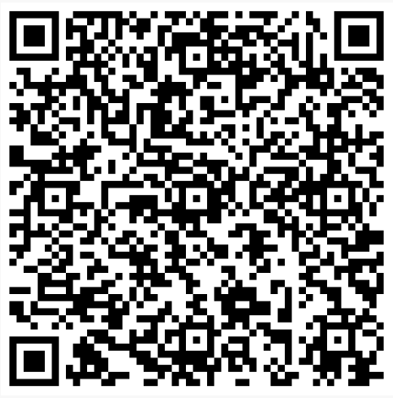 | Thursday 31st July 230-330pm | 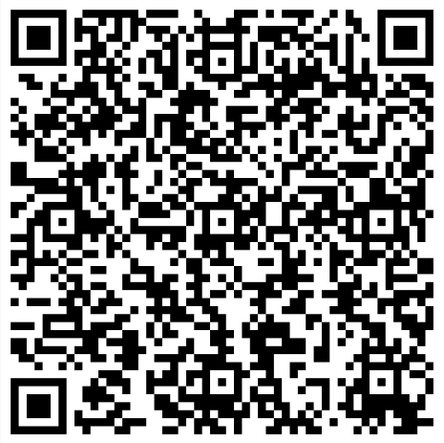 | Wednesday 20th August 230-330pm | 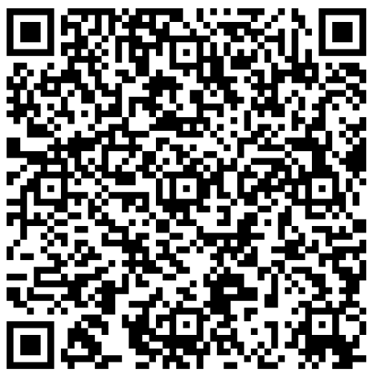
Thursday 17th July 230-330pm | 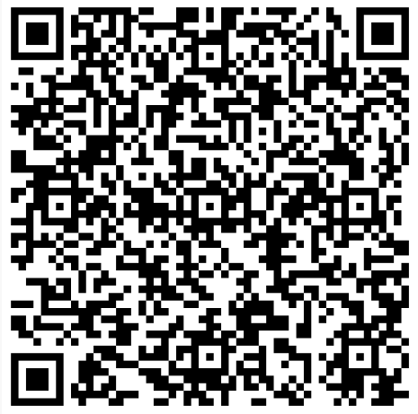 | Tuesday 5th August 230-330pm | 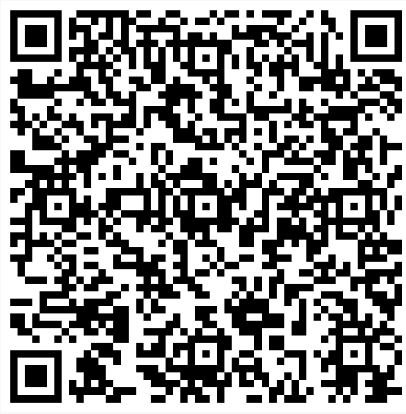 | Thursday 21st August 230-330pm | 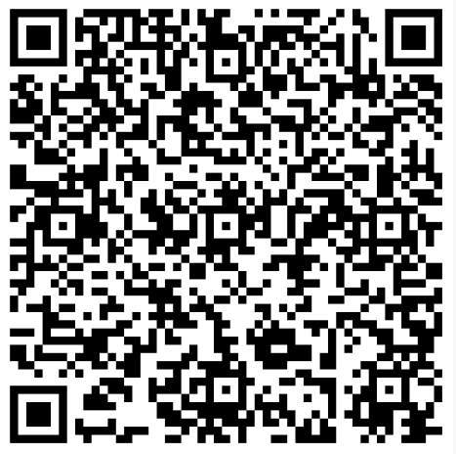
Tuesday 22nd July 230-330pm | 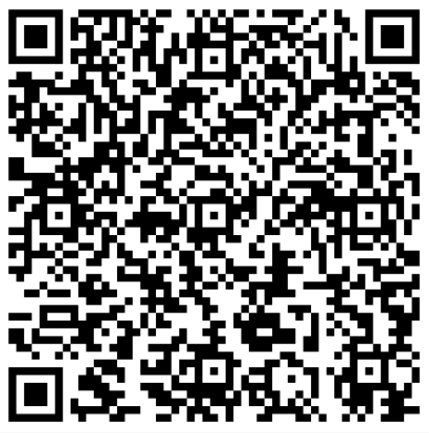 | Wednesday 6th August 230-330pm | 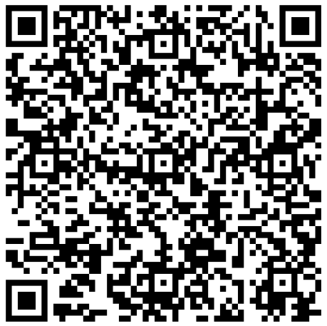 | Tuesday 26th August 230-330pm | 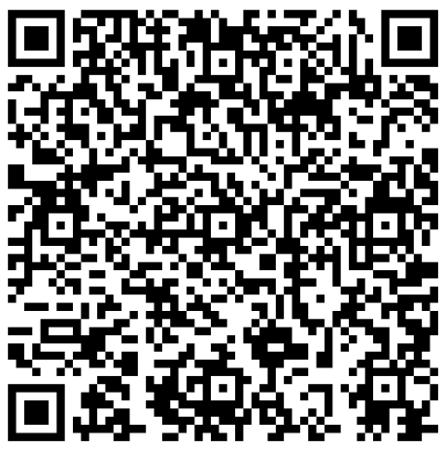
Thursday 24th July 230-330pm | 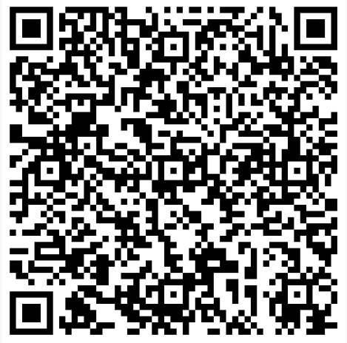 | Wednesday 13th August 230-330pm | 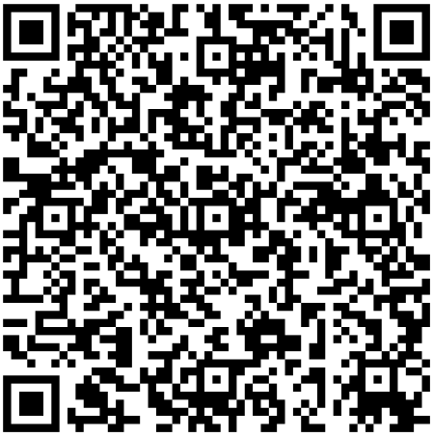 | Wednesday 27th August 230-330pm | 