Caring for Smiles
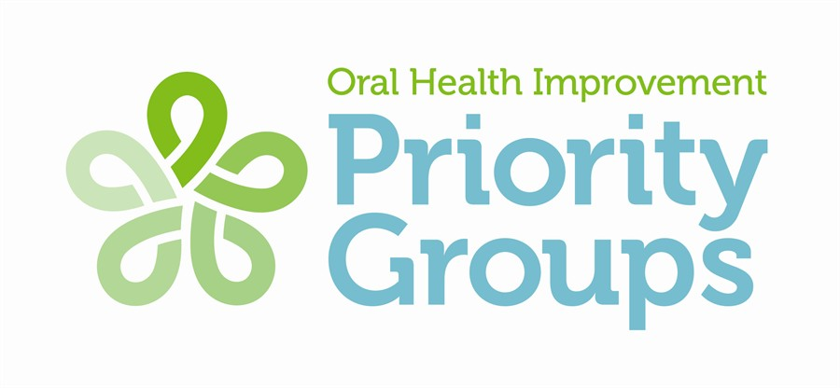
Non-accredited training
Better oral care for dependent older people

Caring for Smiles is Scotland’s national oral health, training and support programme, which aims to improve the oral health of older people particularly those living in care homes.

Education and training of staff play an important role in the delivery and improvement of oral care. All care staff including supervisors and managers are encouraged to take up Caring for Smiles training where it is available.

Staff are invited to attend a 2 hour training session between 2.00 pm – 4.00 pm, delivered by NHSGG&C, Oral Health Directorate.

If you have any issues please email ggc.oral.health@nhs.scot

Caring for Smiles – 0141 201 3553/4217

Kind regards
Margaret Munro
Oral Health Training Officer (Priority Groups)/Team Lead

LEARNING OUTCOMES

LO 1 - demonstrate an understanding of why good oral health is important
LO 2 - Recognise the factors that contribute to poor oral health
LO 3 - Confidently carry out day-to-day oral care for residents who require assistance
LO 4 - Know when and how to report any health concerns
LO5 - Understand the importance of the different oral care forms e.g risk assessment, care plans and daily documentation
LO6 - To be able to carry out an oral health risk assessment
LO7 - Understand what techniques and strategies may help those residents with dementia who resist oral care.

2/

PLEASE RIGHT CLICK YOUR CHOSEN DATE AND SELECT “OPEN HYPERLINK"

THIS WILL OPEN THE REGISTRATION PAGE TO COMPLETE YOUR DETAILS TO REGISTER

Wednesday 3rd September 2025

https://link.webropolsurveys.com/EP/31532F731B0118E0

Wednesday 10th September 2025

https://link.webropolsurveys.com/EP/3859E27C948BA292

Wednesday 17th September 2025

https://link.webropolsurveys.com/EP/CD371607F92BAA2A

Wednesday 24th September 2025

https://link.webropolsurveys.com/EP/4C2A1798BE531089

