Care Opinion – Frequently Asked Questions

Q. Why can’t I respond to posts?
A. The most common cause of this is your account being signed out. Sometimes when using a new computer or internet browser, or after a system update you will become logged out, which prevents you from responding. Check the tab at the top right of the page to see if you are logged in correctly. It should look like this:
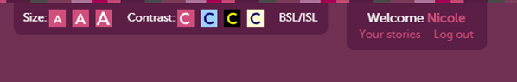

Q. Why isn’t the link in my email notification working?
A. Please note that the link included in the alert email only works once before requiring you to sign in. If you have already clicked it and moved computer or closed a tab you will need to log in to the Care Opinion website to respond to the story.

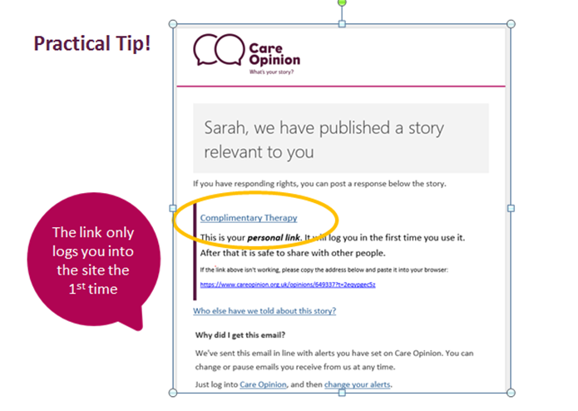

Q. I’ve forgotten my password?
A. If you lose your log in details – please go to www.careopinion.org.uk log in page. Then click ‘Forgotten your password’. You will be asked to enter your email address and Care Opinion will send you an email with your details. If you don’ receive an email please check your junk email.

How do I search for stories?
A. If you click the white triangle next to the search button this will bring up the 'Your Search' Box and you can then customise your search



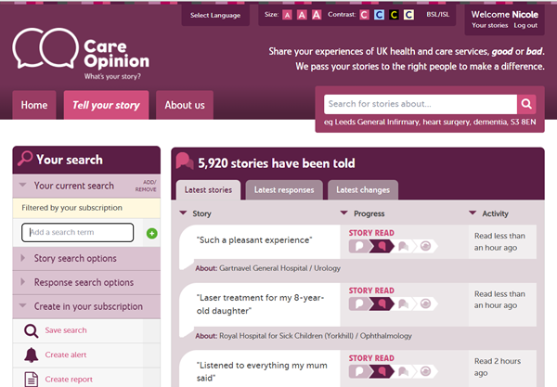

You can then type in what you are looking for;

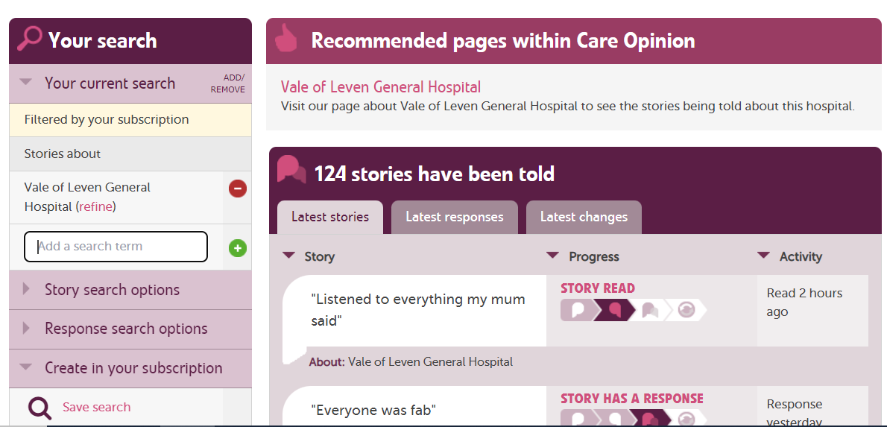

This search will show only stories relating from the Vale of Leven.

There are three important things to notice in the screenshot above:
- To add a term, type it in the box, and then click the green plus button
- To remove a term, click the red minus button next to it
- The search shown above will only show stories within your subscription. You know this because it shows the search "filtered by your subscription". If you don't see this on your search, then your search will begin from all the stories on Care Opinion, instead of just the stories in your own subscription.

One common mistake is to type a term in the box, or select an option from one of the additional subscriber filters, and forget to add it to the search with the green plus button

Q. Why isn’t my ward/service/specialty listed on Care Opinion?
A. The Care Opinion service tree is primarily based on Acute Services in NHS Greater Glasgow and Clyde. The tree lists hospital site first and then the services which are based at this site.
The names of some services have been changed to help the public identify them more easily, for example, Podiatry is listed as ‘Foot Care (Podiatry)’.

Although care has been taken to include as many services as possible, Care Opinion implementation is still on-going, so if you don’t see your service listed, please contact the PEPI team at PatientExperience@ggc.scot.nhs.uk

Q. Can I edit my response?
A. Once you have submitted a response you will have half an hour to make any changes to your response then it will either be read by a Care Opinion moderator or be made public.

Q. How do I share a story with my staff?
A. Each story on Care Opinion has its own unique link. This makes it easy to share stories with relevant staff.

To share a story, copy and paste the URL link. It will look like this:
Everyone in the ward was just so lovely | Care Opinion

Download as a PDF or Word Document
You can also download a copy of the story and any responses when you are logged in.
- Open the story
- Scroll down to under the "show your support box"
- Click "download story and responses"
- Choose your format
- Click "generate"

