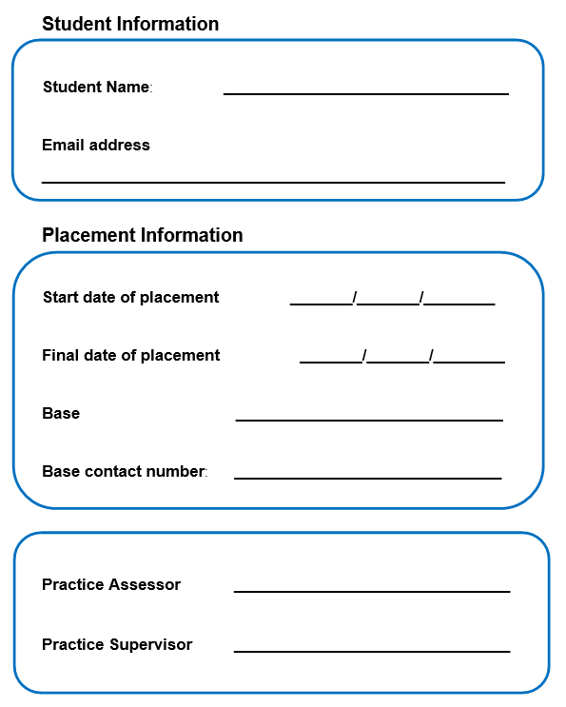[](https://www.bing.com/images/search?q=greater+glasgow+and+clyde+ns+logo&id=E1184621F5D93FB70E318F2CF901CF7A3CD32B55&FORM=IQFRBA)

***Care Home – Pre registration Student Nurse Learning Resource*** *–*

*“Developing essential knowledge, skills and Professional Behaviours*

Care Homes

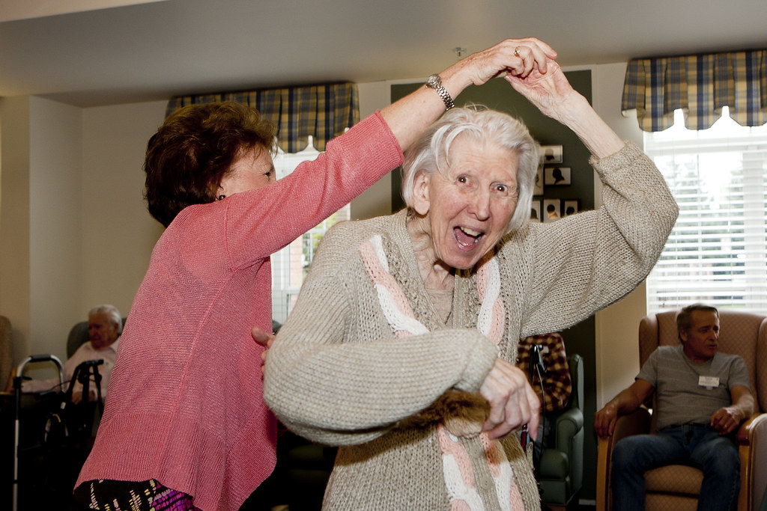

Care Home L earning Pack reviewed 2021, 2023

Add contents page and EDI check – still to be done post feedback

# Learners in the Care Home

Care homes for adults are unique and exciting Practice Learning Environments (PLE) for student nurses, because they are very different from hospital wards and community nursing teams. The residents live there, and receive care and nursing interventions, secondary to continuing to live fulfilling lives. The section below highlights the major differences between social care (care homes) and other PLEs you might have experienced, and the breadth and depth of learning available to you as a supernumerary student nurse. Remember, supernumerary means you are not counted as an official member of staff as outlined in the [Safe Staffing Act 2019](https://www.gov.scot/publications/health-and-care-staffing-scotland-act-2019-overview/), but will be expected to carry out personal care and other caring and nursing activities, as a member of the care home team. Please take a proactive role in your learning, seek out learning, spend time with the care assistants, spend time with the activities team and manager, and spend time with the nurse; learning what makes their job unique with their high levels of autonomy and independent clinical decision making.

Please follow this [“skills for health” link](https://www.skillsforcare.org.uk/resources/documents/Regulated-professions/Nursing/How-to-make-the-most-of-student-nurse-placements/How-to-make-the-most-of-student-nurse-placements-in-social-care-settings.pdf) which shows which platform proficiencies and skills annexes can be achieved in a care home placement – there are over 100 that can be signed off in your PAD. (See page 52 in the link in particular).

Adult placement students will receive a variety of experiences in the care home

placement, from person centred care planning for a new admission, palliative care nursing including complex drug calculations, right through to leading and managing a team of staff and delegating all the care activity for a shift. Care homes are a rich learning resource for communication from residents with varying diagnoses from dementia to learning disabilities to engaging with relatives, colleagues and the wider multi-disciplinary team to name a few. Pre-admission assessments, social work care reviews, weekly GP visits, safe storage and ordering of medication, fundamental nursing skills and understanding the legal side of Power of Attorney, Adults with Incapacity, audit systems and financial planning.

Mental health nursing students will find many learning opportunities in the care home environment. With ample opportunity to learn safe and effective personal care and practice appropriate moving and handling, students will also play a part in creating, reviewing, and discontinuing care plans for residents. Students will meet residents who have been assessed under the Adults with Incapacity Act and learn about the necessity for a section 47 certificate before personal care can be undertaken. Residents can sometimes be subject to community treatment orders under the Mental Health (Care and Treatment) (Scotland) Act 2003/2015. Those older people with functional mental illnesses such as Schizophrenia, Bipolar disorder and depression are just as likely to require assisted living in later life and care home placements represent an opportunity to learn about how these illnesses present as a person becomes older. Students may come across those with early onset dementia, Huntington's disease or Wernicke Korsakoff syndrome and compare their care to those living with advanced Dementia wand learn how meaningful activities can help their health and wellbeing. Care homes provide a vital resource to many people who are admitted to mental health areas as their care is 'stepped down' from acute hospital admission and student placements provide excellent experience for future mental health nurses.

Learning disabilities students will also have access to many learning experiences within a wide range of settings.  The care home environment is one such setting that offers a wealth of opportunities in developing fundamental knowledge and skills when caring for such a vulnerable population with a range of care needs. Many care homes support people living with a learning disability or who have similar cognitive and sensory difficulties; so many skills and experiences are transferrable. Students will be supported to engage in the delivery of safe, effective relationship based (person-centred / relationship based) care utilising nursing practices to enhance and maintain a person’s daily living activities, advocating for their needs and wishes, positive risk taking approaches and communicating in different ways to be able to connect with and be the voice of the people you are caring for. Learning disabilities students often have to go that extra mile with placements, by looking in depth at the care provided for people without a learning disability, and applying that to people encountered on previous placements, in order to demonstrate to supervisors and assessors that the overall module outcomes are also met. Frequently in care homes positive behavioural support approaches and solution focussed therapy is used to support a variety of people living in the home.

# Introduction to your care home placement workbook

Please complete this short questionnaire at the start your PLE in the Care Home.

|  |
| --- |
| **Write three words describing your impression of a care home, prior to starting.** |
| **What are your expectations regarding this Care Home placement?** |
| **What do you expect to learn in your Care Home placement? Which skills and proficiencies can be signed off?** |
| **What do you think the nursing role is in Care Homes?**  **How is this different when the resident lives in the home and you are therefore a guest?** |

# The Organisational Background

In March 2022, in Scotland there were 1,051 Care Homes for adults, with 33,352 people over 18 living in these care environments (Public Health Scotland, 2022). [Care home census for adults in Scotland - Statistics for 2012 – 2022 - Care home census for adults in Scotland - Publications - Public Health Scotland](https://www.publichealthscotland.scot/publications/care-home-census-for-adults-in-scotland/care-home-census-for-adults-in-scotland-statistics-for-2012-2022/#:~:text=On%2031%20March%202022%2C%20there,31%20March%202012%20(37%2C335).)

Most people moving into a care home in Scotland have been assessed as requiring 24 hour r nursing care and are likely to have highly complex health and social care needs. These assessments are carried out in partnership between social work services and NHS staff, but more importantly with the residents, their family, friends and informal care network. Some residents pay for their place in a care home, some pay part of it, and others are funded by the social work department (HSCP). This means there is a range of highly trained staff such as senior carers or nursing assistants, therefore a diverse group of people to learn from and skills to develop. Many senior carers are NMC practice supervisors.

The transition of a person moving from their own home into 24 hour residential and nursing care can be a distressing and difficult time both for residents and their families. Almost all the residents will die in the home too and will all have anticipatory care plans (future care planning) in place for this eventuality. Demonstrating care and compassion is essential in all areas of nursing, but especially so during life-changing transitions.

As well as the diversity of health and social care needs of people living in care homes, the skill mix of registered nurses and social care staff with varying qualifications and experience means that the philosophy of care is often different from the NHS. In most care homes, there is only one registered nurse who needs to prioritise the health and wellbeing of all of the residents themselves, including making clinical assessments and decisions independently. This is a significant skill in itself.

It is extremely important to acknowledge that people do not enter Care Homes with the expectation of requiring hospital-based technological intervention. A Care Home environment should be an extension of the person’s own home. This means as a learner, you must understand the theoretical principles taught in University and apply them to the environment in which you practice. There is not a cupboard full of supplies to use, each care or nursing item is bought by the resident, or prescribed on an individual basis. This is why Care Homes are operated, registered and regulated in a completely different, and much more stringent way to the NHS.

To find out more about the inspection and regulation of Care Standards in Care Homes please log onto [www.careinspectorate.com](http://www.careinspectorate.com/)

The Care Inspectorate (formerly known as the Care Commission), are responsible to the Scottish Government for the regulation of, inspection of and supporting improvements in Care Homes and other services.

You should make yourself familiar with the key Health and Social care Standards,

- [My Support, My Life](https://www.gov.scot/Resource/0052/00520693.pdf).

There is also a free online learning resource, ‘Care Home Nursing: Changing Perspectives’ that would be of benefit for you to access. <https://www.futurelearn.com/courses/nursing-care-homes>

Further reading and information available from Scottish Care <https://scottishcare.org/>

SSSC <https://www.sssc.uk.com/>

Scottish Government - <https://www.gov.scot/publications/coronavirus-covid-19-open-with-care---supporting-meaningful-contact-for-care-home-residents-at-and-after-level-0-letter-to-sector/>

# Care Home team structures and The SSSC

Within Social Care and Care Home environments, there is a regulatory body called the Scottish Social Services Council (SSSC). All staff in a caring role (besides NMC registered nurses) must be registered with the SSSC and undergo significant number of Scottish Vocational Qualifications (SVQ) modules and courses up to and including SVQ level 5 - (equivalent to your degree). The SSSC has a [Code of Practice](https://www.sssc.uk.com/the-scottish-social-services-council/sssc-codes-of-practice/) which outlines clear standards of professional practice and behaviour that all registrants must follow – this closely aligns with the same principles of the NMC’s Code of Conduct. This is very different to the way NHS health care support workers HCSW are trained and supported currently.

In social care and care home environments, there is a noticeable difference in the staffing structure to the staff structure in the NHS.

Care Home Manager

Deputy Manager/Clinical Services Manager

Registered Nurse(s) - 1 or 2 on shift for the home

SSSC Senior Carers

SSSC Carers

Ancillary Staff - Chefs, Receptionsist, Activity Co-ordinators, Maintainance staff

SSSC senior carers have completed additional qualifications to enable them to take on an extended role within care. They have a higher level of skill because of this – and student can learn greatly from them.

These extended roles often surprise nursing students as SSSC senior carers may be trained to complete medication administration and many other clinical activities within their care homes. For example, senior carers might complete care plans and wound management. This is an aspect which is very specific to social care, and not usually seen in the NHS.

As a result of their extended knowledge and skills, the NMC have recognised the contribution that these carers have in relation to student nurses – therefore they have deemed that SSSC senior carers (who are on the supervisor section of their register) can become NMC Practice Supervisors. (Supervisor only, not Practice Assessor.)

It is important to note however that if your Practice Supervisor is a SSSC senior carer, that they are not able to supervise you administering medications. This is due to the fact they are on a different register than you are working towards. However, you can shadow, observe and discuss the administration of medicines with you, provided that they administer them to the resident.

# LEARNING OPPORTUNITIES IN CARE HOMES

### A note on personal care, food fluid nutrition, and essential care activity.

Because the residents live in the home, they will have extensive and often complex care plans, so that all their daily needs, wants and lifestyle choices are met, and so that care and nursing can be dovetailed with these needs. For example, a resident admitted to a home recently likes a glass of milk on waking at 11 am, then two cups of coffee, then tea in the afternoon, then orange juice with his evening meal, and water up until he goes to bed at 1 am. This has been his whole life routine so must be continued now that he lives in a care home.

Because of the complexity of care planning, it is essential that you spend time getting to know the resident's and their care plans, by working closely with them, attending to personal and essential care, food fluid and nutrition and continence management.

In addition to this it is essential to acknowledge that a registered nurse attending to someone's personal care, is very different to a carer attending to this. Nurses are simultaneously undertaking clinical and dynamic risk assessments as well as undertaking the physical washing and dressing task with a resident; in no specific order of priority the nurse must assess-

Cognitive state, stress and distress levels, speech, alertness, mood, emotions, skin colour, appearance and temperature, mobility, signs of weight loss or gain e.g. loose clothes and rings, dexterity, falls risk and balance, colour and odour of urine, frequency colour and consistency of bowel movement, pressure areas, eye, nose, ear and mouth health, nail health and cleanliness, respiratory rate, presence of cough, sputum colour, consistency, vision and hearing, quality of hair, their room / environment assessment – trip hazards, evidence of hiding food, cleanliness of environment, room temperature and lighting, security devices such as, falls mats, bed rails or crash mats, maintenance of PEG pump, location of call bell, cleanliness of equipment, furniture and personal effects such as spectacles and hearing aids, levels of clothing, toiletries and clinical products in stock, integrity of wound dressings, quality of footwear (dynamic falls assessments) pain levels, locations, descriptions and intensity, ability to chew and swallow, amount of food and fluid consumed, any nausea or vomiting, colour consistency of vomit, ability to use moving and handling equipment, assess ability to consent, was their continence product fitted correctly, what is the quality of their speech and many more.



# ACTIVITIES

## “Grab Bag” Activities for students.

The Care Home Education Facilitators (CHEFs) recognise that Practice Assessors and Practice Supervisors can be very busy at times and thus have provided activities for students to work on independently at the care home when clinical activity is particularly high.

So, what are they?

Bite sized learning activities that students can pick up and complete whilst on placement.

They are designed to be interactive, related to the residents you are caring for and self-directed.

One or two sided, A4 sized activity sheets and a range of topics.

Each worksheet will help towards evidencing to your practice supervisors your achievement of platform proficiencies and skills annexes so they can be signed off.

Please print out a copy or photocopy a sheet for your use so future students can also use them too.

**The care home will have copies of these activities in a folder to copy, or in digital format to print off – please ask.**

## Care Home / Social care Workbook Activities

You will be allocated time during placement to complete some / all of these activities by your PS/PA - you can choose which you feel fit your learning requirements. They can be done in order or as your PS/PA advises in line with your learning objectives, proficiencies and available learning opportunities. At the end of each activity there is space for you to reflect on that week in light of your new learning. Discuss the activities with your PS/PA after you complete each one. The evidence gathered, can be used to assist staff signing off your proficiencies at the back of the PAD. Try focusing on one activity per week.

### ACTIVITY ONE:- A TEAM APPROACH TO CARING

Identify the managerial and staffing structure within the Care Home environment. Plan time with each staff member to discuss their roles, responsibilities and any challenges they face; include the Care Home Manager, senior carers, Registered Nurse, Carers, Activity Coordinator, Cook/Chef and any other staff.

Following these discussions, produce a short summary denoting the main roles and responsibilities of these staff members.

Complete a reflection of this week’s learning.

*Change family names and details within your reflection to preserve confidentiality.

Visit the Scottish Social Services Council (SSSC) website and compare their codes of practice to the NMC code of conduct

**Helpful Hints (questions to ask):-**

What are your main duties and responsibilities?

When and how do you decide to involve other health professionals in aspects of residents’ health and well-being?

What aspects of each role provide learning opportunities for nursing students?

What do you believe are the most positive aspects of working in a Care Home?

Do you think there are any challenges in working in Care Homes?

How do you keep up to date with current practice?

What do you believe are the differences in your role as compared to NHS hospital-based staff?

***Related NMC Platform:-***

***Platform 1 – Being an accountable professional***

***Platform 5 – Leading and managing nursing care and working in teams***

***Platform 7 – Coordinating Care***

REFLECTION ON PRACTICE



### ACTIVITY TWO:– HEALTH AND SOCIAL CARE STANDARDS

This week familiarise yourself with the [Health and Social care Standards](https://www.gov.scot/Resource/0052/00520693.pdf) (2017).A copy can be found in the Care Home or accessed via the Scottish Government website. Pay particular attention to the five underlying principles of dignity and respect, compassion, being included, responsive care and support, and wellbeing.

Choose three residents in conjunction with your PS, read their care plans and consider how each individual’s care is mapped to the five underlying principles.

Complete a reflection of this week’s learning.

*Change family names and details within your reflection to preserve confidentiality.

**Helpful Hints:-**

Consider each principle and provide specific examples of how the staff team (and yourself) have provided person-centred care i.e. Principle 2.22. Mr S was a professional footballer when younger. He is supported in a person- centred way to maintain his interest in football by being accompanied by care home staff each week to the local football match.

Look at the care plans for residents. Do they include a personal history/social story/personal history which is reflected in their activities and choices about how they are supported by staff?

What documentation does the hospital or community social work provide to help start creating care plans?

Observe the interaction between staff and visitors. Is privacy provided by families/groups when required?

Do any residents access NHS services i.e. Speech and Language, Dieticians, Mental Health support? How is this accessed?

What are the links and integration with the local community? Do residents go on outings or holidays?

Are resident’s individual likes/dislikes regarding food taken into consideration

***Related NMC Platform:-***

***Platform 1 – Being an accountable professional***

***Platform 3 – Assessing Needs and Planning Care***

***Platform 4 – Providing and Evaluating Care***

***Platform 7 – Coordinating Care***

REFLECTION ON PRACTICE



### ACTIVITY THREE:- Prevention and Control of Infection.

This week, familiarise yourself with the Prevention and Control of Infection policy within the care home. Who developed this policy?

If you have had a prior placement in the NHS, how does this compare with policies and guidance set by the NHS and nationally? Are there significant differences between care homes, hospitals and the community?

Consider the key documents upon which best practice is underpinned such as national and local strategies, drivers, guidelines or policies which pertain to care homes. Find out about any current initiatives within the care home.

Choose, with your PS/PA’s help, a resident* or group of residents* who have particular needs which require consideration of infection control policies. Identify these needs and discuss with your PS/PA how these needs can be met.

Complete a record of this week’s learning.

*Change family names and details within your work to preserve confidentiality.

**Helpful Hints:-**

You may find it useful to have completed the [Scottish Infection Prevention and Control Education Pathway](https://learn.nes.nhs.scot/2482) (SIPCEP)

Does the company who owns the home create their own policies? Why would they need to do this?

Consider any situations which may require additional infection control measures or public health reporting, eg. Flu virus or Norovirus (transmission based precautions). Why might a resident be considered vulnerable in relation to infection prevention?

How is PPE accessed? Where is PPE kept? How much does PPE cost? How do staff decide whether they need to use PPE? Discuss with members of the staff team the overall philosophy of care. How does it differ to an acute hospital setting?

What about spread of infection when a resident likes to walk all around the home?

What are the local arrangements for disposal of hazardous/infectious substances?

Imagine you are a resident who needs assistance i.e. to use cutlery. How do you think the resident might feel being assisted to eat by someone with an apron and gloves on? Would you wear an apron and gloves if you were carrying out this assistance in your own home; in an acute hospital environment? Would you wear PPE to change a dry dressing or to wash somebody’s face? What about walking a resident to the lounge physically supporting them?

***Related NMC Platform:-***

***Platform 1 – Being an accountable professional***

***Platform 2 – Promoting Health and Preventing Ill Health***

***Platform 3 – Assessing Needs and Planning Care***

***Platform 4 – providing and evaluating care***

***Platform 5 – Leading and managing nursing care and working in teams***

REFLECTION ON PRACTICE



### ACTIVITY FOUR:– CONTINENCE

This week investigate continence management support. Choose a resident after discussion with your PS/PA, with whom you have supported in terms meeting their continence needs.

Focus on the assessment tools in the care home, the clinical skills observed and practised, the equipment/aids used and the involvement of the multi- disciplinary team where applicable. You should include examples of how the continence management differs between an acute hospital and a care home environment.

Provide a rationale for observed nursing actions, using web-based and literature-based sources as well as discussions with care staff. Your findings will form the basis for a discussion with your PS/PA at the end of the week.

Complete a reflection of this week’s learning.

*Change family names and details within your report to preserve confidentiality.

**You may wish to consider:-**

Which assessment tools have been used in the resident’s care plan?

How often are reviews of the care plan carried out?

How often may the resident’s needs vary?

Can you think of why the resident’s needs might vary?

Where do continence aids come from?

What happens if you have too many/too few?

Is there a Continence Advisory Service?

What training is available and accessed by staff?

***Related NMC Platform:-***

***Platform 2 – promoting health and preventing ill health***

***Platform 3 – Assessing Needs and Planning Care***

***Platform 4 – Providing and Evaluating Care***

REFLECTION ON PRACTICE



### ACTIVITY FIVE:– ADMISSION AND TRANSFER TO THE HOME

This week ask for help to identify a resident who has recently moved to the home. Speak with them and or their family about their experience, thinking about what nursing staff can do to help in these situations.

Discuss with your PS/PA or the home manager what is required to be sent when a resident is admitted to hospital and think about why. What do they expect to receive in return when a resident returns to the home after discharge? Is this typically done well? Come up with potential considerations or ideas about how this might be improved.

Complete a reflection of this week’s learning. *Change family names and details within your report to preserve confidentiality.

**You may wish to consider:-**

There are no stocks of continence products, medicines or dressings in a home.

How long does it take for a prescriber to prescribe what is required AND have it delivered?

What do care home senior carers or nurses need to provide for someone being admitted to the emergency department?

If a resident exhibits frequent stress a distress and is being admitted to the ED, what supports do they need with that and how can it be achieved? What are the effects on the care home?

***Related NMC Platform:-***

***Platform 1 – being an accountable professional***

***Platform3 – assessing needs and planning care***

***Platform 5 – leading and managing care***

***Platform 7 – Coordinating Care***

REFLECTION ON PRACTICE



### ACTIVITY SIX:– LEADERSHIP AND MANAGEMENT

Manage the diary (with support for a minimum of 1 shift) – be responsible for managing the diary for the day, ensuring that diary activities are prioritised and managed in a timely manner.

Delegate workload (with for a minimum of 1 shift) - be in charge of a unit or section of the home, delegating workload including other students if applicable and ensuring that you are the phone holder for the unit. The workload will be changing and challenging regularly, using your own skills and leadership to delegate.

Discuss with your PS/PA how they manage to prioritise all the nursing and management tasks with the acute needs of residents? How can the team support this?

Complete a reflection of this week’s learning.

**You may also wish to consider:-**

What happens when a staff member calls in sick?

What do care home senior carers or nurses need to provide for someone being admitted to the emergency department?

How do you delegate tasks to very experienced care staff? What inter-professional skills are required?

What are the main responsibilities of the nursing staff and Senior care staff, how does this effect the team dynamics and delegation of workload?

***Related NMC Platform:-***

***Platform 5 – leading and managing nursing care, working in teams***

***Platform 7 – Coordinating Care***

REFLECTION ON PRACTICE



|  |
| --- |
| **Write three words describing your impression of a care home, towards the end of your placement. Compare this to what you wrote at the start of placement.** |

# REFERENCES and resources

NHS National Services Scotland (2016). Care Home census for Adults in Scotland. Available at: [http://www.isdscotland.org/Health-Topics/Health-and-](http://www.isdscotland.org/Health-Topics/Health-and-Social-Community-Care/Publications/2016-10-25/2016-10-25-CHCensus-Report.pdf) [Social-Community-Care/Publications/2016-10-25/2016-10-25-CHCensus-](http://www.isdscotland.org/Health-Topics/Health-and-Social-Community-Care/Publications/2016-10-25/2016-10-25-CHCensus-Report.pdf) [Report.pdf](http://www.isdscotland.org/Health-Topics/Health-and-Social-Community-Care/Publications/2016-10-25/2016-10-25-CHCensus-Report.pdf) Last accessed 17th September 2018.

NHS Education for Scotland. Scottish Infection Prevention and Education Pathway. Available at: [https://www.nes.scot.nhs.uk/education-and-training/by-](https://www.nes.scot.nhs.uk/education-and-training/by-theme-initiative/healthcare-associated-infections/scottish-infection-prevention-and-control-education-pathway.aspx) [theme-initiative/healthcare-associated-infections/scottish-infection-prevention-](https://www.nes.scot.nhs.uk/education-and-training/by-theme-initiative/healthcare-associated-infections/scottish-infection-prevention-and-control-education-pathway.aspx) [and-control-education-pathway.aspx](https://www.nes.scot.nhs.uk/education-and-training/by-theme-initiative/healthcare-associated-infections/scottish-infection-prevention-and-control-education-pathway.aspx) Last accessed 17th September 2018.

Scottish Government (2017) Heath and Social Care Standards. My Support, My Life. Edinburgh. Available at: <https://www.gov.scot/Resource/0052/00520693.pdf> Last accessed 17th September 2018.

[Alzheimer Scotland](https://www.alzscot.org/?gclid=EAIaIQobChMI0ICmpv_B3QIVi-d3Ch2ZHQR0EAAYAiAAEgJ_ofD_BwE)

[The Code for nurses and midwives (2015)](https://www.nmc.org.uk/standards/code/)

[Getting to Know me – Alzheimer Scotland](https://www.alzscot.org/information_and_resources/information_sheet/3472_getting_to_know_me)

[RCN Care Home Journey.](https://www.rcn.org.uk/clinical-topics/older-people/professional-resources/care-home-journey)

[Getting To Know Me](https://www.alzscot.org/information_and_resources/information_sheet/3472_getting_to_know_me)

[Care Inspectorate](http://www.careinspectorate.com/)

<https://www.skillsforcare.org.uk/resources/documents/Regulated-professions/Nursing/How-to-make-the-most-of-student-nurse-placements/How-to-make-the-most-of-student-nurse-placements-in-social-care-settings.pdf>

[Scottish Care](http://www.scottishcare.org/)

Age UK <https://www.ageuk.org.uk/scotland/>

Mental Welfare Commission <https://www.mwcscot.org.uk/>

Sites pertaining to Care Homes are:-

Scottish Social Services Council (SSSC) – [www.sssc.uk.com](http://www.sssc.uk.com/)

Eating Well in Care Homes for Older People (Care Commission 2009) Available from <http://www.holyroodpr.co.uk/images/uploads/documents/18SEPeatingwell.pdf> Last accessed 22nd September 2011-09-22

Remember I’m still me (Care Commission and Mental Welfare Commission for Scotland 2009) Available from <http://www.mwcscot.org.uk/web/FILES/Publications/CC_MWC_joint_report.pdf> Last accessed 22nd September 2011-09-22

Living and Dying Well (Scottish Government 2008) Available from <http://scotland.gov.uk/Resource/Doc/239823/0066155.pdf> Last accessed 22nd September 2011.

Care and Respect Every Time (NMC 2009) Available from [http://www.nmc-](http://www.nmc-uk.org/Documents/Guidance/nmcCareandRespectEveryTime2009.pdf) [uk.org/Documents/Guidance/nmcCareandRespectEveryTime2009.pdf](http://www.nmc-uk.org/Documents/Guidance/nmcCareandRespectEveryTime2009.pdf) Last accessed 22nd September 2011.

National Dementia Strategy 2017-2020 [https://www.gov.scot/publications/scotlands-national-dementia-strategy-2017-](https://www.gov.scot/publications/scotlands-national-dementia-strategy-2017-2020/) [2020/](https://www.gov.scot/publications/scotlands-national-dementia-strategy-2017-2020/)

Searchable databases for literature sources and evidence are:- [http://www.nmap.ac.uk](http://www.nmap.ac.uk/)

[http://www.bubl.ac.uk](http://www.bubl.ac.uk/)

[http://www.bbc.co.uk](http://www.bbc.co.uk/)

[http://www.scotland.gov.uk](http://www.scotland.gov.uk/)[http://www.statistics.gov.uk](http://www.statistics.gov.uk/)

[www.show.scot.nhs.uk/SIGN](http://www.show.scot.nhs.uk/SIGN)

[Health and Care (Staffing) (Scotland) Act 2019: overview - gov.scot (www.gov.scot)](https://www.gov.scot/publications/health-and-care-staffing-scotland-act-2019-overview/)

Review team 2024:

Jodie Turner – Care Home Education Facilitator – Glasgow

Jamie Gillies - Care Home Education Facilitator – Glasgow

Allan Dickins - Care Home Education Facilitator – Glasgow

Review team 2021:

Allan Dickins – Care Home Education Facilitator – Glasgow

Julie Smith – Practice Learning Lead, University of Dundee

Mandy Ross – Care home facilitator – Fife

Elizabeth Morrison – Clinical Academic Fellow – University of Dundee

William Rae – Clinical Academic Fellow – University of Dundee