NHS Greater Glasgow & Clyde Staff Bursary 2024/2025
Online Application Guidance
Due to various improvements suggested recent Bursary User Feedback and Service Improvement requirements, the Staff Bursary Application form is now online. The questions are the same, however there are a few changes that have been made.

1. Overview of the Application Form
- The application form is now submitted electronically through MS Forms. The application form can be accessed and completed from any device (laptop, tablet or smart phone).
- The application form now only asks for your Manager’s details. Your Manager will receive a separate email with the relevant information to compete.
- There is no longer a requirement to submit additional course information, however you will still need to state course commencement date and an estimation of fees for the year.
- The majority of the application questions are mandatory. You will not be able to submit your application unless the Mandatory questions are completed.
- You should receive an electronic receipt within 10 minutes of completing your application form. If you do not receive a receipt after 24 hours, please get in contact with the Staff Bursary Team.
- The application form cannot be saved as you go. You may want to type or write out your responses before starting your application form.

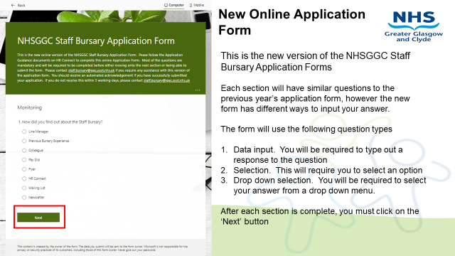

2. The Questions
There are SIX Questions. We would suggest you put as much detail in as possible to ensure you gain the maximum amount of funding. In previous high scoring applications, each answer contained in excess of 250 words per question.
The six questions are -
- Why have you chosen this course of study? Please provide both professional and personal reasons.
- How does this course of study link to your most recent Development Review or Appraisal and your current PDP - Personal Development Plan (or your own objectives if no recent PDP)? Please provide specific examples, outlining why they are important
- How will you apply your learning to support appropriate NHSGG&C work objectives (e.g. local team / department or corporate service objectives)?
- What positive changes would patients/customers in NHSGG&C see as a result of you undertaking this learning? Please provide examples.
- How will you evaluate the learning from the course of study (including evaluation of the course of study as well as evaluation of the impact on the service as appropriate)? Please provide examples
- Please provide any additional information in support of your application
You may want to type or write the questions out first as you cannot save your application form as you go.

3. Submitting Your Application Form
When you have completed your Application form, you will be requested to digitally sign and agree with the comments stated. Once your application form is fully complete, you will need to click on the ‘SUBMIT’ button to submit your application form. If there is anything missing, you will be unable to submit your application form.
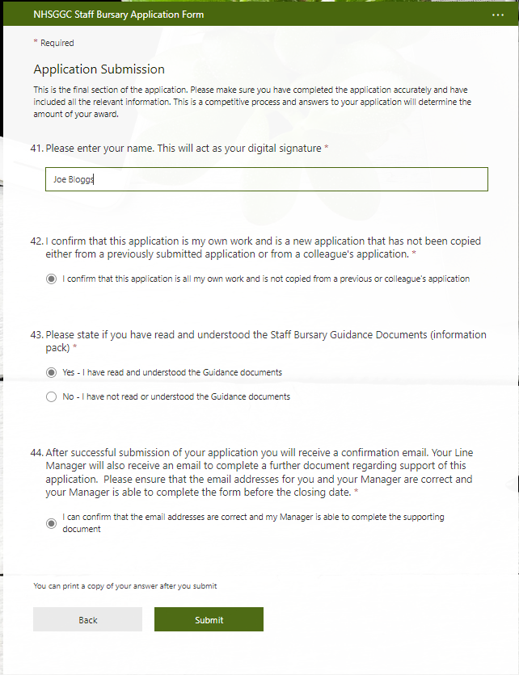
If you are having difficulty with this application form, or require an additional format, please contact LE Support on
staff.bursary@ggc.scot.nhs.uk
or
LE Support 0141 278 2700 (option 3)
Good luck with your Application for funding towards your chosen qualification

Regards
Staff Bursary Team

