DRAFT Terminating an Assignment – Step-by-Step Guide

Please note this process should be used when the employee has two posts, i.e. a substantive and a bank post.

Please ensure that Part 1 and Part 2 are completed otherwise the termination will not progress to Payroll.

PART 1 – Termination

Navigate to NHSS Manager Self Service

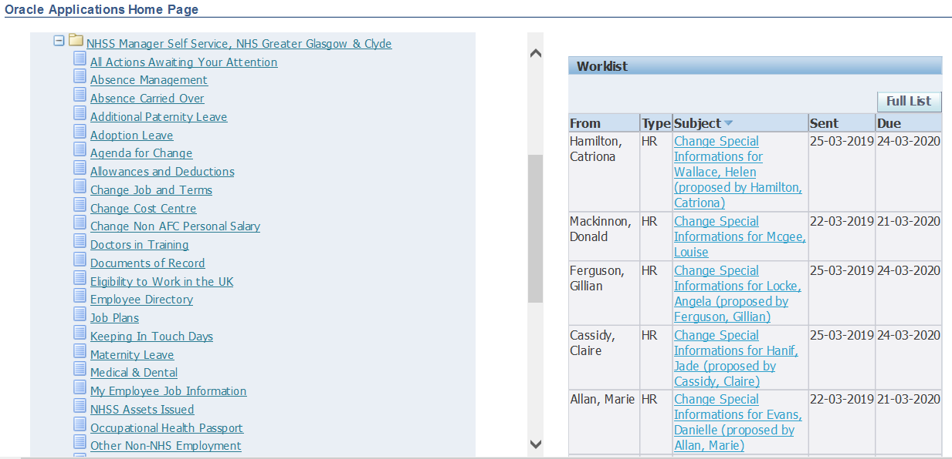

- Click ‘Termination’
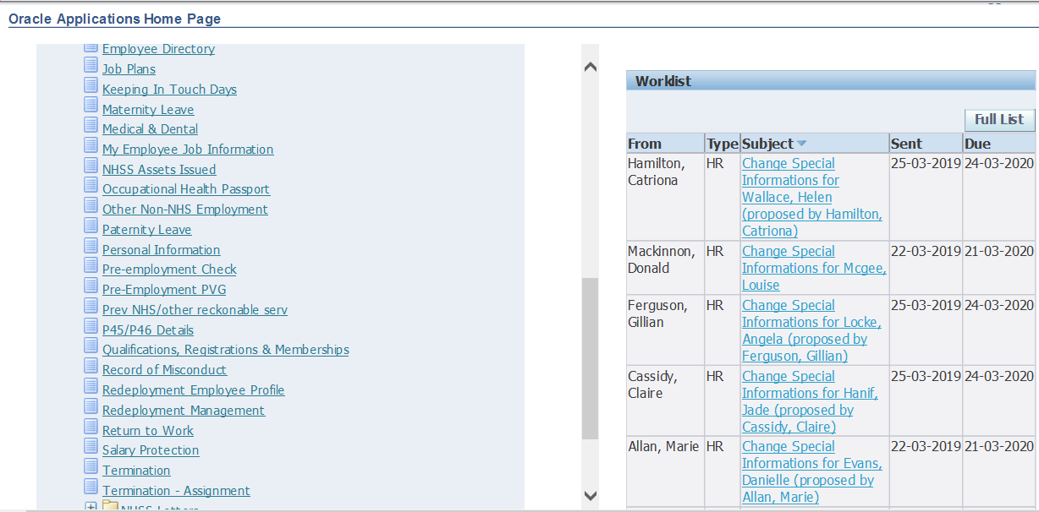

- Select employee from hierarchy to whom transaction applies and click ‘Action’
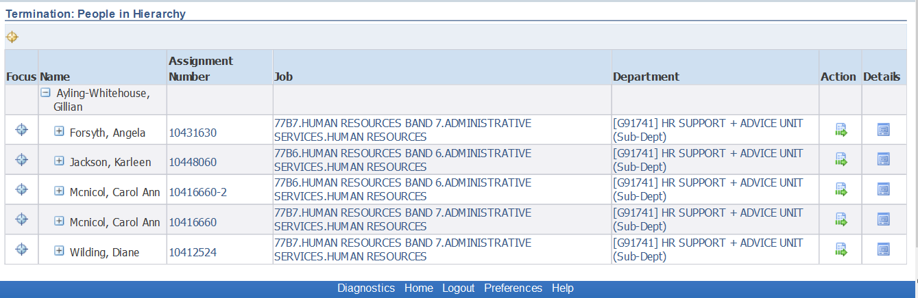
Pink, Colin
Red, Susan
Red, Susan
Blue, Dan
Brown, Joe
G12345 OFFICE DEPARTMENT (Sub-Dept)
G12345 OFFICE DEPARTMENT (Sub-Dept)
G12345 OFFICE DEPARTMENT (Sub-Dept)
G12345 OFFICE DEPARTMENT (Sub-Dept)
G12345 OFFICE DEPARTMENT (Sub-Dept)
71A4 OFFICE SERVICES
71A3 OFFICE SERVICES
71A3 OFFICE SERVICES
71A2 OFFICE SERVICES
71A2 OFFICE SERVICES
10412348
10412367
10412356-2
1041234
10412356
Smith, Robert
3. Choose appropriate employment
- If the below warning message displays contact eESS@ggc.scot.nhs.uk as the post you are trying to terminate as set as the ‘primary’ post and this needs to be changed by eESS Support Team before you can progress.
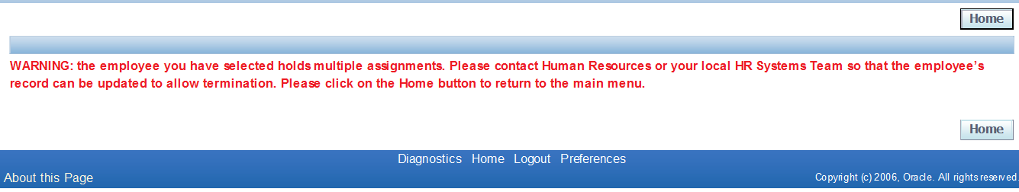
- Change Effective Date to the day after the termination date, click ‘Continue’
Type in the effective date or use the calendar function

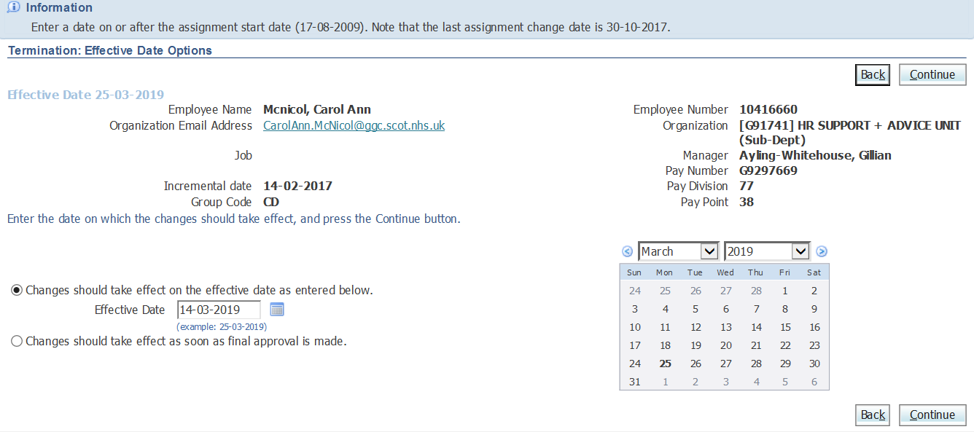
Susan.Red@ggc.scot.nhs.uk
Sus

Red, Susan
Sus

- Scroll down to Assignment Status change (half way down the page) from Active Assignment to Terminate Assignment
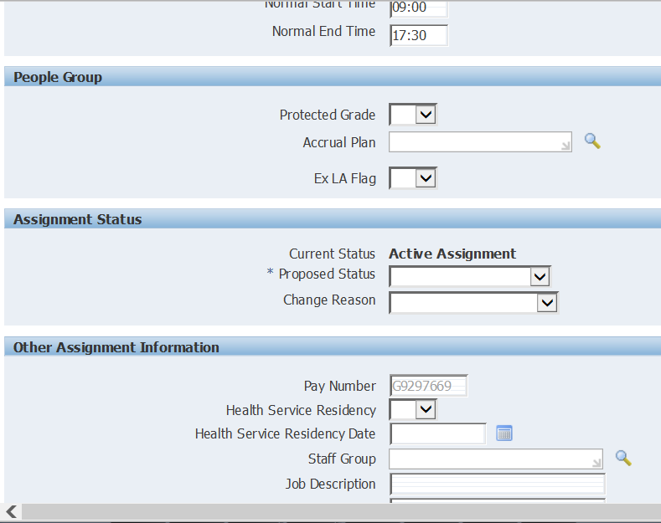 | 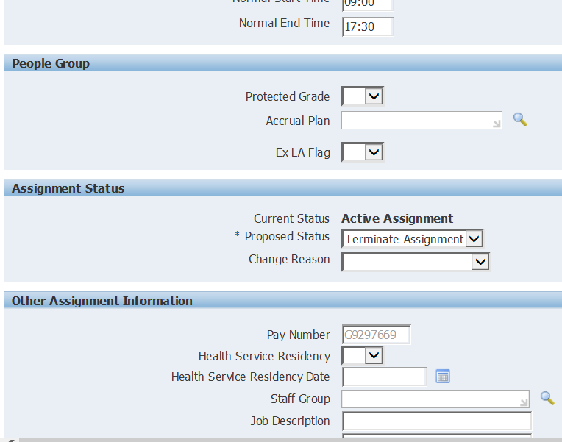

- Click ‘Next’ (bottom or top right hand)
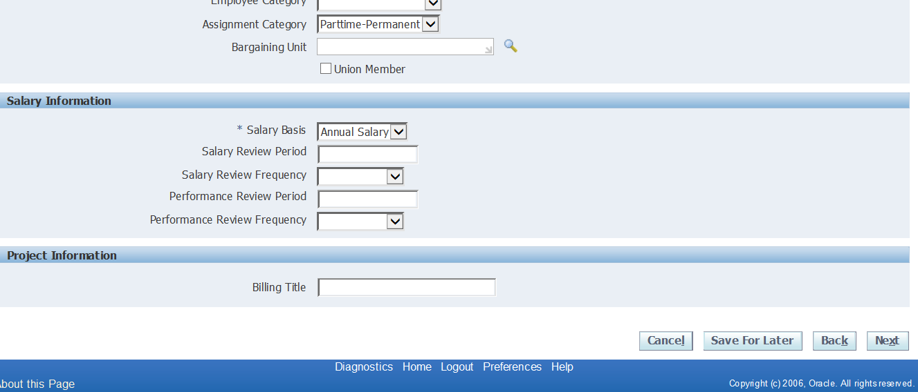
If a warning message appears, ignore this and click ‘Next’ again

- Review changes made, identifiable by blue dot, click ‘Submit’
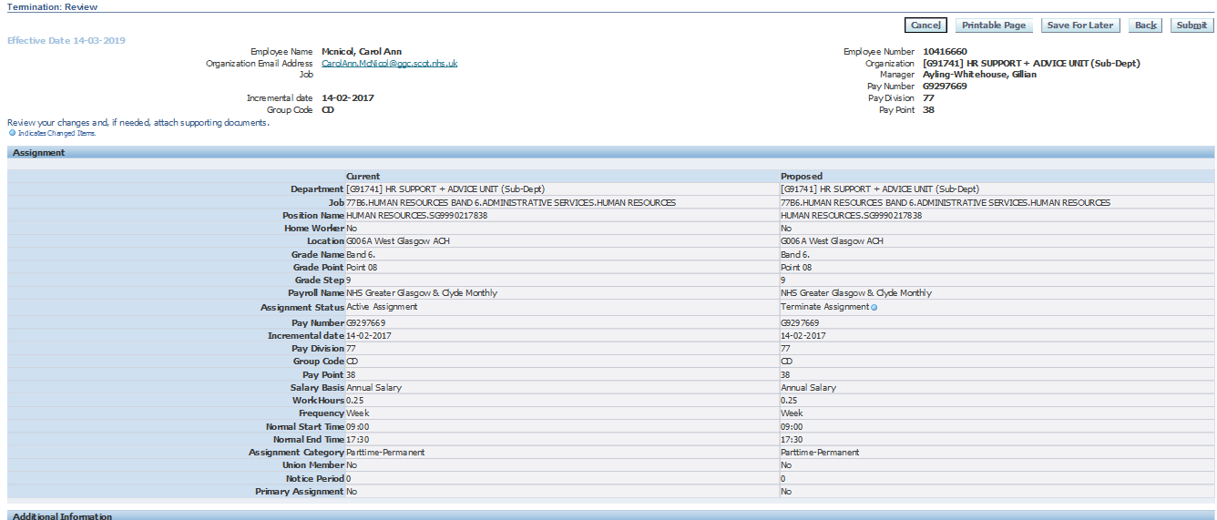

- You will then receive a confirmation message that the part 1 transaction has been submitted which will then sent to your line manager for approval.

PART 2 – Termination: Assignment

Navigate to NHSS Manager Self Service

** Before Proceeding you need to work out undertaken annual leave/public holidays **

- Click ‘Termination-Assignment’
- Select employee from hierarchy to whom transaction applies and click ‘Action’
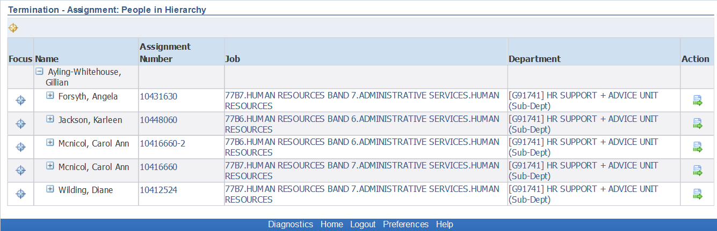
G12345 OFFICE DEPARTMENT (Sub-Dept)
G12345 OFFICE DEPARTMENT (Sub-Dept)
G12345 OFFICE DEPARTMENT (Sub-Dept)
G12345 OFFICE DEPARTMENT (Sub-Dept)
G12345 OFFICE DEPARTMENT (Sub-Dept)
71A4 OFFICE SERVICES
71A3 OFFICE SERVICES
71A3 OFFICE SERVICES
71A2 OFFICE SERVICES
71A2 OFFICE SERVICES
10412348
10412367
10412356-2
10412356
1041234
Blue, Dan
Red, Susan
Pink, Coln
Red, Susan
Smith, Robert
Brown, Joe
3. Click ‘Add’
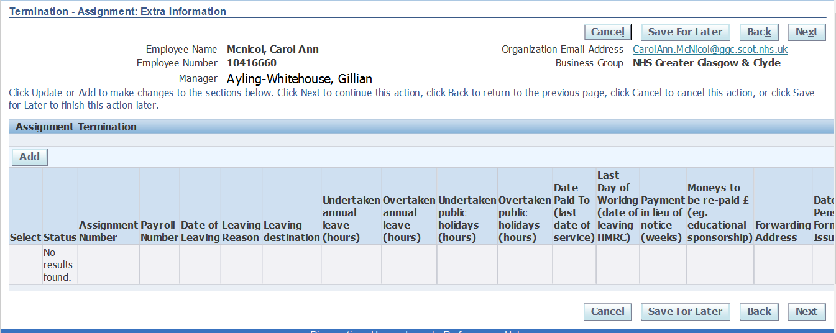

4. Enter the following information, using the date fields and lookups:
*Indicates mandatory field

- Assignment Number (use Search icon by selecting magnifying glass icon)
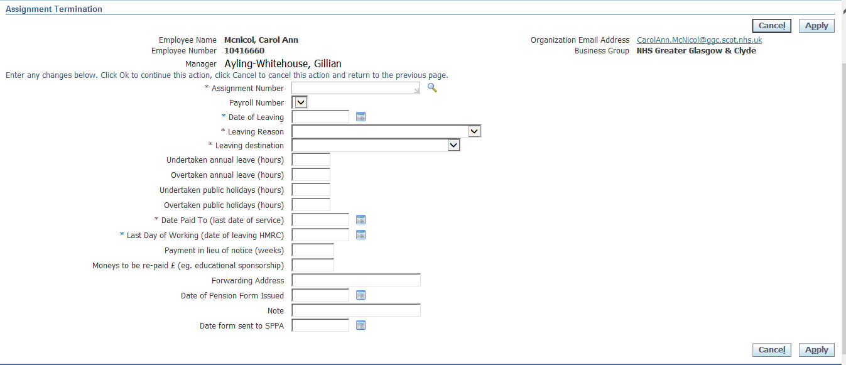

New page will appear as pop-up, click ‘Go’

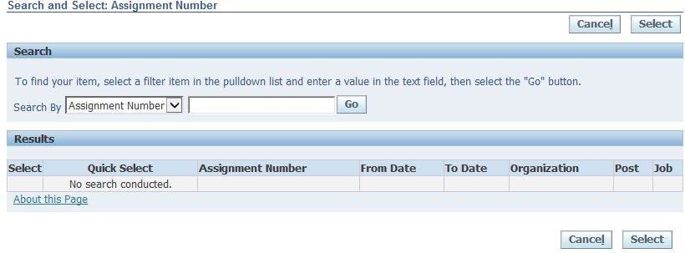

Select correct assignment to be terminated, then select ‘Quick Select’

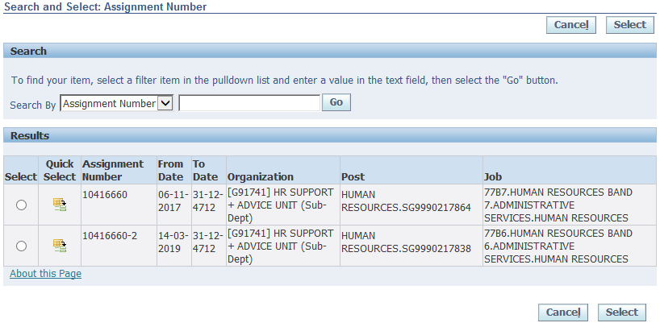
71A4 OFFICE SERVICES
71A3 OFFICE SERVICES
G12345 OFFICE DEPARTMENT (Sub-Dept)
G12345 OFFICE DEPARTMENT (Sub-Dept)
ADMIN SERVICES123400
ADMIN SERVICES 123990
10412356
10412356-2

- Payroll Number (Select from LOV (list of values))
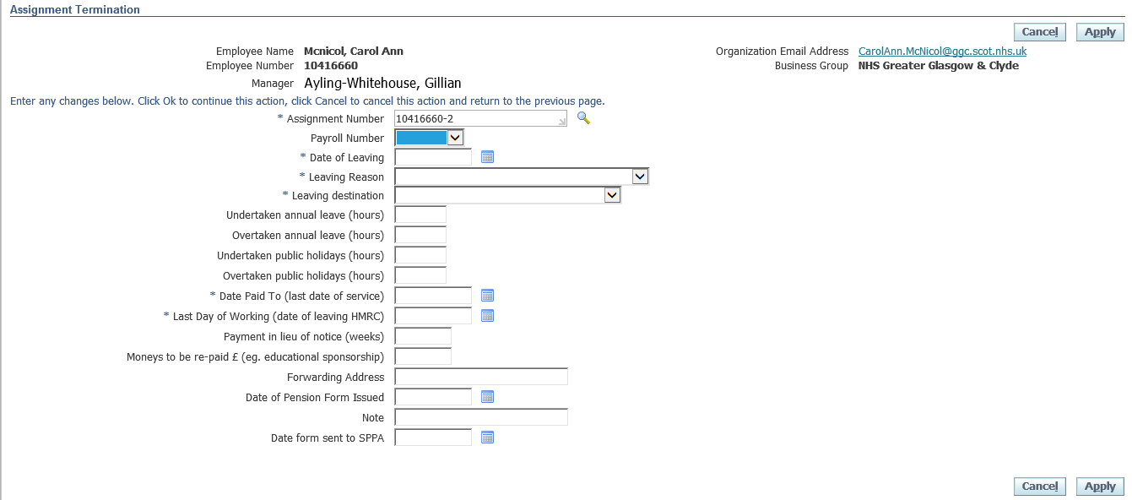
10412356

- Date of Leaving (actual last day, including any outstanding A/L)

- *Leaving Reason
Please refer to SOP to ensure correct combination of Leaving Reason and Leaving Destination is used. https://www.eess.nhs.scot/wp-content/uploads/ManagerSelfService/REF228-MSS-Termination-Assignment-v.1.3.pdf

- *Leaving Destination
Please refer to SOP to ensure correct combination of Leaving Reason and Leaving Destination is used. https://www.eess.nhs.scot/wp-content/uploads/ManagerSelfService/REF228-MSS-Termination-Assignment-v.1.3.pdf

f. Undertaken annual leave (hours)
** N.B The number of hours owed must be added to the Date Paid To field** for example if the date paid to is 31st August but they employee is owed 15 hours in undertaken annual leave the Date Paid To would change by an additional two days

- Overtaken annual leave (hours)

h. Undertaken public holidays (hours)
** N.B The number of hours owed must be added to the Date Paid To field** for example if the date paid to is 31st August but they employee is owed 15 hours in undertaken annual leave the Date Paid To would change by an additional two days

- Overtaken public holidays (hours)

j. *Date Paid To (normally actual last day)
** See undertaken annual leave notes below**

k. *Last Day of Working (normally actual last day)

l. Payment in lieu of notice (weeks)

m. Moneys to be re-paid £ (e.g. educational sponsorship)

n. Forwarding Address

o. Date of Pension Form Issued
p. Note

q. Date form sent to SPPA

Example of Completed Assignment Termination:
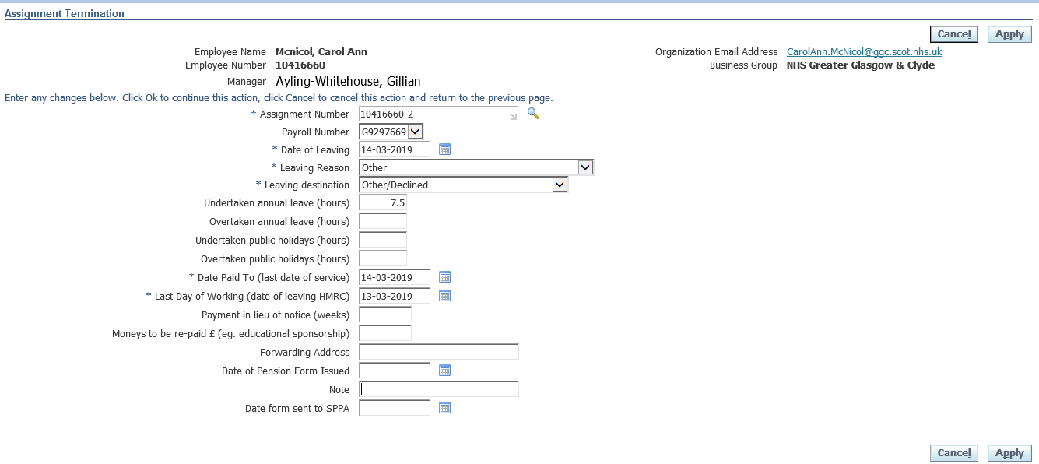
G11118X
10412356

5. Click ‘Apply’, then click ‘Next’

6. Review changes and click ‘Submit’

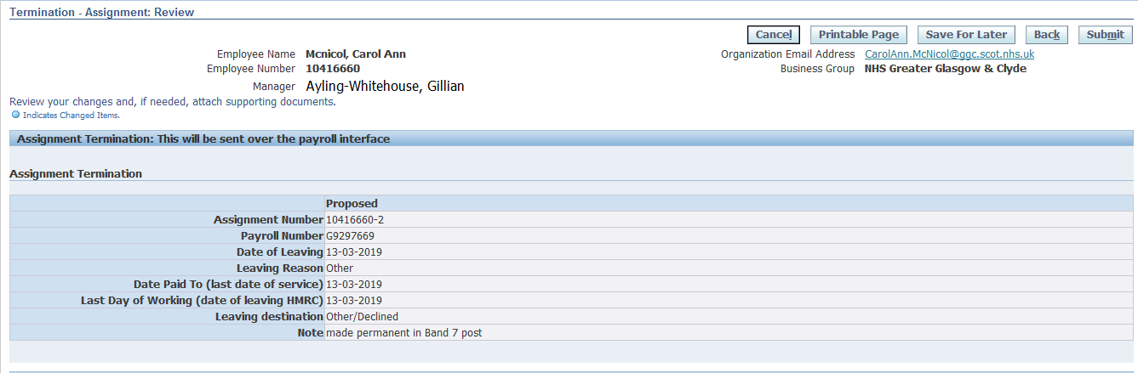

- You will then receive a confirmation message that the part 2 transaction has been submitted which will then sent to your line manager for approval.

- Click Home

