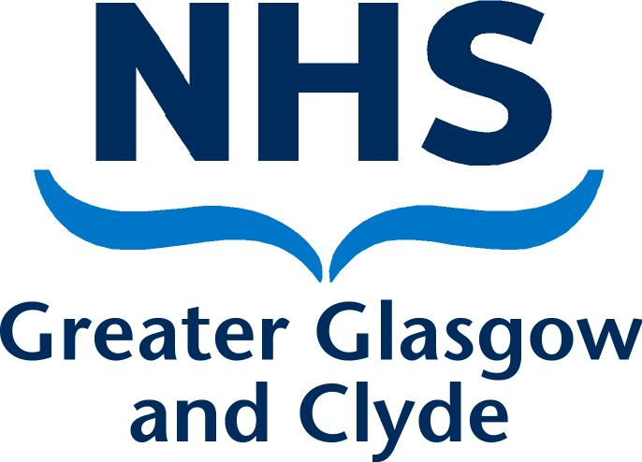

NHS Greater Glasgow and Clyde Healthy Minds Network

Mental Health Anti-Stigma small bids invite 2022-2023

1. Context
Despite supportive policy within Scotland, the experience of people with mental health issues in our communities remains poor. Mental health-related stigma and discrimination does not only occur within health and social care, but also within financial inclusion, employability, and education. This is in the context of the social determinants of health and equality issues predominantly amongst those with protected characteristics.

More than two-thirds (71%) of people with mental health problems in Scotland have experienced stigma and discrimination. In addition, 1 in 3 young people in every classroom will experience a mental health problem, and 3 in 4 say that they fear the reaction of their friends.

The impact of stigma and discrimination can be wide-ranging, including making someone’s mental health problems worse and stopping them from getting support.

2. Bid Specification
The NHS Greater Glasgow and Clyde Healthy Minds Network would like to invite creative bids from organisations working across Greater Glasgow and Clyde to help address some of the issues that surround mental health stigma and discrimination. This year, we particularly welcome bids that:
- Generally address the stigma that surrounds mental health. (For example, work could look at the labels that are often applied to mental health conditions, such as Depression, Bipolar Disorder, or Schizophrenia, and the self-stigma, or public stigma that surrounds these labels).
- Address stigma and discrimination around mental health in ethnic minority communities.

The themes of interest and types of approaches that we have received in the past are provided below for information. This list is not exhaustive and we welcome other approaches that are not included. We particularly encourage bids that demonstrate innovative thinking.

Theme | Selected approaches
1. General Mental Health Anti-stigma and Discrimination Work | Examples of previous approaches:  - Training  - Research  - Creative/artistic approaches  - Awareness raising work  - Resource development  - Face-to-face activities
2. Reducing Stigma and Discrimination among Ethnic Minority Communities

We welcome bids from statutory or voluntary sector organisations. Funding of up to £5,000 can be applied for.

Please note that the Fund is not intended for bids that solely look to promote positive mental health and wellbeing. To be considered for funding, applications must include a focus on addressing the stigma and discrimination that surrounds mental health.

Decisions of the scoring panel will be final and correspondence will not be entered into in relation to unsuccessful bids.

3. Deliverables
Organisations must submit an application by the closing date of Friday 9th September 2022. Applicants will be notified of the outcome of their submission by Friday 23rd September 2022.

We require the work to be delivered by Friday 31st March 2023, unless an alternative timeline is agreed with NHS Greater Glasgow and Clyde. A summary report describing the work delivered and any recommendations for future practice should be delivered within a timeframe agreed with NHS Greater Glasgow and Clyde. Funding will be paid upon completion of the project within the agreed timeframes.

Successful organisations must follow the below terms of reference:
- Have User Involvement - Organisations must develop a methodology that meaningfully engages users throughout the course of their project.
- Maintain Open and Honest Communication - Successful organisations must maintain open and honest communication channels with NHS Greater Glasgow and Clyde. This includes around any potential delays to deliverables.
- Be Equalities-focused – Successful organisations must ensure that equality is at the heart of their project. This includes ensuring that those with protected characteristics are not knowingly or unknowingly discriminated against at any stage.
- Produce High Quality Reporting and Evidence - Organisations should ensure robust methodology and provision of evidence throughout the project.

4. Support throughout the process

Pre-application
We will be holding an online Q&A before the submission is due. The Q&A will be facilitated by the Mental Health Improvement Team at NHS Greater Glasgow and Clyde, and will run from 1.00 – 2.00 pm on Wednesday 31st August 2022. It will be available to anyone who is interested in submitting an application. During the Q&A, we will provide an overview of what we are looking for, and provide a space to answer any questions ahead of the full submission. To join the session, please email the Mental Health Improvement team on ggc.mhead@ggc.scot.nhs.uk.

Post-application
Where relevant, successful applicants will have access to resources and training that support them in the development and completion of their project.

Successful applicants will also have access to a Learning Set. The aims of the Learning Sets are to support organisations to produce better evidence from their projects, and to build capacity for the future. This includes activities that focus on topics such as adopting an anti-stigma approach, involving people with lived experience, and evaluation approaches.

5. Application

Please complete the details below and return to the Mental Health Improvement team by email at ggc.mhead@ggc.scot.nhs.uk no later than noon on Friday 9th September 2022.

- Contact details
Please include your name, organisation, email address and telephone number.
- Description of proposal, including which theme is covered, main aims and objectives.

- Outline what the intervention is hoping to achieve from the perspective of tackling the stigma of mental health.
(e.g. specific outputs)
- Describe the specific target group(s) that this initiative would be aimed at and brief justification for their inclusion. This could be a specific neighbourhood / geographical focus/ communities of interest/protected. characteristic.
- Outline the Equalities / Tackling Inequalities dimensions considered within the proposal.
- Outline the ways in which the proposal demonstrates innovative thinking in the area of mental health stigma.
- What is your timescale?
(When will the project start and what is the completion date?)
- Briefly, breakdown the costs envisaged for this proposal.
(Include details regarding any match funding and in-kind support)
- Describe how you will evaluate the initiative?
(Include detail around specific methodologies and timeframes)

- NHS Greater Glasgow and Clyde should be clearly acknowledged as the funder and copyright owner of any resources produced by this funding and in communications about the project, such as summary reports, and resources should be made available for open use via a Creative Commons Licence or similar.

Anti-Stigma Project Proposal prepared by Laura Andre on behalf of the NHS Greater Glasgow and Clyde Mental Health Improvement Team – August 2022.

