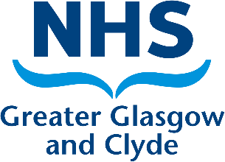
Activities 3rd year students should undertake in a non-NHS placement.

Here are some tips, ideas and suggestions about the activities they should be undertaking in order to complete the placement and enter the NMC register.

They are very much focusing on achieving their proficiencies in the blue pages, and that means working at a higher level - a big jump from 1st and 2nd year and many will be fairly independent too and may only need direct supervision with medicines.

Some of the things I'd expect them (and maybe some 2nd years too) to be doing are -

- Taking two or three hours out to sit and make a case study on one of your residents.
- Completing the resident of the day activities each day
- Managing the diary and delegating anything
- Clinical decision making if someone becomes unwell
- Chairing or providing significant input to any social work or family reviews.
- Creating an entire care plan on a made up resident who has just been admitted. (could be done as a pair of students)
- Running the shift and delegating activity.
- Reflecting on the life of someone living in the home, and how attending activities is meaningful and fulfilling.
- Going out to spend a day with - liaison nurse, CPN, GP, social worker, etc.
- Spending time with management / directors learning about staff appraisals, quality assurance, funding and audits.
- Undertaking audits.
- Writing an evidence based info leaflet on a condition such as Parkinson's and how to care for someone living with this.
- Comparing wound care plans in the home to those found in the NHS.
- Learning blood sampling normal values and explaining why some residents might have chronically abnormal bloods.

The list is endless! Please help facilitate these activities with the students as well as all the usual clinical activity.

